Chapter 2
Historical Review

2.1 Evolution of AI Study Platforms
The landscape of Educational Technology (EdTech) has rapidly shifted from fragmented tools where one app handles transcription and another handles quizzing to integrated "All-in-One" ecosystems. This evolution is driven by the need to reduce "cognitive switching" for students, allowing them to remain in a single environment for the entire learning lifecycle: from consuming content to self-assessment.
- The Renaissance of Spaced Repetition Algorithms
A key component of this evolution is the integration of memory retention science directly into content consumption.
- Historical Foundations: The concept of "spaced repetition" dates back to Hermann Ebbinghaus’s "forgetting curve" in 1885 and was later operationalized by the Leitner System of physical flashcard boxes in the 1970s.
- Algorithmic Shift: While early digital tools like SuperMemo and Anki relied on static algorithms (like SM-2) to schedule reviews, modern platforms have begun implementing advanced schedulers such as the Free Spaced Repetition Scheduler (FSRS).
- AI Integration: Unlike legacy tools that required manual card creation, the current generation of AI platforms automates this process. By parsing lecture transcripts, these tools instantly generate flashcards mapped to optimal retention intervals, effectively merging content creation with long-term retention strategies.
2.2 Democratization of Accessibility & Universal Design
The rise of AI has transformed accessibility from a costly accommodation into a standard feature for all learners.
- From Stenography to Neural ASR: Historically, accurate transcription required expensive human stenographers or early, error-prone dictation tools like Bell Labs' "Audrey" (1952). Today, Automatic Speech Recognition (ASR) has commoditized this capability, allowing students with hearing impairments or auditory processing disorders to access "Universal Design" learning materials instantly.
- Impact on Learning: Research indicates that synchronized text-audio interfaces (like those found in modern transcription tools) significantly aid not just disabled students, but also non-native speakers and visual learners, standardizing "multimodal" learning as a baseline expectation for new platforms.

2.3 State-of-the-Art Case Study: TurboLearn AI & NoteGPT
Two prominent examples that mirror the architecture of LectureMate are TurboLearn AI and NoteGPT. These platforms represent the current "State of the Art" in automated study aid generation.
- NoteGPT: The All-in-One Assistant
NoteGPT has established itself as a comprehensive learning hub by integrating video summarization, flashcard creation, and an AI chat assistant into a single interface.
- Workflow: It allows users to upload YouTube videos or audio files, which are then processed to generate "professional-grade" transcripts and study notes.
- Feature Set: Beyond simple summaries, it includes an "AI Humanizer" to refine text and a specific "YouTube Video Summarizer" that extracts key concepts without requiring the user to watch the full footage.
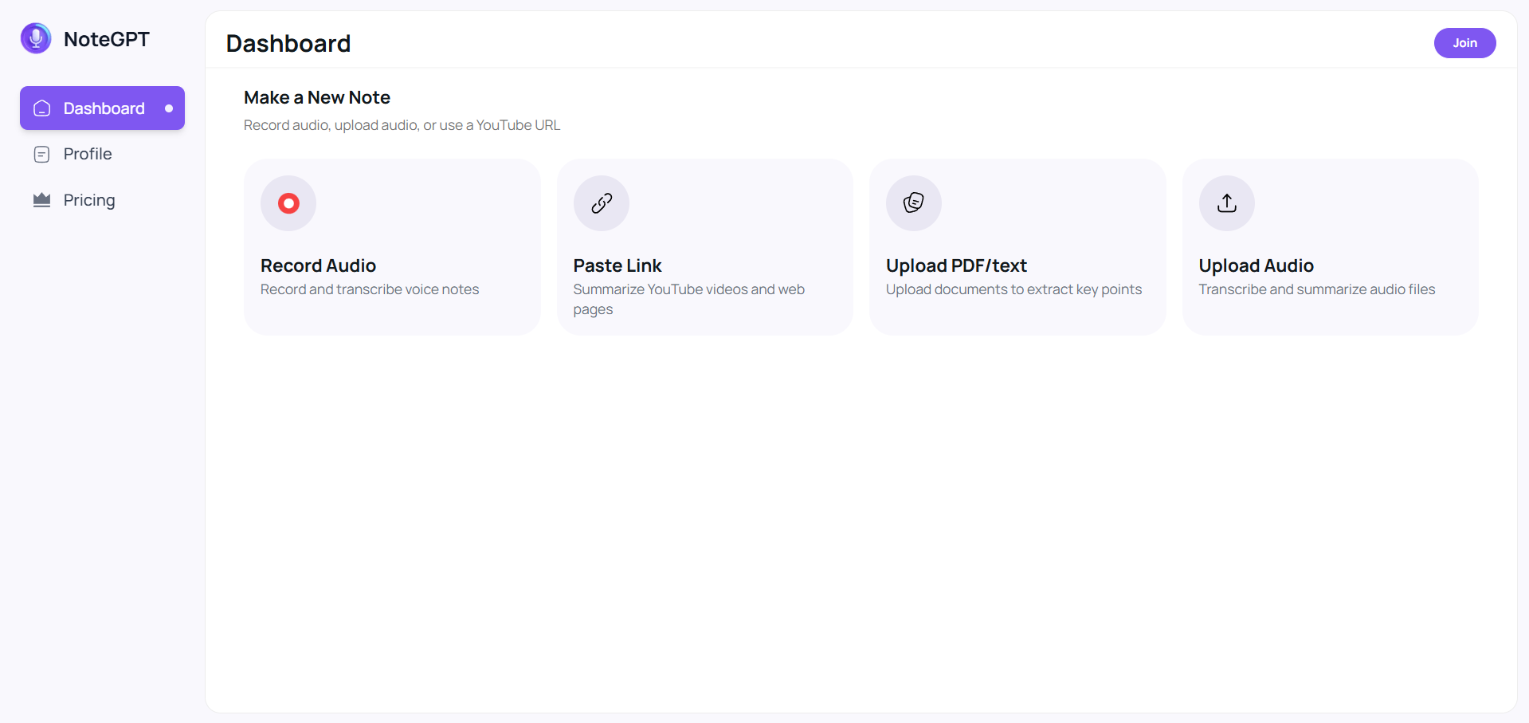
Figure 2.1 NoteGPT - UI

- TurboLearn AI: Instant Content Transformation
TurboLearn AI focuses heavily on speed and instant conversion of lectures into active study materials.
- Core Function: It markets itself as a tool that "instantly converts lectures into comprehensive notes, flashcards, and quizzes," aiming to replace manual note-taking entirely.
- Differentiation: Unlike basic summarizers, TurboLearn organizes content into a "Study Stream," effectively creating a personalized feed of knowledge that combines inputs from PDFs, audio, and videos.

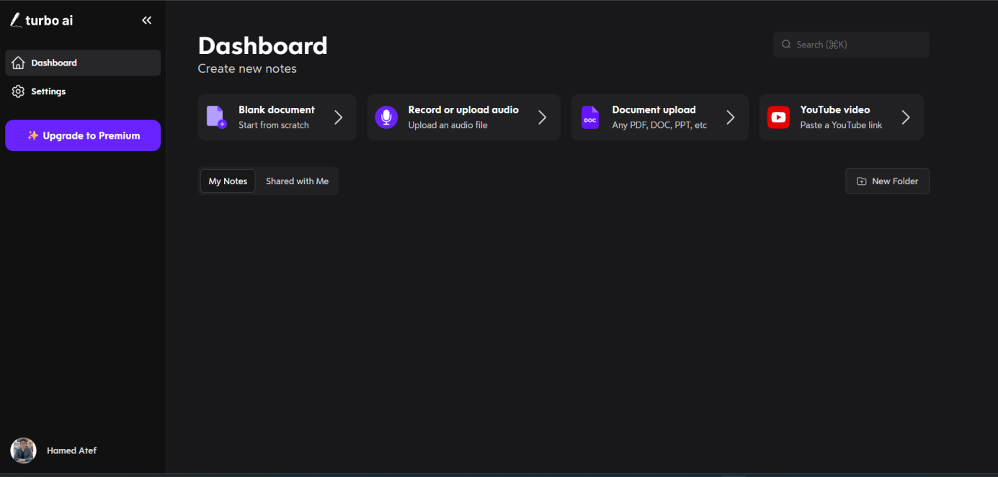
Figure 2.2 TurboLearn AI - UI

2.4 Ethical Frontiers: The Privacy Paradox
As AI study tools proliferate, a significant historical tension has emerged regarding student data privacy.
- The Cloud vs. Privacy Conflict: Most commercial "freemium" AI tools operate by processing student data on external cloud servers. This raises concerns under frameworks like FERPA and GDPR, as sensitive lecture content or student performance data may be ingested to train public models.
- The Shift to Local AI: In response to these surveillance and data harvesting risks, a new trend is emerging towards "Local AI" and self-hosted models. This historical pivot suggests a market opening for platforms (like LectureMate) that can offer the power of Large Language Models (LLMs) while keeping data processing entirely offline or within a private infrastructure.
2.5 Accuracy and Performance Metrics
A critical factor for these platforms is the accuracy of their AI-generated outputs. Research and industry benchmarks provide the following performance data:
- Speech-to-Text (ASR) Accuracy
The foundation of these platforms is the transcription of spoken lectures.
- AI Performance: Modern AI transcription models (such as those used by these platforms) achieve approximately 99.8% accuracy in optimal audio conditions. In more challenging environments with background noise or heavy accents, this accuracy typically ranges between 80-90%.
- Comparison: While human transcription remains the "gold standard" at ~99% consistency, AI tools have bridged the gap significantly, offering a much faster and more cost-effective solution for students.
- Content Generation Accuracy
- Notes & Quizzes: TurboLearn AI specifically claims a 99% accuracy rate for its generated notes and quizzes. This high level of precision is achieved by using advanced LLMs that are fine-tuned to extract educational context rather than just generic text.
- Summarization Reliability: Independent tests of AI summarizers (like NoteGPT) indicate that while they excel at identifying "purely human" or "purely AI" content, they can sometimes struggle with "humanized" AI text. However, for the purpose of educational summaries, they are rated as highly reliable for capturing core concepts.
2.6 Conclusion
The success of platforms like TurboLearn AI and NoteGPT validates the market demand for integrated study tools. However, the historical trajectory suggests that the next generation of tools must go beyond simple integration. By combining high-accuracy transcription (~99%) with advanced retention algorithms (Spaced Repetition) and robust privacy protections (Local AI), future platforms can address the ethical and pedagogical gaps left by current market leaders. This sets the benchmark for the LectureMate project, positioning it not just as a tool for efficiency, but as a holistic, privacy-conscious learning environment.

