Chapter 4
AI Brain Architecture

4.1 Introduction
Transforming Structured Text into EducationalIntelligence,Following the conversion of audio and visual content into organized, ready-to-process text as detailed in Chapter 2, the system enters its most critical phase: the application of its core artificial intelligence layer the AI Brain.
This brain consists of an integrated dual-system architecture, where each component complements the other:
- LM-Titan(The Edge Core): Powered by the Ollama framework, utilizing quantized models like Llama 3 (8B) or Qwen-2 to achieve high-speed inference on consumer-grade GPUs.
- LM-Cloud(The Frontier Intelligence): Utilizing advanced APIs (e.g., GPT-4o or Gemini Pro) for complex reasoning tasks that require a broader world-knowledge base."
This chapter begins by explaining how the system intelligently prepares text for analysis, then proceeds to compare the two systems and demonstrate their complementary applications in the educational context.
4.2 The Text Acquisition Pipeline
From Audio to Structured Transcript,To generate high-quality summaries, create meaningful questions, and prepare presentation materials, the system first requires an accurate and well-structured transcript of the lecture.
- Two Integrated Extraction Pathways
The system employs two complementary approaches for text acquisition, ensuring reliability and coverage.
- Path One: The Whisper Automatic Speech Recognition Model
This path processes any audio or video file, regardless of whether pre-existing captions are available. It is particularly valuable for newly recorded content, unpublished materials, or lectures with unavailable or poor-quality captions.

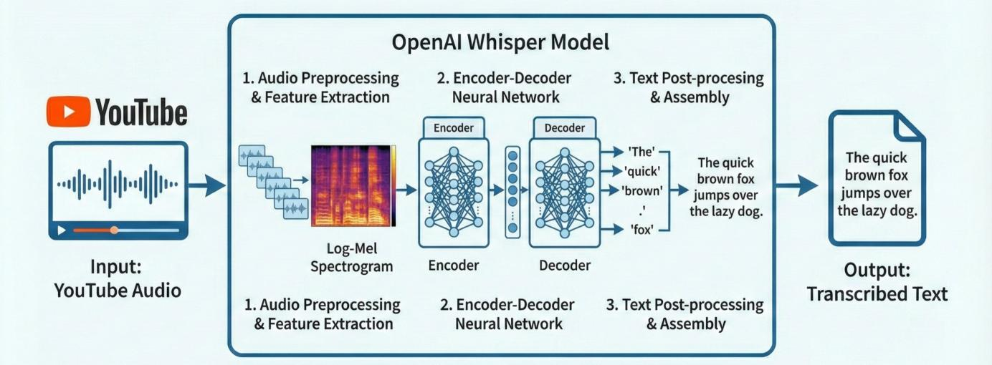
Figure 4.1 Gemini.Nano Banana-Showing OpenAl Whisper Model

- Path Two: The YouTube Transcript API
This method extracts existing captions directly from video platforms. It is significantly faster and consumes fewer computational resources. This approach leverages the educational value added by instructors who have reviewed and refined their lecture captions.
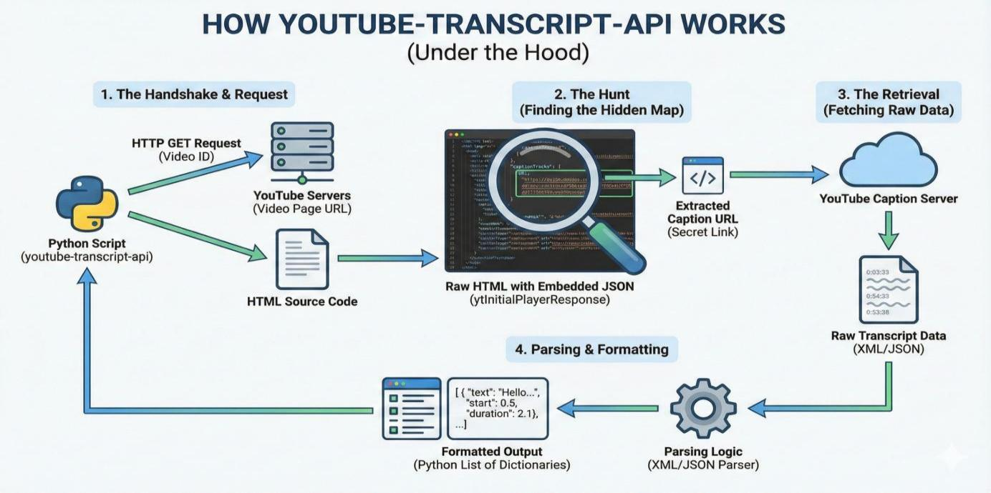
Figure 4.2 Gemini.Nano Banana-Showing HOW YOUTUBE-TRANSCRIPT-API WORKS
- Specialized Processing for Arabic and Academic Content
The system implements advanced processing techniques tailored for Arabic educational content. This includes handling the diverse range of Arabic dialects encountered in academic settings, accurately recognizing specialized scientific and technical terminology in Arabic, and intelligently processing code-switching between Arabic and English, which is common in technical and scientific lectures.

4.3 The Dual AI System: Rationale Behind the Architecture
- The Philosophy of Complementary Design
The two systems LM-Titan and LM-Cloud are not mere alternatives but complementary solutions designed to address different sets of requirements and constraints.
- LM-Titan (The Local Powerhouse) prioritizes absolute data privacy and predictable operational costs. It operates entirely within a local network, ensuring no sensitive academic content is transmitted externally. After an initial hardware investment, the cost per request is effectively zero, making it economically efficient for high-volume, daily use. It delivers high performance for medium-complexity tasks but has inherent limitations in model size and reasoning depth compared to cutting-edge cloud models.
- LM-Cloud (The Unlimited Cloud Intelligence) offers access to the most advanced and powerful language models available. It provides immense flexibility, scaling resources up or down instantly based on demand. It operates on a pay-per-use model, which is ideal for variable or project-based workloads. However, it requires a stable internet connection and involves transmitting data to a third-party service, which introduces considerations around privacy, compliance, and ongoing costs.
The choice between systems is not static; it is a strategic decision based on the specific lecture content, institutional policies, and desired educational outcomes.

- LM-Titan: Guaranteed Local Performance and Privacy

LM-Titan represents the self-reliant, high-performance local mode. Its defining feature is complete data sovereignty, as all processing occurs on local servers or workstations, making it indispensable for handling sensitive content such as unpublished research discussions, medical training sessions, or confidential corporate training.

Its operational model is based on a fixed capital investment in hardware (like high-performance GPUs), leading to predictable long-term costs with no variable fees. It provides full operational independence, functioning without an internet connection, which guarantees availability and can be crucial in environments with restricted or unreliable connectivity. For standard educational tasks like generating summaries and key points for typical-length lectures, it offers exceptionally fast response times.

This mode is ideally suited for established educational institutions with robust IT infrastructure, for any project involving strictly confidential material, and for scenarios requiring intensive, daily processing where cloud costs would become prohibitive.

- LM-Cloud: Scalable Cloud-Based Intelligence

LM-Cloud leverages the vast computational resources and continuous innovation of major cloud AI platforms. It provides access to state-of-the-art models that typically surpass the capabilities of locally runnable models in terms of reasoning depth, coherence, and task complexity. This makes it exceptionally powerful for deconstructing long (multi-hour), complex lectures or generating sophisticated, exam-style questions.

The system offers on-demand scalability, instantly adapting to handle any workload without the need for local hardware upgrades. It benefits from continuous, automatic updates and improvements from the API provider, ensuring access to the latest AI advancements. Its cost structure is operational and flexible, aligning expenses directly with usage, which is advantageous for pilot projects, variable workloads, or institutions without upfront capital for hardware.

This mode is the preferred choice for processing very long and intricate lectures, for tasks demanding the highest level of analytical reasoning or creative structuring, for temporary or experimental projects, and for rapid prototyping and development of new educational features.

4.4 The Intelligent Orchestration Layer:How the System Makes Decisions
- Semantic Routing Logic
"The Orchestration Layer acts as a Semantic Router. It analyzes the 'Task Complexity Score' before execution. For instance:
Routine Tasks: (Basic transcription cleaning, bullet-point summaries) are routed to LM-Titan.
Complex Tasks: (Cross-lecture synthesis, complex mathematical reasoning, or generating nuanced pedagogy-based quizzes) are escalated to LM-Cloud if the local confidence score falls below a predefined threshold."
- The Automatic Selection Mechanism
The system does not merely offer two modes; it includes an intelligent orchestration layer that can recommend or automatically select the appropriate engine based on a holistic analysis of the task.
This layer evaluates multiple factors: the length and complexity of the lecture transcript, the presence of sensitive keywords or topics that mandate local processing, the specific educational task requested (e.g., simple summary vs. deep Q&A generation), and the explicit preferences or policy settings of the user or institution. A configurable rule-set allows administrators to define priorities, such as "always use local for medical lectures" or "use cloud for summaries over 5000 words."

- Intelligent Hybrid Integration
In advanced configurations, the system can strategically employ both engines within a single workflow. For instance, LM-Titan could perform initial processing, rapid summarization, and basic keyword extraction. LM-Cloud could then be invoked for more demanding phases, such as generating nuanced essay questions or creating a detailed concept map. The results are then synthesized into a final, cohesive output, combining the speed and privacy of the local system with the advanced capabilities of the cloud.
4.5 The Educational Content Generation Engine
- Core Educational Tasks
Regardless of the underlying AI engine selected, the system executes a consistent suite of pedagogical tasks through a unified prompt orchestration and formatting layer.
The engine performs Multi-Level Summarization, producing an executive abstract capturing the core thesis, a comprehensive study summary for thorough understanding, and a concise list of key points for quick review. It conducts Core Concept Extraction, identifying and defining technical terminology, mapping the relationships between different ideas presented, and outlining the logical flow of the lecture's argument.
It facilitates Assessment Tool Creation by generating multiple-choice questions that test factual recall and application, true/false statements with corrective explanations for misconceptions, short-answer questions that probe deeper understanding, and complete self-assessment quizzes. Finally, it automates Teaching Material Preparation, drafting structured PowerPoint-style presentations, organizing study notes in a logical hierarchy, and formulating practice worksheets and problem sets.

- Adaptation to Educational Needs
The system dynamically adapts its output based on several axes. It tailors language and detail to the learner's Level, whether beginner, intermediate, or advanced. It adjusts its approach based on the Subject Type, such as theoretical, practical, mathematical, or literary. It aligns its task execution with the Learning Objective, be it foundational comprehension, practical application, or critical analysis. Furthermore, it can vary presentation styles to accommodate different Learning Styles, including visual, auditory, and reading/writing preferences.

4.6 Quality Assurance and Performance
- Performance Benchmarks
The system is designed with specific performance targets for different tasks. For summarizing a 30-minute lecture, the target processing time is under 30 seconds. For generating a set of questions, the target is under 45 seconds. The overarching goal for content accuracy is consistently above 90%, ensuring reliable educational utility. Cost-efficiency is also a key benchmark, with LM-Titan aiming for near-zero marginal cost per task and LM-Cloud targeting a predictable and reasonable cost per request based on cloud provider pricing.
- Mechanisms for Continuous Improvement
To maintain and enhance quality, the system employs several mechanisms. It incorporates a Feedback Loop, learning from user corrections and preferences to refine future outputs. It performs regular Comparative Analysis, benchmarking the outputs of both its local and cloud engines to identify strengths, weaknesses, and opportunities for optimization. It undergoes Scheduled Updates, periodically integrating newer versions of language models and improving its internal processing algorithms. Finally, it demonstrates Adaptive Performance, fine-tuning its operations based on observed usage patterns and institutional goals.

4.7 The Core Innovation
The primary innovation of this system lies not merely in its application of artificial intelligence, but in its sophisticated integration and strategic orchestration of AI to serve precise educational objectives. It successfully balances the critical vectors of educational quality, data privacy and security, operational efficiency and cost, and system flexibility and adaptability.

The final outcome is a comprehensive system that transforms a lecture from a transient event into a persistent, evolving educational resource. This resource can be continuously utilized, refined, and built upon, creating sustainable and growing educational value for all participants in the learning process.

4.8 Conclusion: An Integrated Intelligent System

- The Added Educational Value
The integrated AI brain delivers significant value across the educational ecosystem.

For students, it provides personalized, ready-to-use study materials, enables immediate and effective self-assessment, and dramatically reduces the time required for review and organization of lecture content.

For educators, it automates the time-consuming preparation of teaching aids, offers analytical insights into their lecture content and delivery structure, and supports the continuous development of teaching effectiveness.

For institutions, it enhances the overall efficiency of the educational process, helps standardize the quality of pedagogical materials, and enables intelligent archiving and data-driven analysis of educational content.

