Chapter 5
System Implementation & UI

5.1 System Architecture Overview
LectureMate is engineered using a modern, decoupled architecture to ensure scalability and high performance. The system is divided into three core layers:

- Frontend Layer: Built with React 18 and TypeScript, serving as the interactive client-side application. It utilizes Vite for optimized building and Tailwind CSS for rapid, responsive styling.
- Backend API Layer: A Node.js/Express server that acts as the central orchestrator. It manages API routes, communicates with the database, and spawns child processes for heavy computational tasks.
- Intelligence Layer: A hybrid AI engine combining Google Gemini 1.5 Flash (Cloud) and Qwen 2.5 (Local GPU) to process transcripts and generate educational content.

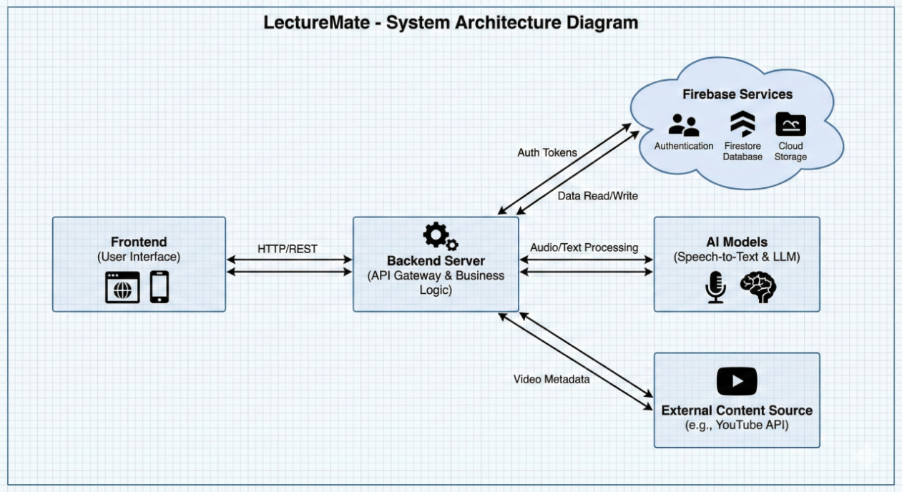
Figure 5.1 LectureMate - System Architecture Diagram
5.2 User Authentication & Security
The authentication module is designed to provide a secure and seamless entry point for users, leveraging Firebase Authentication for identity management.
- Sign Up Interface
The registration page offers a user-friendly form with real-time validation.
- Key Features:
- Password Strength Meter: A dynamic indicator that evaluates password complexity (Weak, Fair, Good, Strong) in real-time as the user types.
- Social Login: Integration with Google OAuth for one-click registration.
- Visual Feedback: Uses Framer Motion to add smooth entrance animations to the login cards.
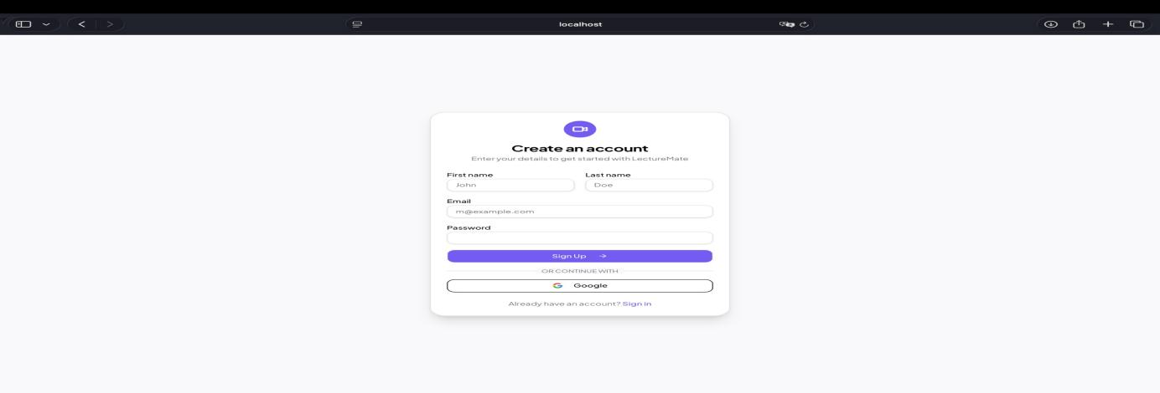
Figure 5.2 LectureMate-Sign Up Page

- Sign In Interface
The login interface ensures secure access for returning users.
- Key Features:
- Bilingual Support: The interface automatically adapts layout direction (RTL/LTR) based on the user's language preference (Arabic/English).
- Error Handling: "Toaster" notifications provide immediate feedback for incorrect credentials or network issues
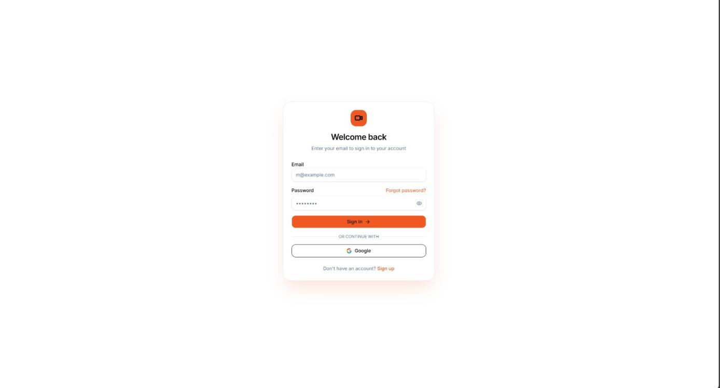
Figure 5.3 LectureMate-Sign In Page

5.3 Dashboard & Workspace
The Dashboard serves as the central command center, offering users a personalized overview of their learning progress.

- Statistics & Overview
Upon logging in, users are greeted with a "Welcome Back" message and a statistical summary of their activity:

- Key Metrics: Four dynamic cards display:
- Total Lectures: Number of videos analyzed.
- Completion Rate: Percentage of lectures fully studied.
- Study Time: Total time spent learning (calculated from video duration).
- Cards Created: Number of flashcards and slides generated.

- Continue Learning
A "Continue Learning" section highlights the most recent lecture the user was interacting with, displaying a progress bar that indicates whether the lecture is still processing or ready for study.

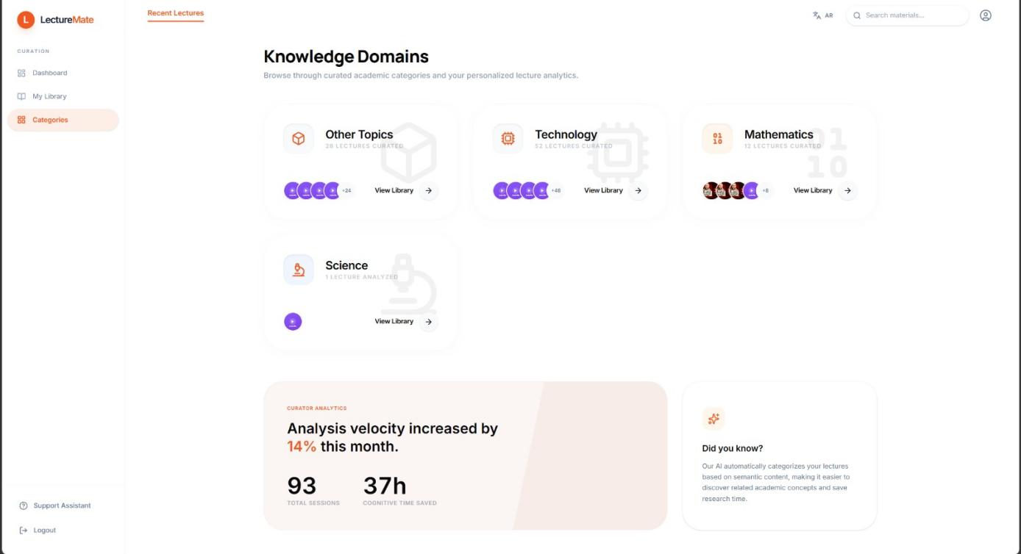
Figure 5.4 LectureMate-Dashboard showing the categories of lectures

5.4 Lecture Analysis Workflow
The "New Analysis" page is the starting point for processing content.
- Input Mechanism: Users simply paste a YouTube URL. The system validates the link and retrieves metadata (thumbnail, title, duration) using the youtubeService.
- Configuration Options: Users can select their preferred processing mode before starting:
- LM-Cloud (API): Uses Gemini for fastest results.
- LM-Titan (GPU): Uses the local Qwen model for privacy.
- Real-time Feedback: A multi-step progress indicator informs the user of the current stage: "Downloading Audio" → "Transcribing" → "Generating Summary".

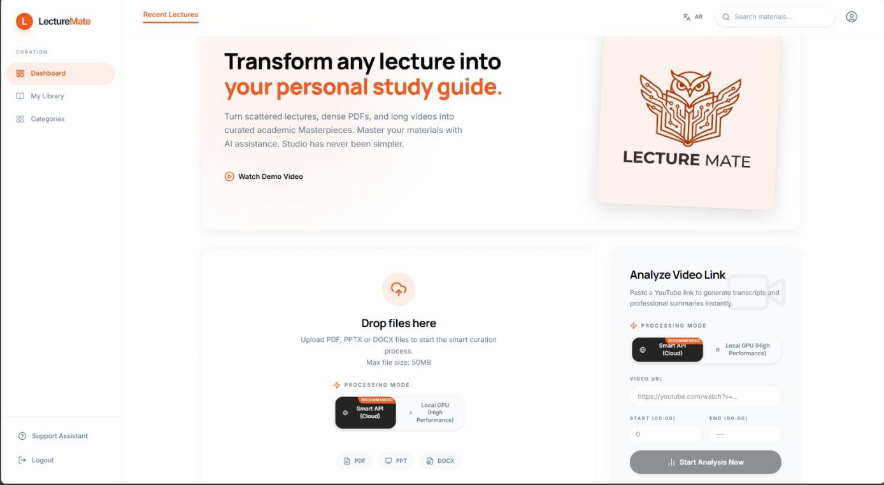
Figure 5.5.1 LectureMate-New Analysis Page with URL,Upload Video,Record Audio input and Model selection
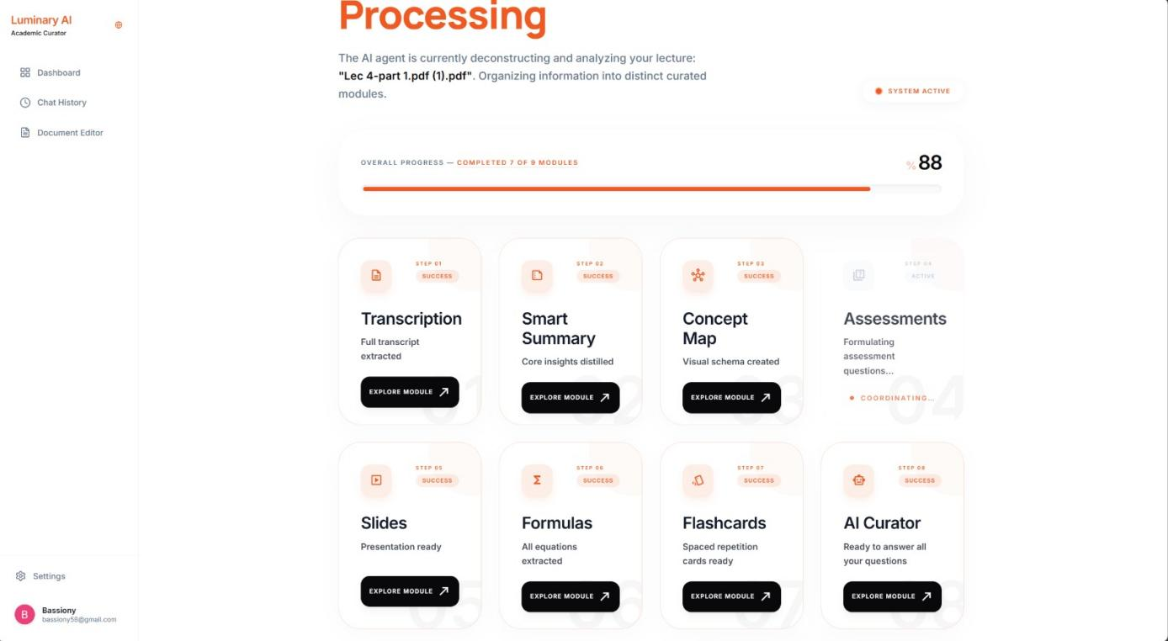
Figure 5.5.2 LectureMate-showing the process for analyzing a lecture

5.5 The Integrated Learning Environment
The core value of LectureMate is delivered through the Lecture View, a tabbed interface that organizes generated content into digestible modules.

- Summary & Transcript Tabs
- Abstractive Summary: Displays a structured summary generated by the AI, broken down into an Introduction, Key Points, and Conclusion.

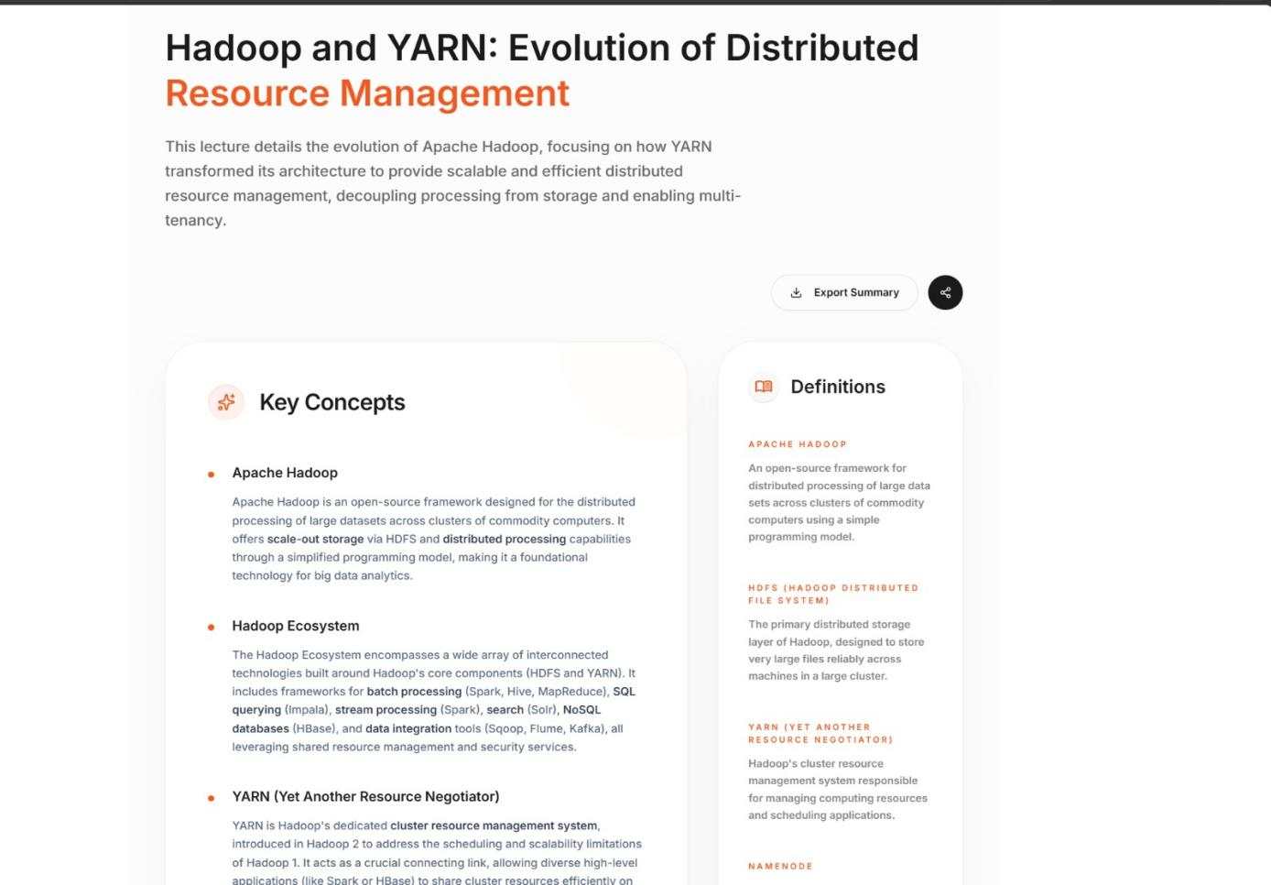
Figure 5.6.1 LectureMate-showing the summarization of the lecture
- Interactive Transcript: A time-synced transcript view that allows users

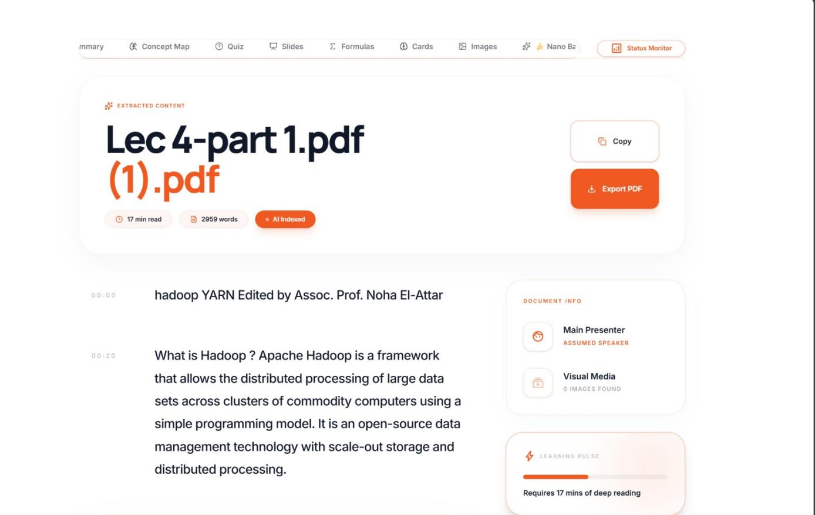
Figure 5.6.2 LectureMate-showing the Full Transcript of the lecture

- Assessment & Study Tools

- Quiz Module: An interactive quiz interface where users can test their knowledge. It provides instant feedback on correct/incorrect answers.

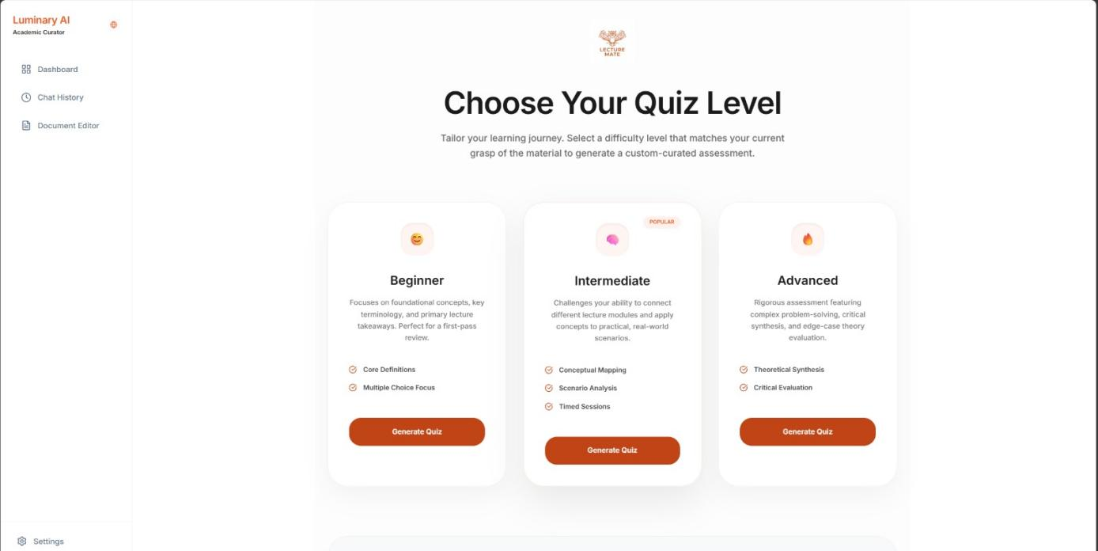
Figure 5.7.1 LectureMate-Choose Quiz Mode

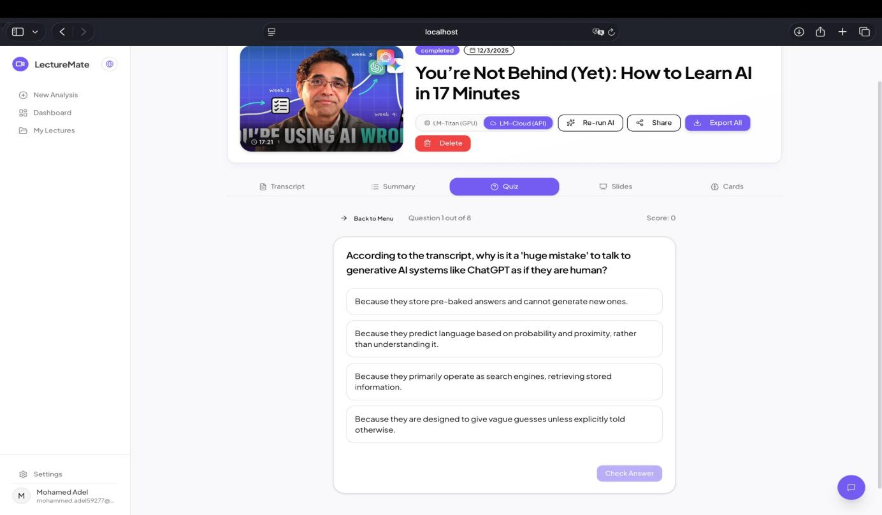
Figure 5.7.2 LectureMate-After selecting the Quiz Mode
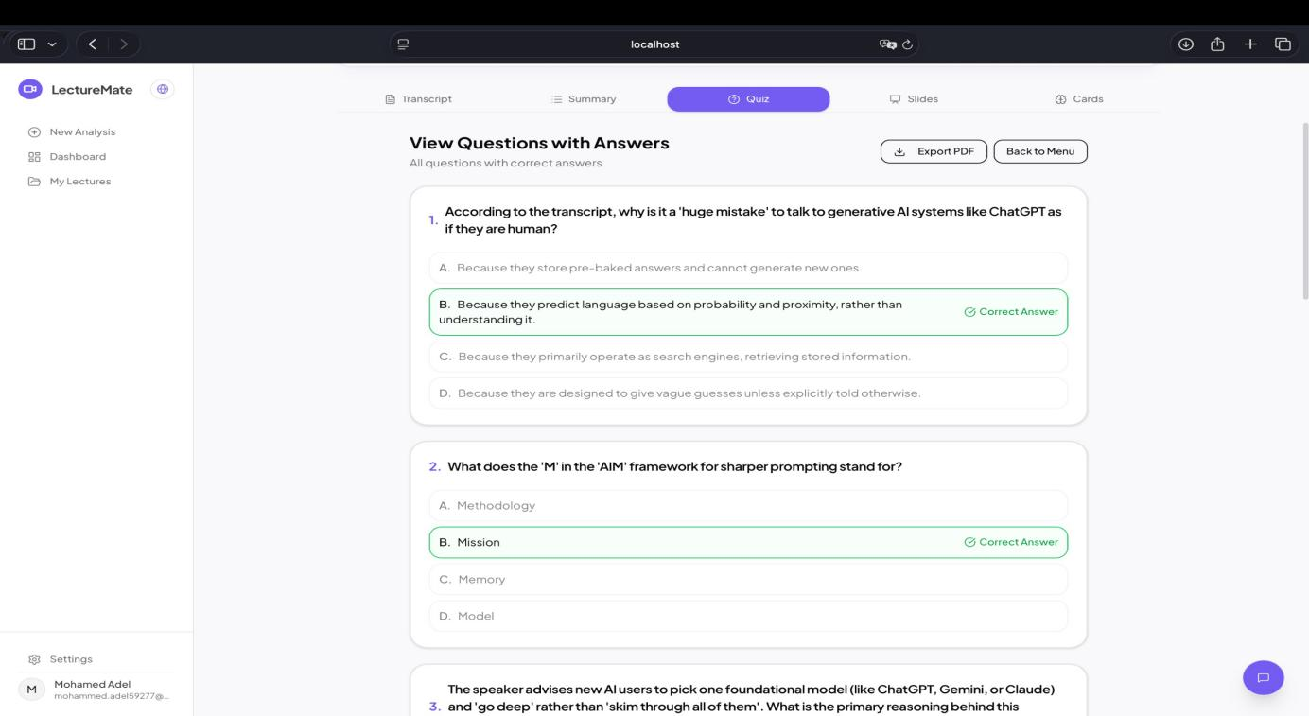
Figure 5.7.3 LectureMate-View Questions with Answers

- Flashcards: A digital flashcard deck for spaced repetition study, helping users memorize key terms and definitions.

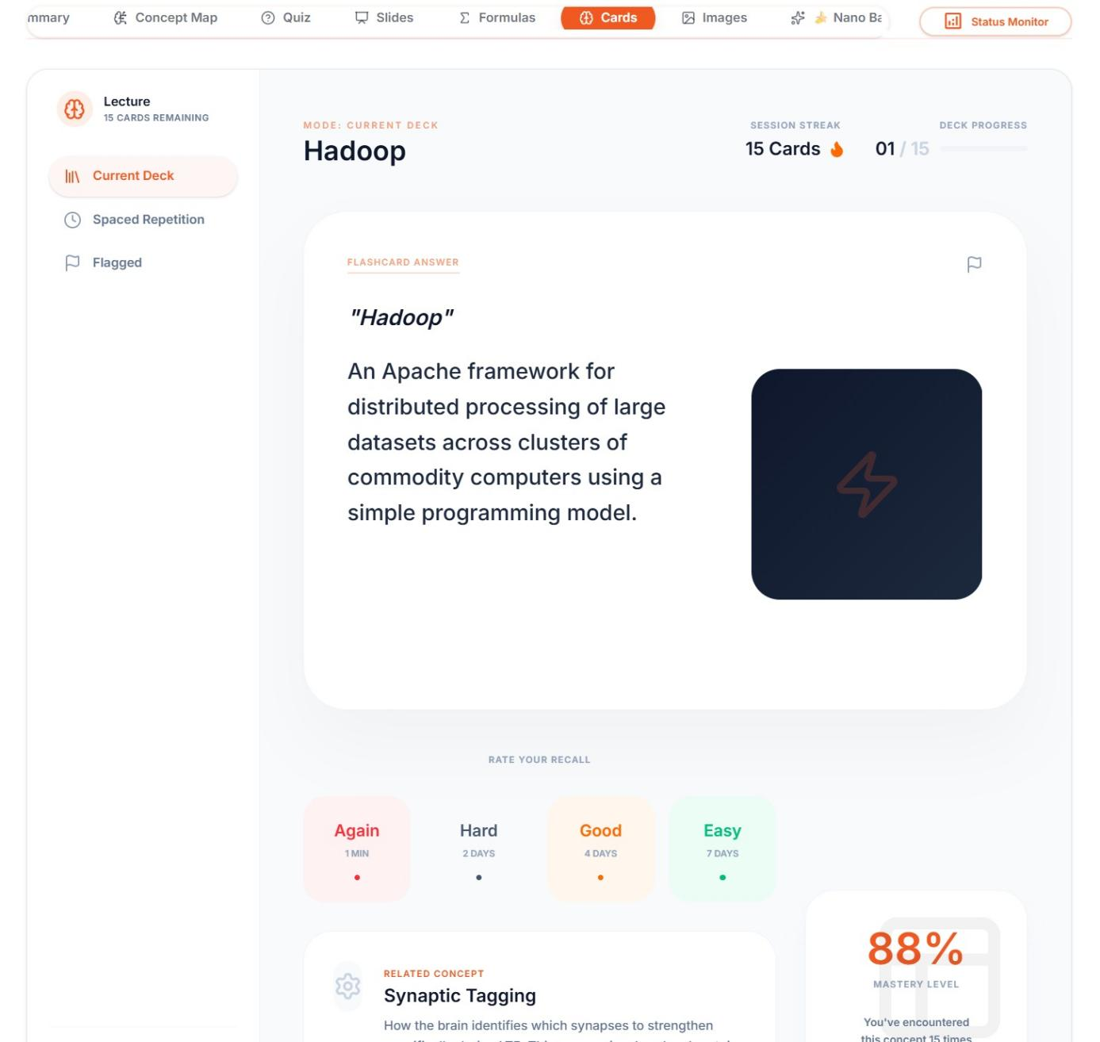
Figure 5.8 LectureMate-Study Flashcards

- Slides Viewer: A presentation viewer that renders the AI-generated slides. Users can toggle between themes (Clean, Dark, Academic) and download the deck as a .pptx file directly.

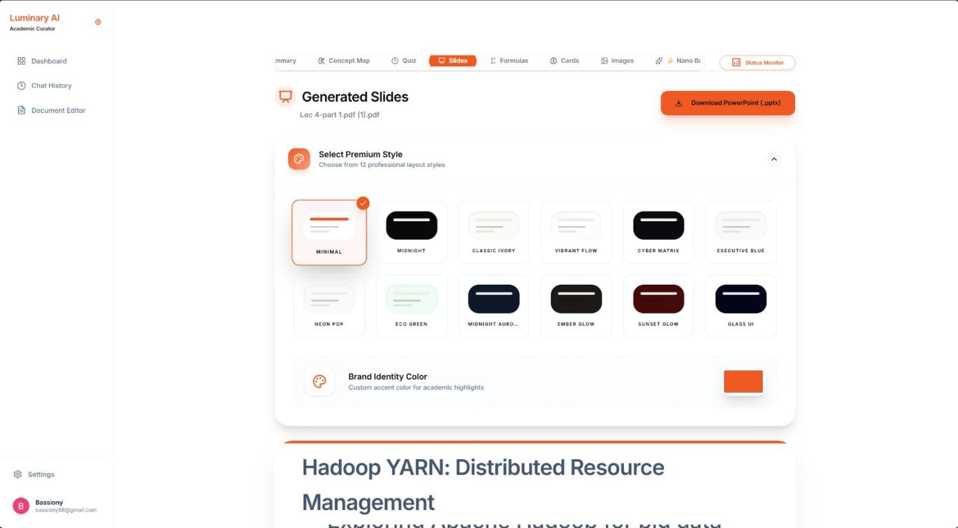
Figure 5.9.1 LectureMate-Generated Slides ,Select Theme

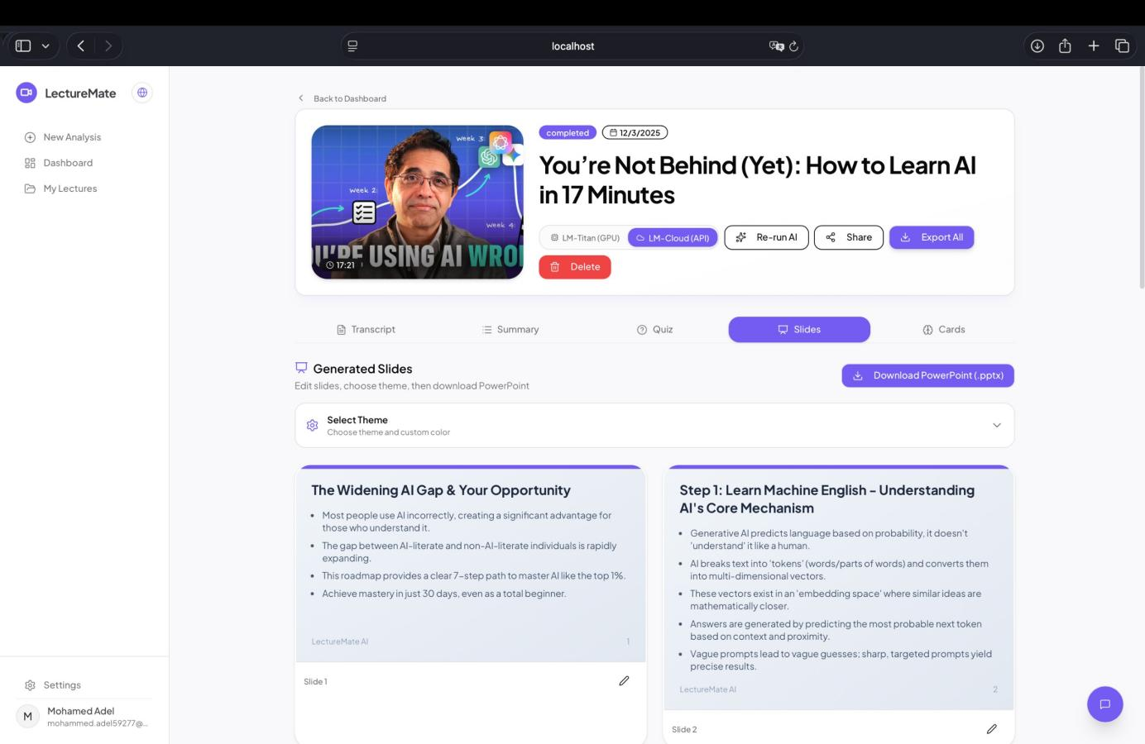
Figure 5.9.2 LectureMate-showing the Slides tab with the "Download PPTX" button after selecting the Theme

5.6 Profile & Settings Management

The Profile page allows users to manage their account details through a categorized sidebar interface.
- General: For updating personal information like display name and profile picture.
- Billing: Displays subscription status ("Pro Plan") and billing cycles.
- Security: Manages password updates and displays account email status.
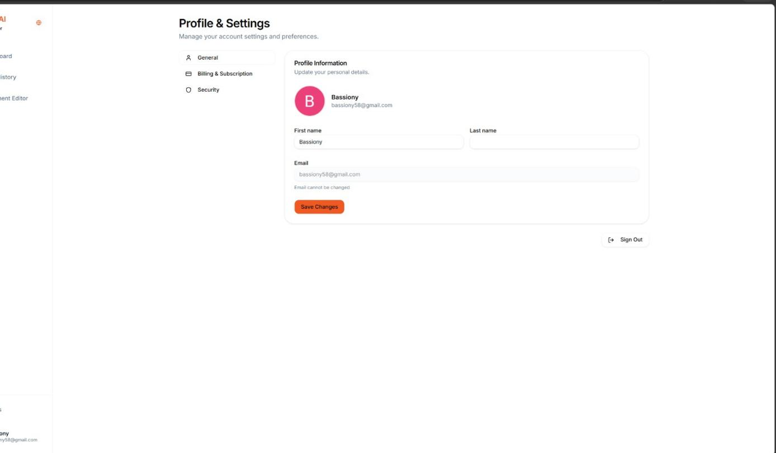
Figure 5.10 LectureMate-Setting profile

5.7 UI/UX Design Philosophy

- Responsive Design: The interface uses a sidebar layout on desktop that transforms into a collapsible drawer on mobile devices, ensuring accessibility across all screen sizes.

- Global Language Toggle: A dedicated button in the sidebar allows instant switching between English and Arabic, triggering a full layout inversion (LTR to RTL) to support Arabic users natively.

5.8 Summary
This chapter detailed the implementation of the LectureMate user interface, demonstrating how the system translates complex backend processing into a simple, intuitive user experience. The flow from secure authentication to the interactive dashboard and rich study tools highlights the system's focus on usability and educational value.

