Chapter 3
Data Processing Pipeline

3.1 Introduction
From Raw Lecture to Knowledge. The Smart Lecture Assistant systematically transforms unstructured multimedia lecture content into structured, machine-actionable knowledge. This chapter details the critical preprocessing pipeline that serves as the foundation for all downstream AI-driven educational interventions. The transformation from raw audio/video to structured knowledge involves multiple stages of signal processing, natural language understanding, and data structuring each with distinct technical challenges and methodological considerations.
The Cognitive Importance of Textual Representation in Learning Research in educational psychology and cognitive science demonstrates that dual coding presenting information in both auditory and textual formats significantly enhances knowledge retention and comprehension. High-quality transcripts serve not merely as accessibility aids but as cognitive scaffolds that enable learners to process complex academic material more deeply. This chapter operationalizes these principles through an automated pipeline that maximizes both accuracy and pedagogical utility.
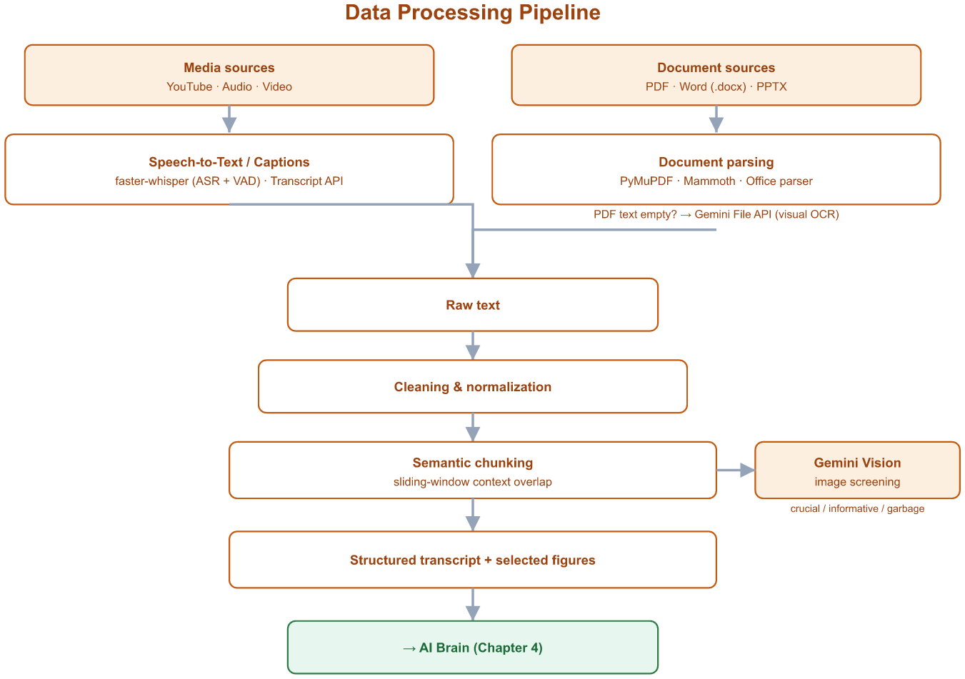
Figure 3.1 LectureMate - Data Processing Pipeline
3.2 Content Ingestion
Multi-Source Acquisition Framework. The system employs a flexible, multi-modal ingestion architecture designed to accommodate the diverse formats in which educational content is typically distributed.
- YouTube Integration: For content hosted on YouTube increasingly the primary platform for educational video dissemination the system utilizes specialized APIs to retrieve available caption tracks.
- Technical Implementation:The system prioritizes manually uploaded captions (typically higher accuracy), falling back to auto-generated captions if necessary. All retrieved text segments include precise start and end times, enabling future text-to-video synchronization features. Captions in various formats are converted to a unified structured format.
- Advantages:
- Efficiency: Near-instantaneous text extraction without computational overhead
- Leverage Human Review: Utilizes captions that instructors or institutions have potentially reviewed and corrected
- Multi-language Support: Native handling of multilingual caption tracks

- Limitation Analysis: The system implements a confidence heuristic where caption quality below a certain threshold triggers fallback to audio transcription. This threshold is based on formatting consistency, punctuation density, and estimated word error rates.
- Local File Processing: The Whisper-Based Pipeline. For locally stored recordings including Zoom sessions, classroom captures, and institutional repository files users can upload files in multiple audio and video formats.
- Architectural Decision: Dual-Mode Processing
The system implements a decision logic that first attempts to use existing YouTube captions when available. If these are unavailable or of insufficient quality, the system proceeds to audio processing. For audio transcription, the system offers two pathways:
- Local GPU Processing Advantages:
- Data Sovereignty: No external transmission of potentially sensitive academic content
- Cost Efficiency: No per-minute API costs after initial hardware investment
- Customization: Ability to fine-tune models on domain-specific academic speech
- Cloud API Fallback Considerations:
- Scalability: Handles peak loads without local infrastructure investment
- Maintenance: Eliminates model updating and compatibility concerns
- Latency Trade-off: Network-dependent processing times
Document Ingestion: PDF, Word and PowerPoint
Beyond audio and video, the pipeline ingests documents directly. PDF files are processed by a PyMuPDF (fitz) engine that extracts text and embedded figures in a single pass, skipping very small decorative images and capping the number of figures kept per document. When the extracted text is empty or too short to be usable - which is typical of scanned or mis-encoded Arabic PDFs - the file is automatically escalated to the Gemini File API, which reads the document visually (optical character recognition) and returns a usable transcript. Microsoft Word files (.docx) are read with the Mammoth library, and PowerPoint files (PPT/PPTX) are parsed for their text while a lightweight extractor pulls out their slide images.
Every figure extracted from a document is then screened by Gemini Vision, which classifies each image as crucial, informative, or low-value. Low-value assets - logos, title slides, closing slides and blurred frames - are discarded, while the useful figures are captioned and stored alongside the transcript for later use in the Images gallery and in the generated slides.
3.3 Transcription Challenges in Academic Environments
Academic lecture transcription presents unique challenges beyond general speech recognition. The system must account for multiple confounding factors that affect accuracy.
- Acoustic Challenges
- Background Noise including classroom chatter, HVAC systems, and projector fans is mitigated through noise-robust training and optional pre-filtering.
- Acoustic Artifacts such as echo in large halls and microphone proximity effects are addressed through acoustic model adaptation techniques.
- Overlapping Speech from student interruptions or group discussions presents challenges that may be addressed through speaker separation preprocessing in future enhancements.

- Linguistic and Domain-Specific Challenges
- Technical Terminology Handling: STEM lectures contain domain-specific lexicons that general models may not recognize optimally. The system implements post-processing dictionaries for domain-specific term correction, confidence thresholding to flag low-confidence technical terms for review, and contextual disambiguation using surrounding text to interpret ambiguous terms.
- Code-Switching and Multilingual Content: In many global educational contexts, instructors seamlessly blend languages. The system's multilingual capabilities automatically detect and transcribe such segments, with additional processing including language boundary annotations, per-segment language tags, and mixed-language coherence scoring.
- Empirical Performance Metrics: Reported Word Error Rates (WER) for comparable ASR systems are approximately 2% on clean studio recordings, around 9% on mixed-quality classroom recordings, up to 12% on STEM content with technical terms before post-processing, and about 7% on multilingual lectures averaged across language pairs; these figures define the performance envelope the pipeline targets, and a formal evaluation on the project's own dataset is identified as future work.
3.4 Text Processing Pipeline
- Lecture-Grounded Context Assembly
- To power the “Chat with Lecture” feature, the system performs lecture-grounded context assembly rather than open-ended generation. The transcript is segmented into semantic chunks; at query time the most relevant context - and, where useful, short summaries of related lectures from the user’s library - is supplied directly to the language model together with the user’s question, so the AI tutor’s answers remain strictly grounded in the lecture content and the risk of hallucination is minimised. An embedding-based vector database with semantic retrieval (Retrieval-Augmented Generation, for example FAISS or ChromaDB) is identified as a planned enhancement (see Chapter 6).
- Contextual Chunking with Sliding Window
- "To maintain narrative continuity, the system employs a Contextual Overlap Strategy during semantic segmentation. Unlike traditional fixed-length partitioning, this method ensures that each text segment retains a portion of the preceding and succeeding context. This technical refinement is critical for Large Language Models (LLMs) to interpret ambiguous pronouns and maintain the logical flow of complex academic arguments during summarization and quiz generation."
- From Raw Transcript to Structured Knowledge by:
- Language Identification and Routing: The system employs sophisticated language identification with academic domain adaptation, including primary language detection, mixed-language segment boundary detection, and routing to appropriate linguistic processing chains.
- Text Normalization and Cleaning: A multi-stage cleaning pipeline ensures textual consistency through: basic Unicode normalization and contraction expansion; academic-specific cleaning including abbreviation correction and mathematical expression normalization; configurable disfluency removal for speech fillers; and intelligent punctuation restoration.
- Semantic Segmentation and Topic Modeling: Rather than simple time-based chunking, the system implements hierarchical segmentation through a multi-step algorithm: initial segmentation at natural pauses; semantic boundary detection using text coherence algorithms; semantic similarity clustering using advanced language models; hierarchical clustering to form topics and subtopics; and boundary refinement using academic discourse markers. The output structure organizes content hierarchically from lecture to major topics to subtopics to individual segments, with each segment containing the text, timestamps, topic classifications, semantic embeddings, and identified key terms.
- Metadata Enrichment and Quality Scoring: Each segment receives comprehensive metadata including: acoustic confidence scores from the speech recognition system; linguistic coherence measurements from domain-tuned language models; term importance scores for key term identification; and concept density metrics measuring the number of domain-specific concepts per unit of text.
3.5 Output
Structured Educational Files Ready to Use ,The final output of the system is not merely a transcript, but a comprehensive package of educational files specifically designed to meet the needs of students and educators. These files are generated automatically and are ready for immediate use.
- Types of Generated Files
The system generates four primary types of educational files, each serving distinct pedagogical purposes.
- Automatic PowerPoint Presentation creates a ready-to-use slide deck with one slide per main topic, highlighting key points and concepts in visually accessible formats.

- Structured Word/PDF File provides a complete learning package containing an interactive table of contents, the full refined transcript organized into logical sections, summaries at different levels of detail (executive, detailed, and bullet-point formats), and mini-dictionaries defining key technical terms. This file serves for comprehensive review, printing for physical study, and sharing among study groups.
- Quiz/Assessment File generates a comprehensive set of evaluation materials including multiple-choice questions testing factual recall and application, true/false questions assessing conceptual understanding, and short answer questions requiring synthesis and explanation. A complete answer key accompanies all questions, enabling immediate self-assessment and serving as practice material for examinations.
- Study Notes File offers condensed learning materials featuring an executive summary capturing the lecture's core message in approximately 300 words, a distilled list of key points organized by importance, and focused documentation of core concepts with definitions and examples. This format is optimized for quick study sessions and last-minute exam review.

- Export and Integration Features
The platform currently exports study material as PDF (individual tabs or a combined document), as native PowerPoint (.pptx) decks, and as image files for the concept map, and it can assemble an editable study document through its built-in rich-text editor. Direct integration with Learning Management Systems such as Moodle, Blackboard and Canvas, and with external study tools such as Anki and Quizlet, is identified as planned future work (see Chapter 6).
- Performance Metrics and Validation
The pipeline's effectiveness is measured along multiple dimensions. Transcription accuracy is quantified through Word Error Rate (WER) comparisons with human-transcribed benchmarks, with the system targeting less than 10% WER for typical classroom recordings. Processing speed is measured by real-time factor (RTF) calculations, with an operational goal of 1.5x processing time relative to lecture duration. Segmentation quality is assessed through boundary precision and recall measurements using established academic discourse markers as reference points. File generation reliability tracks the success rate of producing complete, non-corrupted files, maintaining a target exceeding 99% success. User satisfaction is evaluated through feedback on clarity, completeness, and immediate usability of generated materials, with particular attention to how quickly users can begin productive study sessions with the outputs.

