Chapter 5
System Implementation & UI

5.1 System Architecture Overview
LectureMate is engineered using a modern, decoupled architecture to ensure scalability and high performance. The system is divided into three core layers:

- Frontend Layer: Built with React 19 and TypeScript, serving as the interactive client-side application. It utilizes Vite 7 for optimized building and Tailwind CSS v4 for rapid, responsive styling.
- Backend API Layer: A Node.js 24 / Express server that acts as the central orchestrator. It manages API routes, communicates with the database, and spawns child processes for heavy computational tasks.
- Intelligence Layer: A hybrid AI engine combining Google Gemini (Cloud) and Qwen served locally via Ollama (Local GPU) to process transcripts and generate educational content.

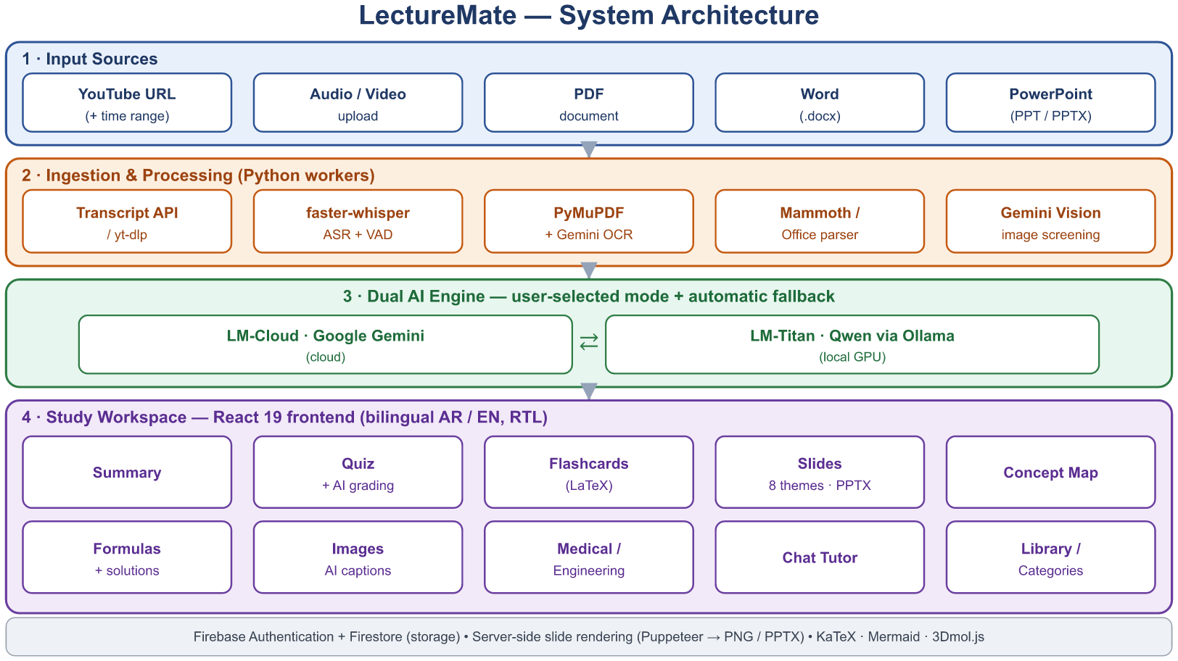
Figure 5.1 LectureMate - System Architecture Diagram
5.2 User Authentication & Security
The authentication module is designed to provide a secure and seamless entry point for users, leveraging Firebase Authentication for identity management.
- Sign Up Interface
The registration page offers a user-friendly form with real-time validation.
- Key Features:
- Password Strength Meter: A dynamic indicator that evaluates password complexity (Weak, Fair, Good, Strong) in real-time as the user types.
- Social Login: Integration with Google OAuth for one-click registration.
- Visual Feedback: Uses Framer Motion to add smooth entrance animations to the login cards.
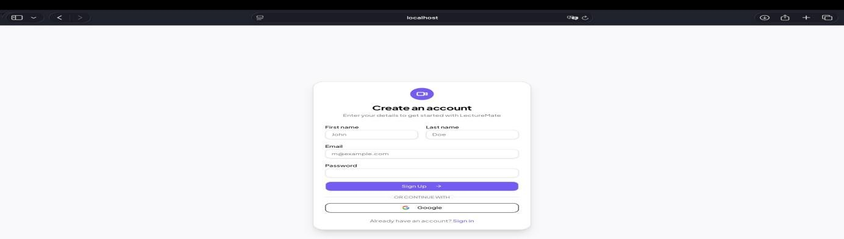

- Sign In Interface
The login interface ensures secure access for returning users.
- Key Features:
- Bilingual Support: The interface automatically adapts layout direction (RTL/LTR) based on the user's language preference (Arabic/English).
- Error Handling: "Toaster" notifications provide immediate feedback for incorrect credentials or network issues

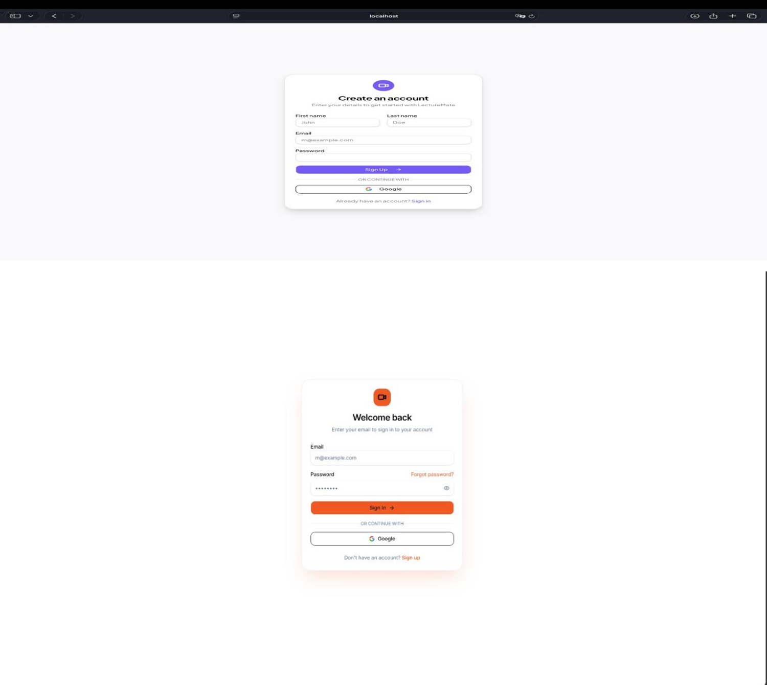
Figure 5.2 LectureMate - Authentication (Sign Up and Sign In)

5.3 Dashboard & Workspace
The Dashboard serves as the central command center, offering users a personalized overview of their learning progress.

- Statistics & Overview
Upon logging in, users are greeted with a "Welcome Back" message and a statistical summary of their activity:

- Key Metrics: Four dynamic cards display:
- Total Lectures: Number of videos analyzed.
- Completion Rate: Percentage of lectures fully studied.
- Study Time: Total time spent learning (calculated from video duration).
- Cards Created: Number of flashcards and slides generated.

- Continue Learning
A "Continue Learning" section highlights the most recent lecture the user was interacting with, displaying a progress bar that indicates whether the lecture is still processing or ready for study.

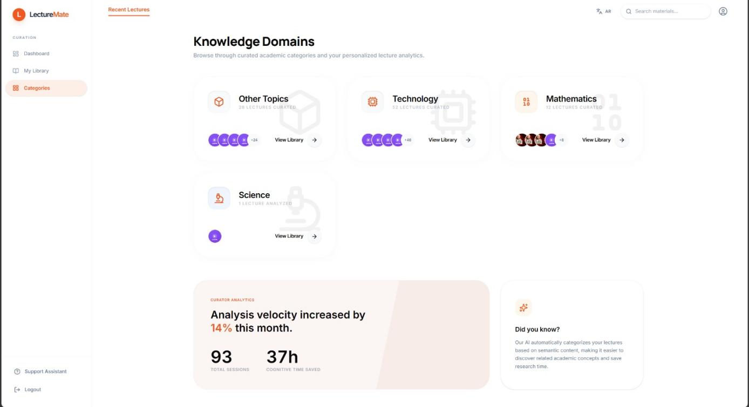
Figure 5.3 LectureMate - Dashboard with statistics cards and recent activity

5.4 Lecture Analysis Workflow
The "New Analysis" page is the starting point for processing content.
- Input Mechanism: Users simply paste a YouTube URL. The system validates the link and retrieves metadata (thumbnail, title, duration) using the youtubeService.
In addition to YouTube links, the New Analysis page accepts uploaded video and audio files, PDF and Microsoft Word documents, and PowerPoint decks. For YouTube sources an optional time range can be selected so that only part of a long lecture is analysed.
- Configuration Options: Users can select their preferred processing mode before starting:
- LM-Cloud (API): Uses Gemini for fastest results.
- LM-Titan (GPU): Uses the local Qwen model for privacy.
- Real-time Feedback: A multi-step progress indicator informs the user of the current stage: "Downloading Audio" → "Transcribing" → "Generating Summary".

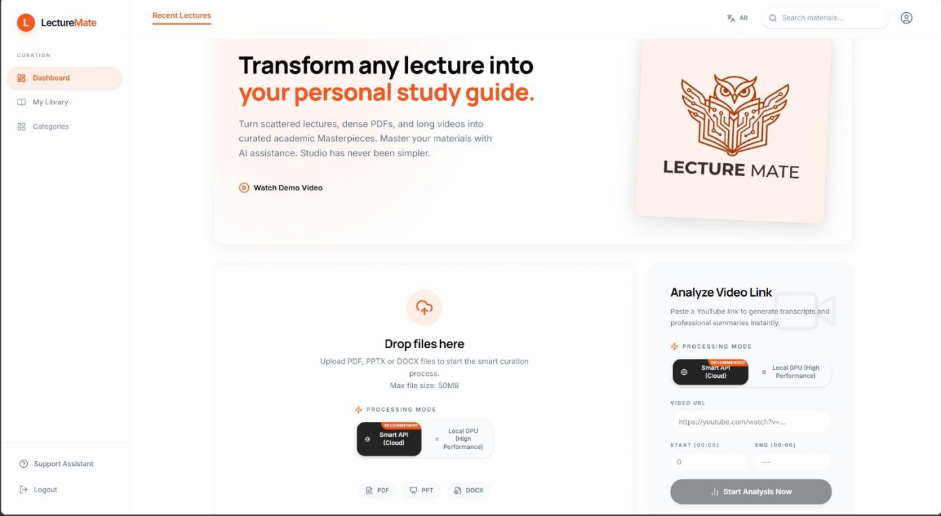
Figure 5.4 LectureMate - New Analysis Page with URL, Upload Video, Record Audio input and Model selection
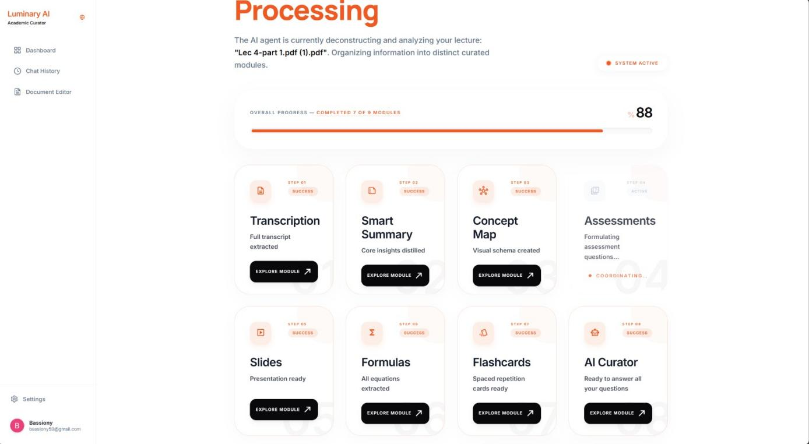
Figure 5.5 LectureMate - showing the process for analyzing a lecture

5.5 The Integrated Learning Environment
The core value of LectureMate is delivered through the Lecture View, a tabbed interface that organizes generated content into digestible modules.

- Summary & Transcript Tabs
- Abstractive Summary: Displays a structured summary generated by the AI, broken down into an Introduction, Key Points, and Conclusion.

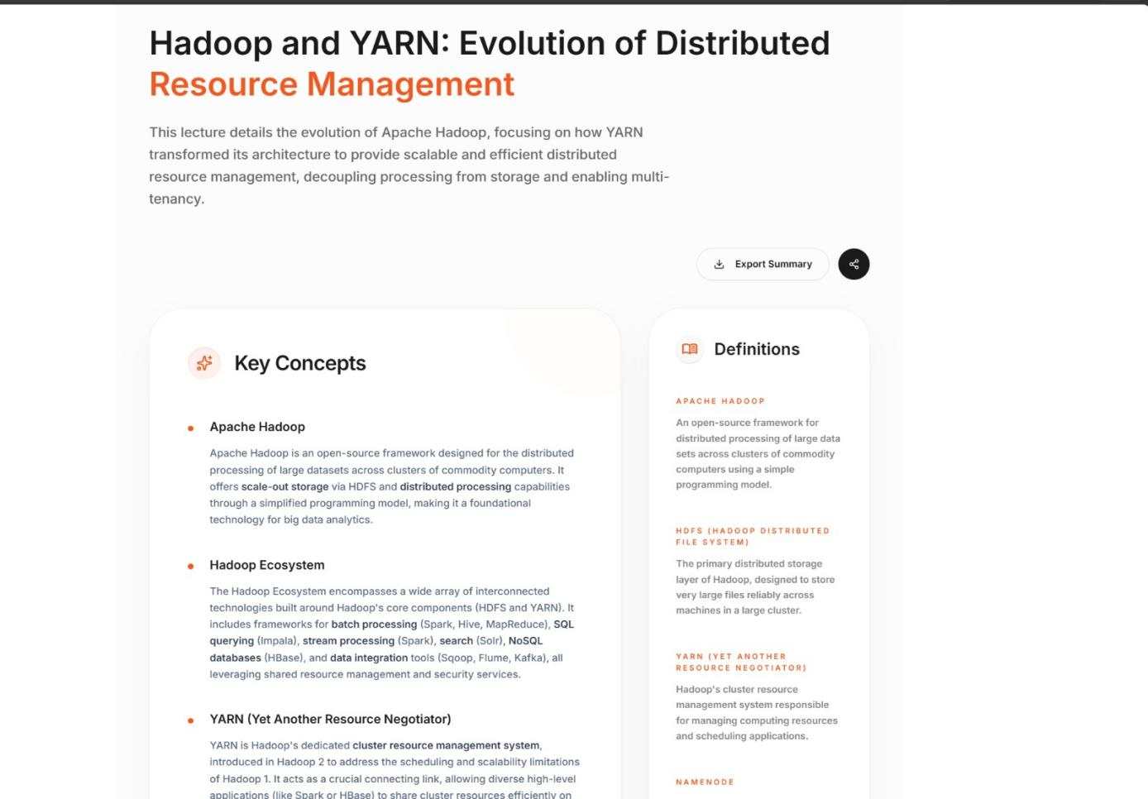
Figure 5.6 LectureMate - showing the summarization of the lecture
- Interactive Transcript: A time-synced transcript view that allows users

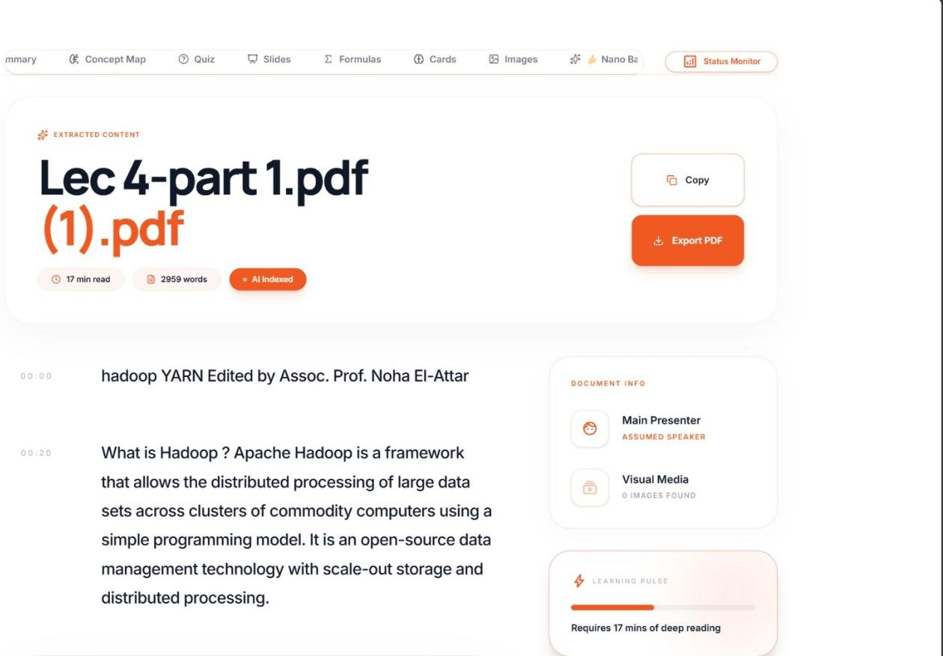
Figure 5.7 LectureMate - showing the Full Transcript of the lecture

- Assessment & Study Tools

- Quiz Module: An interactive assessment of thirty questions offered at three difficulty levels (Comprehensive, Advanced, and Expert). It combines multiple-choice, true/false and open-ended questions; multiple-choice items are timed and graded instantly, while open-ended answers are graded by the AI against the expected key points, returning a numeric score and written feedback.

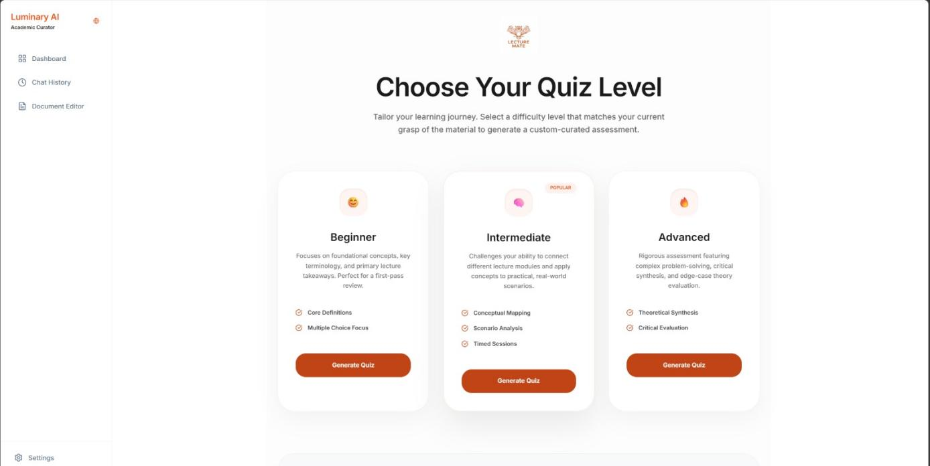

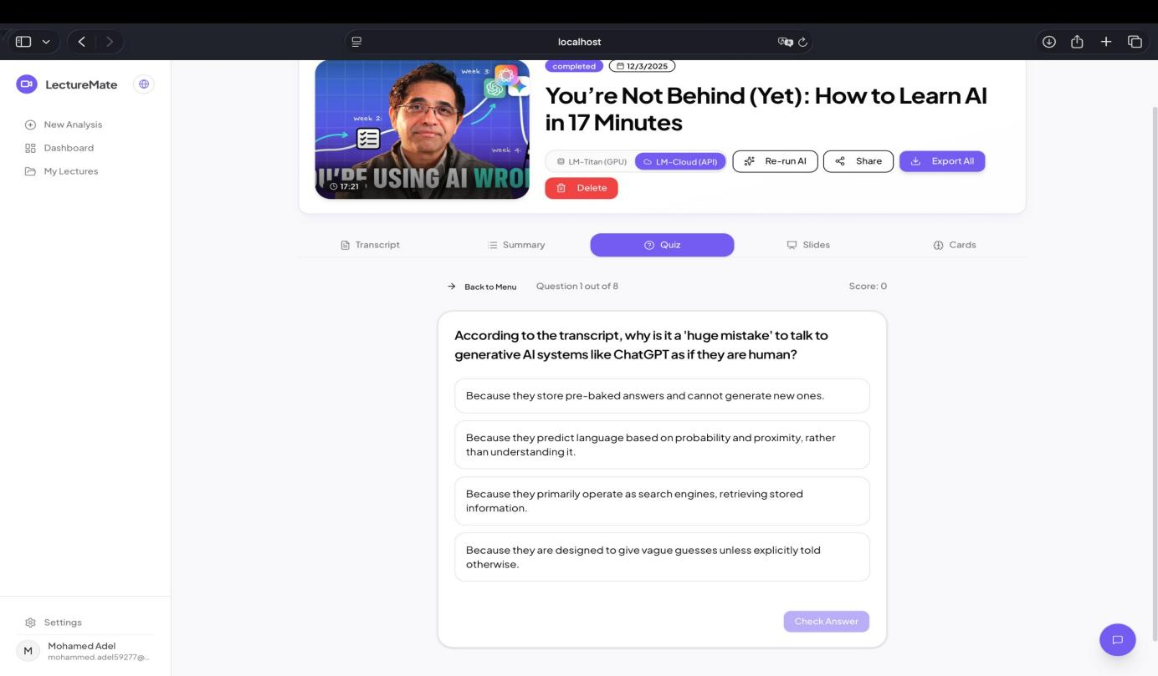
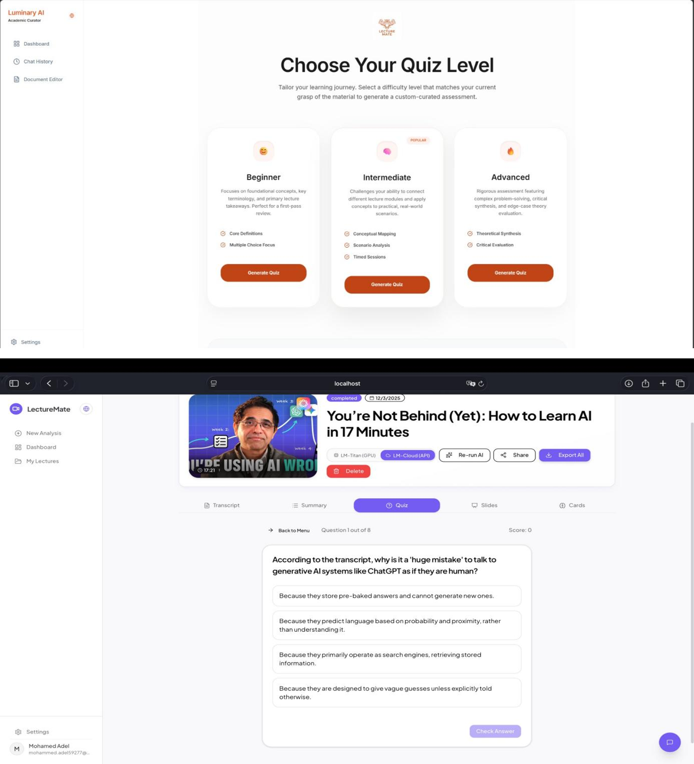
Figure 5.8 LectureMate - Quiz mode selection
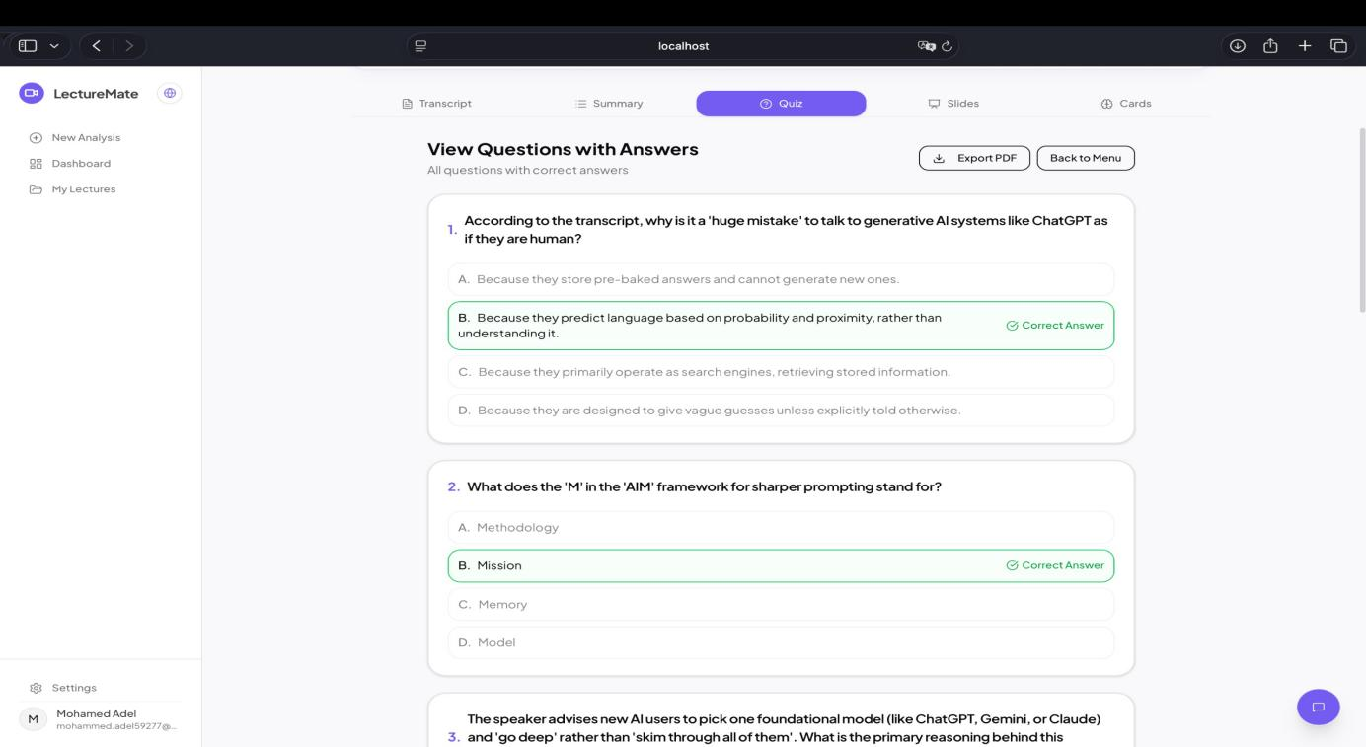
Figure 5.9 LectureMate - View Questions with Answers

- Flashcards: A digital flashcard deck for spaced-repetition study. Each card renders LaTeX mathematics on both faces and can be sorted into review buckets (again / hard / good / easy) so the learner can focus on the weaker material.

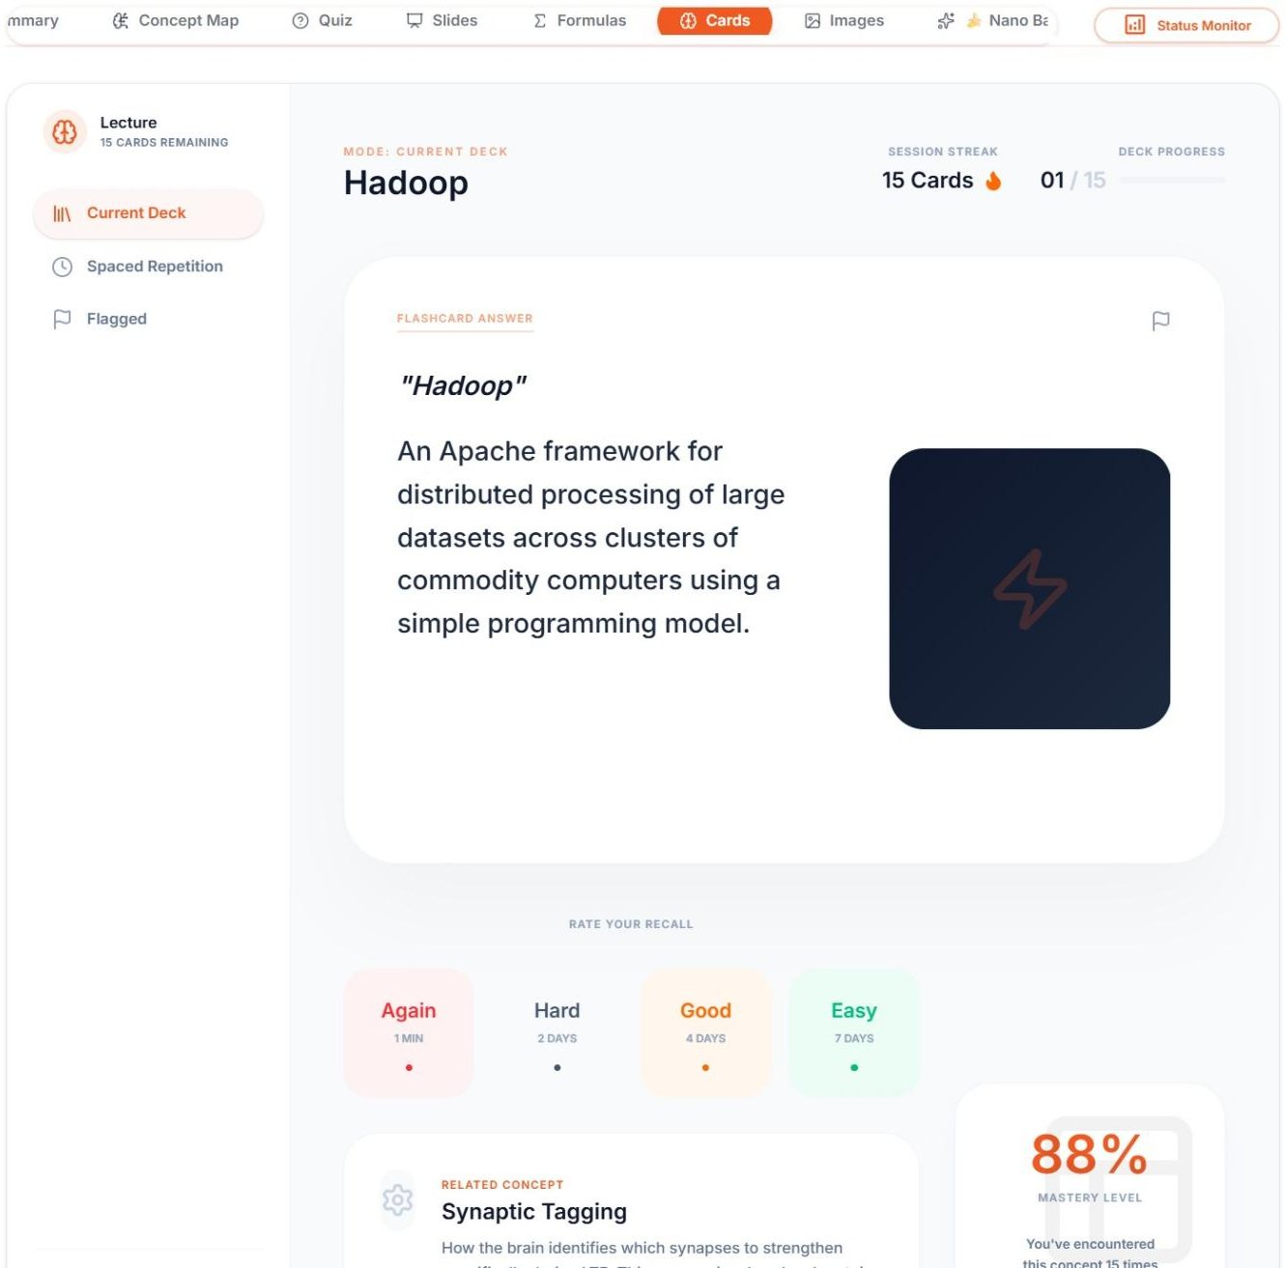
Figure 5.10 LectureMate - Study Flashcards

- Slides Viewer: An in-app presentation viewer that renders the AI-generated deck. The user can choose one of eight visual themes, set a custom accent colour, edit slide text in place, and export the deck to a native .pptx file.

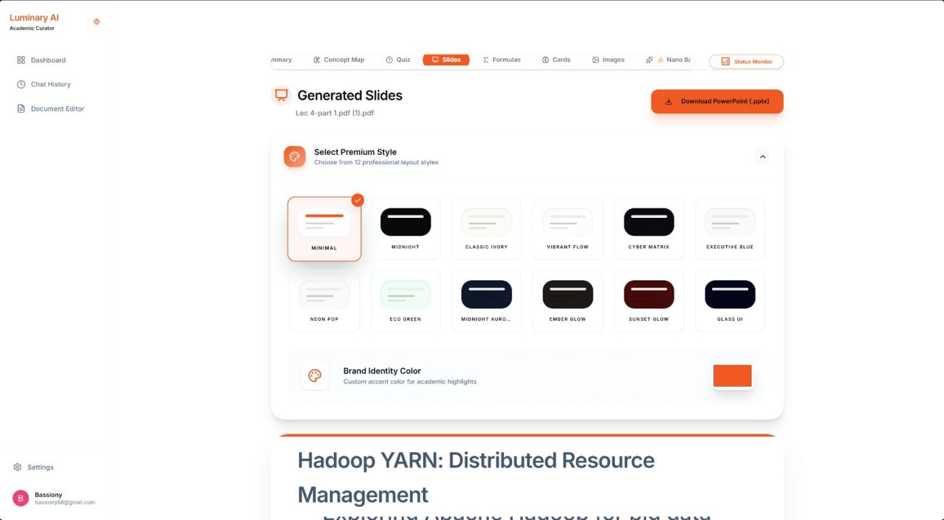
Figure 5.11 LectureMate - Generated Slides, Select Theme

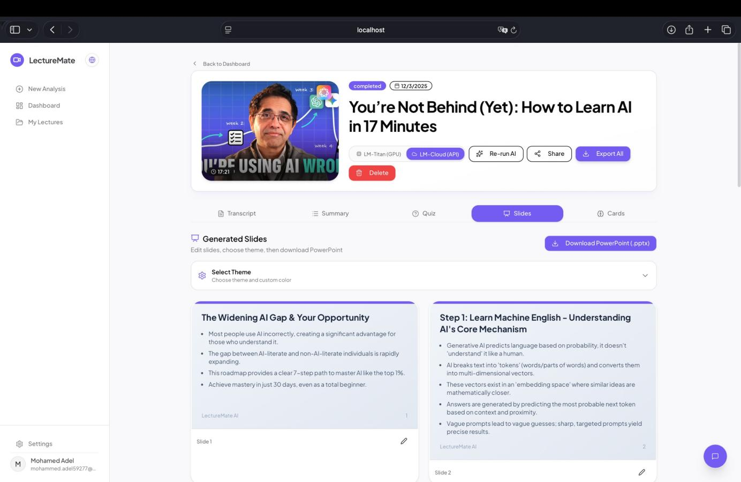
Figure 5.12 LectureMate - showing the Slides tab with the "Download PPTX" button after selecting the Theme
The Slide Generation Engine
Slides are not produced from a single fixed template but from a structured slide grammar of thirteen layout types - title, section divider, bullet list, concept cards, process and timeline steps, statistics, two-column comparison, vector or Mermaid diagram, real-figure, code, and quote - so the model selects the layout that best fits each idea. Each deck is rendered on the server by drawing the React slide components inside a headless Chromium instance at 1280x720 (two-times scale) and capturing every slide as a high-resolution image. The same deck can be exported in three ways: Designed (full-bleed image slides), Text-only (fully editable native PowerPoint text boxes), and Designed + Editable (a hybrid that keeps the visual design as a background while overlaying editable text). Mathematical expressions are rendered with KaTeX and diagrams with Mermaid; Arabic decks are laid out right-to-left with embedded Tajawal fonts, and click-through fade animations are injected directly into the PowerPoint XML.
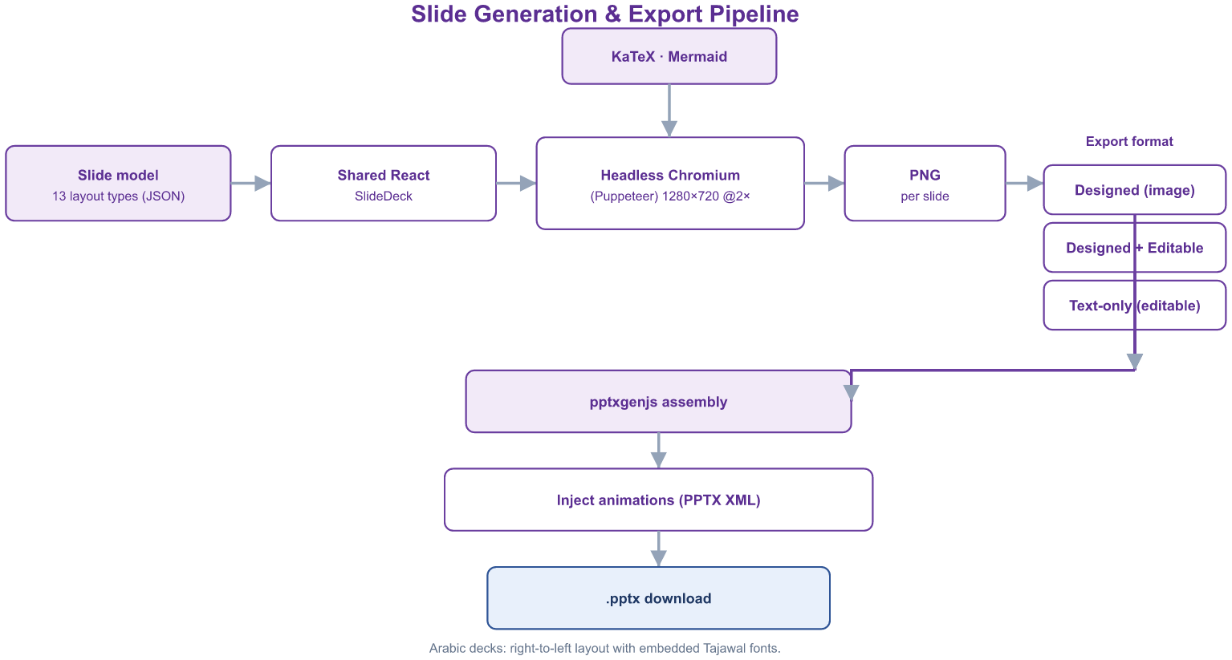
Figure 5.13 LectureMate - Slide Generation and Export Pipeline
Concept Map
An interactive knowledge graph (built with React Flow and a Dagre auto-layout) that draws the lecture's key concepts as nodes and their relationships as labelled, directed edges arranged in a top-down hierarchy. Clicking a node opens a detailed explanation, a guided narration mode walks through the concepts in order, and the graph can be exported as an image.
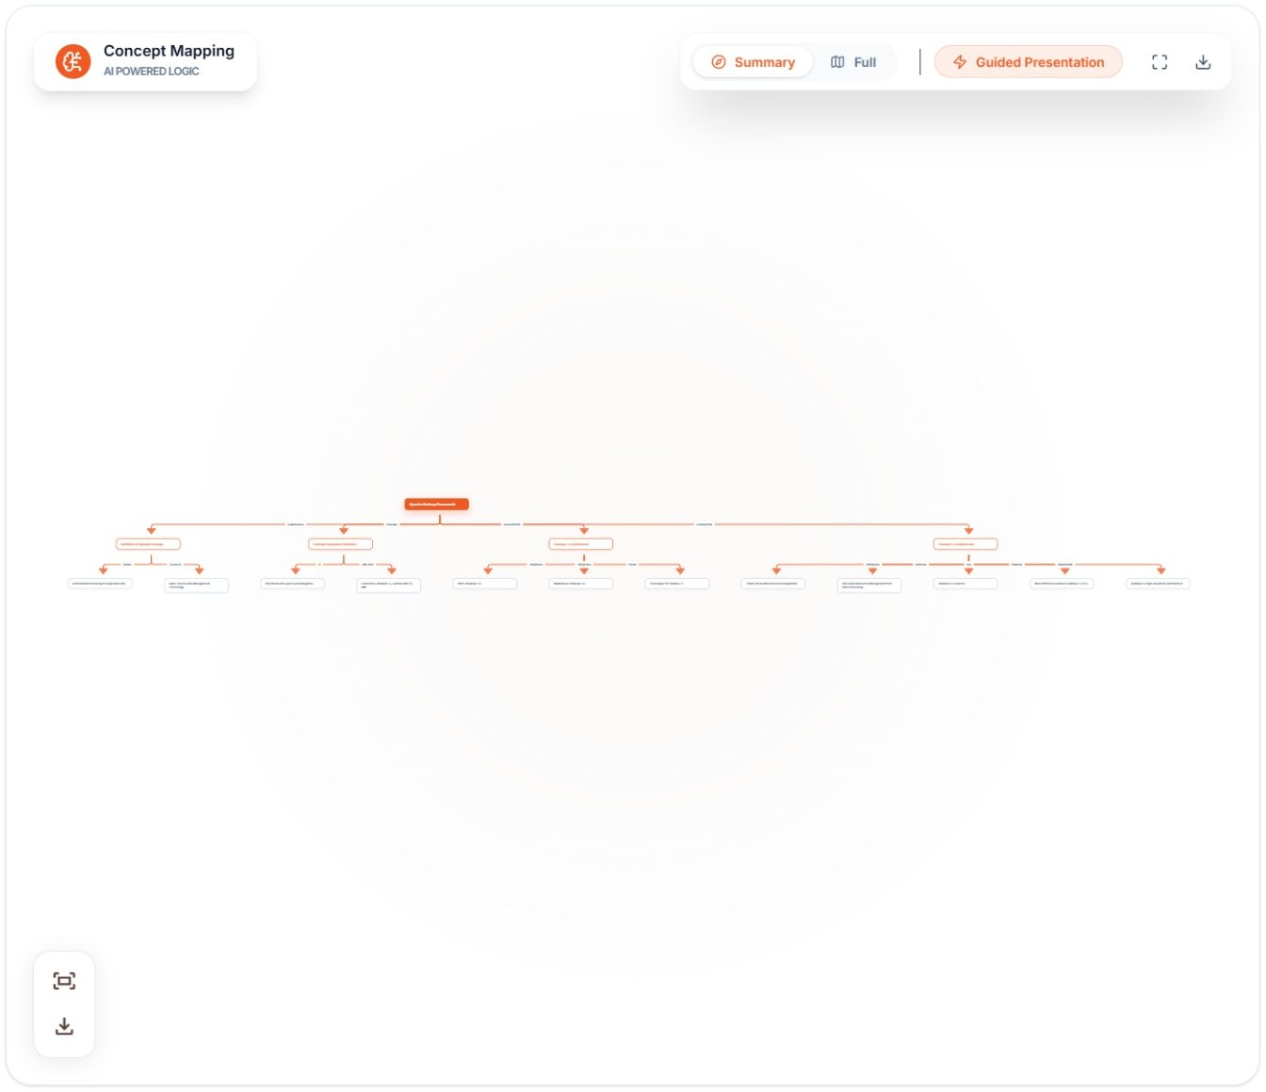
Figure 5.14 LectureMate - Concept Map
Formulas & Equations
Mathematical content is extracted on four levels: formulas stated explicitly, formulas implied by the context, formulas read from diagrams, and the standard formulas expected for the topic. Each entry is rendered with KaTeX and is accompanied by its variables, an optional function graph, and a step-by-step worked solution. The tab is shown automatically only when genuine mathematical content is detected in the lecture.
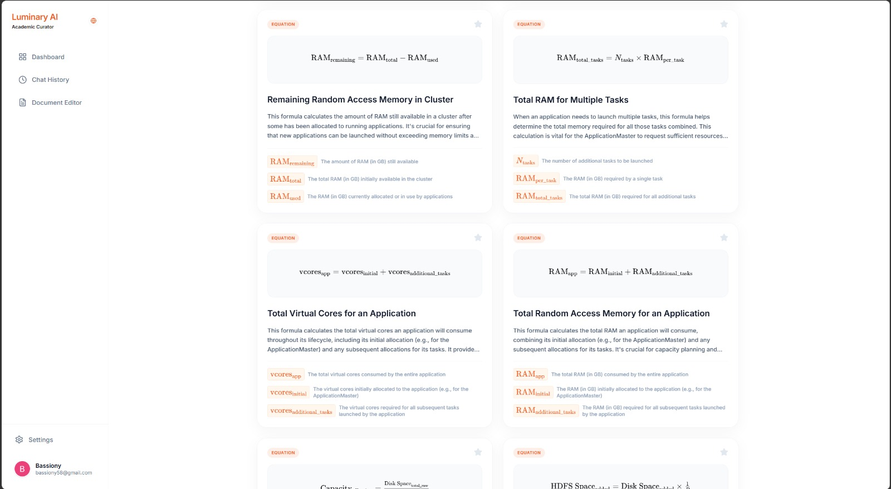
Figure 5.15 LectureMate - Formulas and Equations
Images Gallery
Figures extracted from PDF and PowerPoint sources are screened by Gemini Vision, which discards low-value images (logos, title and closing slides) and writes a short, education-focused caption for each useful figure. The gallery presents these captioned images with a search box and a click-to-expand view.
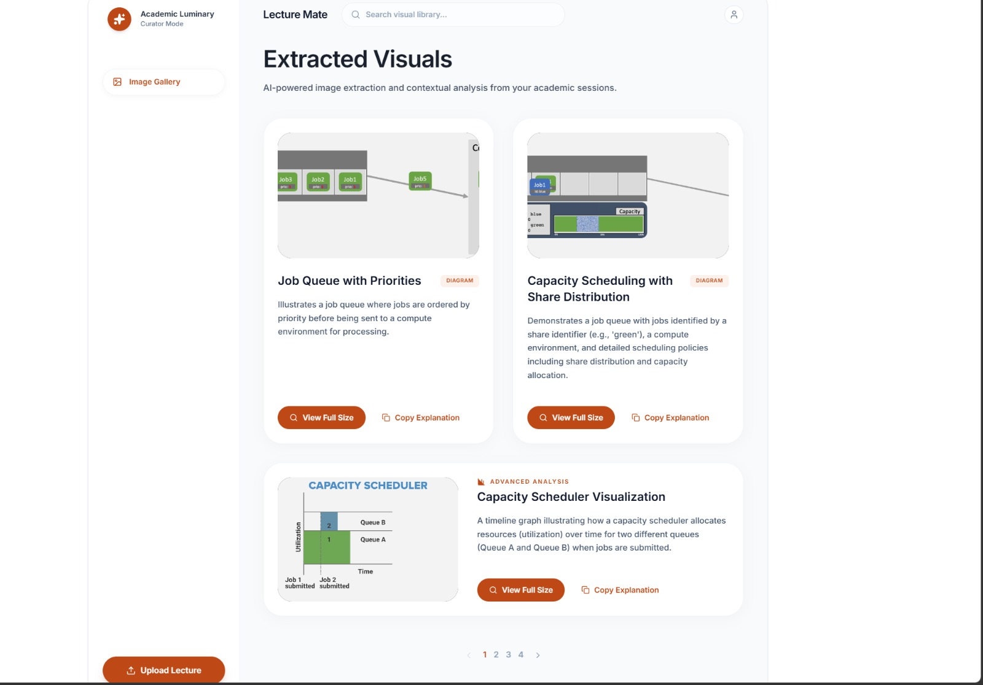
Figure 5.16 LectureMate - Images Gallery with AI captions
AI Chat Tutor
A conversational assistant grounded in the current lecture. The relevant transcript context - and, where useful, summaries of related lectures from the user's library - is supplied to the model so that answers remain tied to the material. The tutor renders Markdown, LaTeX and syntax-highlighted code, accepts an attached image for visual questions, and keeps a persistent per-lecture history.
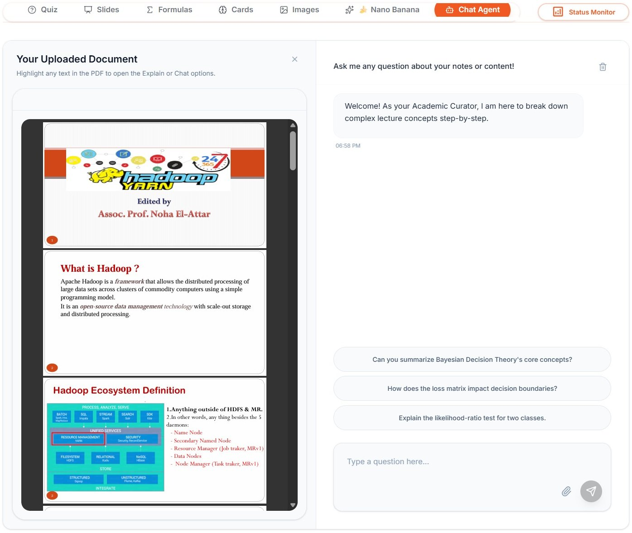
Figure 5.17 LectureMate - AI Chat Tutor
Specialized Domain Views
For lectures classified as medical or engineering, the workspace exposes additional adaptive panels. The Medical Insights panel organises clinical terms, drugs (mechanism, dosage and side-effects), reference calculators such as BMI and GFR, and procedures, with anatomy and pathology diagrams and an interactive three-dimensional molecule viewer (3Dmol.js with PubChem data). The Engineering Lab panel presents electronic components and their specifications, circuit diagrams, compilable code snippets and worked formulas. These panels appear only when the detected category of the lecture warrants them.
Library & Categories
Every processed lecture is stored in a personal Library together with its thumbnail, source type and completion status, and can be searched and resumed. Each lecture is automatically classified into one of eleven academic categories (science, technology, engineering, mathematics, medicine, history, art, language, business, education, or other), so the Library can be filtered by subject.
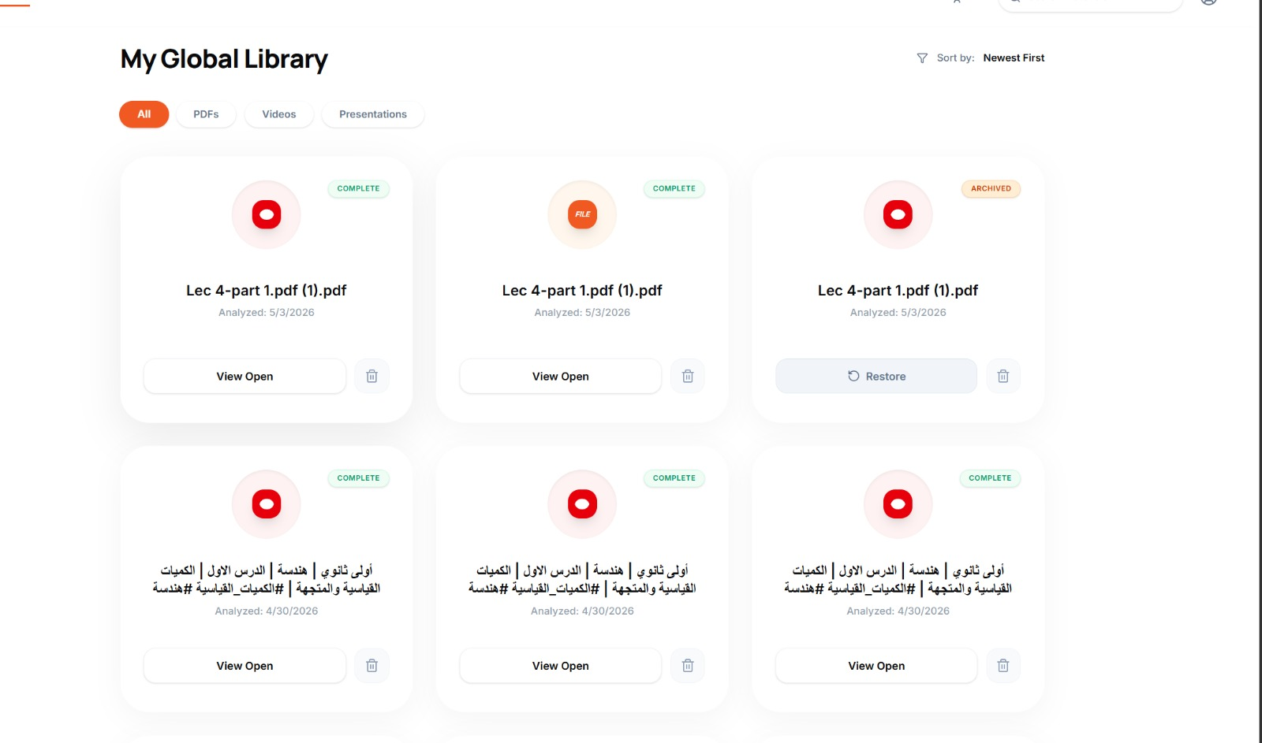
Figure 5.18 LectureMate - Library of saved lectures
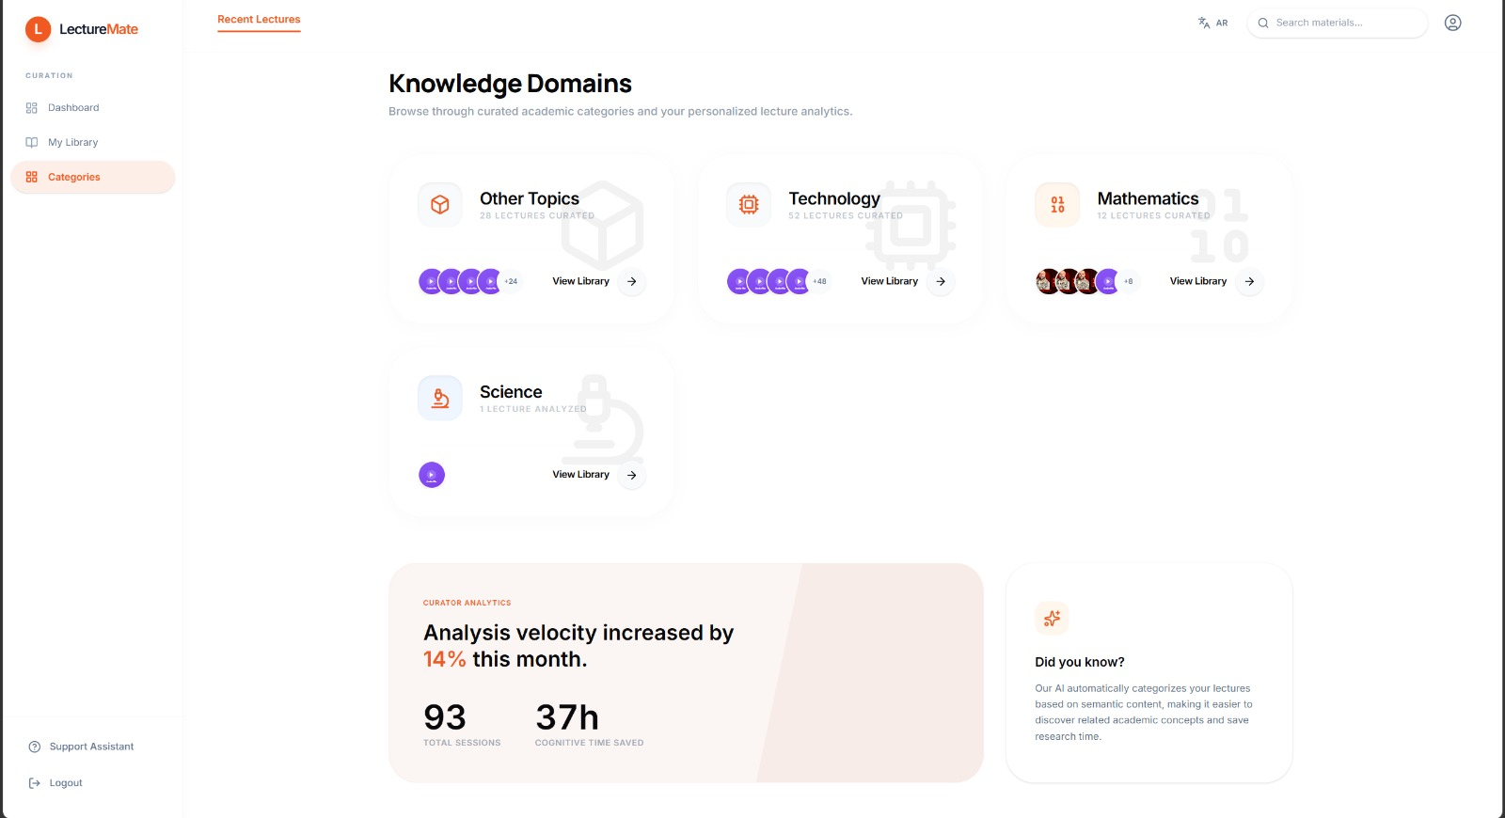
Figure 5.19 LectureMate - Categories browser

5.6 Profile & Settings Management

The Profile page allows users to manage their account details through a categorized sidebar interface.
- General: For updating personal information like display name and profile picture.
- Billing: Displays subscription status ("Pro Plan") and billing cycles.
- Security: Manages password updates and displays account email status.
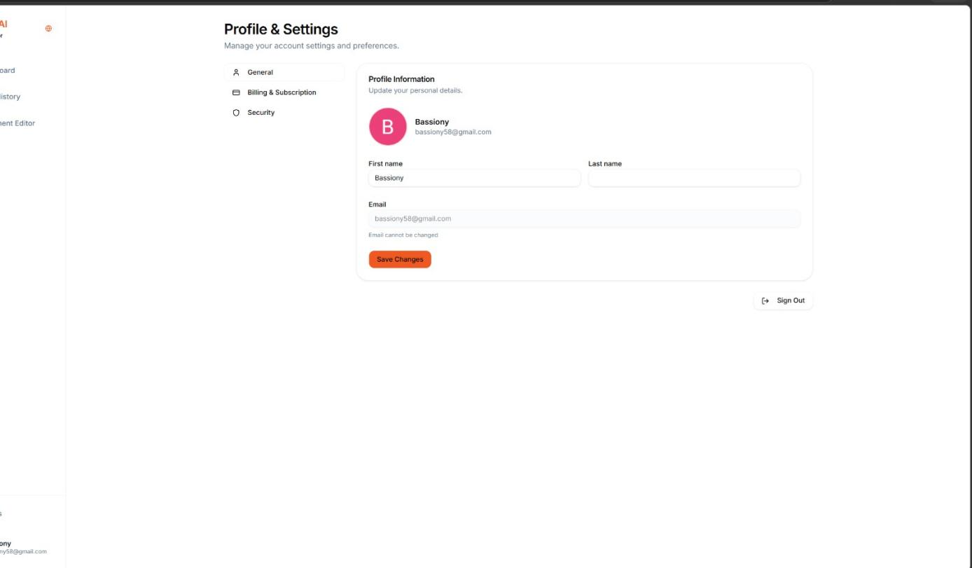
Figure 5.20 LectureMate - Setting profile

5.7 UI/UX Design Philosophy

- Responsive Design: The interface uses a sidebar layout on desktop that transforms into a collapsible drawer on mobile devices, ensuring accessibility across all screen sizes.

- Global Language Toggle: A dedicated button in the sidebar allows instant switching between English and Arabic, triggering a full layout inversion (LTR to RTL) to support Arabic users natively.

5.8 Summary
This chapter detailed the implementation of the LectureMate user interface, demonstrating how the system translates complex backend processing into a simple, intuitive user experience. The flow from secure authentication to the interactive dashboard and rich study tools highlights the system's focus on usability and educational value.

