King Fahd University of petroleum and minerals

Ics202 PROJECT

[Dictionary data structure]

MOHAMMED ALMUBARAK – 202024880

HUSSAIN ALKHALAIF – 202035120

The dictionary holds a list of words (strings) to be used in a spell checker.

**1- Initialization**

First of all, we create a dictionary class that extends AVLTree<String> class, then we initialize the dictionary using three methods:

1. a single string, [public Dictionary(String s)]
2. an empty dictionary [public Dictionary( )]
3. a text file having strings, each on a new line. [public Dictionary(File f)]

in the first method, we create a dictionary with only one string which is will be the root in the avl tree.

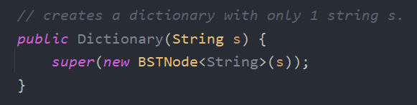

in the second method, we create an empty dictionary.

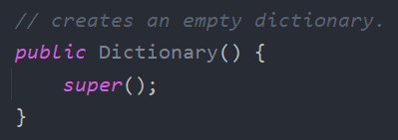

In the third method, we are reading the text file and insert each line to the AVL tree, and the method should throw an exception if the file does not exist.

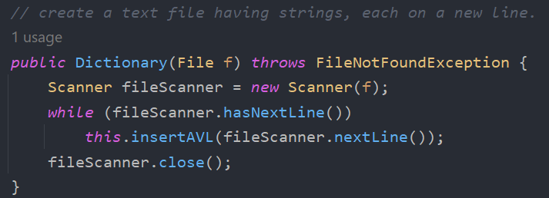

**2- Add new word**

This method adds a new word to the dictionary, it searches for the given word, if it does not exist, then it will add it to the tree, if it exists, it should throw an exception.

For search, we are using search method from BST class, to insert, we use insertAVL from AVLTree class.

**3- Search for word**

This method of type Boolean takes one string, it searches for the given word, if it’s found, then will return true, if it not found, return false.

For search, we are using search method from BST class.

**4- Remove word**

This method takes one string to delete a word from the dictionary, it searches for the given word, if it’s found, it will delete the word from the AVL tree, if it not found, then it should throw an exception.

For search, we are using search method from BST class, to delete, we use deleteAVL from AVLTree class.

**All the exceptions:**

* **WordAlreadyExistsException:**

* **WordNotFoundException:**

* **Catches in the test class:**

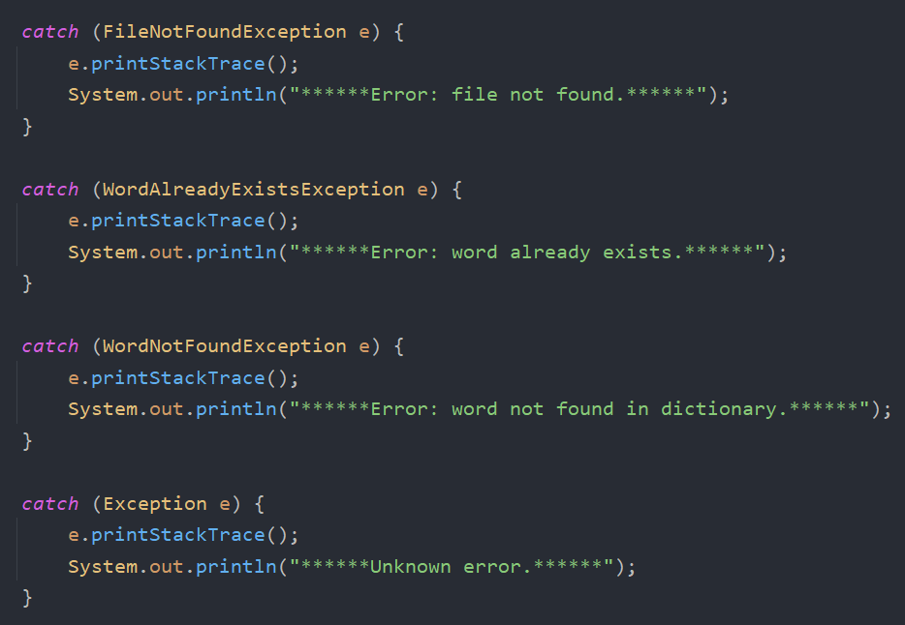

**Test class:**

1. **Initialization**

* **A single string.**

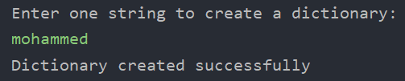

* **Empty.**

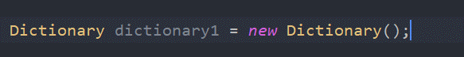

* **A text file having strings.**

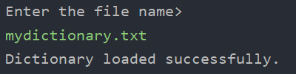

1. **Add new word**

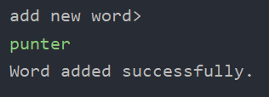

1. **Search for word**

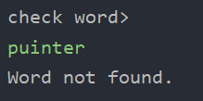

1. **Remove word**



