Different Ways of Displaying Images On Your WebPage

I chose to use MaterilizeCSS as my Exploration. I read that Google had a version like bootstrap, and I really like a lot of google's products, so I thought I give it a try. Materialize is just like bootstrap, so it has a lot of the same concepts. If you’ve used bootstrap, this will be a walk in the park. I added a nav bar from the documentation, it's identical to what we did in class.

1. Set up your index.html in whatever editor you like, and use the 5 tags we learned about in 2830. I also put lang=”us” in the html tag, but it didn’t say it was required.

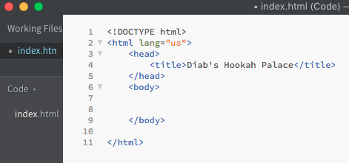

1. Get your CDN’s to link CSS, and import Javascript and jQuery libraries.
   1. I used <https://cdnjs.com/libraries/materialize> to get my CDN’s. I added comments to describe what was what.
   2. While I was at it, I added the viewport to help with mobile browsers

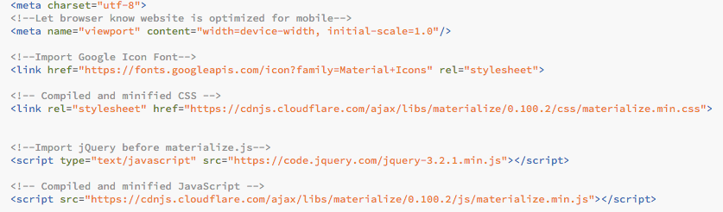

1. Adding a Carousel of Images
   1. To do this, I went to MaterializeCSS.com, and there is documentation on how to do it. I first added the html into the body. I added an h2 to personalize it and added a class (myLayout) to personalize the way my pics fit, but that’s all optional.

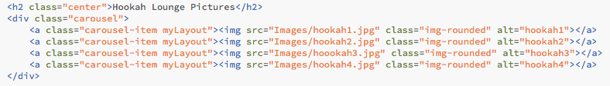

* 1. I then added in the jQuery needed for the Carousel to display when the document is ready

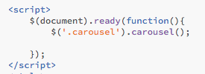

1. Another way to add images to your web page is called a Slider
   1. In order to do this, I also went to materializecss.com and looked at the documentation. I had trouble with the images getting cut off, but I couldn’t solve it. I have the link for this in my sources. I also first added the html to the body.

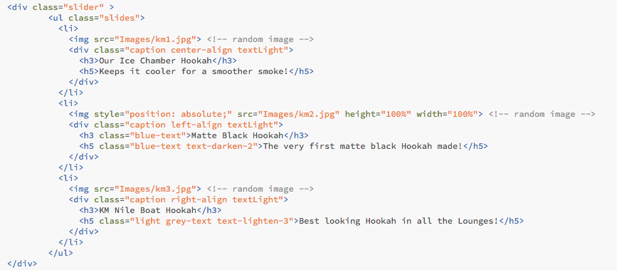

* 1. I then added the jQuery to display the Slider to the existing script tag

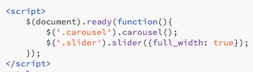

Recap:

Overall, Materialize was easy to use, and really didn’t stray far from Bootstrap. Like I said, I’ve always liked google’s products and wanted to give it a go. The reason I choose different ways to display images on a web page, is because I’m actually going to open my own hookah bar, and I want to have an awesome website. It’s awesome how much code is given to you, and all you have to do is implement it and add the images that you want, also like Bootstrap.

The biggest downfall was the image Slider (the thing I was actually most excited about using) didn’t display the images at the right size. I looked for so much help online, and people were having the same problem as me. I tried the solutions that were given to them, and nothing worked for me. I also got help from a work friend, and he also could not get it to work. The problem was, the height of the image wasn’t tall enough, so it was literally showing ¼ of the image, and the middle of the image at that. Another problem was that the width was too wide. I tried adjusting it using CSS ui-slider class, the actual slider class that was being called on div controlling the slider, actually setting inline style to the image, and even tried to change some jQuery, and nothing seemed to work. I hope to be able to fix this to actually use it for my web site. If I do, I will make sure to update how I did it.