COMM401 SIGNAL AND SYSTEM THEORY

**Giorno's Theme piano**

Ahmed Mohsen 52-22728

Dina Mamdouh 52-7599

horizontal line

# 

# 

# 

# 

# 

# 

# 

# 

# 

# 

# 

# 

# 

**Milestone 1**

# 

**steps:**

1. Imported the needed libraries
2. Created array of frequencies in 4* octave (single hand piano)
3. Created and array (ti) to specify the start time of each note
4. Created an array T to specify the duration of each note
5. While loop which loops 14 times :(length of the frequency array) which adds each single tone to variable x, taking the indices of the 3 arrays in
6. the formula (sine part takes the frequency, unit step takes the duration and start of each note accordingly)

**Milestone 2**

**Objectives :**

1. Adding a noise to our song implemented in milestone 1.
2. Searching for the noise frequencies in the song after adding the noise.
3. Removing the noise we added after searching and finding it to get the original song.

**Procedures :**

1. Creating a new array of frequency to use in plotting the signals in the frequency domain.
2. Creating 2 new random noise frequencies.
3. Creating a noise array of the two random frequencies using the equation : noise = np.sin(2*f1*np.pi*t) + np.sin(2*f2*np.pi*t) * (t >= 0) * (t <= 3).
4. Adding the noise and the original song we had in a new noised song.
5. Getting the indices of the 2 peaks of the noised song using : (np.argpartition) function.
6. Rounding the frequency values at that indices in frequency (f) to get f1new and f2new.
7. Filtering the noised song by subtracting the two found frequencies.
8. Plotting the original song , noised song and the filtered one in both the time and frequency domains.
9. Playing the filtered song using sd.play(x_filtered, 3 * 1024).
10. Making sure that the filtered song and the original song are the same from the plotted graph as shown in the given figure :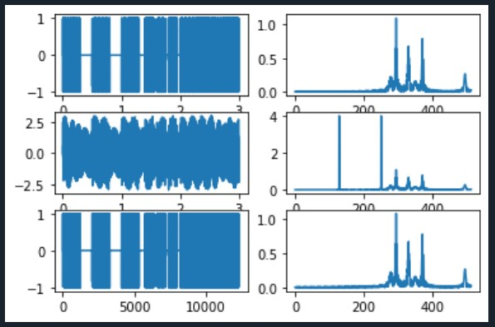

**Achievements:**

1. We learned to add a noise to a song.
2. We learned how to search for a noise in a song.
3. We learned how to remove the noise that we found from the song.
4. We learned how to transform to the frequency domain.