e-Govt Data Exchange Solution

([http://bcdemo.ml](http://bcdemo.ml/))

(Created by Team MoD-i )

1. Department 2 Login to the Portal

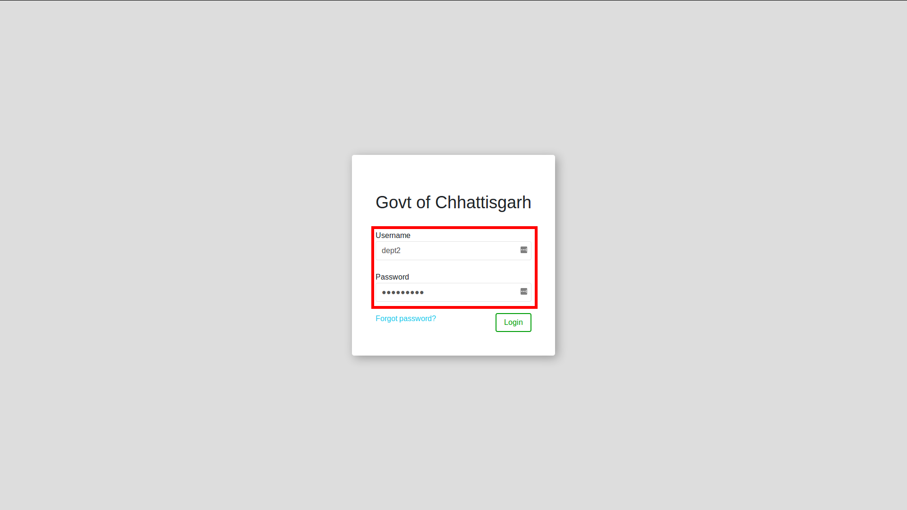

2. Department 2 finds some missing data in the Scheme

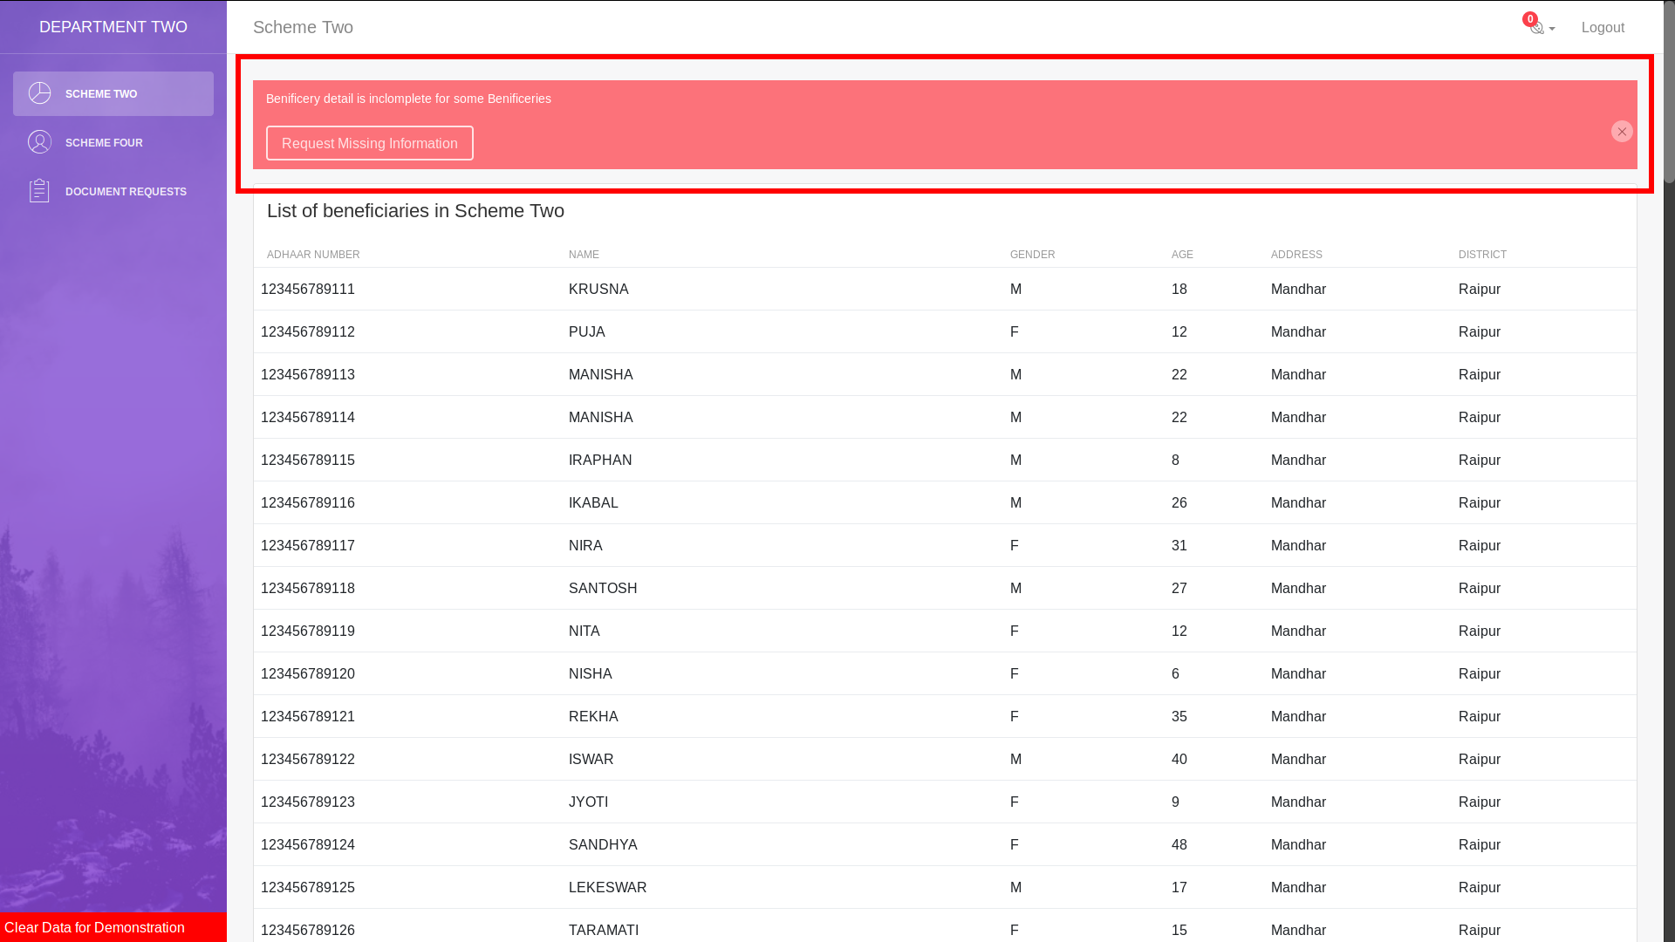

3. Department 2 clicks on “Request Missing Informations”



4. Department 2 selects “Department 1” and sends request by click on “Send Request”

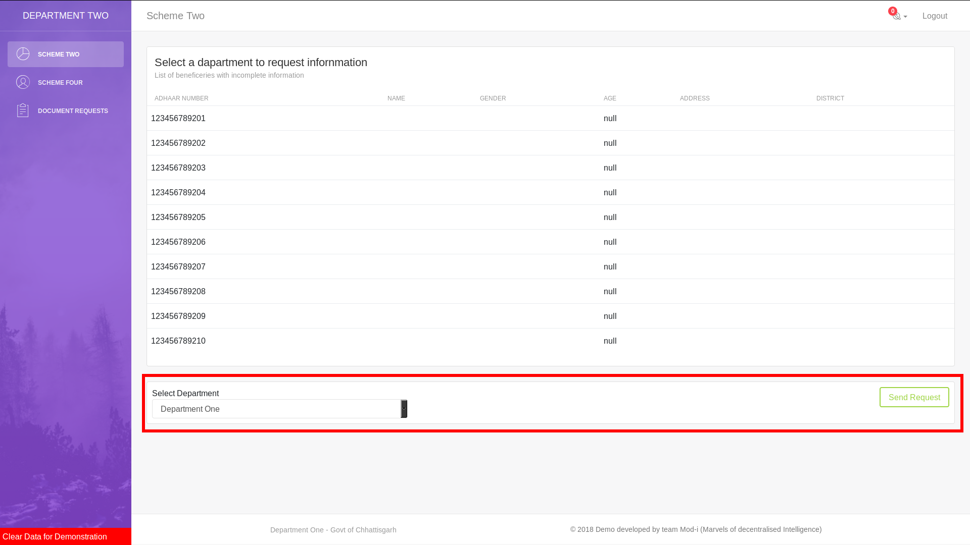

5. Department 2 see a “Success” message

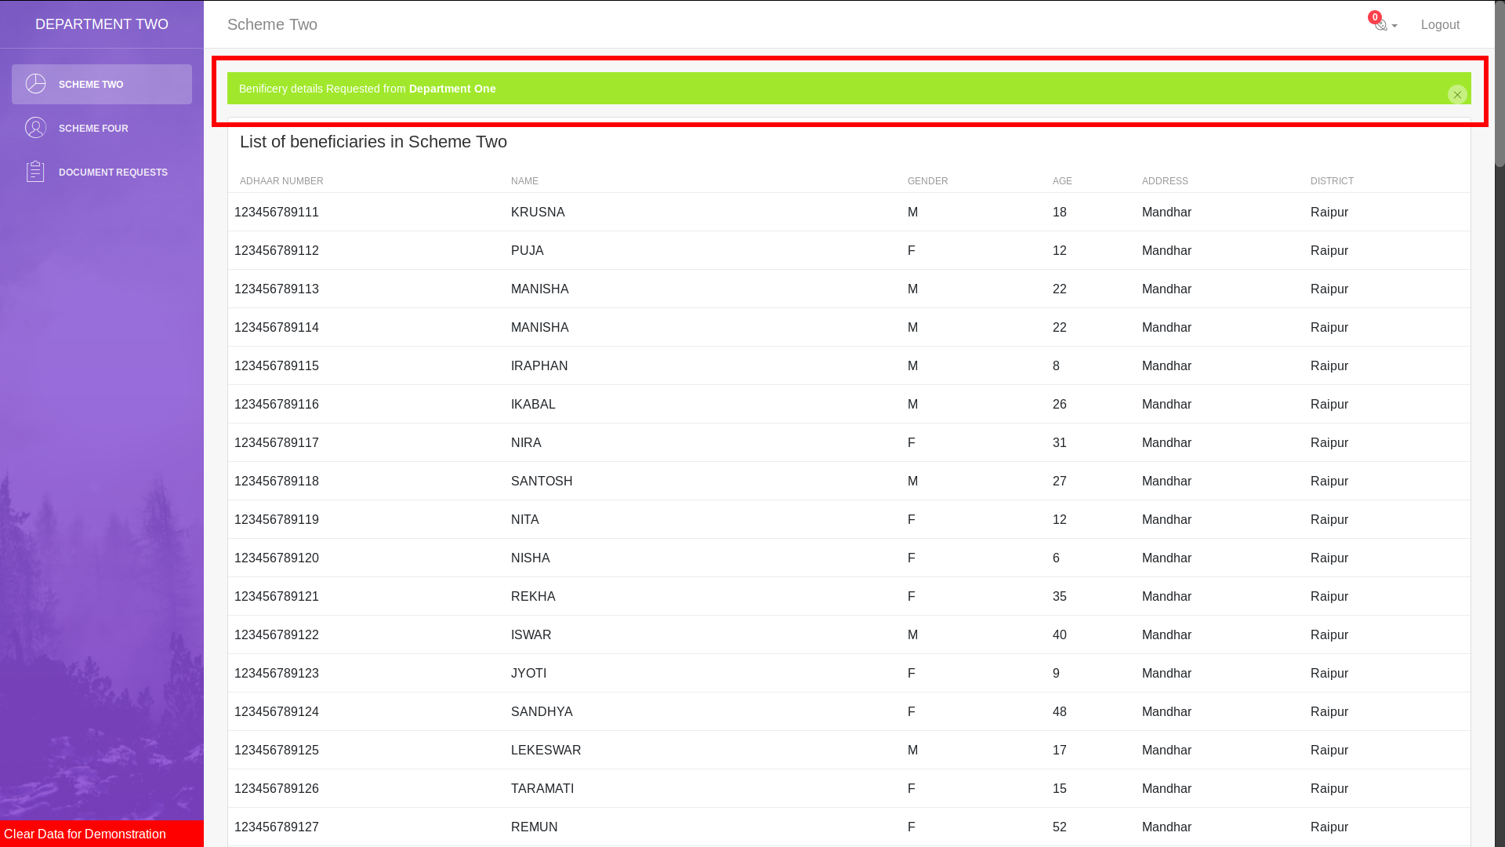

6. Department 1 Login to the Portal

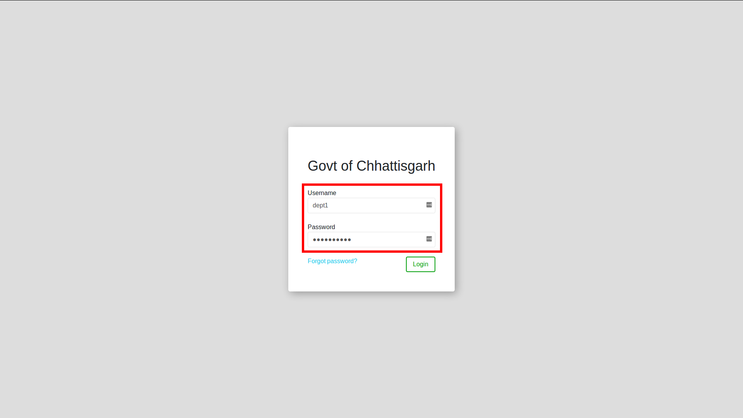

7. Department 1 See “1 Notification” saying “Request from Department 2”

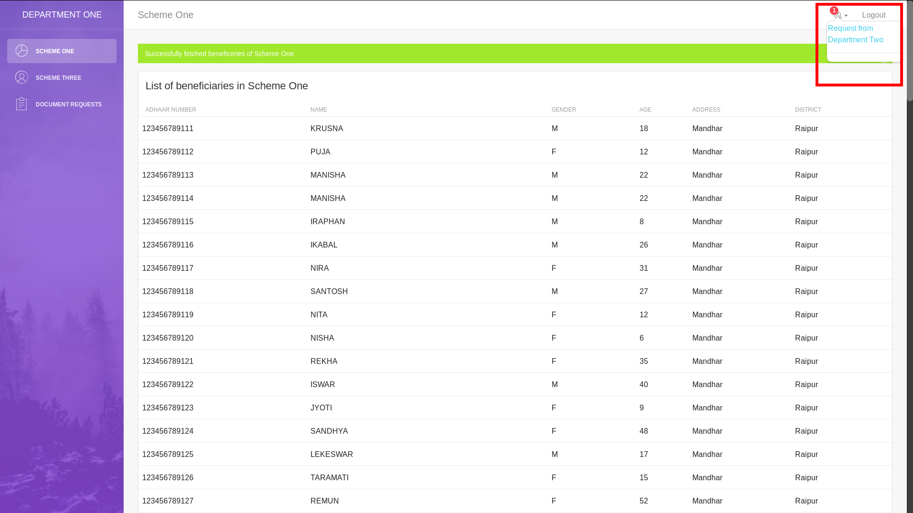

8. Department 1 clicks on the notifcation which shows him the “Requested Data”, Department 1 clicks on “Send Data”

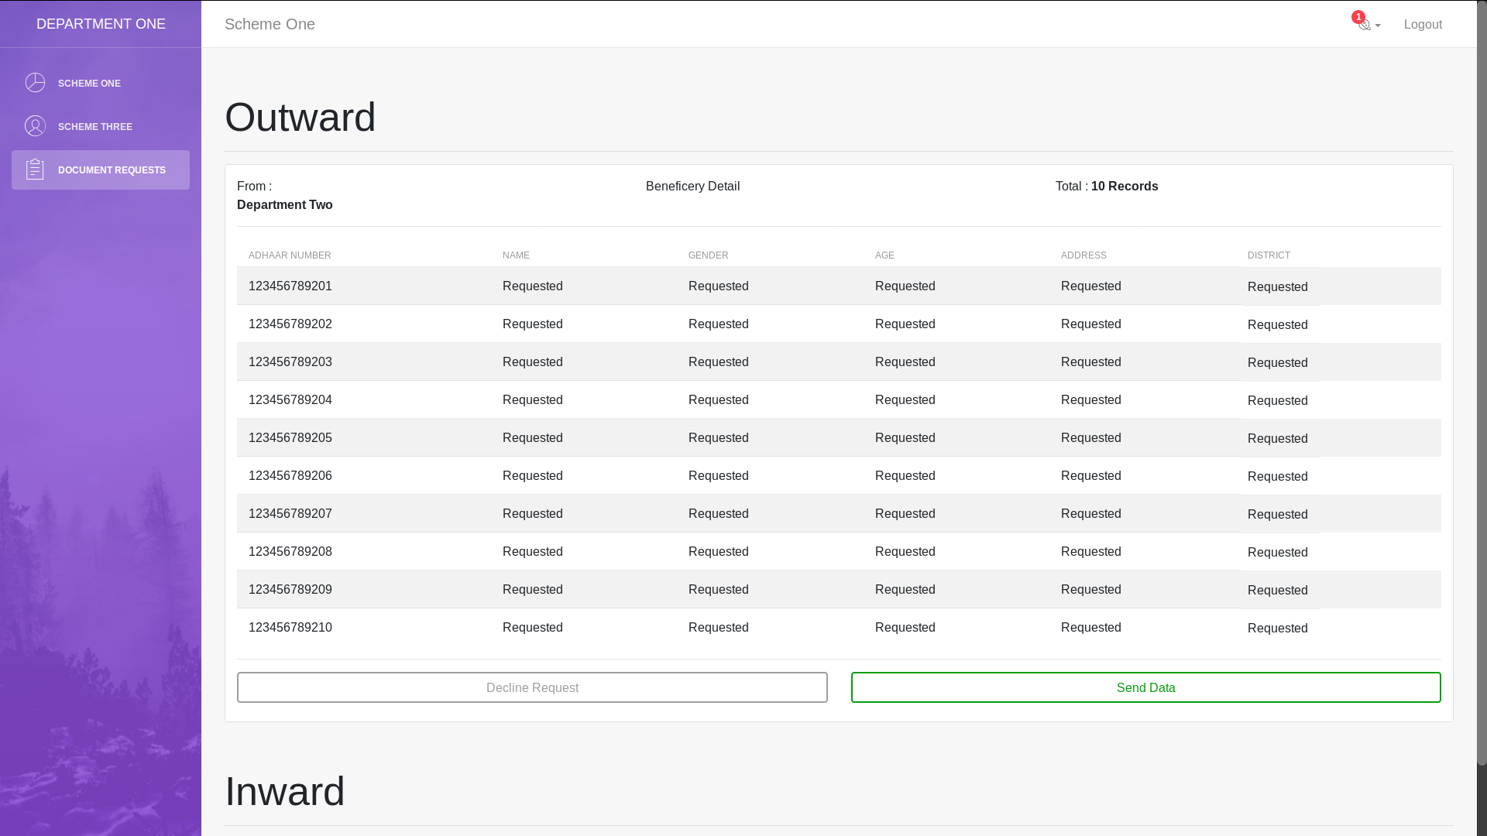

9. After clicking on “Send Data” Department 1 see “Success” message

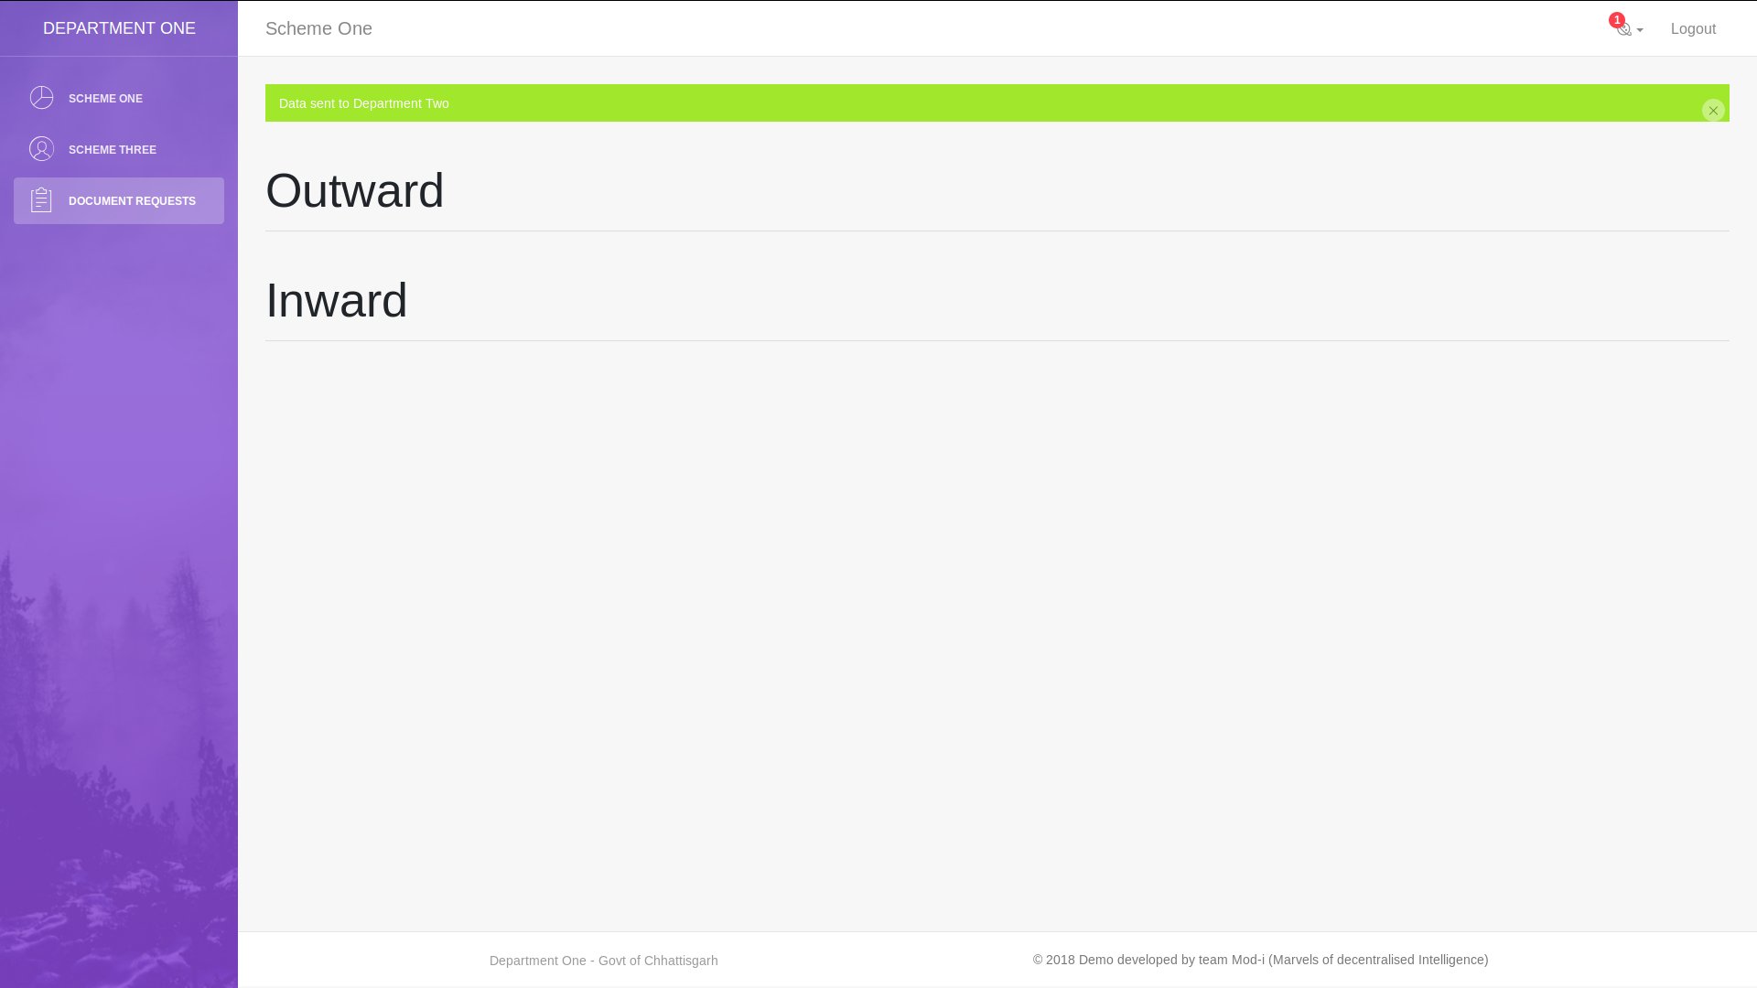

10. Again Department 2 Login to the Portal

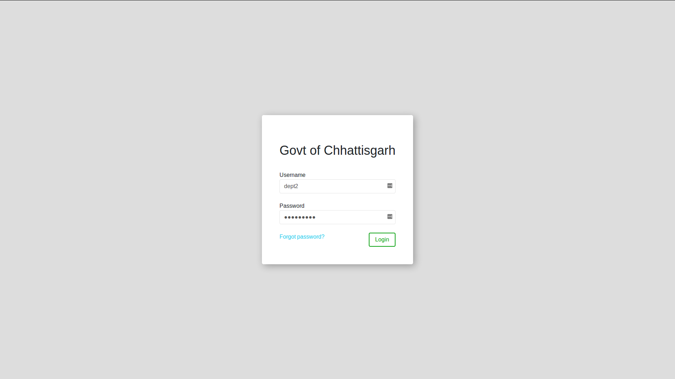

11. Department 2 See “1 Notification” saying “Inward data from Department 1” and clicks on it (Note: Dept 2 still see “Missing data Warning” because he does not have accepted data yet)

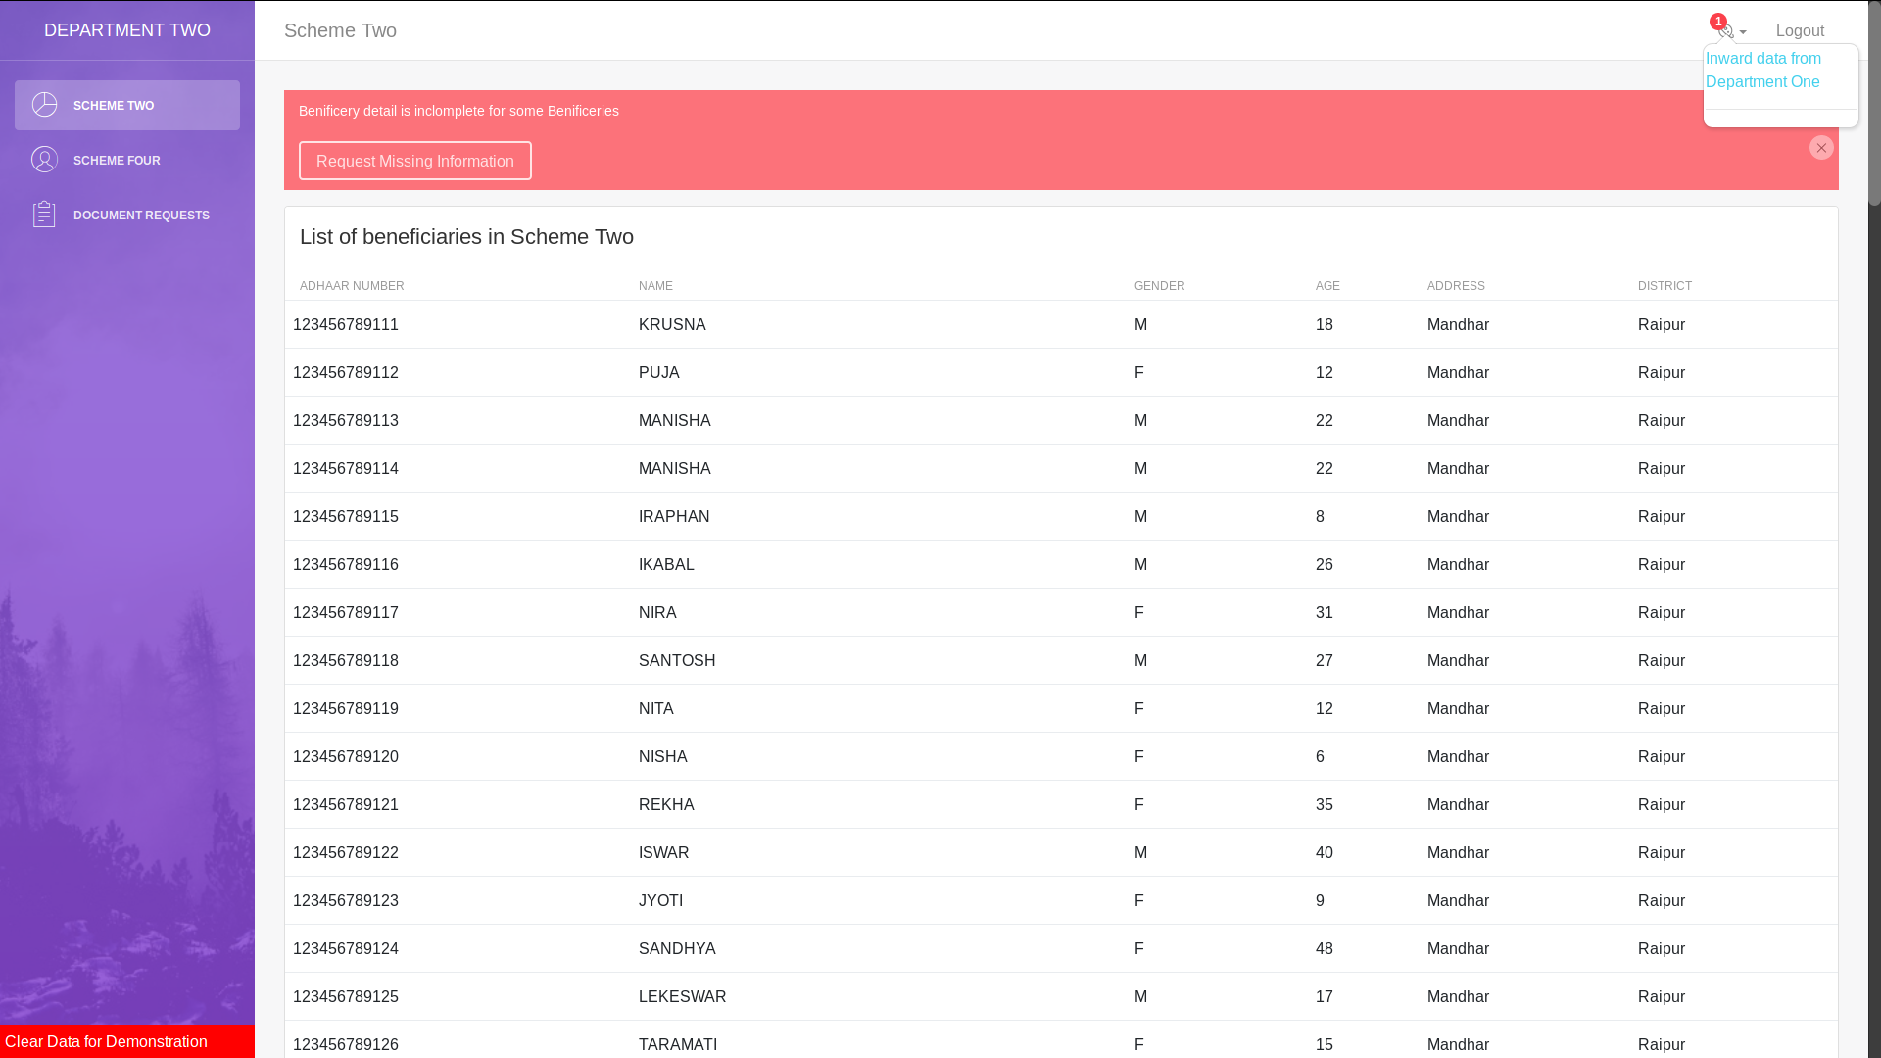

12. After clicking on the notification Department 2 gets option to accept the data, Department 2 clicks on “Accept Data”

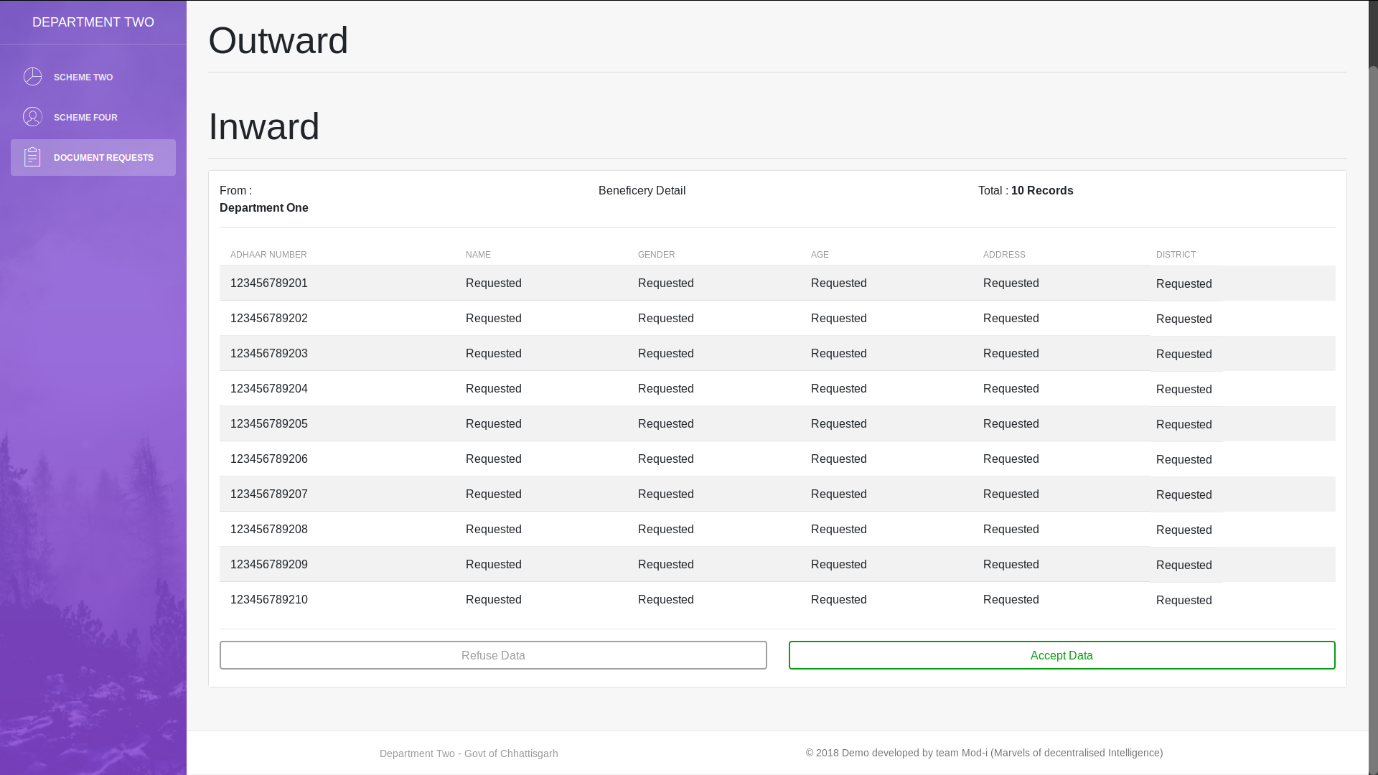

13. After clicking on the “Accept Data” Department 2 gets a “Success” message

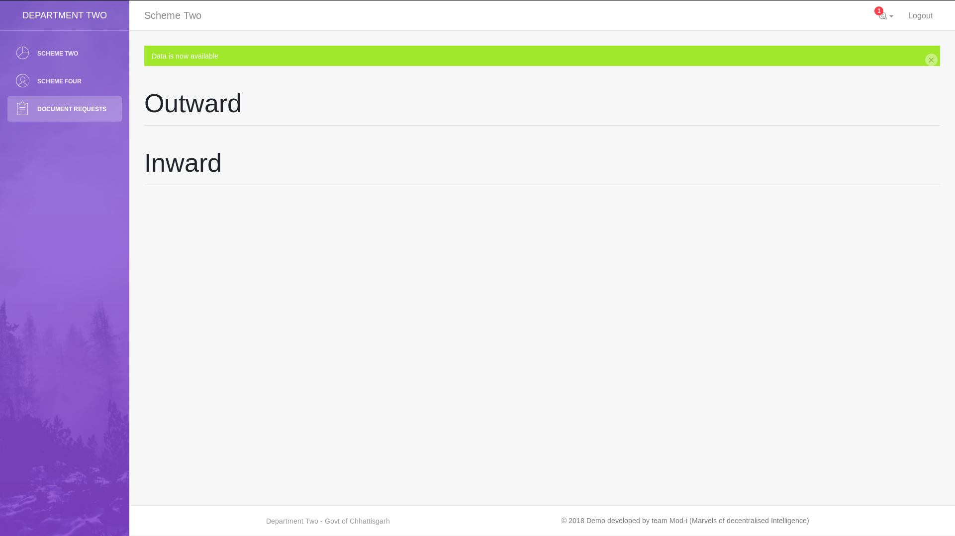

14. Then on clicking on Scheme 2, Department 2 see all the fetched information for the requested Aadhar Numbers

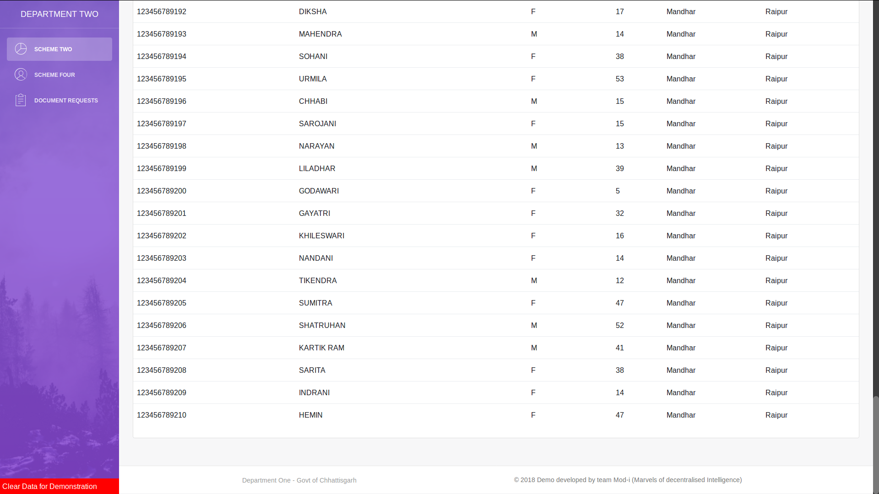

Here the whole process completes. See Point 15 & 16 if you want to repeat the whole operation.

15. Click on the “Clear Data for Demostration”



16. Now Department 2 has some missing information

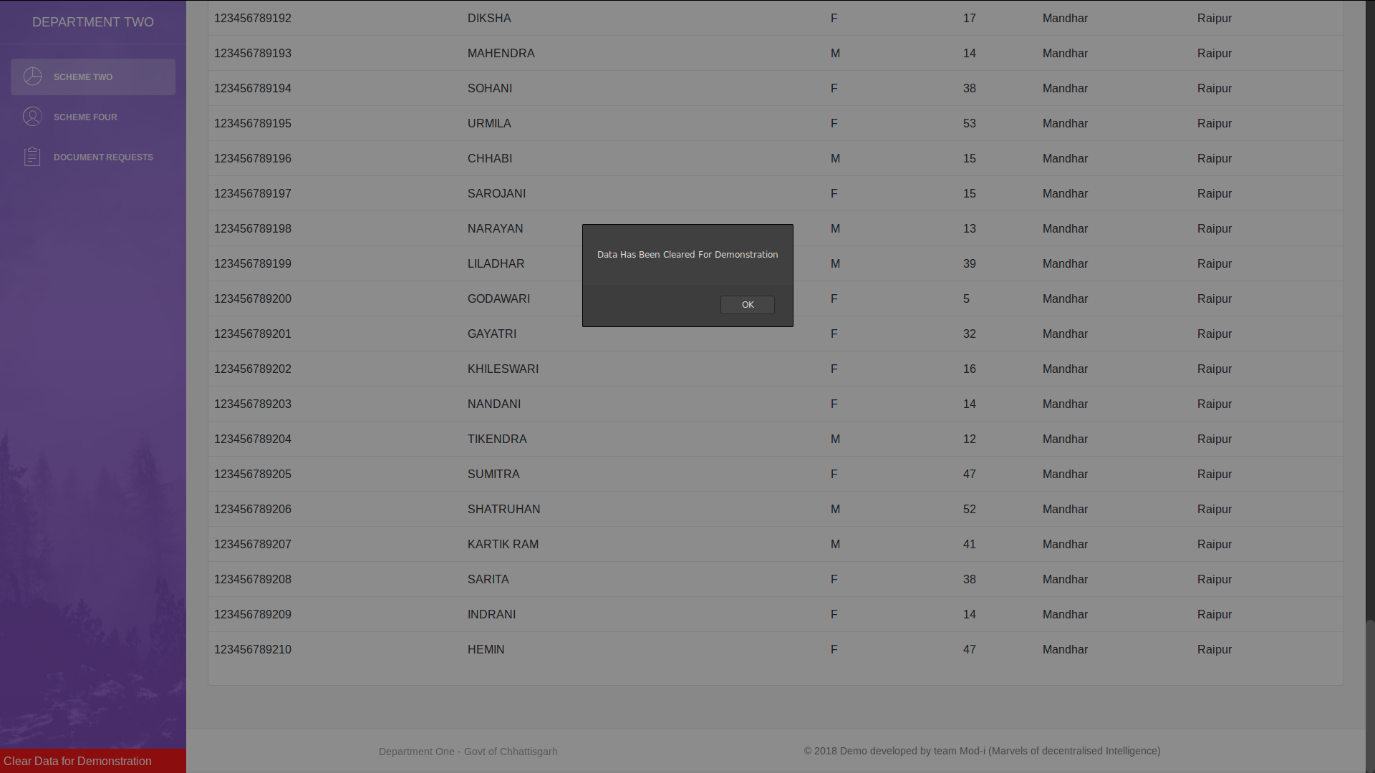

As, department 2 has again few missing data, the whole operation can be repeated.

Thank You..