Lab 06
Procedural Abstraction (Functions Part 1)

Objectives
• Learn how to write functions
• Learn how to use C++ predefined functions
• Learn how to overload functions

Revision Exercises | (30 minutes)

- Mark the following statements as true or false.
  - A value-returning function returns only one value.
  - Parameters allow you to use different values each time the function is called.
  - A value-returning function returns only integer values.
  - When a return statement executes in a user-defined function, the function immediately exits.
  - When variables values are passed to functions, a copy is made and put into the memory reserved for the functions’ variables.
  - In general, we should use global variables as often as we can.

- For the code below, mark with different colours:
- function header  - function body  - function prototype  - function call  - formal parameter  - actual parameter (argument)  - return type  - return statement | #include <iostream>  using namespace std;  double average(int, int);  int main()  {  int a = 3, b = 8;  double avg;  avg = average(a, b);  cout << avg << endl;  return 0;  }  double average(int n1, int n2)  {  return static_cast<double>(n1 + n2) / 2;  }
- Which of the following function headers are invalid? Why?
  - int smaller(int a, b)
  - double total_price(double price, int quantity)
  - print_result(double avg, int min, int max)

- Determine the value of each of the following arithmetic expressions:
a) sqrt(16.0) b) pow(2.0, 3.0) c) pow(2, 3)
d) abs(-3) e) abs(0) f) ceil(7.2)
g) ceil(7.8) h) floor(7.2) i) floor(7.8)
j) 7/(abs(-2) k) sqrt(pow(8,2)) l) pow(3.0,2)/2
- Tutor discuss with students on Q15 – 18, Q20, Q23 a, Q24 b and d from the extra questions at the last section. This should not take more than 15 minutes.

- Write the output of the following program.

#include <iostream>
using namespace std;

int a = 3;

int funct1(int count);

int main()
{
for (int count = 1; count <= 5; ++count) {
a = funct1(count);
cout << a << " ";
}
cin.get();
return 0;
}

int funct1(int x)
{
a += x;
return a;
}

- Write the output of the following program.

#include <iostream>
using namespace std;

int a = 100, b = 200;

int funct1(int a, int b);

int main()
{
int count, c, d;
for (count = 1; count <= 5; ++count) {
c = 20 * (count - 1);
d = 4 * count * count;
cout << funct1(a, c) << " " << funct1(b, d) << endl;
}
cin.get();
return 0;
}

int funct1(int x, int y)
{
return x - y;
}

- Write the output of the following program.

#include <iostream>
using namespace std;

int a = 100, b = 200;

int funct1(int c);

int main()
{
int count, c;
for (count = 1; count <= 5; ++count) {
c = 4 * count * count;
cout << funct1(c) << " ";
}
cin.get();
return 0;
}

int funct1(int x)
{
int c;
c = (x < 50) ? (a + x) : (b - x);
return c;
}

Programming Exercises | (1 hour 15 minutes)
For all the programming questions below, write a driver program to test each function that you make.

Question 1
Write a function called absolute that will take an integer value and return its absolute value. For example, input -57 will produce output 57.

Question 2
For the above program, add another function with the same name absolute that does the same thing, but this time it handles the type double. Test both the functions with different data types.

Question 3
Write a function to compute the factorial for an integer. The formula for the factorial of an integer, n is:
n! = n * (n - 1) * (n - 2) * (n - 3) * …* (2) * (1)
Question 4
One of the simplest geometry problems is to find the distance between two points on a coordinate system.
A
B
d
If we know the position of both points (e.g. points A and B in the figure above) – A(x1, y1) and A(x2, y2), we can compute the distance d as follows:
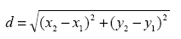
Write a function to compute the distance between two points. The user can only enter integers for the coordinates (x, y) of both points.

Question 5
Write a C++ program that will calculate the perimeter (or circumference) of various shapes. Write a function perimeter and overload it to compute the perimeter of a rectangle, triangle and circle. (Note: The circumference of a circle is determined by 2πr, where r is the radius of the circle and π=3.14159)
Your program may prompt the user to enter the length and width of a rectangle, the lengths of all 3 sides of a triangle and the radius of a circle. Print out the calculated perimeters.
Here’s a sample output for this program:

Enter the length and width of rectangle:
3 7
The perimeter of the rectangle is 20

Enter the length of all 3 sides of triangle:
4 9 15
The perimeter of the triangle is 28

Enter the radius of the circle:
8
The circumference of the circle is 50.2654

*You may design your own program output as you wish. The output above is only a sample.

Question 6
Write a program that will prompt the user for his/her monthly salary and then outputs the amount of tax the user has to pay. Write a function taxAmount to calculate the amount of tax the user has to pay. Use the type double for all variables. The tax rates are given in the table below:

Monthly Salary (RM) | Tax Rate (%)
< 2000 | 0%
2001-3000 | 1%
3001-5000 | 3%
5001-10000 | 6%
>10000 | 10%

For example, if the user earns a monthly salary of RM4000, the amount of tax he/she has to pay is calculated as RM4000 x 0.03 = RM120.

Question 7
Write a function round that takes a double as argument and returns the rounded value of that argument (integer). Hint: you might need to use the ceil() and/or the floor() functions to help.

e.g.: 17.5 → 18 -6.81 → –7
17.49 → 17 -6.37 → –6

Post-Lab

1. Write a program to gauge the rate of inflation for the past year. The program asks for the price of an item (can be of any item that you imagine) of both a year ago and today. It then estimates the inflation rate as the difference in price divided by the price a year ago. Your program should allow the user to repeat this calculation as often as the user wishes. Define a function to compute the rate of inflation. You may create more functions if necessary.

The inflation rate should be a value of type double giving the rate as a percent, for example, 5.3 for 5.3%.

2. Speaking of inflation, our petrol prices are increasing as well! Write a program to calculate how much more we have to pay monthly if the current petrol price increases again. The program should ask for the total amount one has to pay for petrol expenditure every month, and your estimated new petrol price. You may define a function to compute your new monthly expenditure for petrol. Your program should use a globally defined constant for the current petrol price, which is fixed at RM1.92 per liters.

Your program should allow the user to repeat this calculation as often as the user wishes.

3. The principal of procedural abstraction means that your function should be written so that it can be used like a “black box”. The programmer who uses the function should not need to look at the body of the function definition to see how the function works.

The function definition and accompanying comments should be all the programmer needs to know in order to use the function. Read the textbook for more explanations and examples on this.

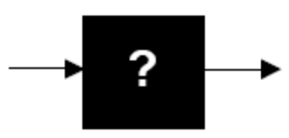

Look back at the programs you have written so far. Put this principal to practice.

Extra Exercises
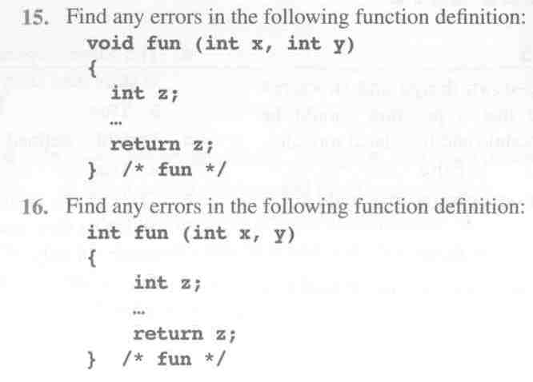
Answer questions 1, 2, 4, 5, 9 from the textbook “Practice Programs section from Chapters 4 and 5” on your own.
Try all the questions below.

