Freight rate prediction
Machine Learning Engineer assessment

Question
The labeled file contains 48,000 loads from 1 January 2025 through 31 October 2025. Each row is a truck load, and the target is posted_rate, the dollar price of that load. I have to price all 12,000 loads in the November–December validation file, and also price one fixed lane, Lexington to Fort Wayne, on every day of December 2025.

October score
Spotter scores November and December after submission, because those rates are not in the files. The score I can compute is the October holdout: train on January through September, then price the 4,853 October loads. The submitted model is histogram gradient boosting on rate per mile.
Score | Value | How to read it
MAE | $115.50 | Average dollar miss
Median absolute error | $38.53 | Miss on a typical load
MAPE | 5.31% | Average miss as a percent of the actual rate
RMSE | $651.11 | Dollar error with large misses counted more heavily
R² | 0.819 | Share of dollar-rate variance explained

This is a good practical score, and it is not a tight fit on every load. A typical October load is off by $38.53, about 2% of the $2,031 median labeled rate. The average percentage miss is 5.31%. R² of 0.819 looks high, and the plain mileage line already reaches 0.817, because distance alone explains most of the dollar variance. The useful gain is the drop in average dollar error from $147.43 on that mileage line to $115.50. About 1.65% of October loads are still off by more than half, which is why RMSE stays near $651.11.

What the labeled loads show
Distance is the main driver of the dollar rate. A load’s rate per mile is much more stable than the total rate: the median is about $2.15 per mile, while the total rate runs from under $100 to more than $25,000 because trip length varies. Short hauls earn more per mile than long hauls, which is the usual fixed-cost pattern in trucking. Equipment shifts the level: reefer is the most expensive per mile, then flatbed, then dry van. Heavier loads cost a little more per mile. Rates per mile are lowest in January, rise into a June peak, and ease off through October. Thursday is the expensive weekday and Sunday is the cheap one. The same city always has the same coordinates, and the stated mileage tracks the straight-line distance between those coordinates.
market_index and quote_signal move only weakly with rate per mile. quote_signal is not a straight line: both very low and very high values sit on more expensive loads.
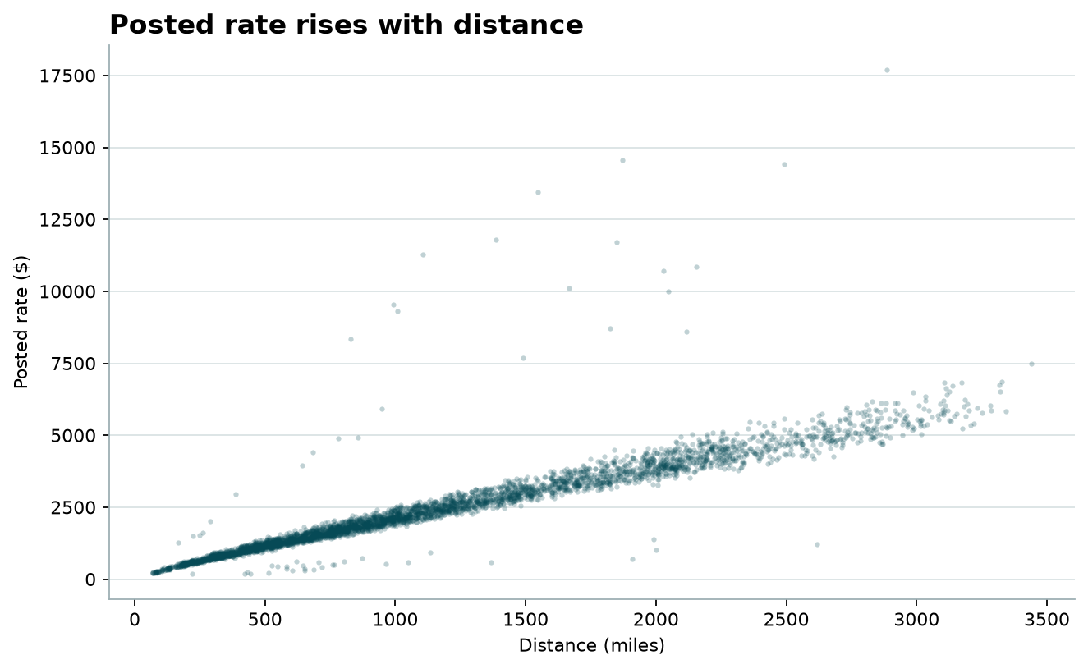
Figure. Posted rate against distance.
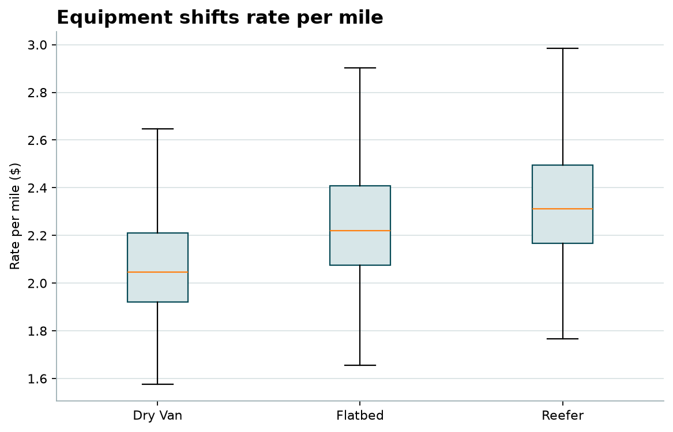
Figure. Rate per mile by equipment. Extreme points are hidden.
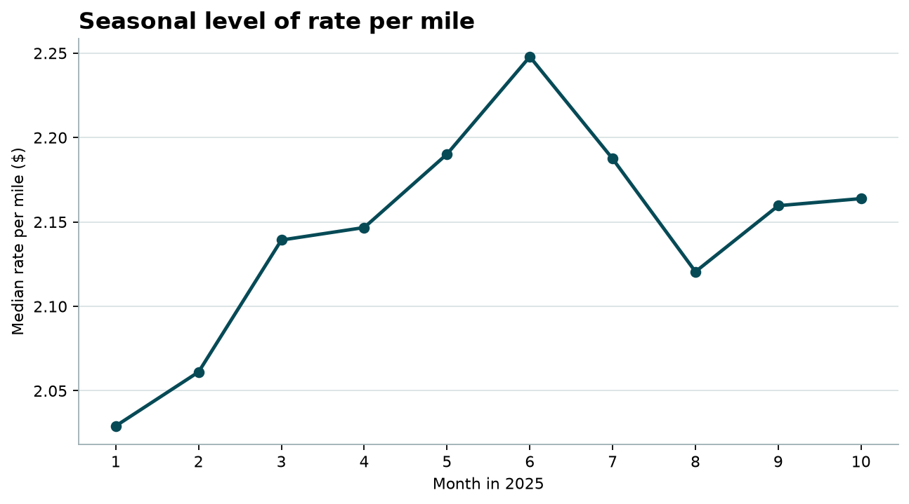
Figure. Median rate per mile by month.
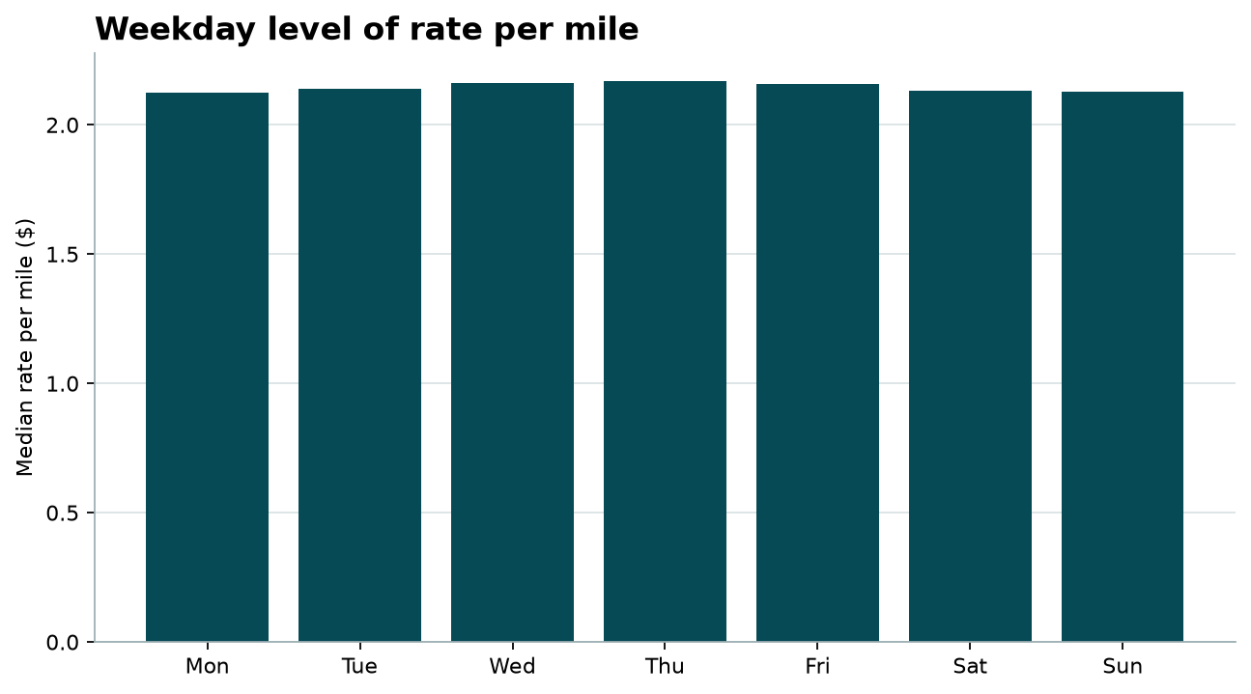
Figure. Median rate per mile by weekday.
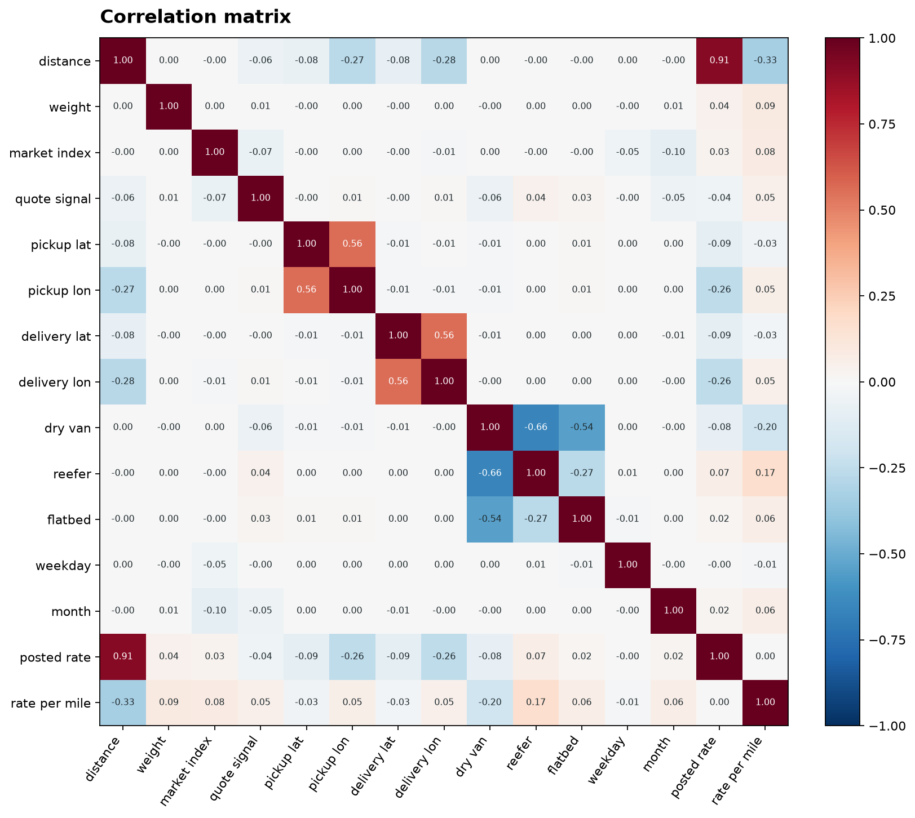
Figure. Pearson correlation matrix. Posted rate moves with distance. Rate per mile moves with short hauls, equipment, and weight.
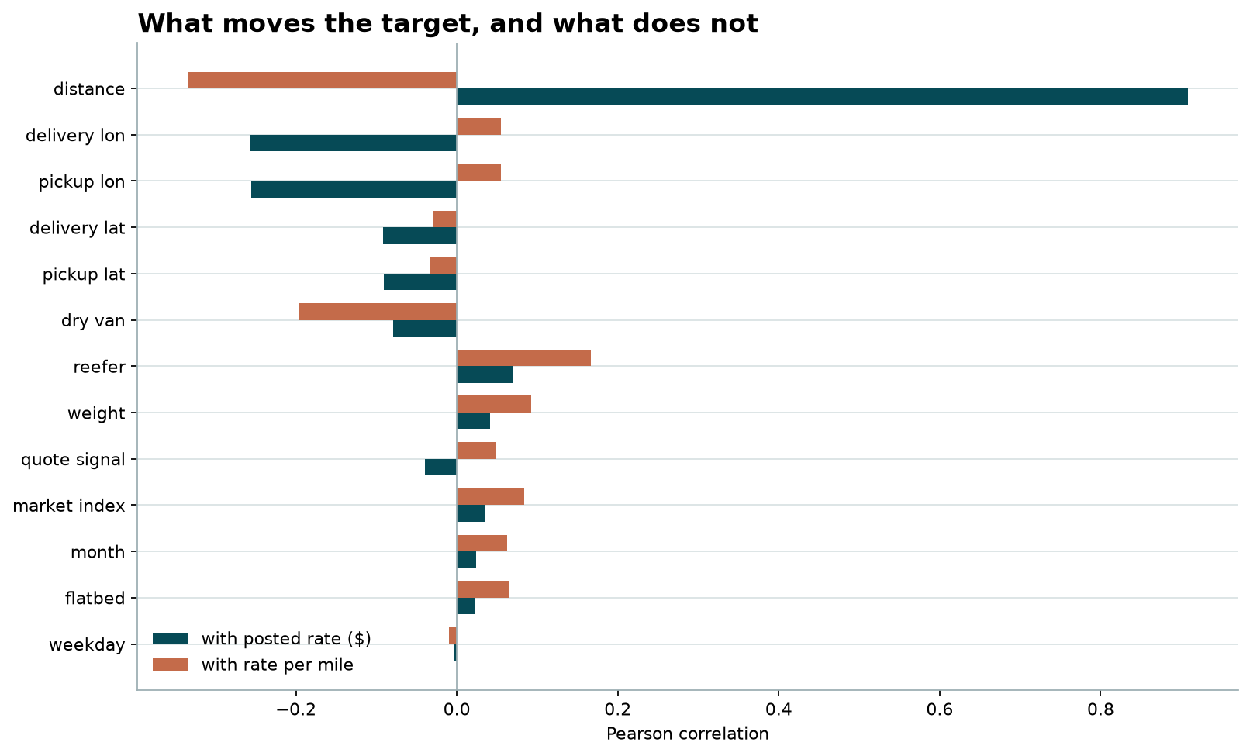
Figure. Correlation of each field with the dollar rate and with rate per mile.
Distance correlates 0.91 with posted rate and -0.33 with rate per mile: longer trips cost more dollars and less per mile. Pickup and delivery longitude also correlate with the dollar rate, at about -0.26, and they correlate with distance, so that signal is mostly east-west trip length. Weight, market index, quote signal, month, and weekday are near zero against the dollar rate. Against rate per mile, reefer is positive and dry van is negative, and weight is mildly positive. Weekday is almost uncorrelated in a straight line, while the weekday chart still shows Thursday above Sunday. Quote signal is also a curve, high at both ends, so a correlation near zero does not mean the field is empty of structure.

Feature engineering and selection
The model does not use the raw columns as they arrived. The target inside the model is rate per mile, and the submitted price is that prediction times distance. Engineered fields are log distance, absolute weight, a missing-weight flag, a negative-weight flag, equipment as a category, pickup and delivery coordinates, day of week, month, and a sine and cosine of the day of year so December can sit next to January on the calendar.
Selection used the correlation screen and the October score, not correlation alone. Distance, equipment, weight, coordinates, and the calendar stay. Coordinates cover the eight cities that appear only in the later file. market_index and quote_signal are out: their correlations with posted rate are about 0.03 and -0.04, and adding them raised October MAE from $115.50 to $128.16. City names are out for the same reason the coordinates stay: a name that never appears in the labeled months has no history to price.

Data quality
Weight is blank on 300 labeled loads and on 165 validation loads. Those cells stay missing. The boosting model can split on “weight was absent” instead of pretending every blank was an average load.
Weight is negative on 292 labeled loads and on 145 validation loads, down to -47,500 lb. The absolute value still lines up with the usual weight effect, so I treat the minus sign as a recording error: the model sees the absolute weight and a flag that the original value was negative.
market_index is blank on 374 labeled loads and on 249 validation loads. I compared a model with those market fields against the same model without them. On the October holdout the market fields raised the dollar error, so the submitted model does not use market_index or quote_signal. That also lets one model price the December chart, which has city, distance, equipment, weight, and date only.
Eight validation cities never appear in the labeled file: Allentown, Charlotte, Chicago, Jackson, Knoxville, Laredo, Norfolk, San Diego. Pickup and delivery latitude and longitude cover those cities, and each known city has one stable coordinate pair. Lexington and Fort Wayne, the December lane, are both in the labeled data.
A thin tail of labeled rates is several times a normal per-mile price. I kept those rows. The model uses absolute-error loss, so a few extreme posted rates do not dominate the fit.

Split and validation
The loads I must price are all after 31 October 2025, so the holdout is the last labeled month. I train on 1 January through 30 September (43,147 loads) and score October (4,853 loads). October is a future month relative to that fit, which is the same situation November and December are in for the final model.
The raw month number for a future month is unseen during that test. Seasonality still reaches December through a sine and cosine of the day of year, so late December sits next to early January on the calendar circle, and through day of week, which repeats all year. After the October comparison I refit the chosen model on all 48,000 labeled loads and use that refit for the submitted files.

Algorithm comparison
Every model below is trained on January through September and scored on the same October loads. Gradient boosting and random forest predict a rate per mile for each load. Prophet, ARIMA, and SARIMAX forecast one daily median rate per mile, because those methods expect a single series over time. Each October load is then priced as that day's forecast, times an equipment factor from the earlier months, times distance. Prophet uses weekly seasonality. A yearly season is not identified from nine months of history. ARIMA order (1, 1, 1) had the best AIC of the orders tried. SARIMAX uses weekday indicators and weekly seasonality, and seasonal order (1, 0, 1, 7) had the best AIC.
Model | MAE | RMSE | MAPE | Median absolute error | R²
Mileage line by equipment | $147.43 | $653.67 | 8.40% | $69.78 | 0.817
Gradient boosting | $115.50 | $651.11 | 5.31% | $38.53 | 0.819
Random forest | $143.55 | $657.27 | 6.64% | $51.44 | 0.815
Prophet | $259.66 | $700.74 | 11.26% | $112.68 | 0.790
ARIMA (1, 1, 1) | $265.17 | $704.41 | 11.37% | $113.10 | 0.788
SARIMAX | $279.25 | $713.27 | 11.63% | $115.91 | 0.782

Gradient boosting is the best October model, at $115.50 MAE and 5.31% MAPE. Random forest is close to the mileage line on dollar error ($143.55) and better than that line on percentage error. Prophet, ARIMA, and SARIMAX land between $259.66 and $279.25 MAE. They track the daily level of the market, and they cannot see that one load is 300 miles and the next is 2,000. R² stays near 0.78 to 0.82 for every model, so it does not separate them. MAE and MAPE do. The submitted files use gradient boosting, refit on all 48,000 labeled loads after this comparison.
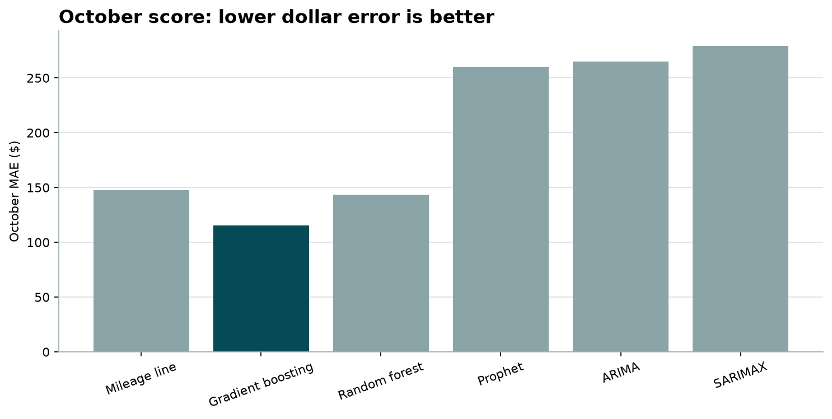
Figure. October mean absolute error by model.
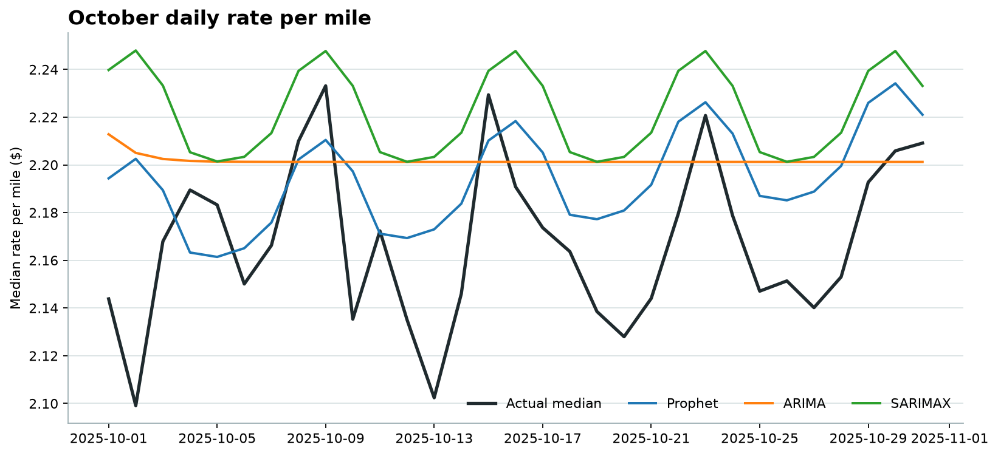
Figure. October daily median rate per mile against the time-series forecasts.

Overfit and underfit check
The posted rate is not one of the model inputs, and the January–September rows do not overlap October. On the rows the model was fit to, MAE is $80.65 and MAPE is 3.67%. On October, MAE is $115.50 and MAPE is 5.31%. The dollar gap is $34.84.
That gap is not the tree memorizing training loads. A deliberately loose tree, depth 20 with one row allowed in a leaf and no penalty, reaches a training MAE of $80.51 and an October MAE of $116.26. The production tree, depth 8, is $80.65 and $115.50. Extra freedom does not cut training error, and it does not help October. Across depths 2 through 16, October MAE stays inside a band of about $3. A forgotten interaction that a deeper tree could capture is not sitting in the data.
The same gap shows up when each earlier month is held out in turn. Training MAE stays near $73 to $81. The next month ranges from about $90 in August to about $151 in June, and October is $115, in the middle of that range. June and July are harder than October. The model is meeting a market that moves month to month, not a bug in the split. The median October residual is about -$21, so the October prices sit slightly above the January–September fit. Dollar error also grows with trip length, from about $44 on the shortest fifth of loads to about $215 on the longest fifth, which follows from pricing rate per mile.
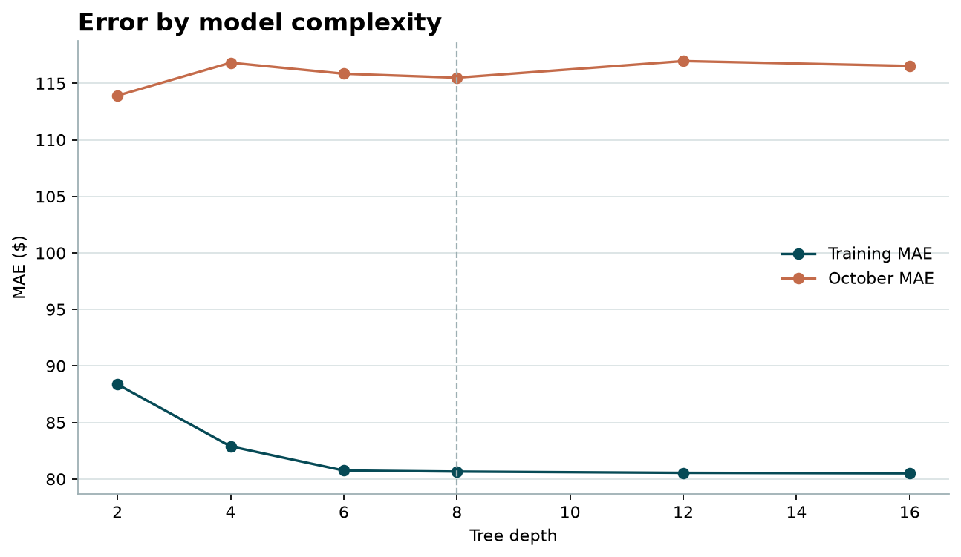
Figure. Training and October error stay flat as the trees get deeper. The dashed line is the submitted depth.
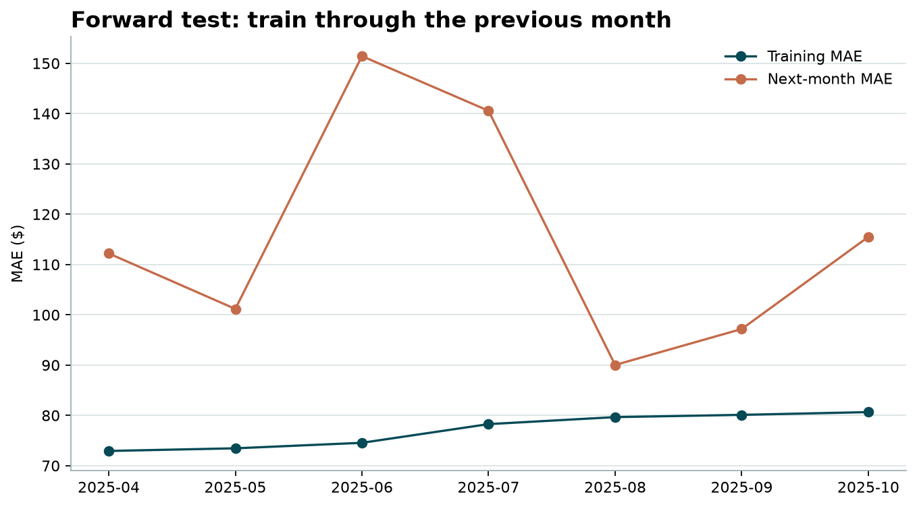
Figure. Each point is a model trained only on earlier months and scored on the next month.

December chart
The chart holds the freight constant: Lexington to Fort Wayne, 360 miles, dry van, 32,000 lb. Only the date changes. Predicted rates run from $787.49 to $812.02, with a mean of $799.08, or about $2.19 to $2.26 per mile. That level fits a short dry-van haul. The shape inside the month is the weekday pattern from the labeled data: Thursday is the peak and Sunday is the trough, repeating each week. There is also a small drift downward through December, in the direction of January, which was the cheapest month per mile in the labeled data. Moving the date on a fixed lane changes the rate by about $25, around 3%. Distance and equipment set the level. The calendar moves it.
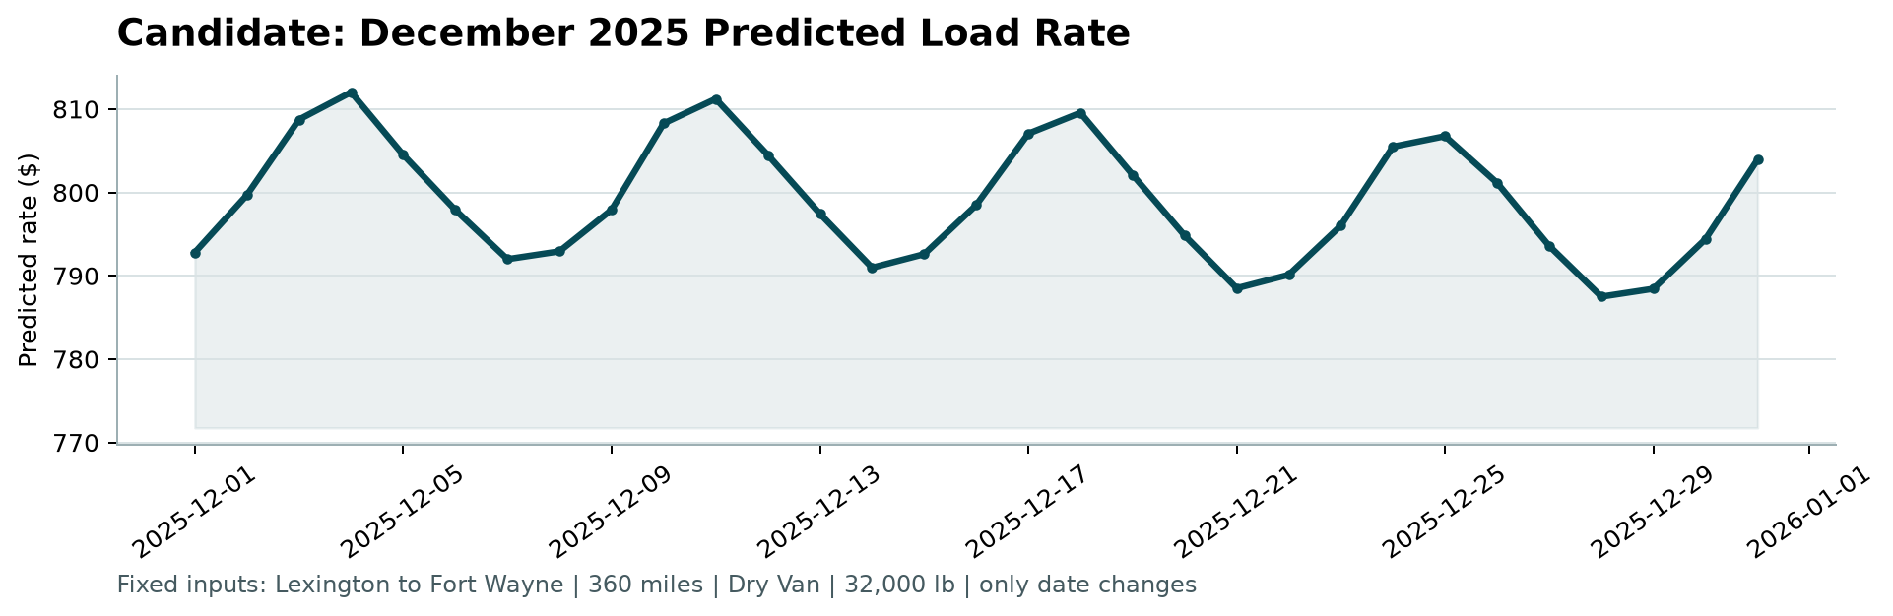
Figure. December 2025 predicted rate for the fixed Lexington–Fort Wayne lane, produced by score.py.

Submitted predictions
validation_predictions.csv has the 12,000 template load ids and a positive predicted_rate. december_predictions.csv keeps the original seven columns and fills all 31 days. score.py accepts both files and writes the chart above. Spotter calculates the official November–December error after submission. Those rows have no rates in the files I was given, so the October holdout is the evidence I can show for the model.

