The Buglist

*This document serves as a place for me to write down notes about bugs, glitches, and possibly broken features across different test builds. It is also a place to jot down ideas and considerations. I don’t expect others to read this, but will highlight particularly important issues and bring them to the attention of those who can resolve them. I will split my thoughts into relevant categories, wherever possible.*

*The most recent session will be displayed on top!*

### **Legend:**

🐛 = Bug. This should or shouldn’t happen, but does or doesn’t.

❓ = Question. Is this supposed to work like that?

💡 = Idea. This made me think of something.

R2 = Trigger, song trigger, song button.

#### **Session 5**

**Build: “Beta_2”**

**Date: 25-11-20**

**Duration:**

*Navigation*:

* 🐛: It’s currently possible to jump over the wall separating the player from the bell, meaning the player can get stuck with the bell.
  + 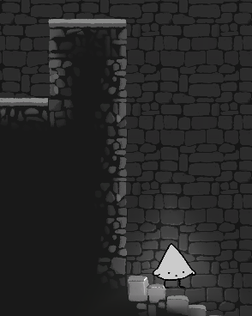

*World*:

* 🐛: When activating the first bell, the purple part of the color dial turns white.
  + 
* ❓: I am not sure if the current bell torches convey what is going on. Also, the emitted light doesn’t match the color.
  + 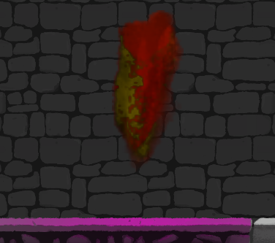
* 🐛: Being able to see parts of the outside world breaks the immersion for me. I think the void should be filled out with black tiles.
  + 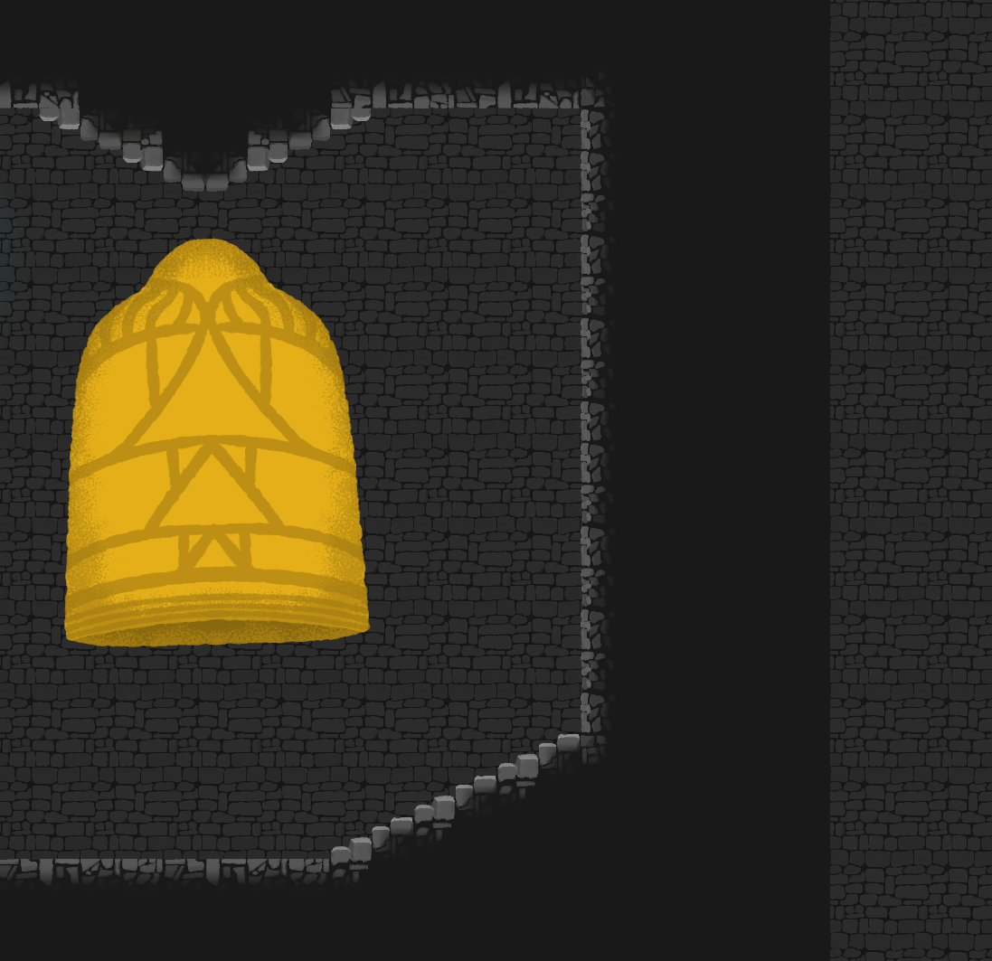
* ❓: I don’t think the barrier should be colored red but this may be a placeholder?
  + 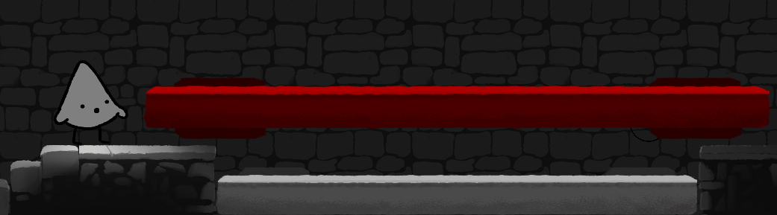
* 🐛: I noticed the light being disrupted by the transition from different sections of the game?
  + 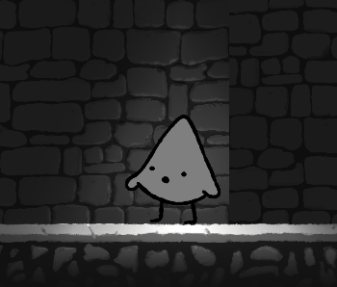

*Puzzle:*

* ❓: Is this puzzle supposed to be solvable with chords? Guessing the player might not know about these at this point or?
  + 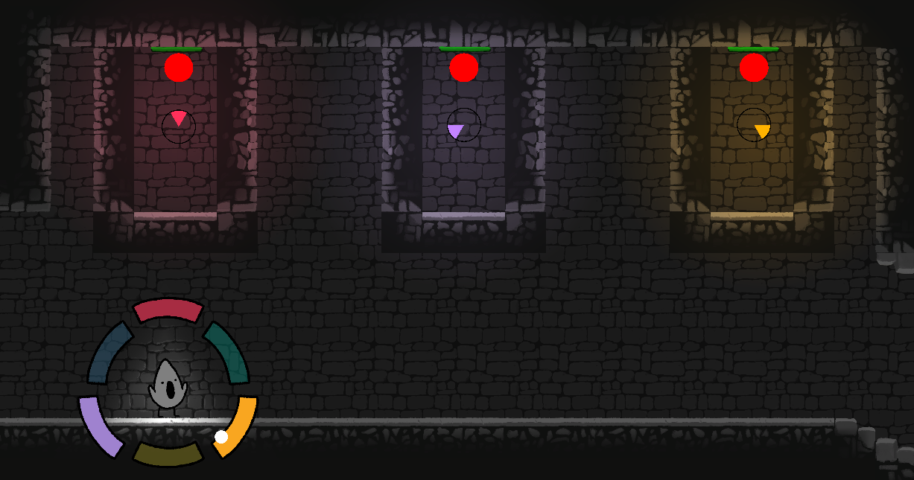
  + ❓: Same with the red colors for balls. Guessing placeholder?
  + ❓: Maybe there could be a bit of sound when balls hit the walls?
* 🐛: The player is currently able to just walk past the barriers in the “luring” puzzle.
  + 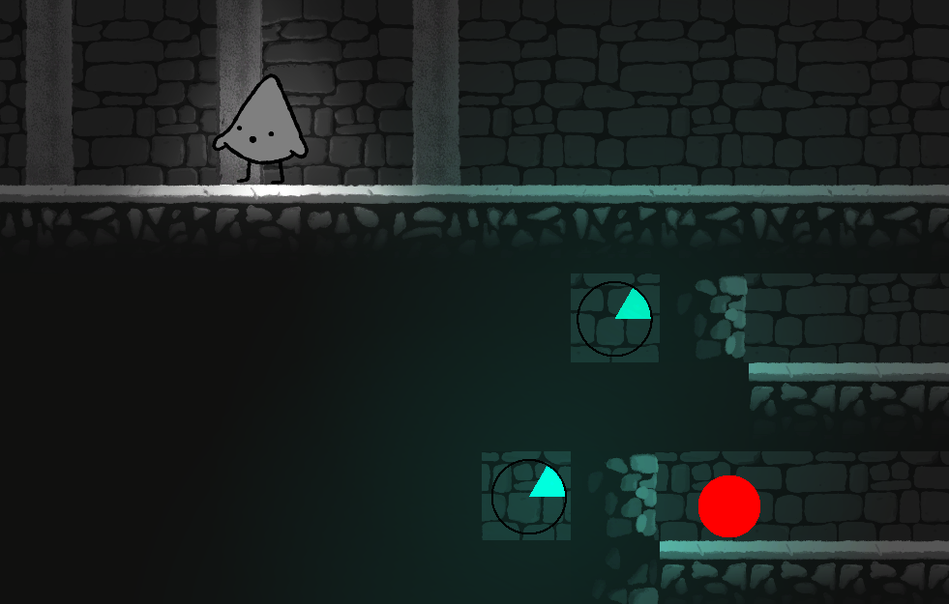
* ❓: Because all four puzzles are about balls, I think the one involving pressure sensitivity runs counter with the logic demonstrated later on. Maybe this puzzle should involve something else, eg, animals?
  + 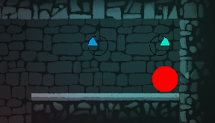
* ❓: Conversely, is this puzzle supposed to be solvable *without* chords? I am not able.
  + 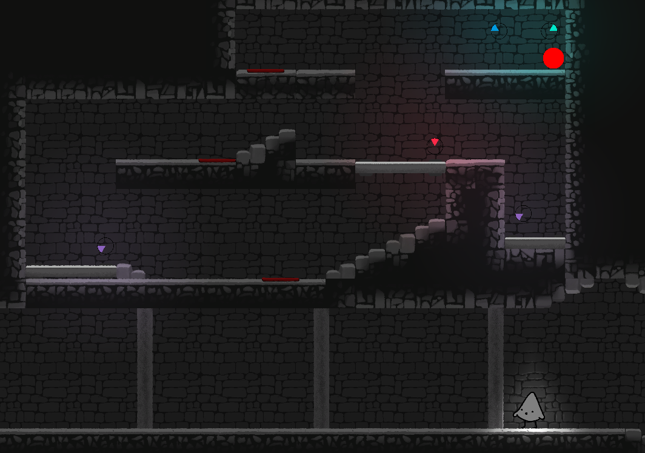
  + ❓: Also, is the player supposed to reverse the puzzle afterwards with the final of these three puzzles? This is not the case with two of the other puzzles.
* 🐛: Similar to before, right before the final door, there is some visible dead space (at the very bottom) and lighting issues:
  + 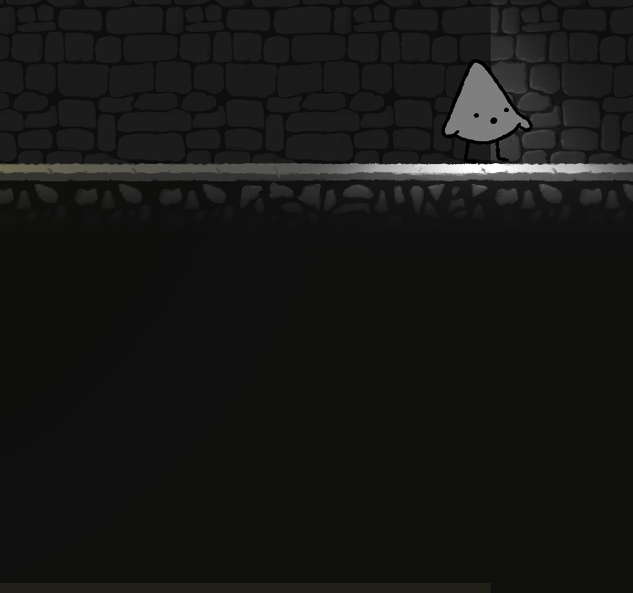
* 🐛: I was only able to open the first part of the door. What am I missing?

*Sound:*

* 🐛: The arrangement of notes does not align with the scale. Purple should have red’s place and then move everything clockwise.
* 🐛: There is a bit of grain with every note when sustained, though the loop is very noticable when playing *orange*.

#### **Session 4**

**Build: f_character_animations_fer**

**Date: 18-11-20**

**Duration:**

*Animation/movement:*

* 🐛: Carefully tilting the analog stick, it is possible to trigger the walking animation without actually moving.
* 🐛: Jumping/falling while pushing towards a wall, will make the character “stick” to that wall until releasing the stick.
  + 
  + ❓: While this happens, a falling animation different to the standard one will play? More of a “flapping”.
* 🐛: This one is kind of tricky: when walking, if you “violently” let go of the stick, the character will often end up facing the wrong direction. So pushing right, then letting go of the stick, the character will end up facing left.
  + I think this one will be very dependent on the quality/brand of the controller and individual ergonomics.
* 🐛: Generally, there is a lot of funkiness in relation to stairs. Standing close to steps/edges produces different mixes of animations.
  + In one case, the legs move without the body.
  + In another, the “dropping down” animation triggers.
  + Think we can design around this by doing slopes instead, perhaps.
* 🐛: Pushing towards a step without jumping, then releasing the analog stick will result in a quick “tremor” of different animations, with the character briefly facing both directions.
* 🐛: Ability to traverse stairs is inconsistent. Sometimes you can walk down and up without problems, other times you have to jump first, etc. It seems to depend on both speed and where you land on the steps.
  + Again, the solution may be to just design more discrete steps or go with slopes.

*Other:*

* 💡: I just realized that the previous note/chord played is still saved, even after opening the wheel again. I think that’s perfectly fine, but I’m just making a note here.

#### **Session 3**

**Build: Prototype v2 (build supplied by Fer)**

**Date: 13-11-20**

**Duration:**

*Wheel:*

* 🐛: Opening the wheel, holding one or more tones, then pressing ‘Q’ to change holding mode, releasing the wheel, and then bringing it back up results in tones being stuck out of bounds from the cursor.
  + 
  + Here, with the reverse starting point:
  + 
* 🐛: Jumping repeatedly makes the character fly.

#### **Session 2**

**Build: a_newWheel**

**Date: 09-11-20**

**Duration: 2 hours**

*Wheel:*

* 💡: Would it make more sense to have the “held” notes move inwards? So as to suggest that they are “locked in”.
* ❓: Holding R2 while circling notes only produces the original note. Is this supposed to work like that? I like the idea of being able to quickly sing through the entire scale.
* ❓: The three final notes (yellow, purple, blue) do not harmonize with any other note. Is this because they are just placeholders?
* 🐛: I had a note (purple) remain highlighted, despite being neither held or song. I am not entirely sure how or why.
  + 
* 🐛: When you select a note, play it, let go of the analog stick, keep holding the song trigger, and then bring up the wheel again, the previous note will sometimes be playing instead of the one chosen.
  + 
  + Another example. Holding the three first chords (red, green, orange), holding the trigger, letting go of the wheel, and bringing it back up results in singing the three chords *or* the purple note (in this example) with a fifty-fifty split chance.
    - 
* 🐛: Because the wheel is deactivated when the analog stick is at its resting point, going directly from red to yellow (for example), makes the sound fall out for a bit and you can tell the wheel very briefly flickers in and out.
  + 🐛: This means that if the player tries to create a chord with red and yellow (for example), the held position of the red note will be reset when passing over the resting point.
* 🐛: Quickly tapping the song button on the same note produces some unfortunate clipping sounds and noises.
* 🐛: Similar to the above, holding a note and letting go of the stick (removing the wheel) produces an undesirable clipping noise.
* ❓: Placing the pointer between two adjacent notes makes it possible to sing both at the same time.
  + 

*Player movement:*

* 🐛: When the player collides with the wall, the sprite gets all jumpy and shaky.
* 🐛: When moving against a wall and repeatedly pressing jump, it is possible to scale upwards.
* 🐛: Standing on the first chandelier while singing will make the player clip through the ceiling. They can then wander around inside the walls.
  + 
* ❓: The player can get momentarily crushed under the chandelier. How do we feel about this?