**CS and SSH**

1. This document is for people who will be connecting to a department Unix or Linux server. In order to connect to a server, you need to know your login information, including your username, your password, and the name of the computer that you will be connecting to. CS Email accounts will require connecting to a server such as ‘linux01.cs.uh.edu’ or ‘login.cs.uh.edu’. Class accounts will require connecting to a server named **‘program.cs.uh.edu**’.

It is recommended that after you have logged in to your Unix account for the first time, that you type “passwd” to change your password to something that only you know.

1. To connect to Unix and Linux machines, users will need a secure form of communication. Telnet and ftp unsecure connections will not be accepted. There are two programs commonly used to establish secure connections:

PUTTY - Putty is available free on the Internet. You can search for “Putty download” or go to: <http://www.putty.org>

SSH - You can get a free educational version of SSH for Windows to install on you computer, from the following location: <http://www.sfsu.edu/ftp/win/ssh/SSHSecureShellClient-3.2.9.exe>

Following are instructions on installing SSH on a Windows computer:

Run SSHSecureShellClient-3.2.9.exe and accept all of the default settings. It usually installs quickly, in less than a minute. When it has finished, it will leave two icons on your desktop.

 This icon is the SSH program

 This icon is for secure FTP and transferring files

1. Run SSH, and click on Quick Connect.

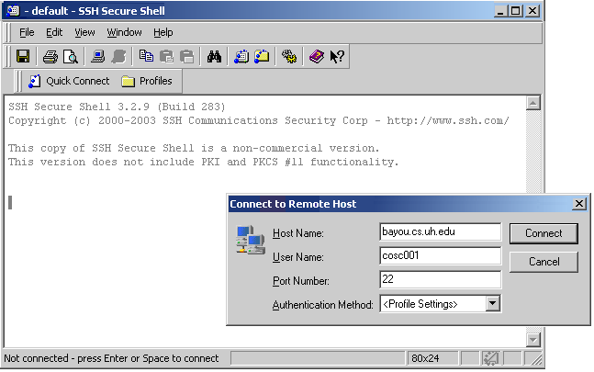

A dialogue box will pop up. Type in the hostname and your username, and click on Connect.

At this point, if this is the first time you are connecting to a new computer, SSH will ask you for permission. Click on Yes.

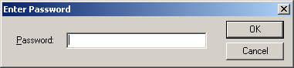In the next dialogue box, type in your password and click OK.

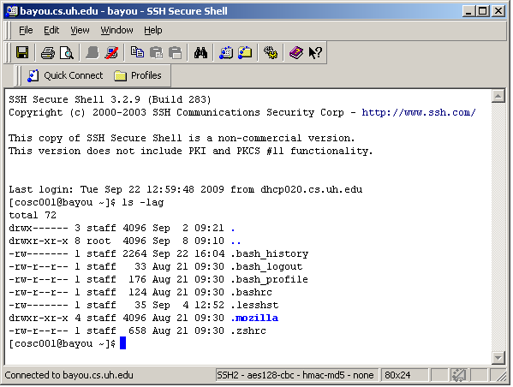

You should now have a command prompt, and it should include your username within brackets if you are in the bash shell. You will be able to type in Unix commands.

Try typing “ls -lag”. (There’s a space between the ‘ls’ and the dash.) The Unix command “ls” will cause the system to list all of the files in your directory, and the extensions will cause it to list more information such as the system files (files with names that start with a dot). When you start off, the only files in your directory are systems files.

1. For further instruction on using the Unix system for your class, consult with your TA or professor. If you want to learn basic Unix commands, you can do an Internet search on “Unix Commands”. There are some helpful websites, including:

<http://www.math.utah.edu/lab/unix/unix-commands.html>

<http://mally.stanford.edu/~sr/computing/basic-unix.html>

1. If you want to use putty, you can do an internet search to find it. Putty is a free software which you can download and install on your computer. Putty is almost identical to SSH in usage, although in Putty the user needs to make sure that “SSH” is checked on the first screen, rather than “Telnet”. In Putty, the user types the username and password *after* clicking on “Open”. Also, putty provides a black screen with white text, while SSH provides a white screen with black text.