# GETTING STARTED

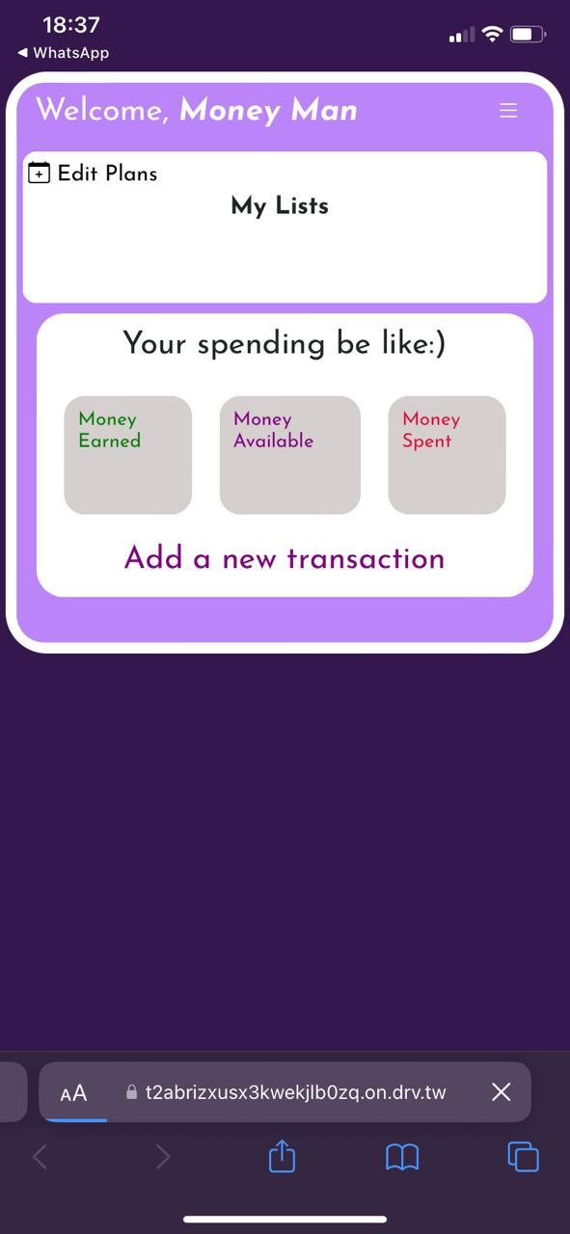

# THE SIDEBAR MENU:

The sidebar menu can be accessed by clicking on the hamburger menu (☰) on the top right corner

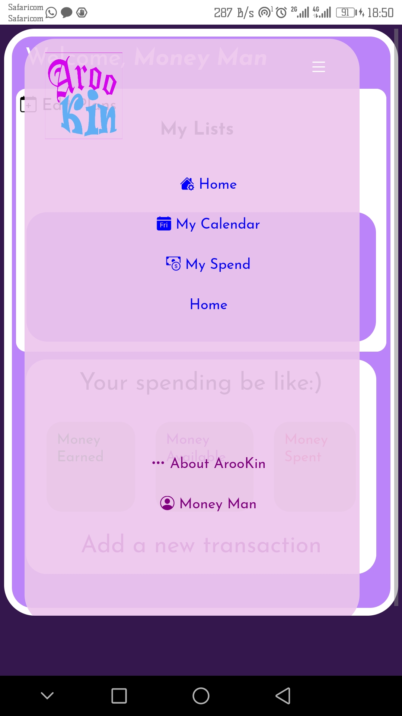

Home-Homepage

MY Calendar-Create and track your plans and tasks

My Spend-Track your accounts

# CREATING A NEW LIST

List in this app is a larger domain that contains related tasks.Simply put a list in ArooKin is like a topic with tasks within it.

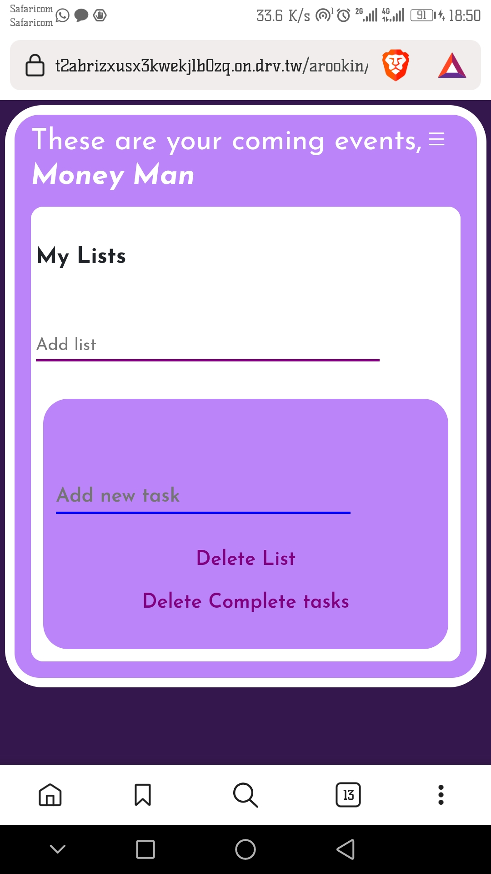

# ADDING TASKS INTO A LIST:

Tasks in Arookin are what exacly should be done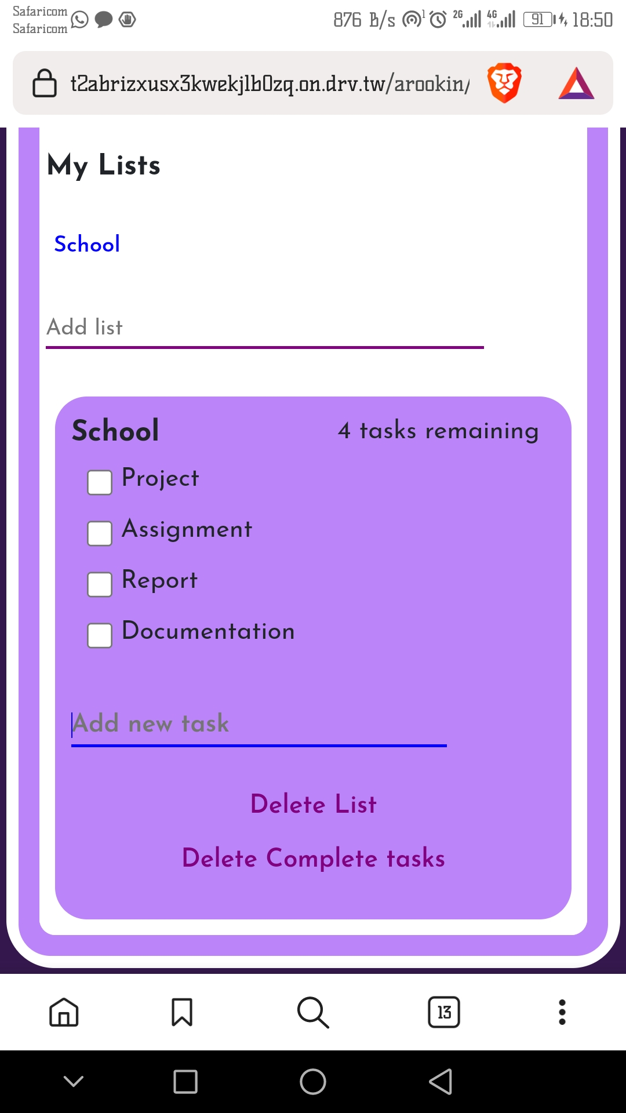

# COMPLETED TASKS

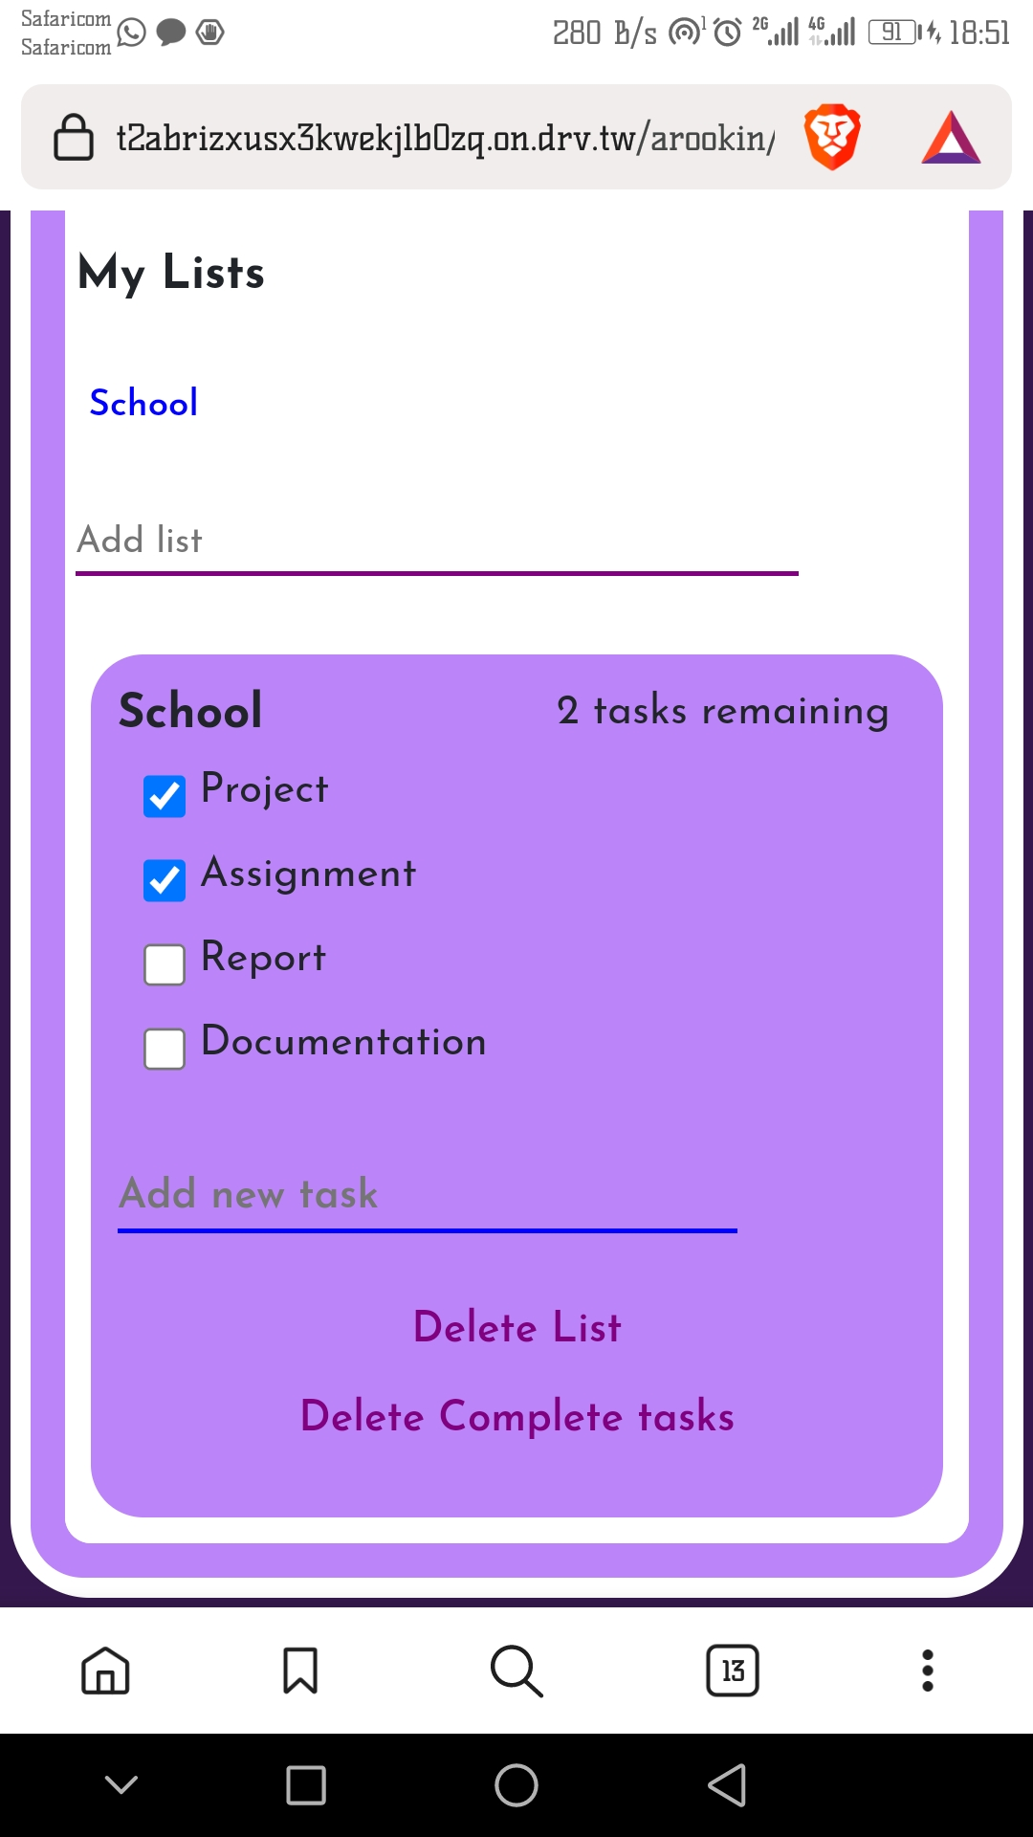

# CLEARING COMPLETED TASKS

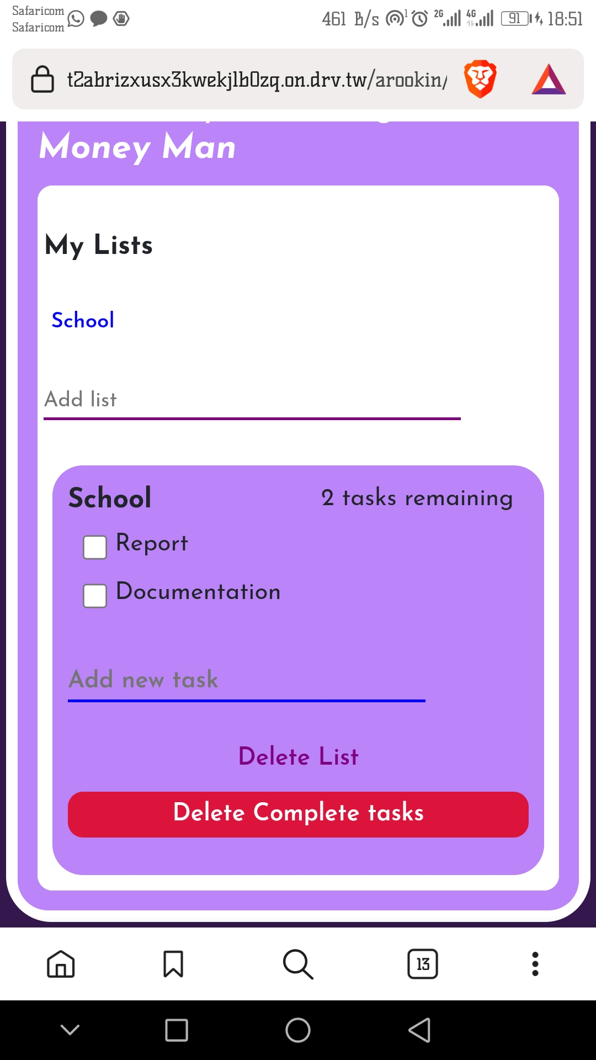

# DELETING A LIST

