**Probability**

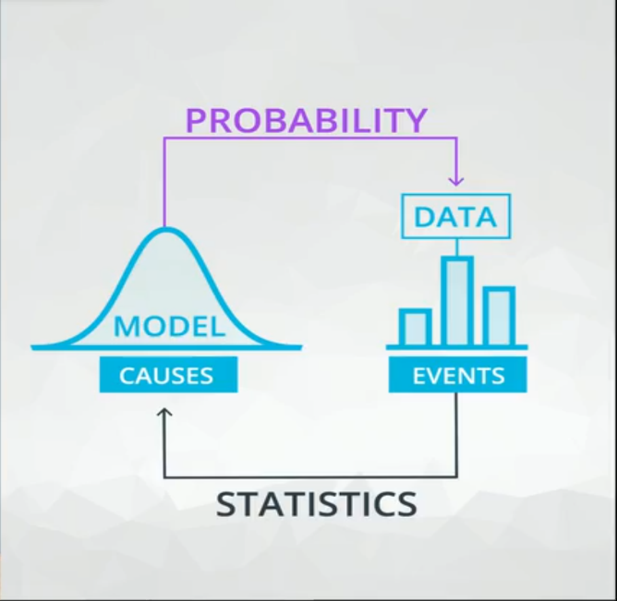Probability is almost the opposite of Statistics.

Probability is making Predictions about events based on models while Statistics is using these events (Data) to make a prediction.

Probability of an events + probability of that event not occurring = 1

P(e1) + p(~e1) = 1

Probability of an event followed by another event = probability of first event * probability of the second event

P (e1, e2, ….., en) = P (e1) * P (e2) * ……. * P(en)

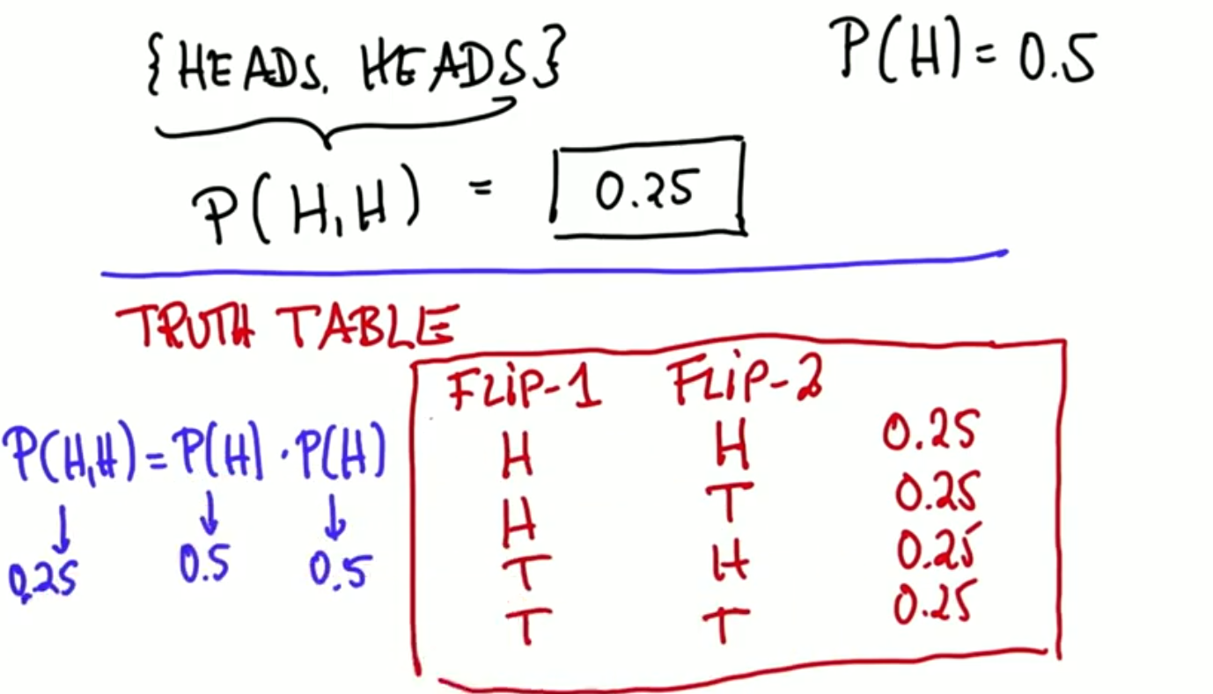

Probability of a specific combined event can be solved by truth table like that:

To get the probability of a coin flipped 3 times to be only one head

You need to draw the truth table of the three flips with all conditions (2^n) n equals to number of flips.

Then you multiply the desired condition flips

[p(H)*p(T)*p(T) + p(T)*p(H)*p(T) + p(T)*p(T)*p(H)] =

(0.5*0.5*0.5 + 0.5*0.5*0.5 + 0.5*0.5*0.5) = (3/8)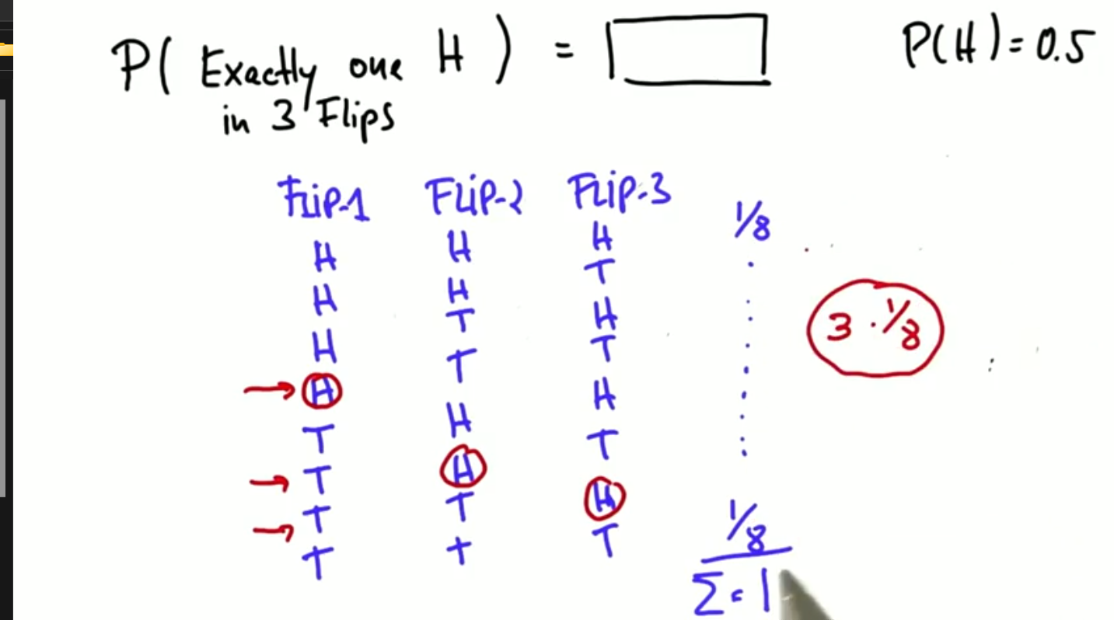

**Summary of all the above:**

first law of probability:

P (e) = 1 – P (~e)

Second law of probability:

Composite Probability = Multiplication of the Probabilities.