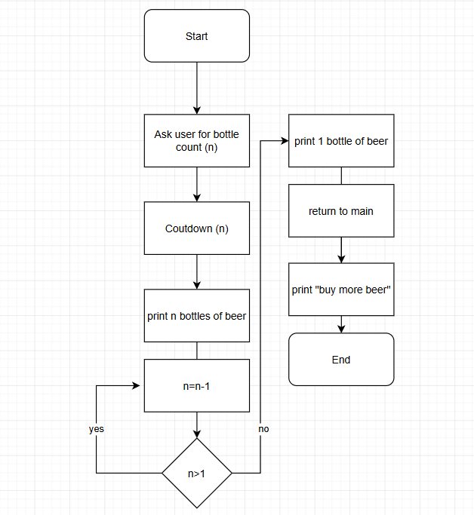
Monika Petersen
CSD325
Module 1.3
6/14/2026

