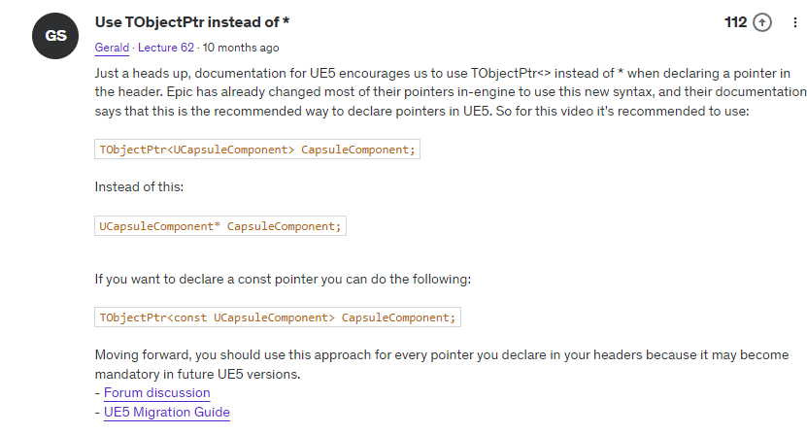

Engine Commands:
- Alt+click on Actor duplicates it.
- F2 renames an object.
- F8 steps out of body so you can move around the scene and see where main Actor is.
- Shift+F1 gives mouse control
- F11 = full screen view
Engine Parts:
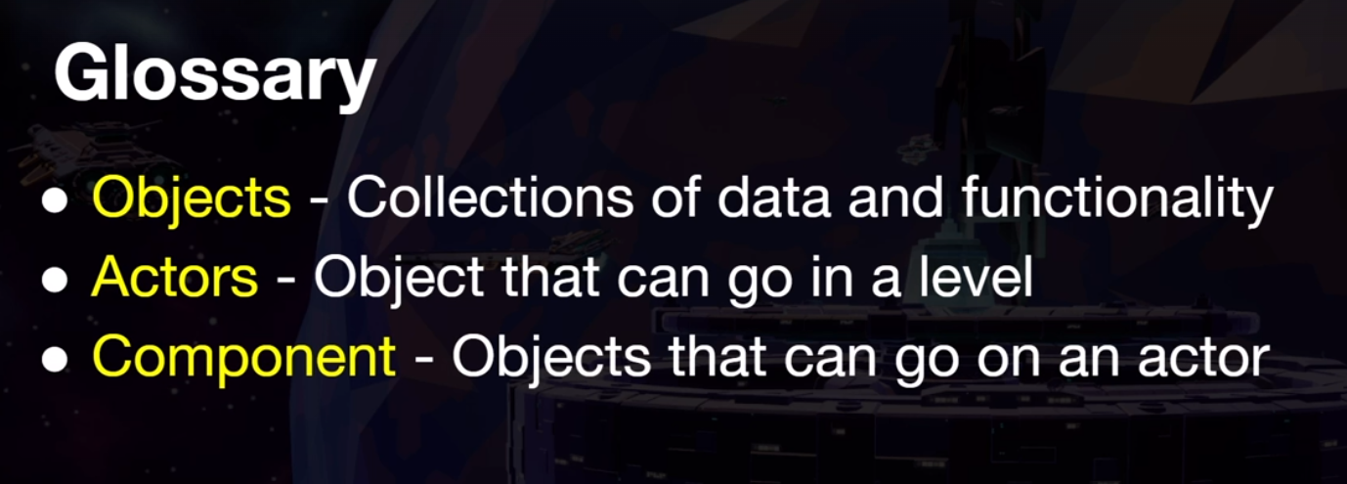
- Directional Light is the sun
- Add a “Floating Pawn Movment” component to something like a simple sphere to get basic movement going.
- By default, in the Enhanced Input System, keys fill in the X value.

Engine Misc:
- Logs on disk are Project->Saved->Logs
- If the Details pane is ever blank, it's a bug. The fix is to rename the variable (really???)
- Bluepring values override C++ values when creating components.

VS/C++:
- To rebuild, close editor then run “Terminal->Run Build Task-><Project Name>Editor-> Win64 Development Build”. Run “clean” ot clean it up.
- Add UPROPERTY to a variable in the .h file to see it in editor. Can also add categories.
- Can use forward delcaration for types in .h, but must use #include in .cpp
- If you see squiggles, might need to generate VS project files. So close the IDE, go to the /Saved, /Intermmediate and /Binaries folders in the project and delete them. Then right click the project and go “Generate Visual Studio project files”. Then when you open the project say yes to the recompile prompt.
- Can't forward delcare something that is not a pointer. So with structs like FinputActionValue they're pretty small so including the header in the .h is ok.
- #include “xxxxxx.generated.h” must be last in includes.
- CastChecked<> instead of Cast but asserts if the cast will succeed. If it fails it can crash the game, but that can be good for debugging.
- “#pragma once” is a guard that prevents us from including the same header file twice.
- Must include header files:
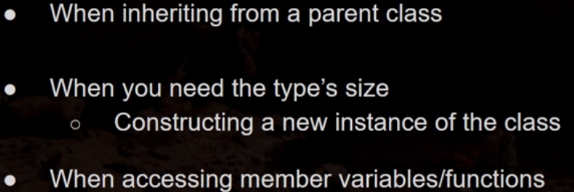
- Called “const correctness” if we use const on something we don't want to change. Could be good for debugging since we know it doesn't change.
- Hot reloading and compiling are different. Not really compiling when you live code, you're hot reloading within the editor but the VS project is still uncompiled. Close the editor, re-open, some changes in C++ would be gone because we didn't compile, we hot reloaded.

Collision:
- Sometimes collision can be messy, so once you've got an asset viewable Collision->Remove Collision
- “10DOP-Z Simplified Collision” is good on barrels because it wraps around it.

Blueprint:
- Select an object in a level, then go to Level Blueprint. Right click and you can create a reference to the object you have selected in the Outliner window.
- “Pure” functions have no side effects but returns values (get ammo, get forward vector). Select “Pure” on the details pane to change function to pure.

Geometry Brushes (or BSP “Binary Space Partitioning”:
- Can be used for testing to quickly set up a world.
- Make sure “Geometry” is selected in the Place Actors panel.
- Don't adjust on the transform, but on the Brush Settings size.
- Make one “Subtractive” to remove gemoetry from the “Additive” one.

Physics:
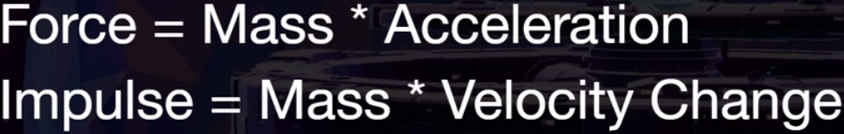

Pawns:
- Our Pawn/Bird will move forward and backwards with W/S, but all direction control is with the mouse.
- Pawns by default don't have a movement component by default, so we have to add one. Enter FloatingPawnMovement. “Floating Pawn Movement” section in Details has tweakable parameters.

- To make sure Bird follows mouse, check these:
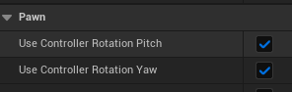
- Create a new C++ class based on Pawn called Bird, then a BP. Starts off like:
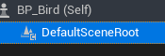
- Bird.cpp/h and BP_Bird for setup and execution. (note bird starts off too high and rotated along Y so adjust height and rotate to have it facing X (red arrow) so adjust in BP).
- Don't adjust transform on capsule, adjuts the Shape fields:
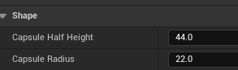
- Add a mesh and an animation in the BP. Worry about animation BP's later.

Characters:
- Character has all of Pawn stuff but additional functions and capabilities designed for humanoid characters. Create a new C++ class from Character. EchoCharacter. Then a BP. Note that there's a lot more default stuff in there than the Pawn.
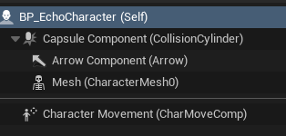
- If you import a character from the marketplace, don't use it directly. Create a BP child class first.
- To make a character in the level the main character, go to the character's BP and look for Pawn in the Details section. Change “Auto Possess Player” to Player 0 (can also set in code).
- Add the Boom and Camera like in the Pawn. Don't need the Mesh or Collider since it comes with Characters by default.
- Arrow Component just shows which way is forward.
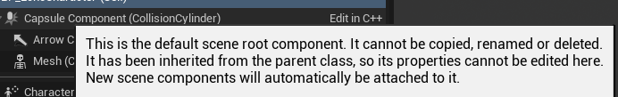
- Can't delete C++ components from the blueprint.
- Gravity is enabled by default, unlike pawns.

Old Input:
- Old Way: Project Settings->Engine->Input. Set up the Axis and Actions mappings there.
- See Pawn/Bird for setup. IA_Move1D, IA_LookPawn and IMC_Pawn. Uses W,S as movement and it follows your mouse for the direction.
Enhanced Input:
- Make sure that the plugin is being used (Edit->Plugins->Enhanced Input). and the Build.CS has the correct value. Trash “Saved”, “Intermediate” and “Binaries” folders from project. Right click .uproject file and select “Generate Visual Studio Project Files”. Then when you run the project choose to rebuild.
- Console commands:
  - showdebug enhancedinput
  - showdebug devices
- For Characters, we want to use WASD to move and the mouse just for the camera.
- By default buttons will map their values to the X axis. So for movement, if we want a button to be the Y axis, use “Swizzle” and change it to YXZ, so use that on W and S because those are the Y value. A and D can stay the same.
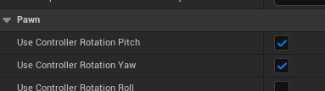
- When created, the Y mouse values will work but not the X. If you do the same trick for Pawns then the character will rotate with the controller, but we don't want that becaues the character always moves parallel to the ground. And we don't want the character to rotate with the mouse anyway So DON'T DO THIS
- Uncheck them all in the BP and use code to make sure they're all false (See
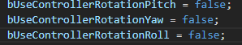
- So don't want character to inherit pitch/yaw but we want the camera to move. So on the Camera Boom->Details->Camera Settings:
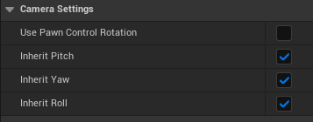
- This just means that we inherit the yaw from the parent component, in this case the capsule collider. We don't really want our capsule to rotate with our controller, so this is the challenge. So how do we rotate our spring arm without rotating the component it's attached to?
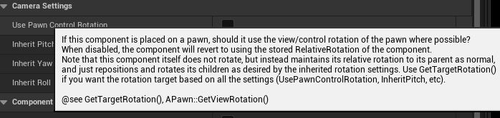
- Toggle that On and it fixes the issue with the camera.

- For movement, the default way moves the character in the direction of Forward and Right in relation to the character, NOT where the camera is pointed.
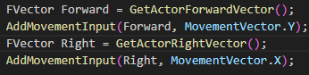
Rotation Matrix (used so that the character will move in the direction of the camera):
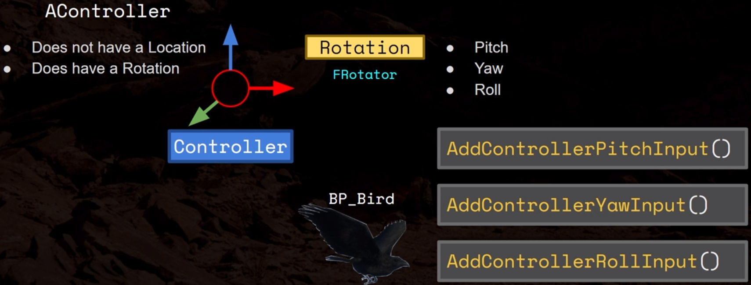
Now we want the character to move in the direction of the controller. They don't have a forward vector per se but it does have a rotation. So we want to get that forward vector of the controller IE look at the controller's rotation and find out what the forward vector would be.
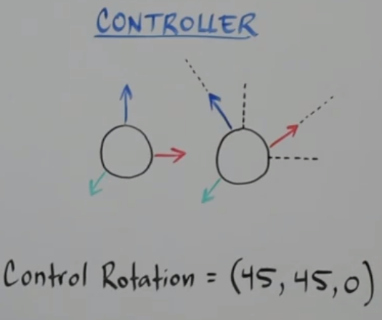
- We use the Rotation Matrix.
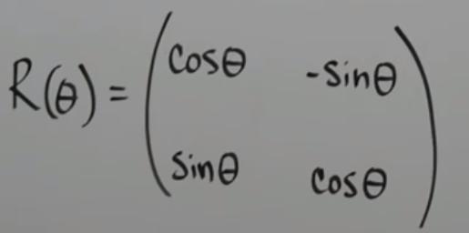

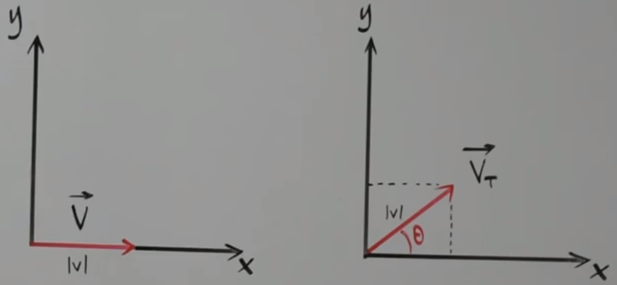
- |V| is the magnitude of the vector. Rotating by angle called theta. What is the resulting vector? Vt, (t stands for transformation). We need the x and y component of the new vector.

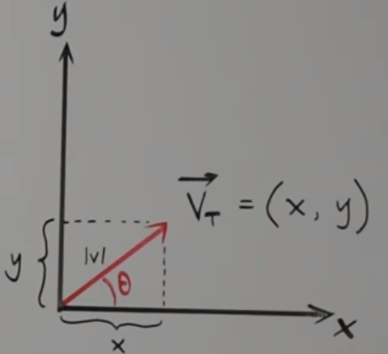
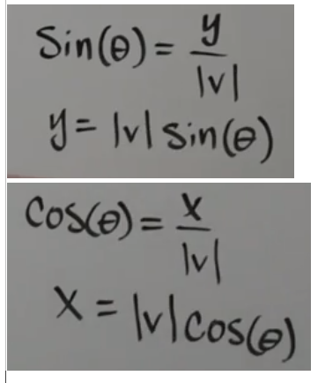
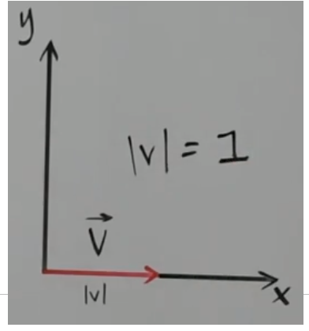
The rotation matrix is the formula mathematicians came up with to deal with this. Want to multiply a vector by a matrix.
Consider V to be a unit vector.
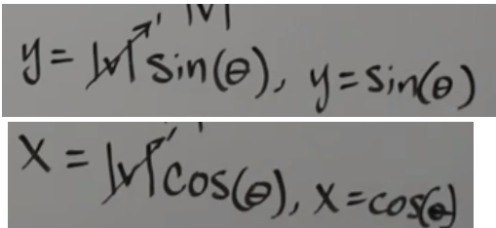
So the original vector:
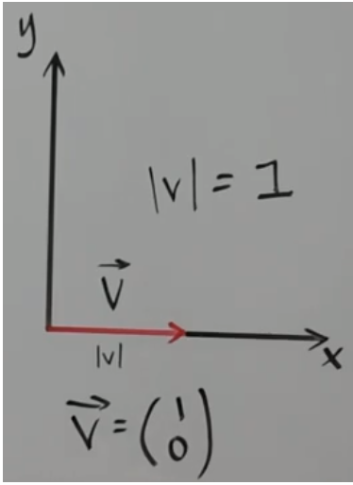

So multiply the vector by the rotation matrix (dot product) NOTE: Technically the vector should be on the right of the matrix (see my text below the image)
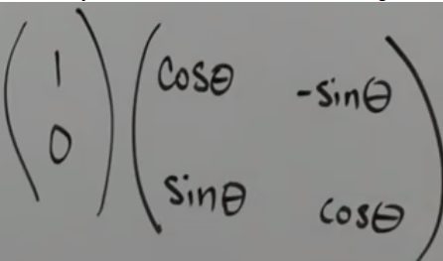
| Cos(-) -Sin(-) | | 1 |
| | | |
| Sin(-) Cos(-) | | 0 |
| | | |

- Cos(-) * 1 + -Sin(-) * 0
- Sin(-) * 1 + Cos(-) * 0

Result (dipshit teacher didn't put result on screen).

| Cos(-) |
| |
| Sin(-) |
| |

But we already determined that X is Cos(-) and Y is Sin(-), so
new vector is (Cos(-), Sin(-))

You can do this in 3D as well, and in UE we have the ability to create a rotation matrix and use angles to create a vector corresponding to that rotation. If our controller starts off with 0,0,0 for its rotation, then as we rotate the controller and change it's yaw, pitch and roll we have 3 angles, one for yaw, pitch and roll. We can use rotation matrices to find the vectors corresponding to those x,y,z directions of that rotation. This is how we can find the forward and right vectors of our controller's rotation.

Controller Directions:
We want to find out which way is forward, but we don't care about pitch or roll since we're moving parallel to the ground.

GetUnitAxis can return a few things:
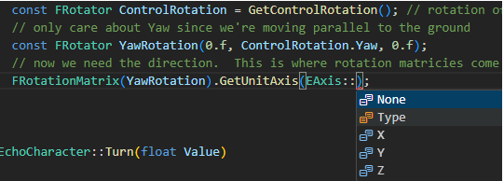
If we choose X, then calling GetUnitAxis() returns an Fvector3D and this vector is the X axis corresponding to our yaw rotation. So the FrotationMatrix has the ability to return a vector, and we're taking a vector in it's base position (essentially pointing in the forward direction) and rotating it (like a gizmo) according to the yaw, pitch and roll and taking the X vector from that. So that code above returns an Fvector that reps the direction our controller is looking in.

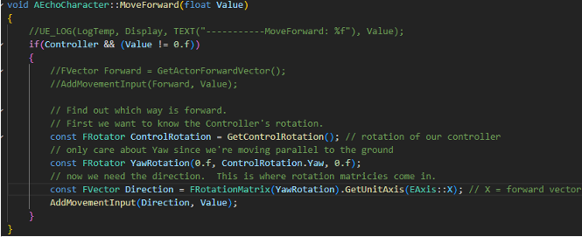

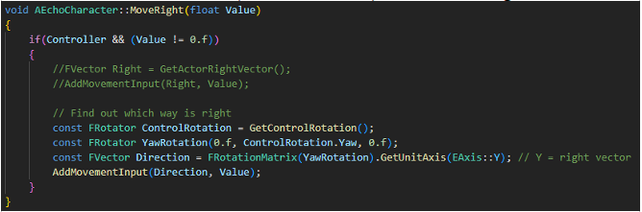
You now move in the direction of the controller, but only for forwards and backwards (MoveForward), not MoveRight

Now the character is moving in the right direction, but it's always facing it's forward vector, it's not rotating with the camera. So if we want our character to orient itself towards our movement, there's a variable for that in the BP

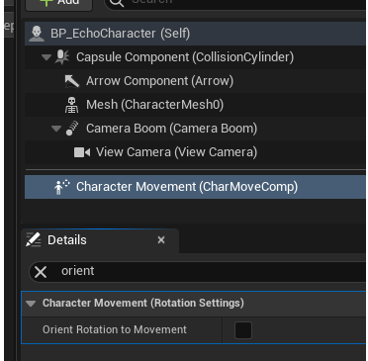
Turn that one and you rotate in the direction of the movement, and you do it smoothly. How fast you rotate is a variable:

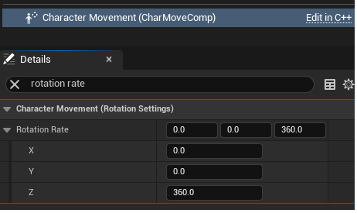
In C++:
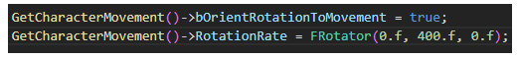
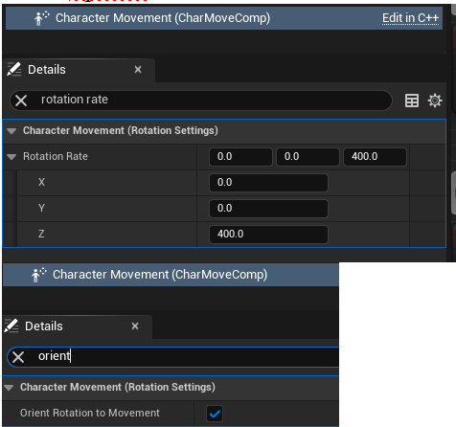
Then in BP editor:

It's strange that is' X,Y,Z (the axis about which our character rotates)
and we know that yaw is a rotation about the z axis.

