Practical – 4: Develop a Simple Calculator Application using Flutter.

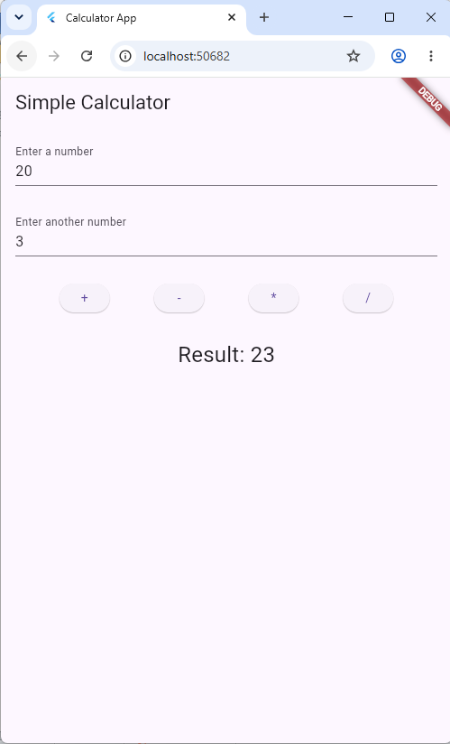
main.dart

import 'package:flutter/material.dart';
import 'pages/calculatorscreen.dart';

void main() {
runApp(const MainApp());
}

class MainApp extends StatelessWidget {
const MainApp({super.key});

@override
Widget build(BuildContext context) {
return MaterialApp(
title: 'Calculator App',
home: CalculatorScreen(),
);
}
}

Calculatorscreen.dart

import 'package:flutter/material.dart';

class CalculatorScreen extends StatefulWidget {
const CalculatorScreen({super.key});

@override
State<CalculatorScreen> createState() => _CalculatorScreenState();
}

class _CalculatorScreenState extends State<CalculatorScreen> {

final TextEditingController _firstNumberController = TextEditingController();
final TextEditingController _secondNumberController = TextEditingController();

double _result = 1;

void _add() {
setState(() {
final firstNumber = double.tryParse(_firstNumberController.text) ?? 0;
final secondNumber = double.tryParse(_secondNumberController.text) ?? 0;
_result = firstNumber + secondNumber;
}
);
}

void _subtract() {
final firstNumber = double.tryParse(_firstNumberController.text) ?? 0;
final secondNumber = double.tryParse(_secondNumberController.text) ?? 0;

setState(() {_result = firstNumber - secondNumber;});
}

void _multiply() {
final firstNumber = double.tryParse(_firstNumberController.text) ?? 0;
final secondNumber = double.tryParse(_secondNumberController.text) ?? 0;

setState(() {_result = firstNumber * secondNumber;});
}

void _divide() {
final firstNumber = double.tryParse(_firstNumberController.text) ?? 0;
final secondNumber = double.tryParse(_secondNumberController.text) ?? 0;

if (secondNumber != 0) {
setState(() {_result = firstNumber / secondNumber;});
}
}

@override
Widget build(BuildContext context) {
return Scaffold(
appBar: AppBar(
title: Text('Simple Calculator'),
),
body: Padding(padding: EdgeInsets.all(16.0),
child: Column(children: [
TextField(
controller: _firstNumberController,
decoration: InputDecoration(
labelText: 'Enter a number',
),
),

SizedBox(height: 30),

TextField(
controller: _secondNumberController,
decoration: InputDecoration(
labelText: 'Enter another number',
),
),

SizedBox(height: 30),

Row(
mainAxisAlignment: MainAxisAlignment.spaceEvenly,
children: [
ElevatedButton(
onPressed: _add,
child: Text('+'),
),
ElevatedButton(
onPressed: _subtract,
child: Text('-'),
),
ElevatedButton(
onPressed: _multiply,
child: Text('*'),
),
ElevatedButton(
onPressed: _divide,
child: Text('/'),
),
],
),

SizedBox(height: 30),

Text(
'Result: $_result',
style: TextStyle(fontSize: 24),
),

],)

),
);
}
}

