Practical -12: Design Flutter Application for Stateless and Stateful Widgets.
A Stateless Widget is a widget whose appearance does not change after it is built. It does not store or update any data during runtime. Stateless widgets are suitable for displaying fixed content such as text, images, icons, and labels.

Characteristics
- Immutable (cannot change after creation)
- Does not maintain state
- Displays static content
- Rebuilt only when its parent widget rebuilds
- Simple and efficient
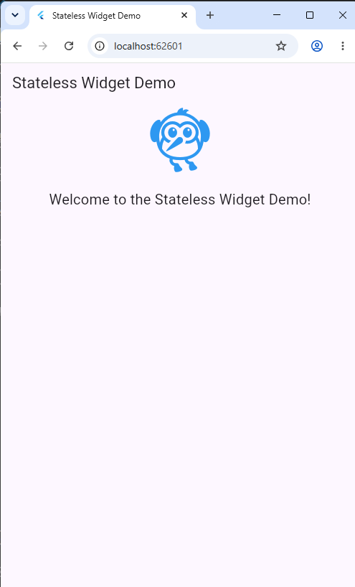
main.dart

import 'package:flutter/material.dart';
import 'pages/homepage.dart';

void main() {
runApp(const MainApp());
}

class MainApp extends StatelessWidget {
const MainApp({super.key});

@override
Widget build(BuildContext context) {
return const MaterialApp(
debugShowCheckedModeBanner: false,
title: 'Stateless Widget Demo',
home: HomePage()
);
}
}

homepage.dart

import 'package:flutter/material.dart';

class HomePage extends StatelessWidget {
const HomePage({super.key});

@override
Widget build(BuildContext context) {
return Scaffold(
appBar: AppBar(
title: Text('Stateless Widget Demo'),
),
body: Center(
child: WelcomeWidget(),
),
);
}
}

// Custom Stateless Widget

class WelcomeWidget extends StatelessWidget {
const WelcomeWidget({super.key});

@override
Widget build(BuildContext context) {
return Column(children: [
Icon(Icons.flutter_dash, size: 100, color: Colors.blue),

SizedBox(height: 20),

Text(
'Welcome to the Stateless Widget Demo!',
style: TextStyle(fontSize: 20),
)

],
);
}

}

A Stateful Widget is a widget whose user interface can change during the execution of an application. It stores mutable data (state) and updates the UI whenever the state changes using the setState() method.

Characteristics
- Maintains mutable state
- UI changes dynamically based on user interaction
- Uses the setState() method to rebuild the widget
- Suitable for interactive applications
Examples:
- Counter App
- Login Form
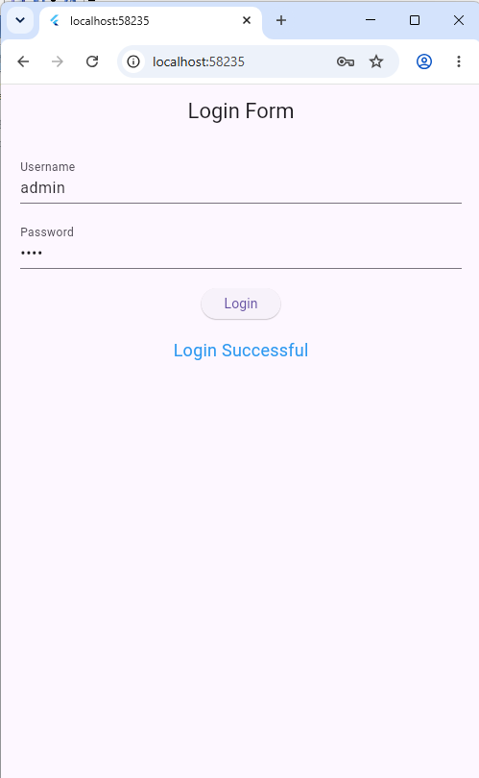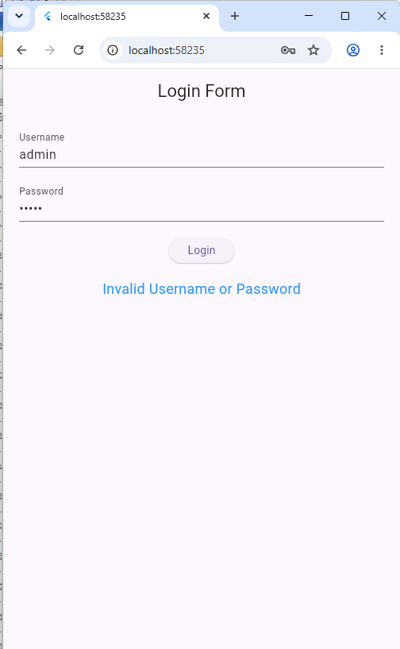
main.dart

import 'package:flutter/material.dart';

void main() {
runApp(const MyApp());
}

// Root Widget
class MyApp extends StatelessWidget {
const MyApp({super.key});

@override
Widget build(BuildContext context) {
return const MaterialApp(
debugShowCheckedModeBanner: false,
home: LoginPage(),
);
}
}

loginpage.dart

import 'package:flutter/material.dart';
// Stateful Widget
class LoginPage extends StatefulWidget {
const LoginPage({super.key});

@override
State<LoginPage> createState() => _LoginPageState();
}

class _LoginPageState extends State<LoginPage> {

String message = "";

final TextEditingController usernameController =
TextEditingController();

final TextEditingController passwordController =
TextEditingController();

void login() {

if (usernameController.text == "admin" &&
passwordController.text == "1234") {

setState(() {
message = "Login Successful";
});

} else {

setState(() {
message = "Invalid Username or Password";
});

}
}

@override
Widget build(BuildContext context) {

return Scaffold(

appBar: AppBar(
title: const Text("Login Form"),
centerTitle: true,
),

body: Padding(
padding: const EdgeInsets.all(20),

child: Column(

children: [

TextField(
controller: usernameController,
decoration: const InputDecoration(
labelText: "Username",
),
),

const SizedBox(height: 20),

TextField(
controller: passwordController,
obscureText: true,
decoration: const InputDecoration(
labelText: "Password",
),
),

const SizedBox(height: 20),

ElevatedButton(
onPressed: login,
child: const Text("Login"),
),

const SizedBox(height: 20),

Text(
message,
style: const TextStyle(
fontSize: 18,
color: Colors.blue,
),
)

],
),
),
);
}
}

