1 | Develop a Laravel Web Application Based on the Following Instructions: A. Project Setup
A.Create a folder for your Laravel project.
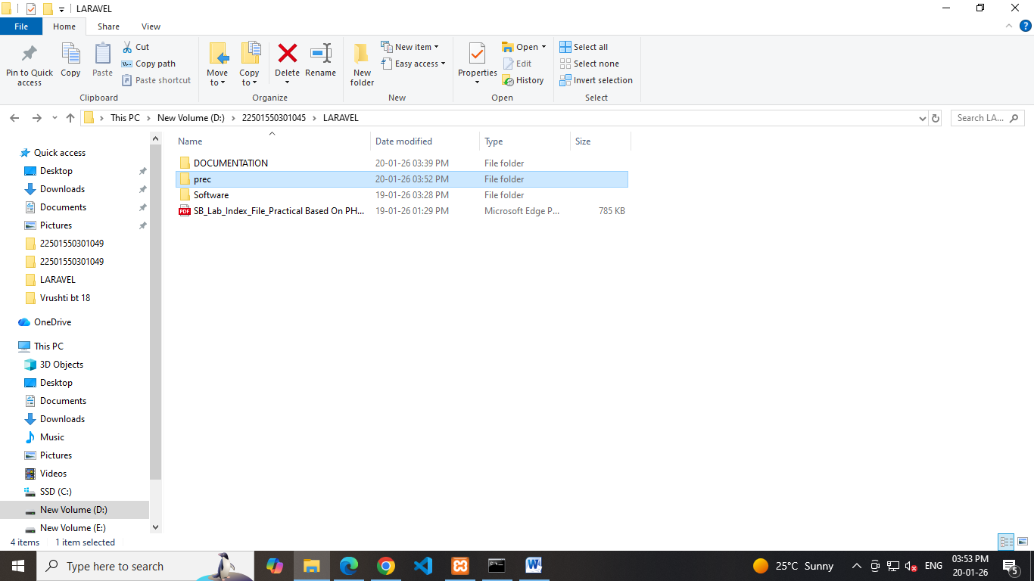

Open the terminal in that folder.
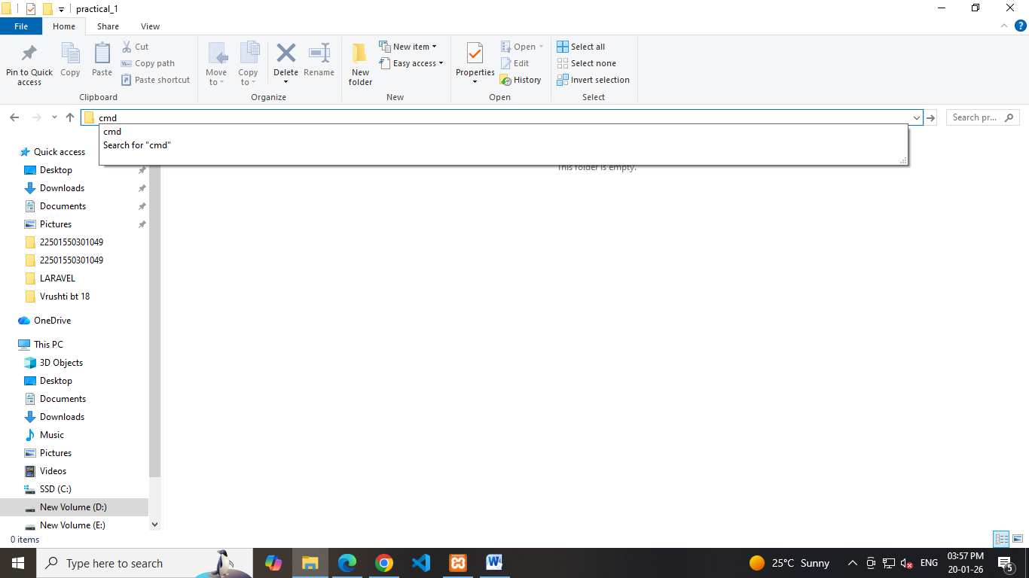

B. Create a Laravel Project
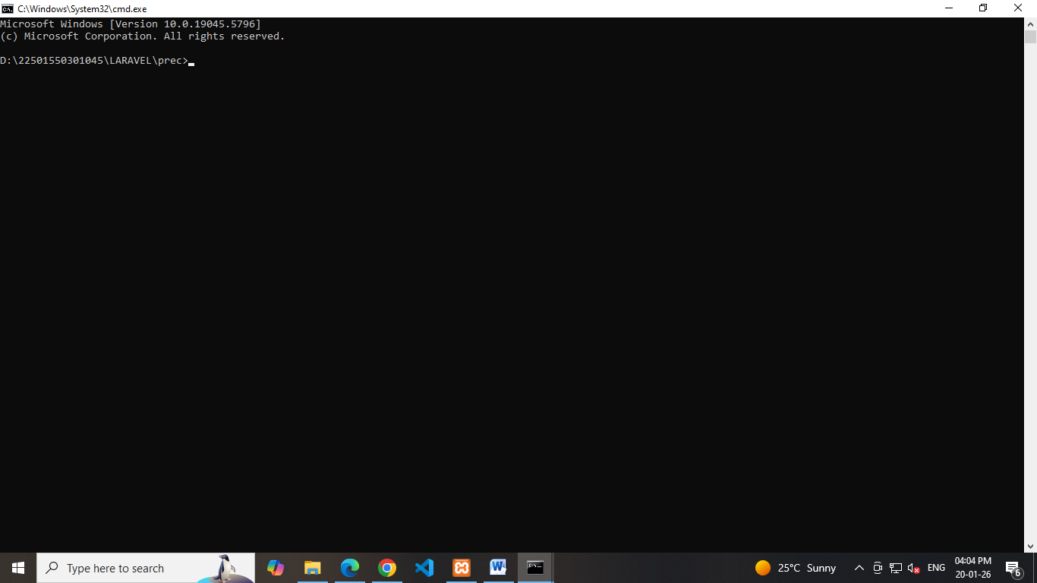
Create a Laravel project using the terminal with a project name.
Choose “None” for the starter kit and press enter for default options.
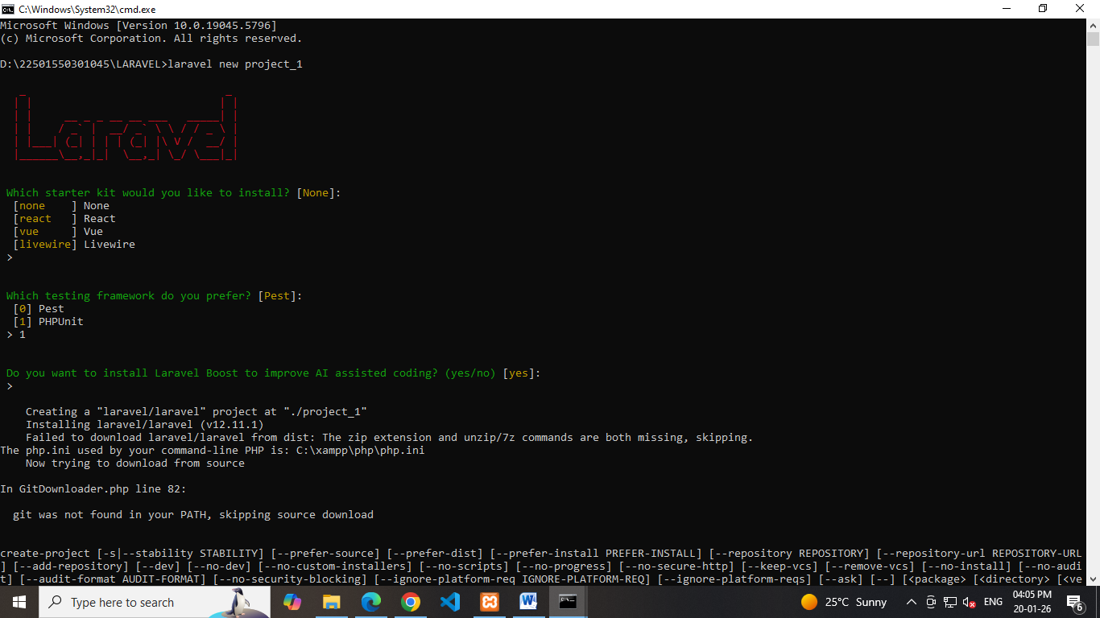
Select MySQL as the database.
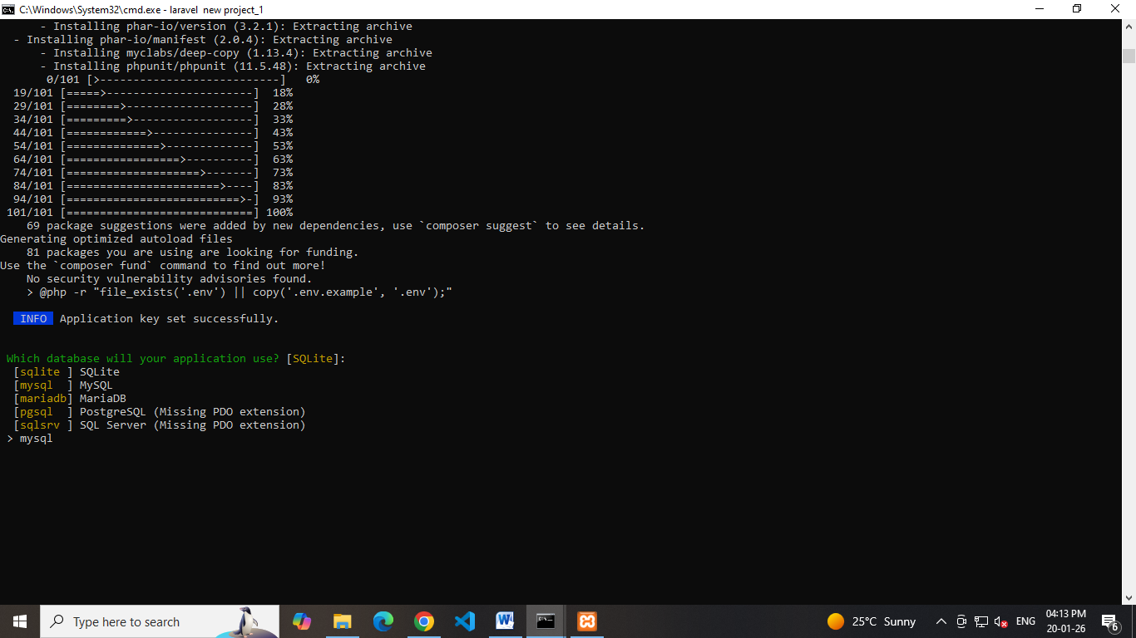
C. Build and Serve the Application
Move into the project directory.
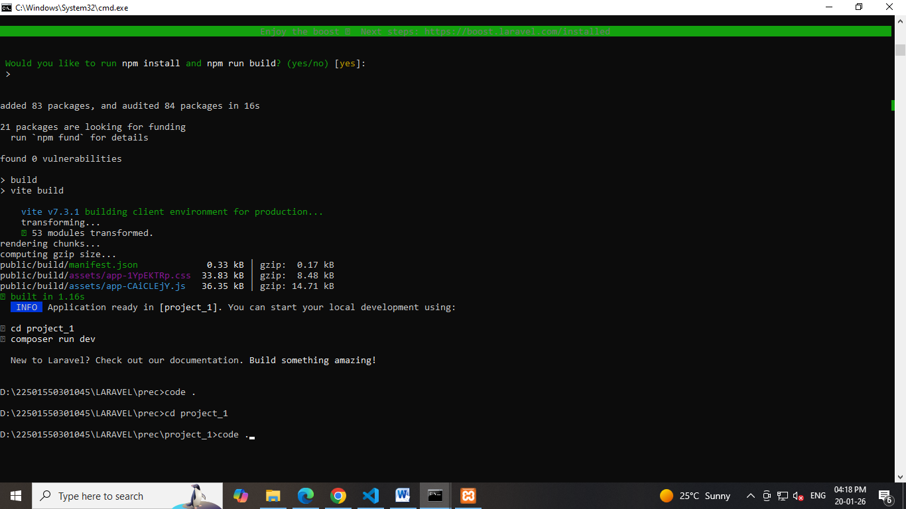
Run the necessary NPM and Artisan commands to serve the application
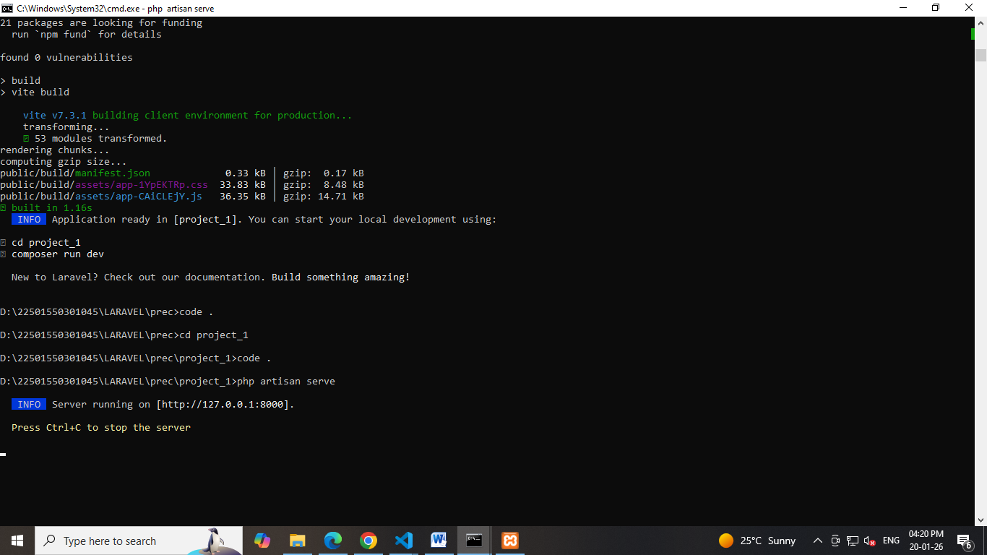

Modify the Welcome Page
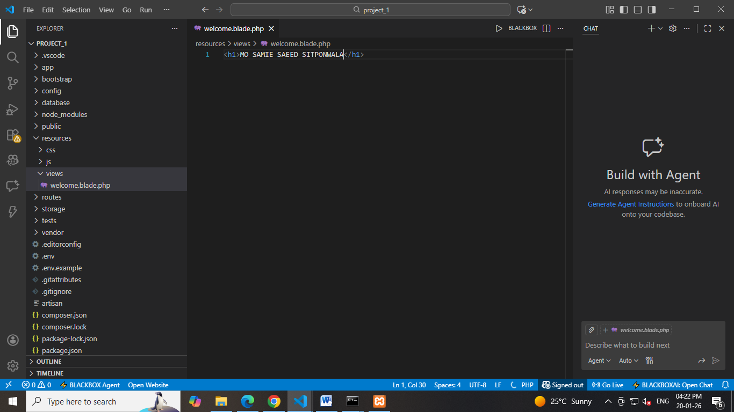

Open welcome.blade.php and display your full name.
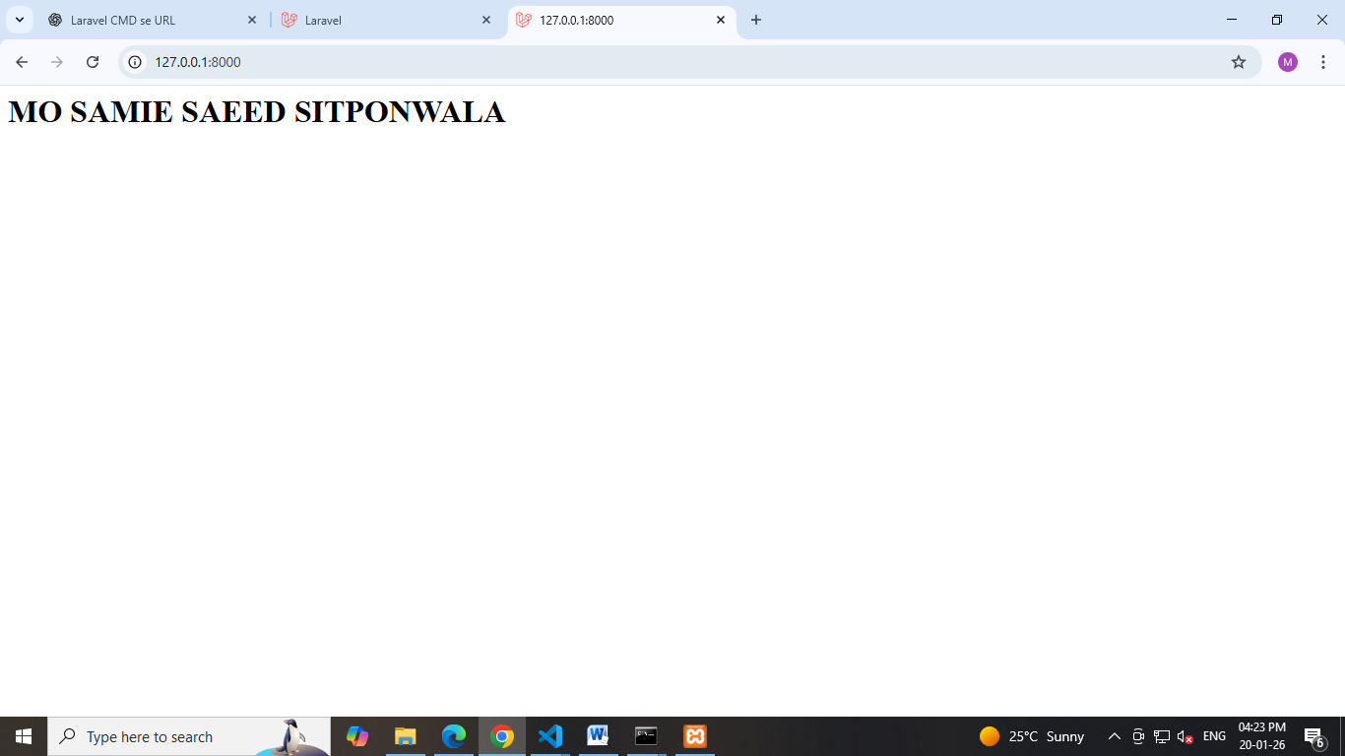

E. Create a New Blade View
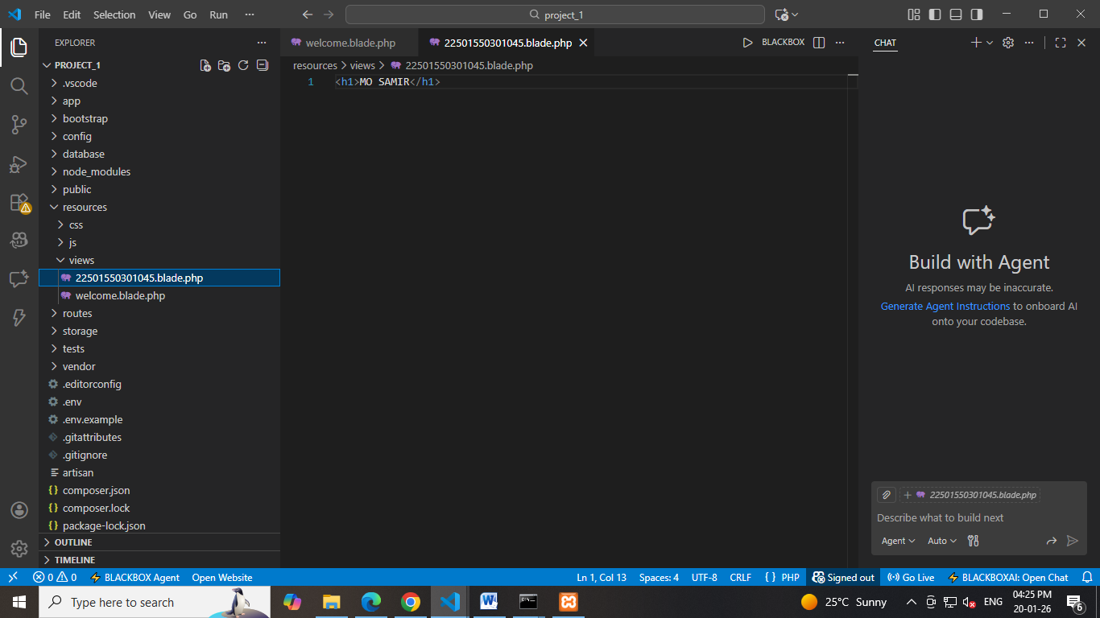
Display any custom heading in it.
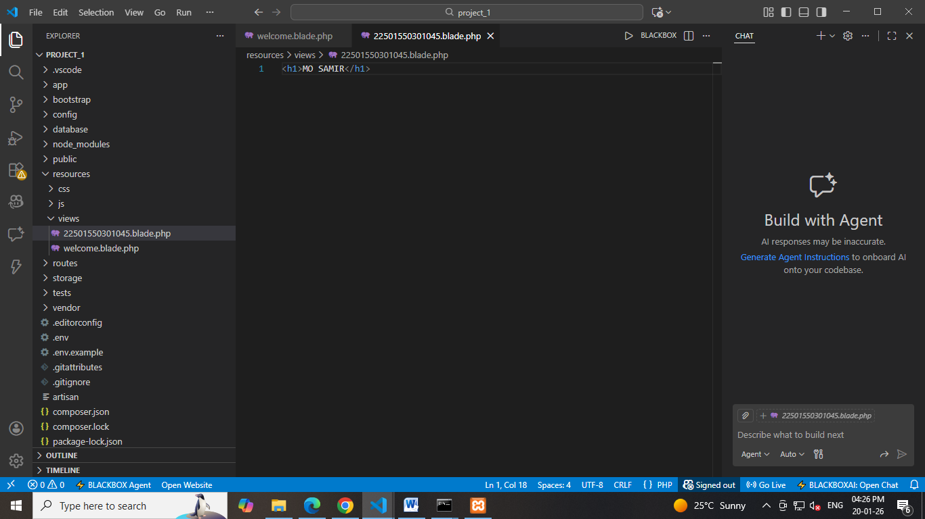

F. Update Routes
Define a route in web.php to load the new view when /home is accessed.
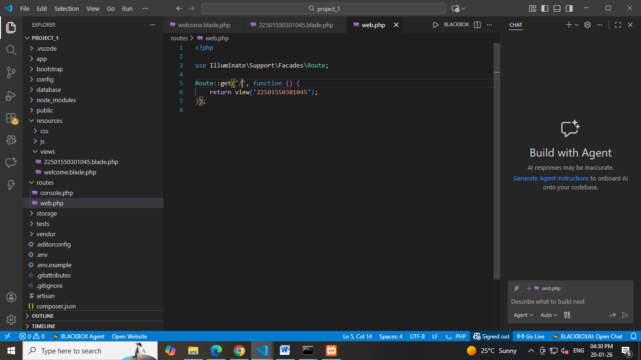
Set this route to replace the default / route if needed.
