Perform the Following Tasks Related to Laravel Routing:
A .Routing Basics.
- Create a Blade view file and display content via a defined route.
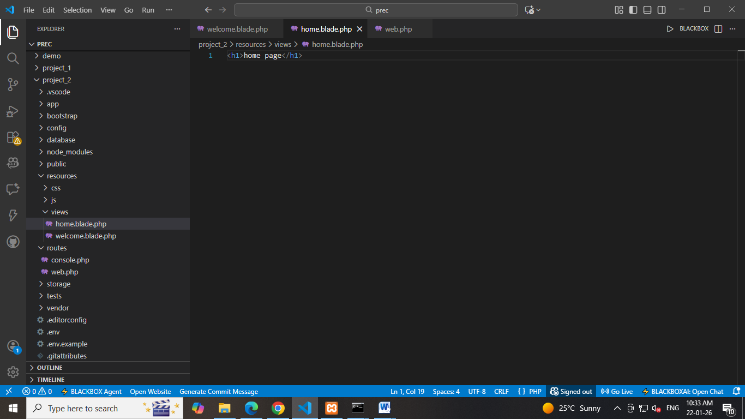

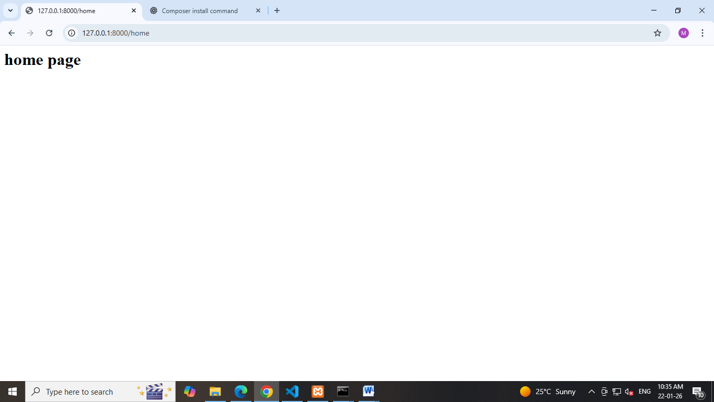

- Define Routes
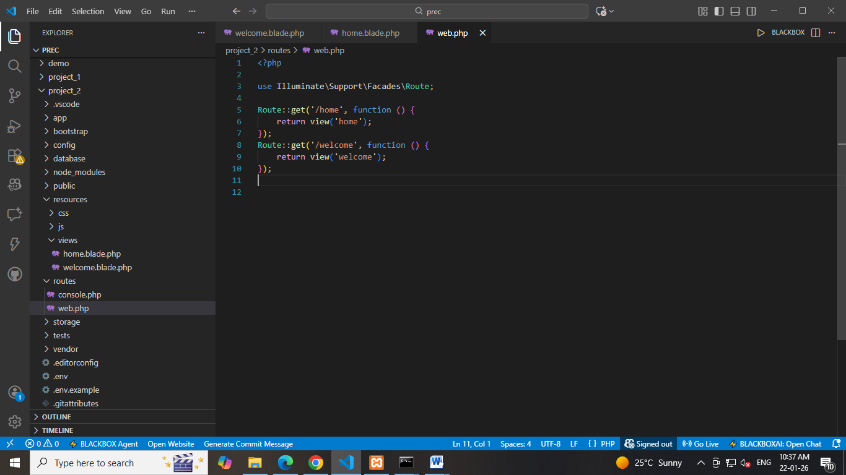

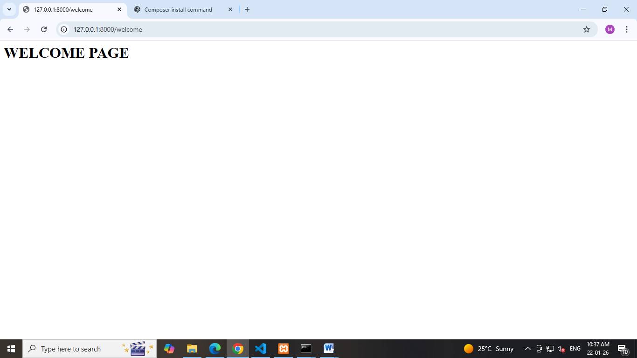

- Define a basic route using Route::get() method.
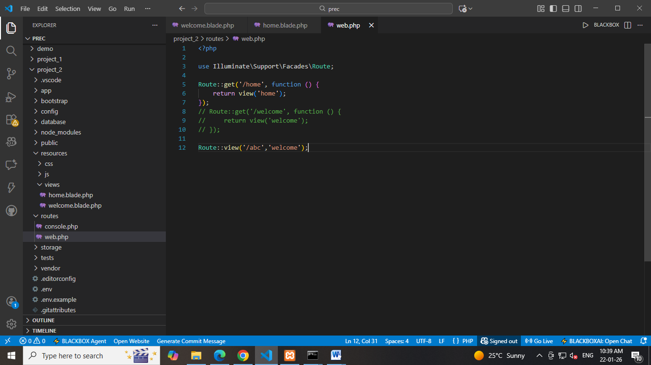

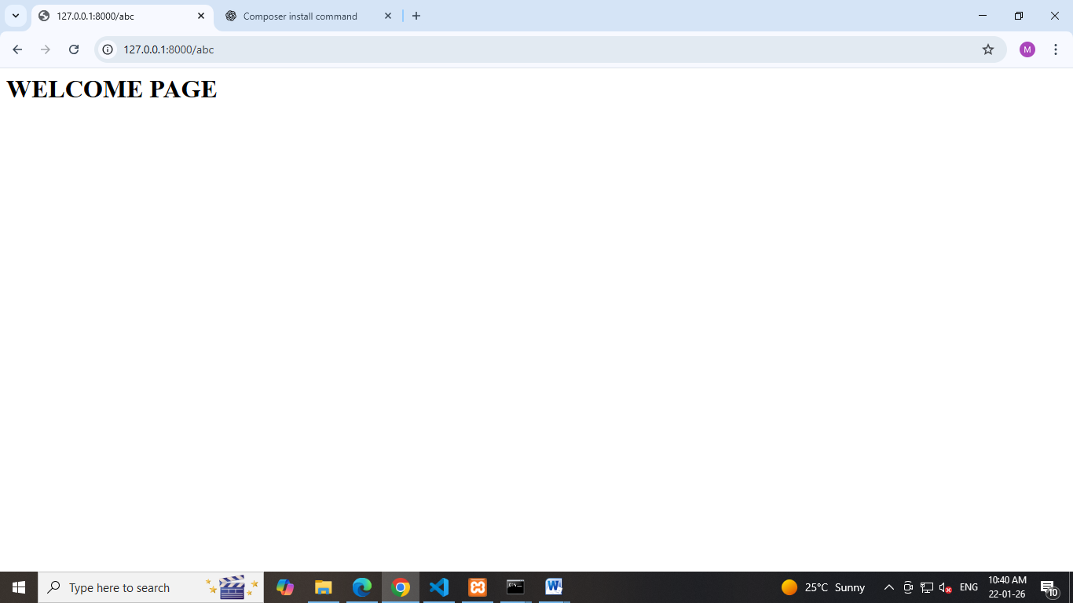

- Pass Data via Routes
- Create a route that accepts a parameter (e.g., /about/{name}).
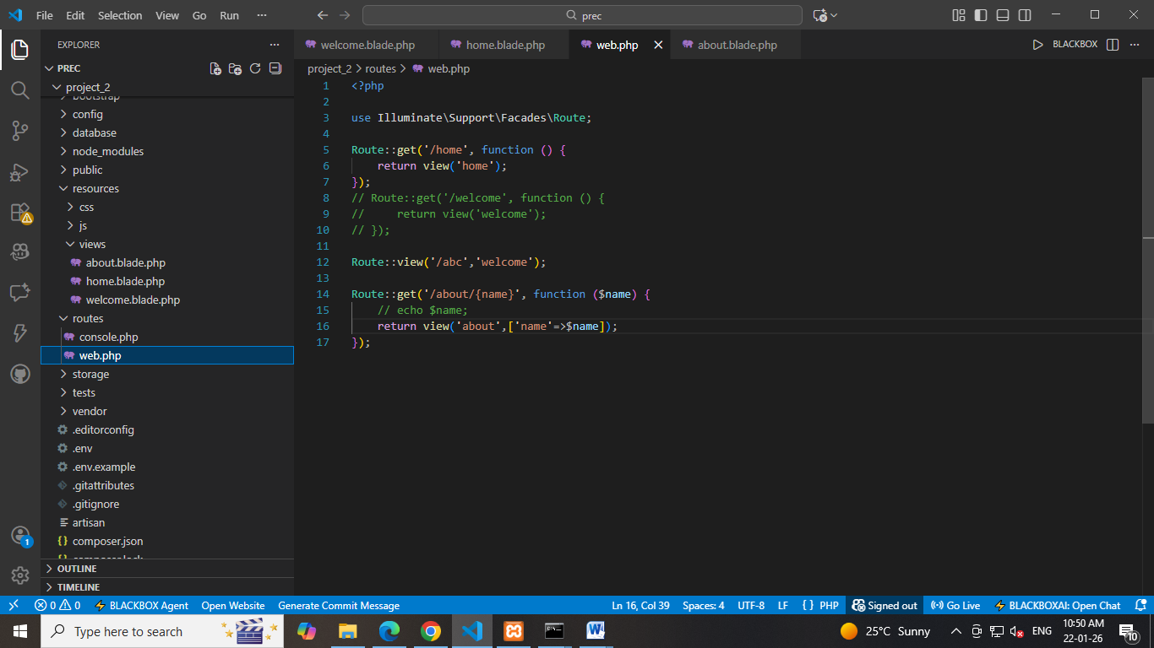

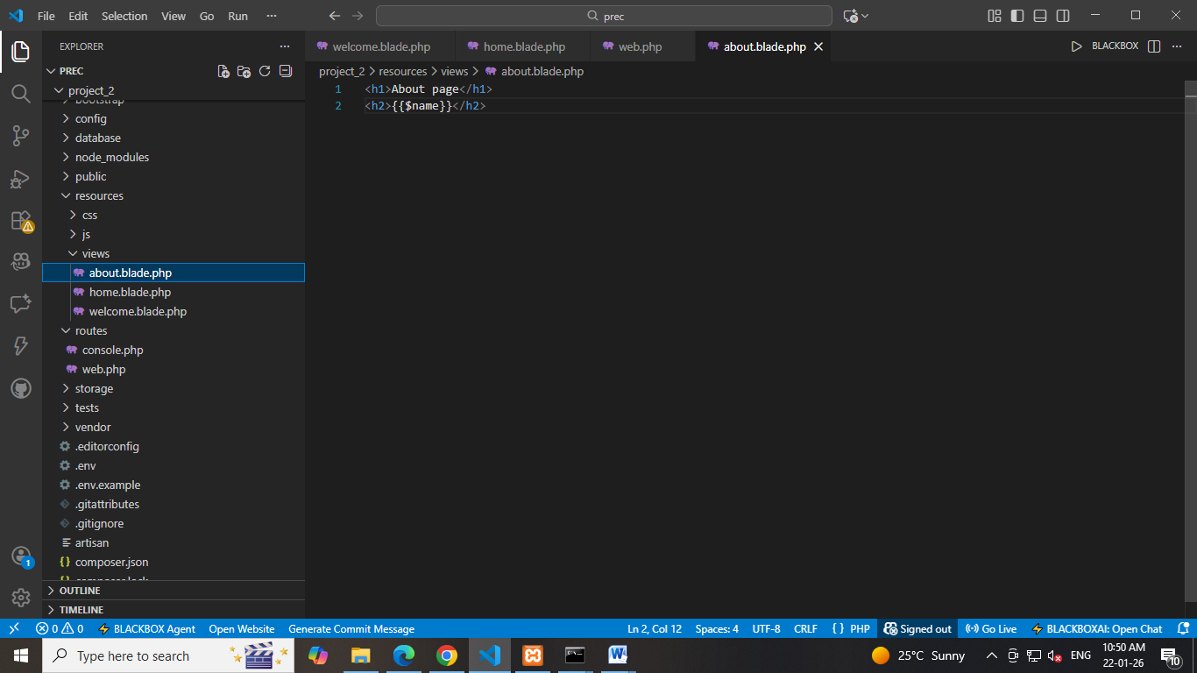

- Pass and display this parameter in a Blade view using Blade syntax.
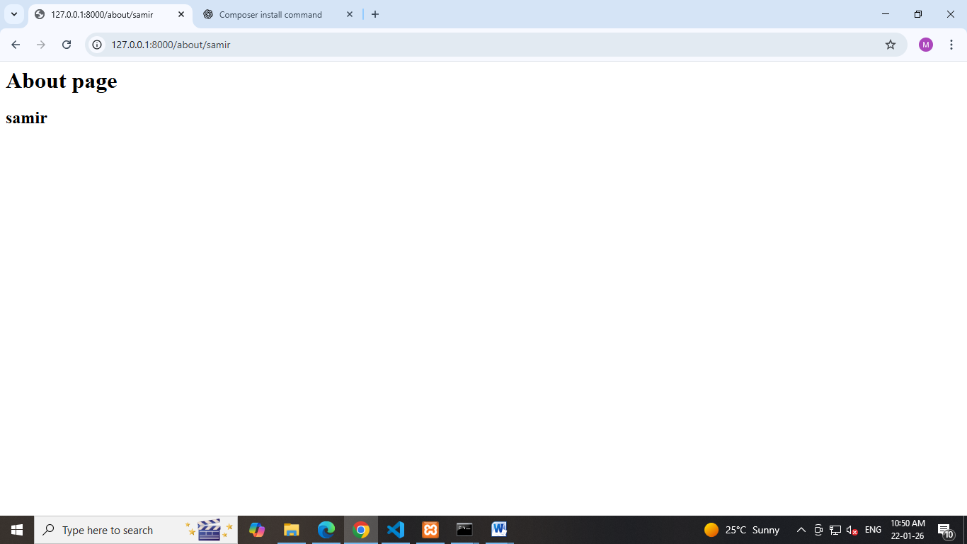

- Anchor Tag with Routing
- Add anchor () tags inside a Blade view to link to other defined routes.
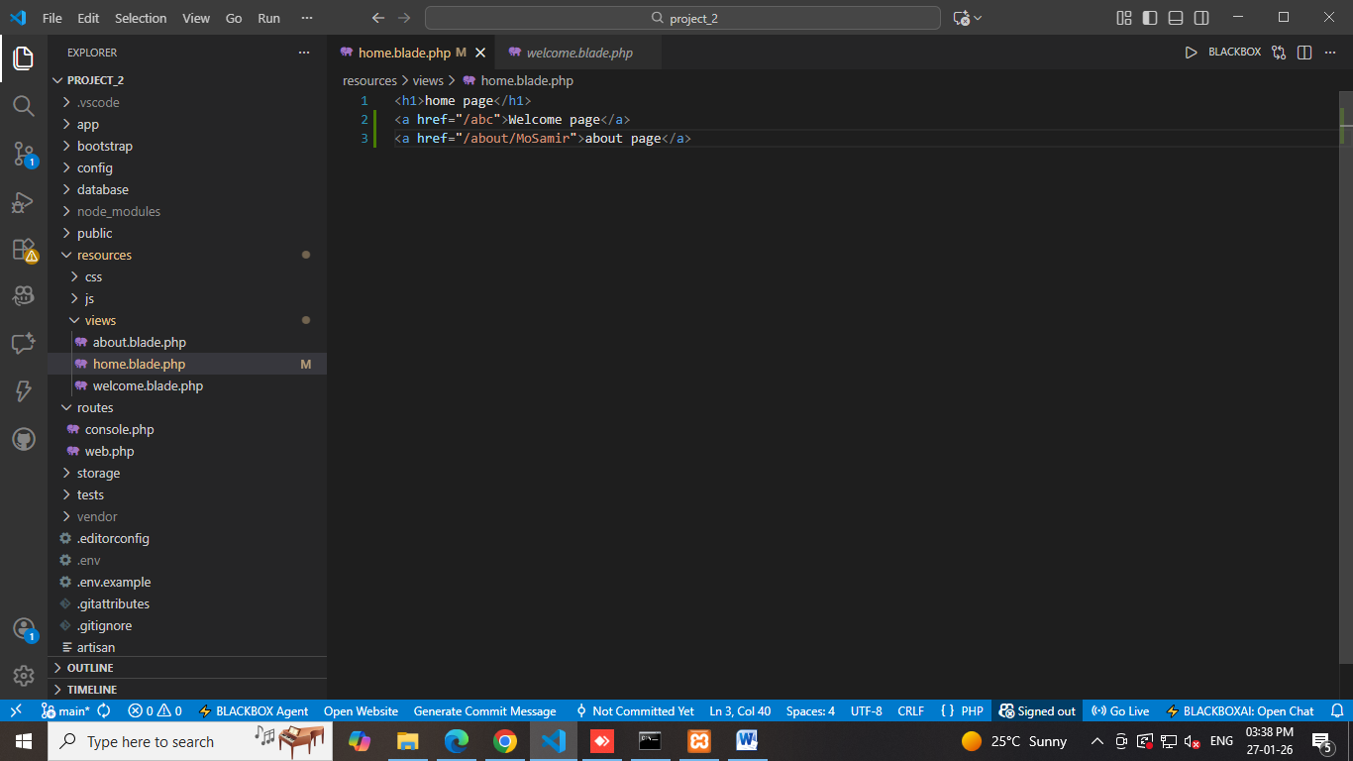

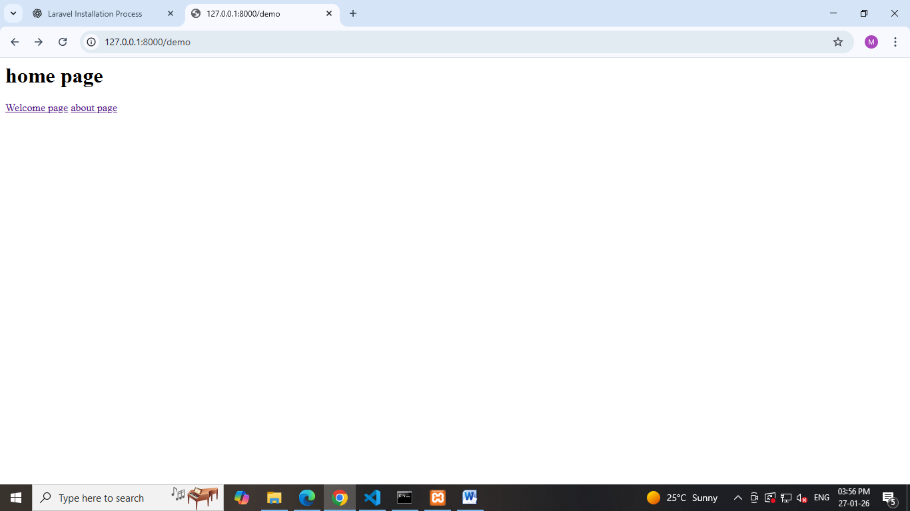

- Redirection
- Create a route that redirects from one path to another using redirect().
