PROJECT 1
- Develop a Laravel Web Application Based on the Following Instructions:
A. Project Setup
- Create a folder for your Laravel project.
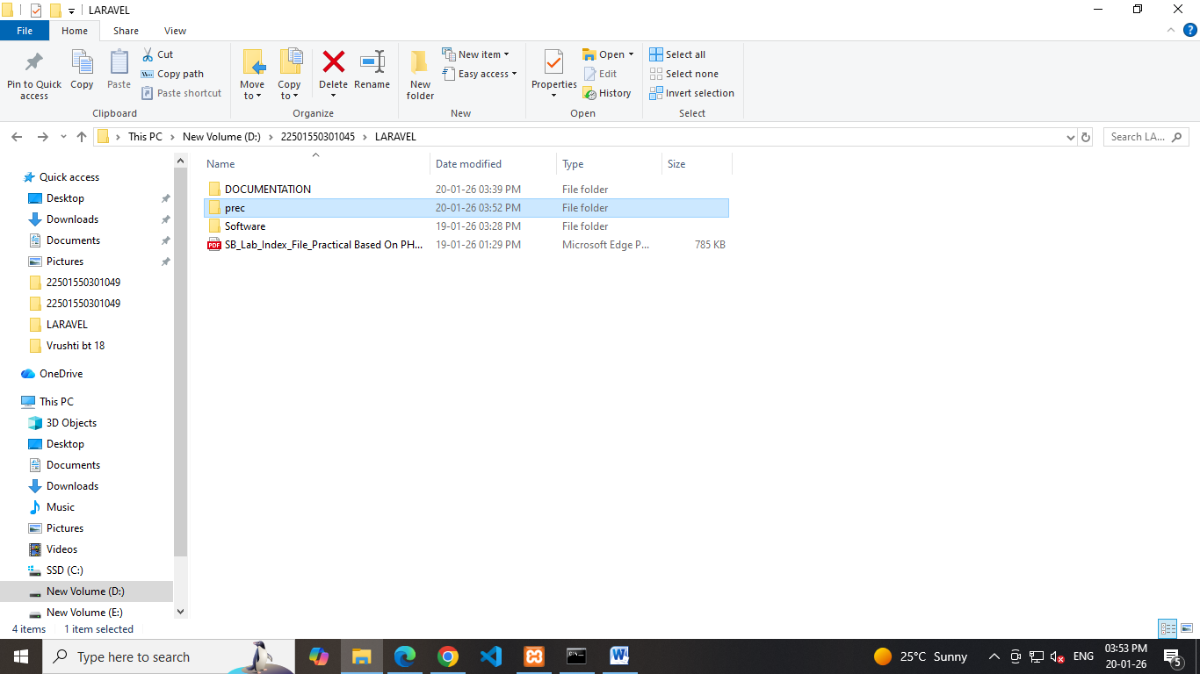
- Open the terminal in that folder.
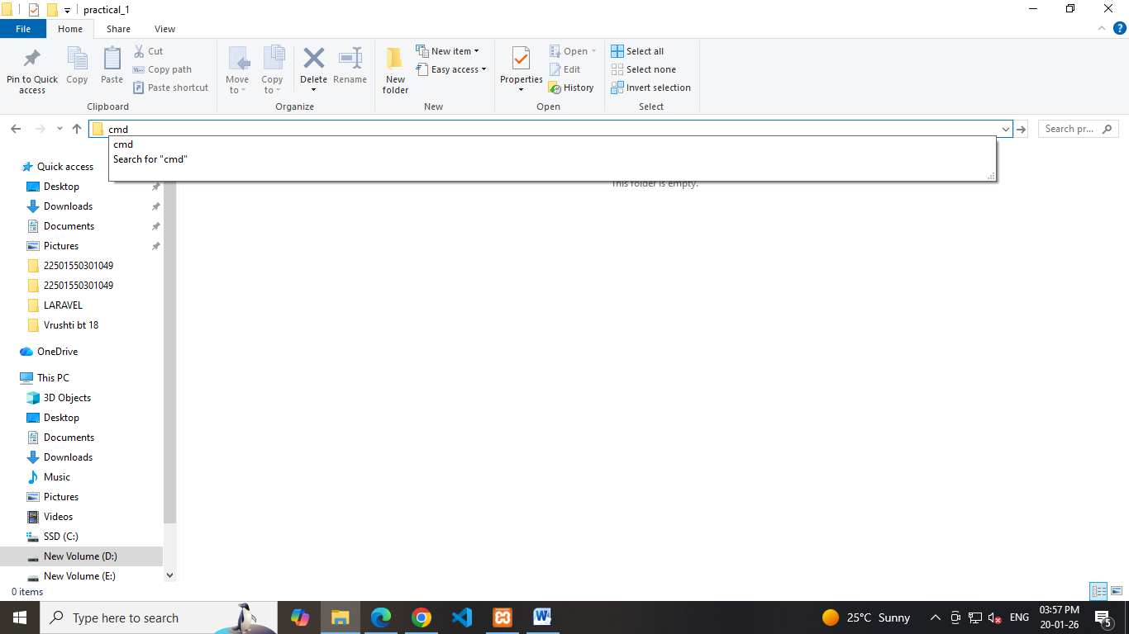

B. Create a Laravel Project
- Create a Laravel project using the terminal with a project name.
- Choose “None” for the starter kit and press enter for default options.
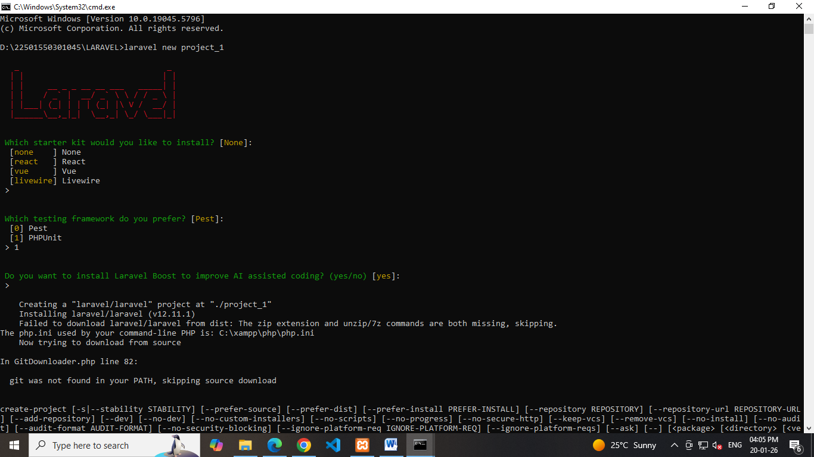

- Select MySQL as the database.
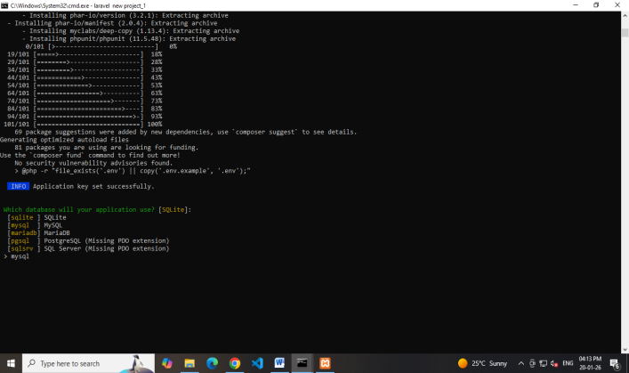
C. Build and Serve the Application
Move into the project directory.
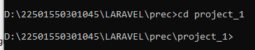

Run the necessary NPM and Artisan commands to serve the application.
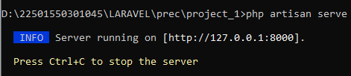

D. Modify the Welcome Page.
Open welcome.blade.php and display your full name.
