- WHAT IS MIDDLEWARE GROUP?
- HOW TO REGISTER MIDDLEWARE IN A GROUP?
- APPLY A GROUP OF MIDDELWARE TO ROUTE GROUP.
- APPLY TO GROUP OF MIDDLEWARE TO SINGLE ROUTE.

MIDDLEWARE GROUP
- MIDDLEWARE CAN APPLY ON A SINGLE ROUTE.
- MIDDLEWARE APPLY A GROUP ROUTE
- MIDDLEWARE APPLY ON ALL ROUTE


Create the view and home file.
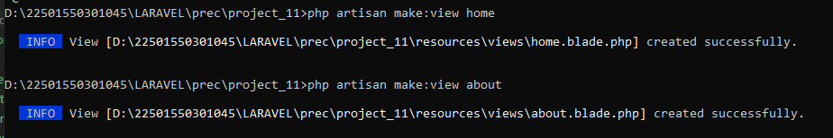

Web.php
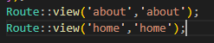
We create middleware:
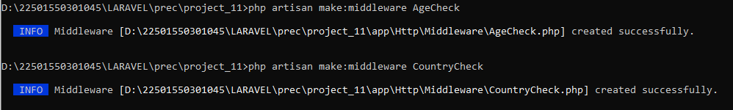

App.php
Include both middleware
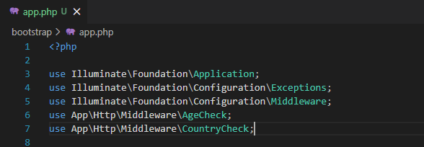
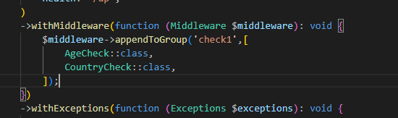
Now register the middleware in a group
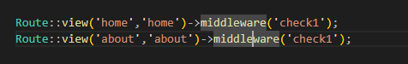
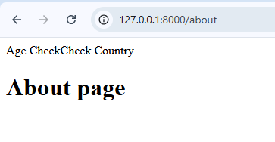
Country check code:
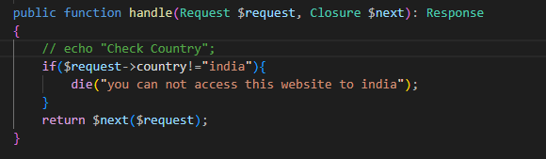

Age check code:
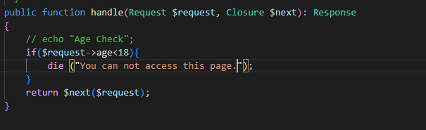

Apply a group of Group middleware to Route group:
Without middleware:
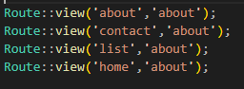

Using middleware condition:
