- Make middleware
- Make routes
- Apply middleware on the route
- Apply multiple middleware on route

- Make middleware
- php artisan make:middleware AgeCheck
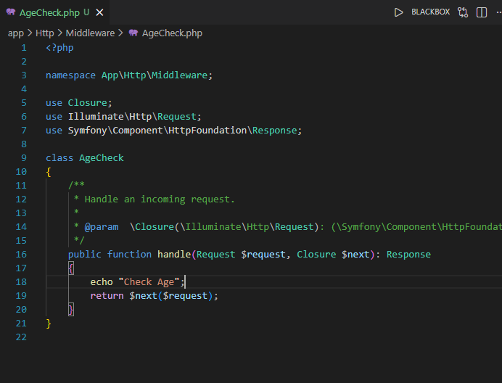
Note : we do not require the register of this middleware (route middleware) like global middleware and group middleware in app file.directly we import like below code.
Web.php
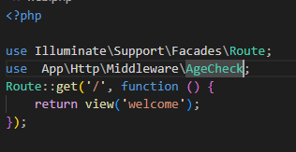
Now we create the 02 view (home and about)
Create home:
Create about:
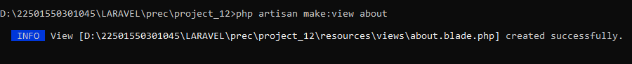
Now we apply the middlewarein home.vlade.php file.
Create country chech middleware:
Country middleware:
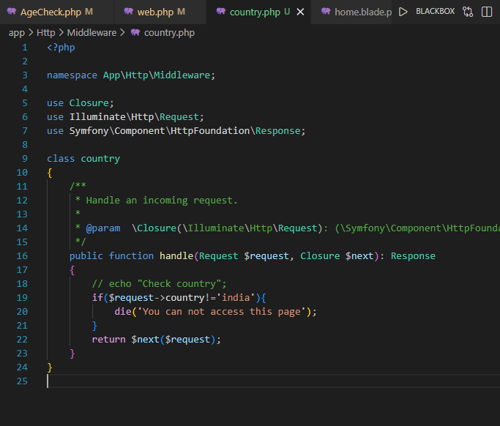
Multiple middleware call:
