- What is named Routes?
- How to make a named route?
- How to use named route from view ?
- How to use named route controller ?
- How to pass params in named router ?

Firstly we create the view and controller
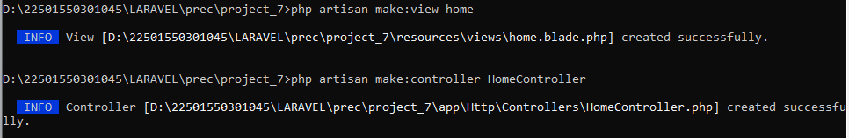
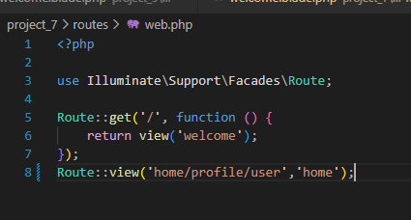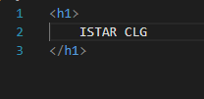
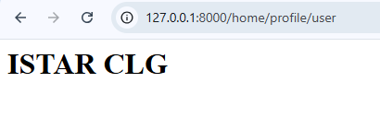
Welcome.blade.php
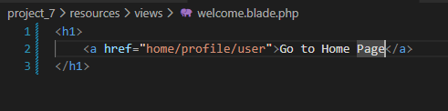
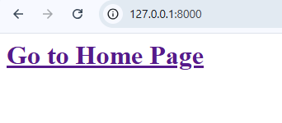
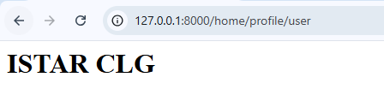
How to use the named route from view ?
Give Route name(web.php)
Welcome.blade.php
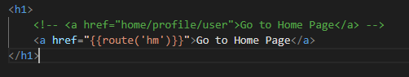

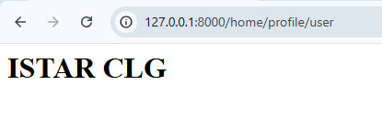
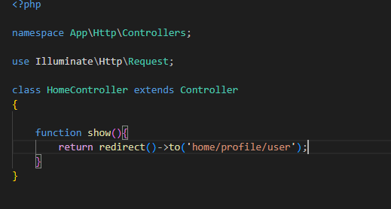
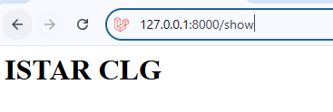
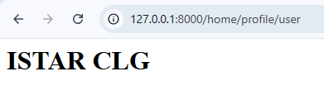
Solution:
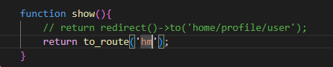
How to pass params in names route?
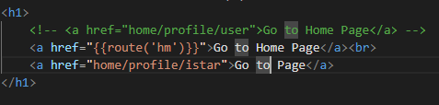
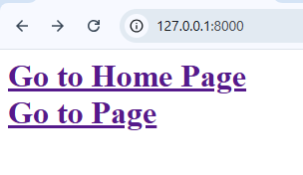

Pass dynamic data through controller
Web.php
HomeController.php
