Route group with controller
- What is route Grouping with controller ?
- Make some routes for controller
- Make route groups of controller
- Interview Question

First create the controller:

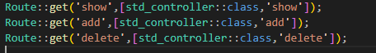
Now we create a group:
