1.what is blade template
2.expression of blade template
3.display variable
4.execute functions
5 if else
6.for loop
7 for each
1.what is blade template.
Blade is a simple yet powerful templating engine for executing php code this is included in the laravel framework .the template engine is a module or tool for executing code. We can write PHP tages also in the blade template. To use blade template view should end with the .blade.php extension.

2.Expression of blade template.
3.display variables
Web.php
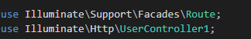
userCountroller.php
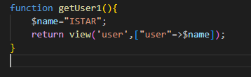
User1.blade.php
