EXERCISE:
- WHAT IS ROUTING.
- HOW TO MAKE ROUTE.
- OPEN VIEW WITH ROUTING & PASS DATA WITH ROUTING.
- ANCHOR TAG.
- REDIRECT WITH ROUTING.
- ROUTING METHODS.

- Routing Basics
- Create a Blade view file and display content via a defined route.
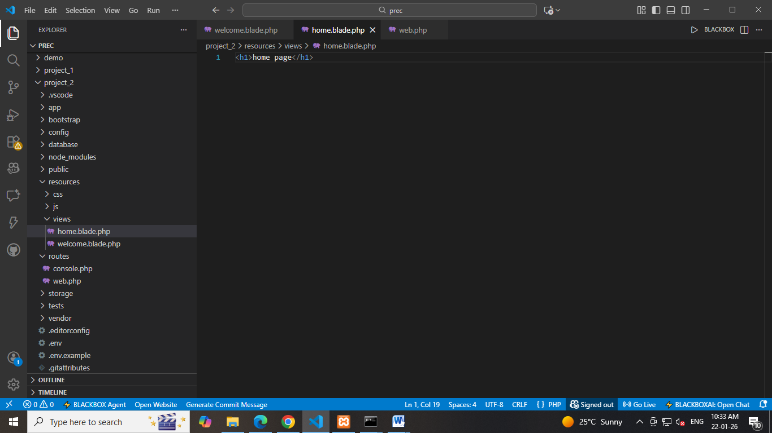
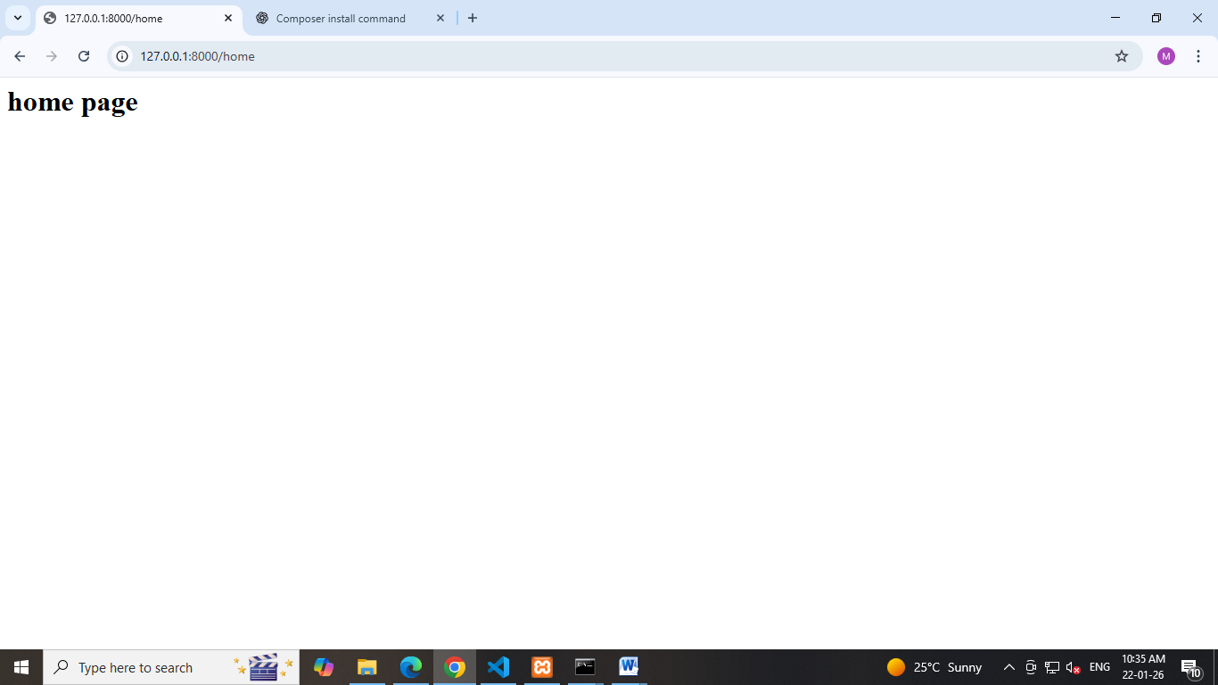
- Define Routes
- Define a basic route using Route::get() method.
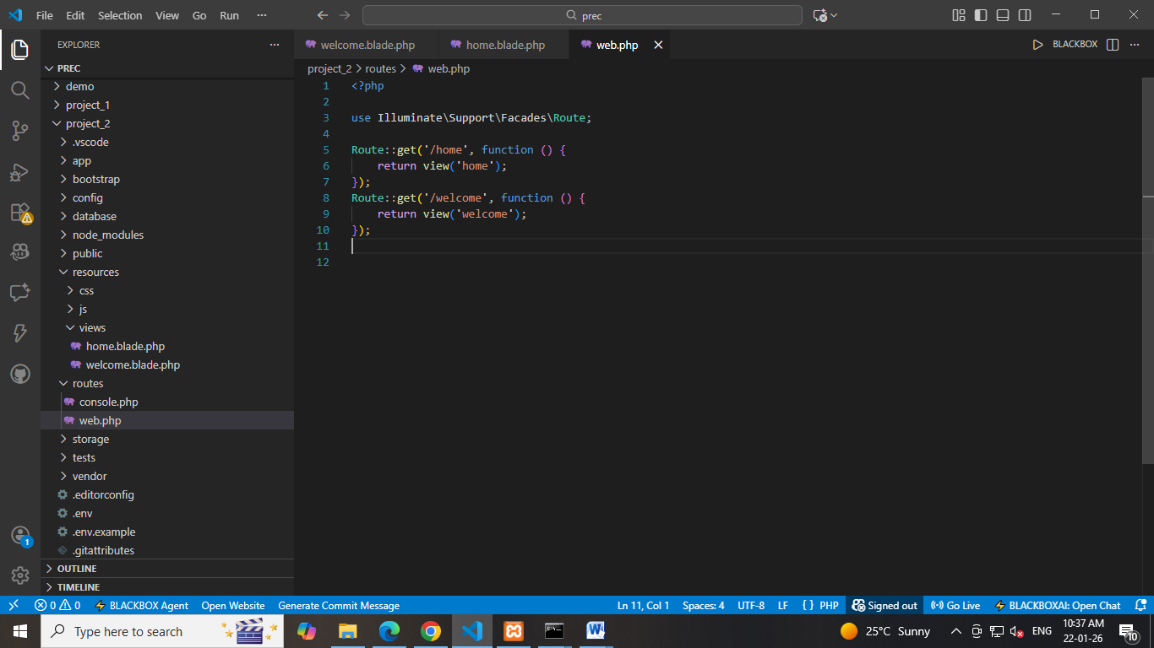
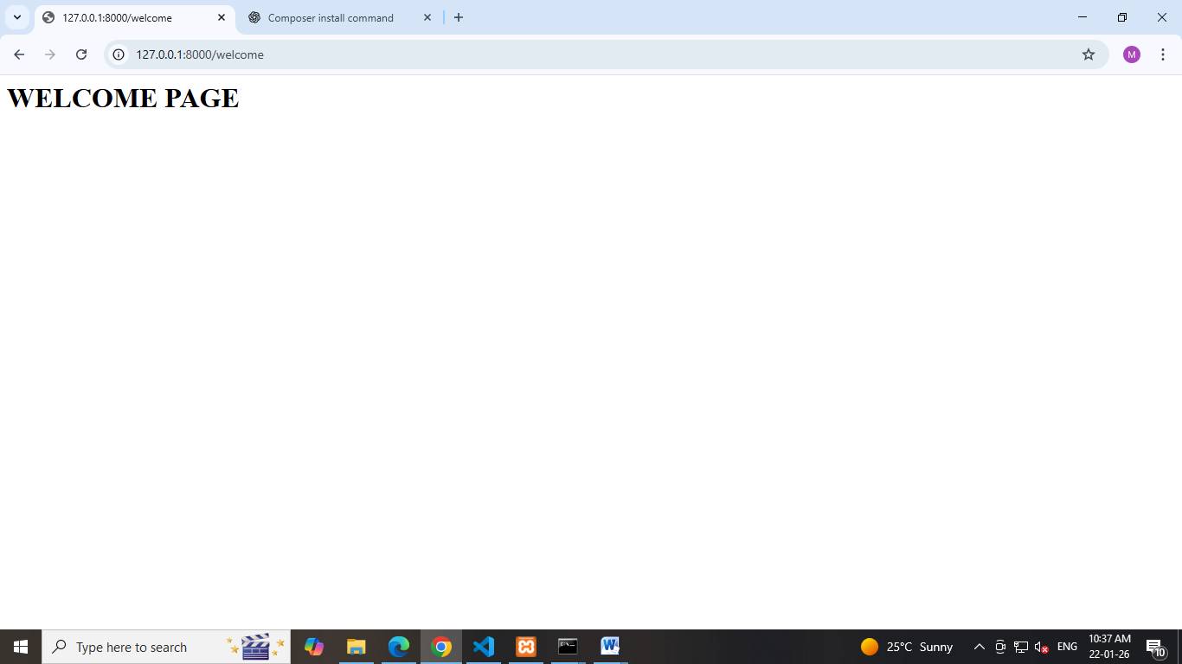

- Change the route path and access it via a browser.
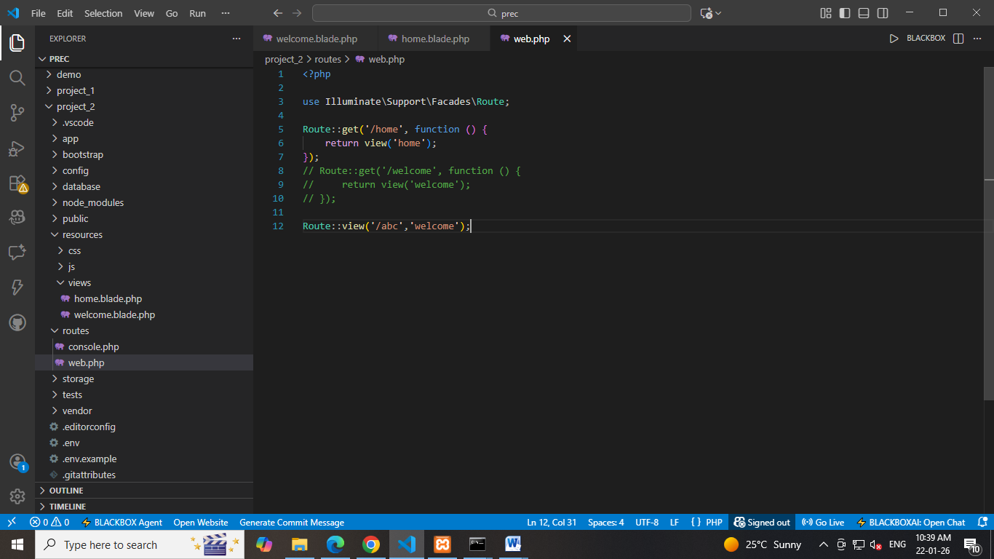
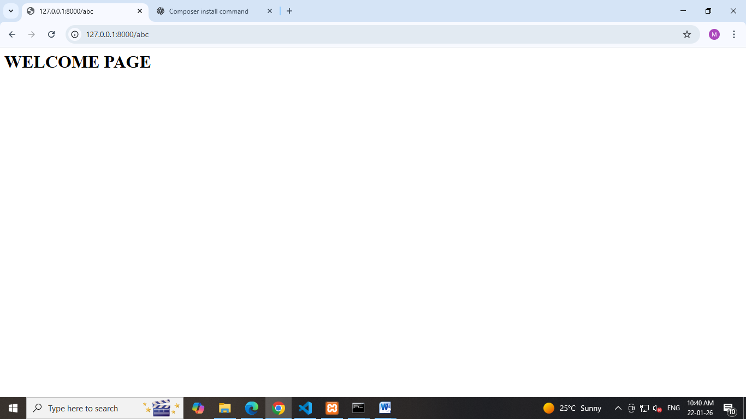

- Pass Data via Routes
- Create a route that accepts a parameter (e.g., /about/{name}).
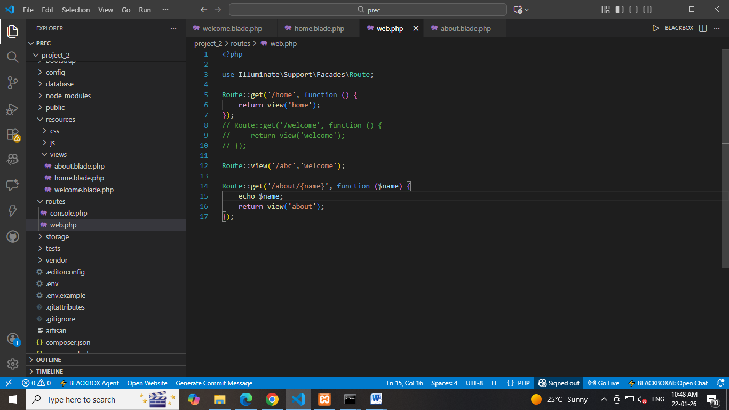
- Pass and display this parameter in a Blade view using Blade syntax.
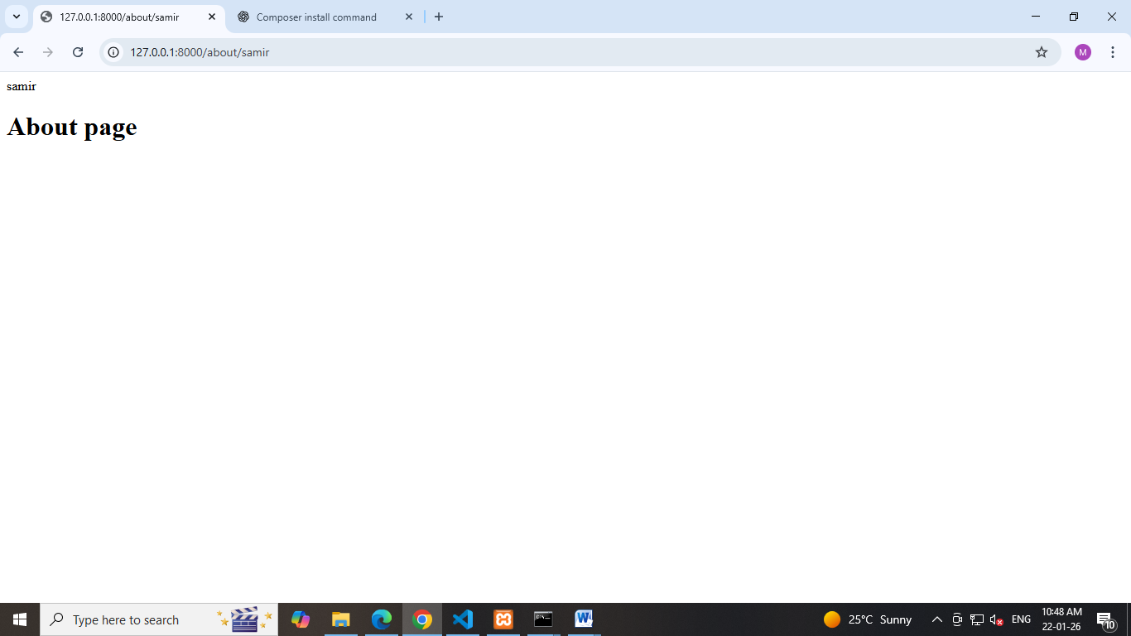

Another way:
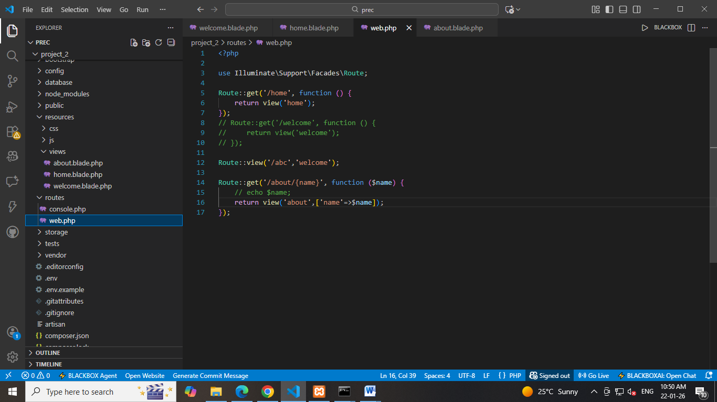
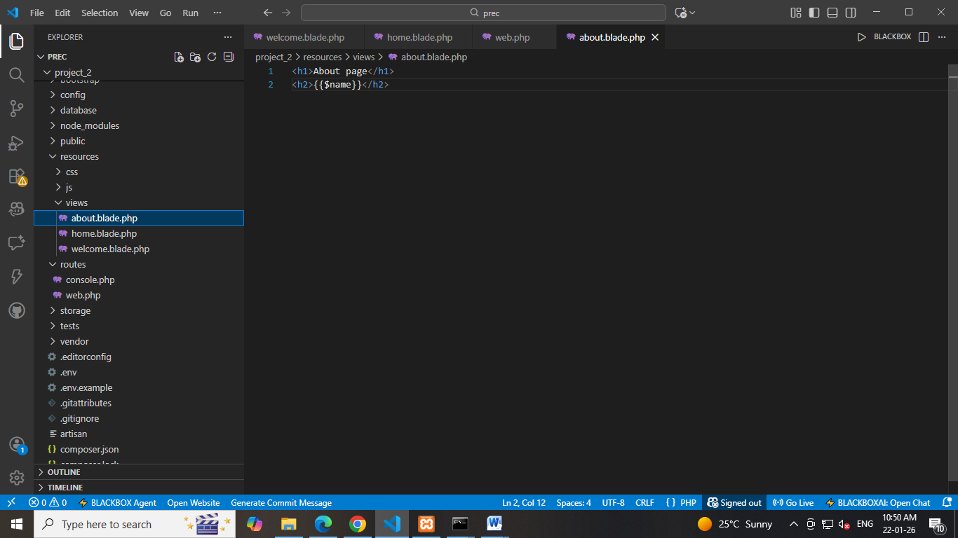
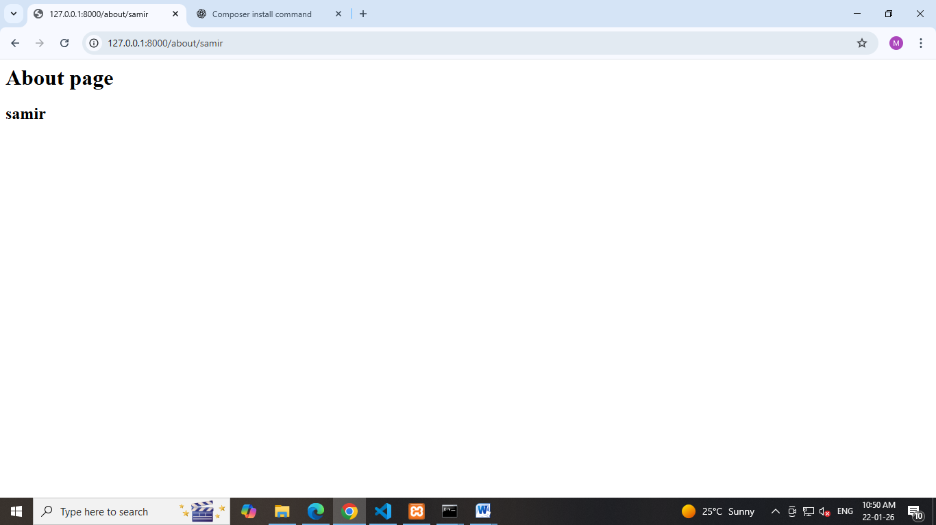

- Anchor Tag with Routing
¬ Add anchor () tags inside a Blade view to link to other defined routes
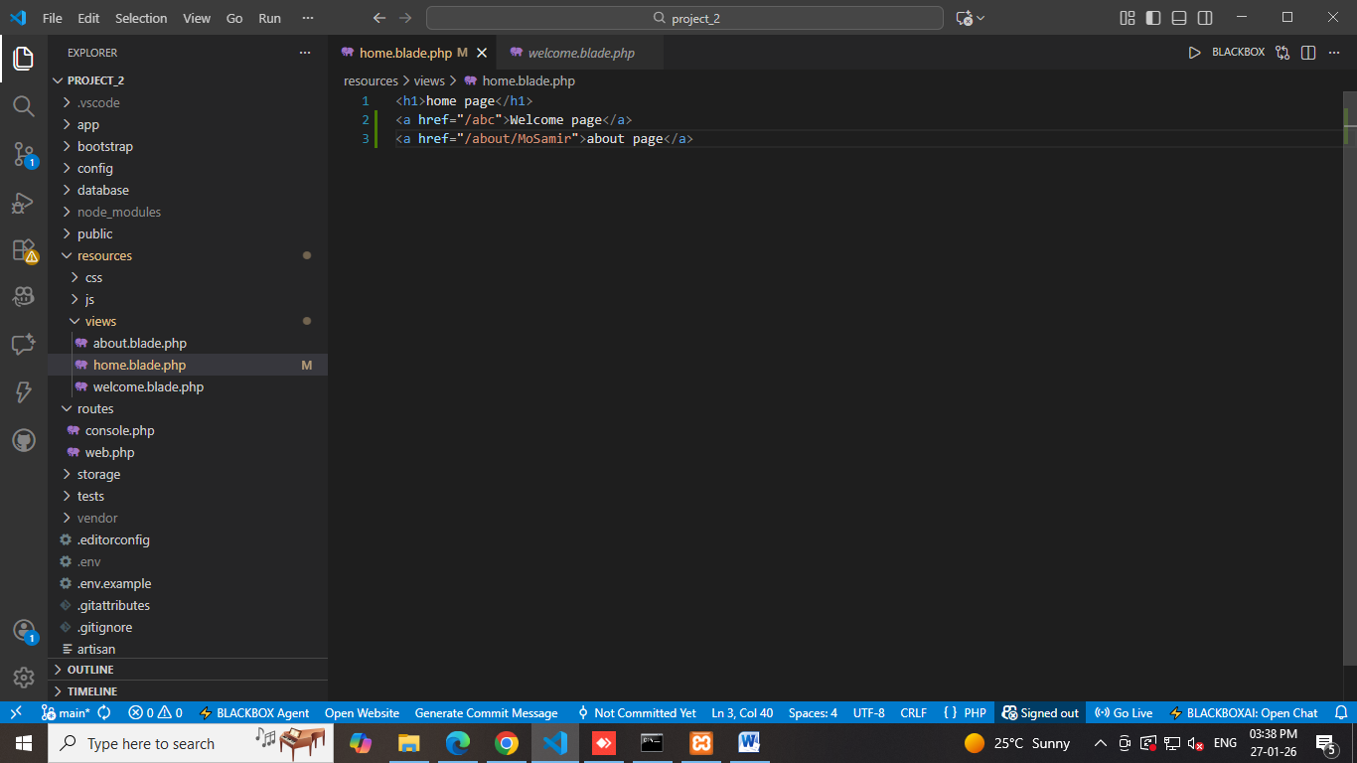

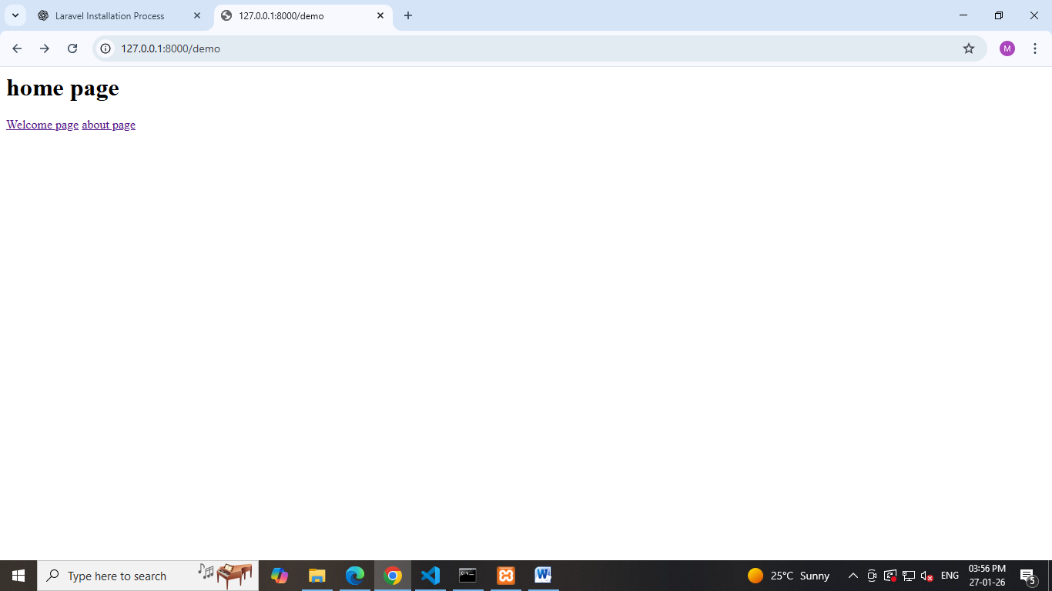

- Redirection
Create a route that redirects from one path to another using redirect().
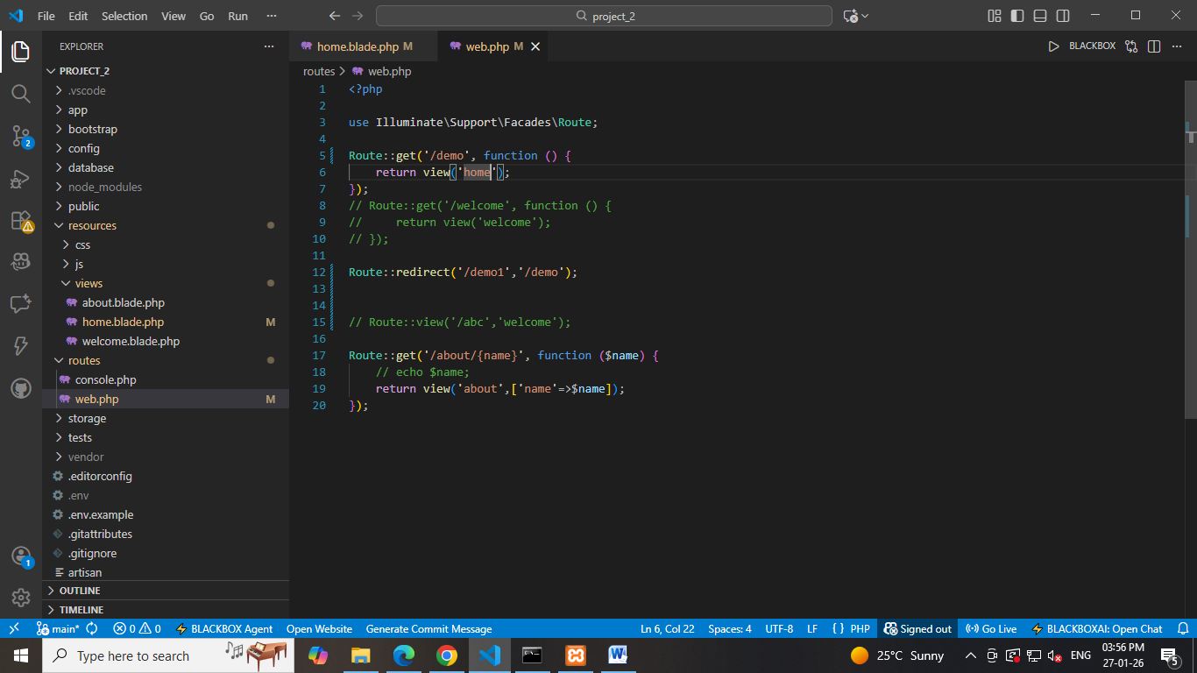

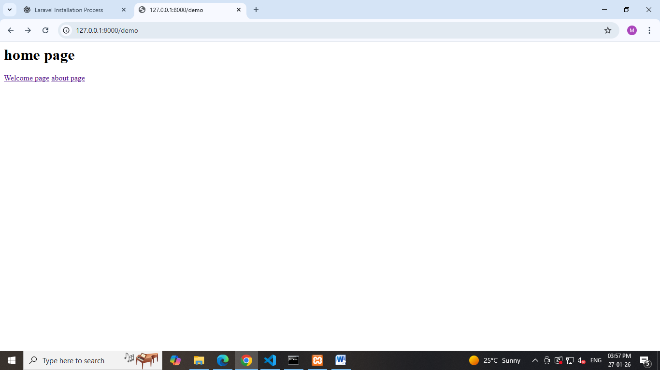

Route::get($uri,$callback);
Route::post($uri,$callback);
Route::put($uri,$callback);
Route::patch($uri,$callback);
Route::delete($uri,$callback);
Route::options($uri,$callback);
Route::view($uri,$callback);

