Including subviews in laravel
1. What is subview.
2. make subviews:
php artisan make:view common.header
php artisan make:view common.inner
php artisan make:view home1
php artisan make:view home2
php artisan make:view controller UserController1
3. use subviews
4. pass data from view to subviews
5. check if sub view exists(student side)

2&3 make subviews and use

Header.blade.php
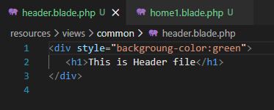
Home.blade.php
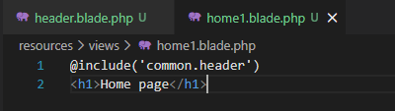
Web.php
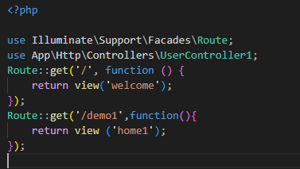
http://127.0.0.1:8000/demo1
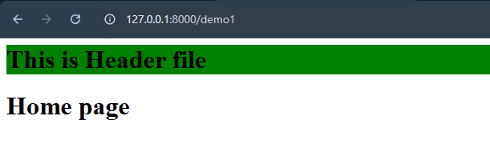
pass data from view to subviews
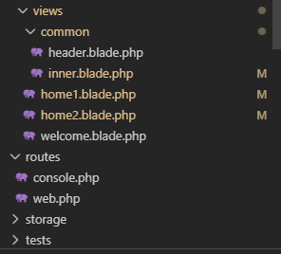

Usercontroller1.php
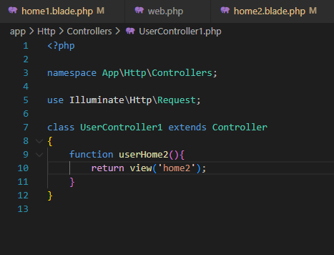
Web.php
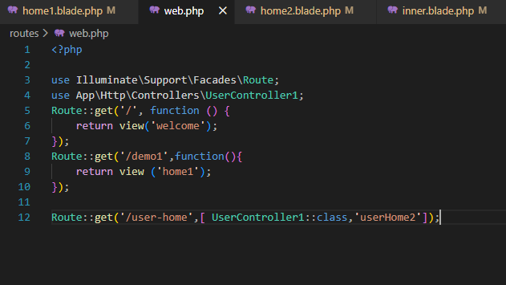
Home2
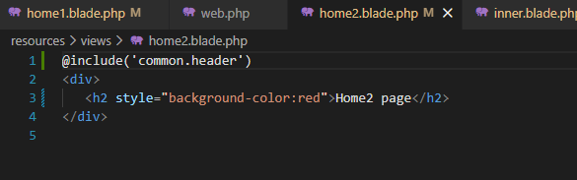

Home2.blade.php
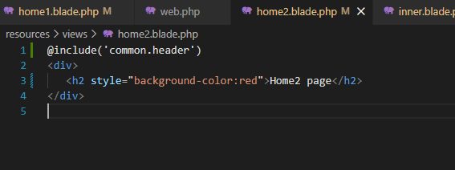
User-Home
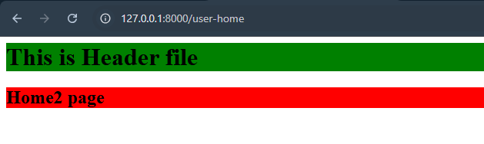
Inner.blade.php
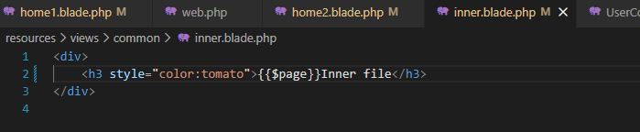
Home1.blade.php
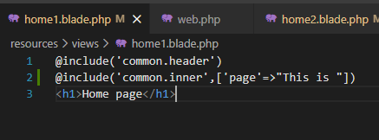
Demo1
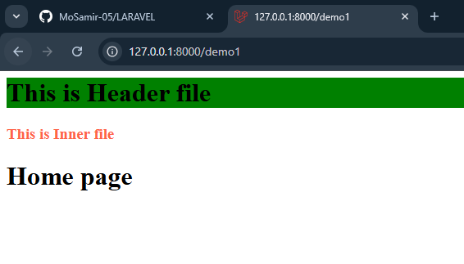
Pass data from mainview to subview
Home1.blade.php
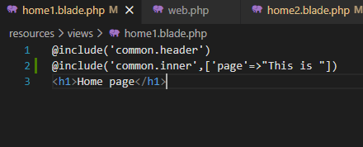
Inner.blade.php
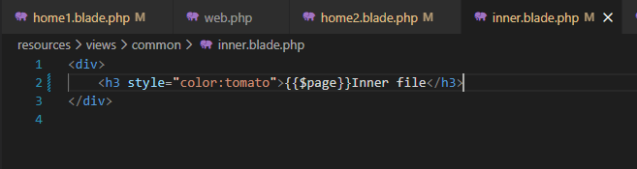
Demo1
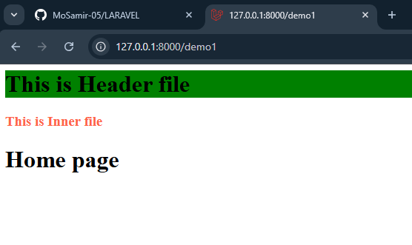
Home1.blade.php
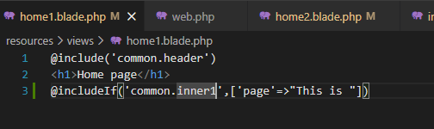
Demo1 without inner
