Advanced Library Management System
Complete Database Structure and Explanation

1 users
👉 Login users (Admin, Librarian, Student)
- id (PK)
- name
- email
- phone
- password
- role_id (FK)
- status
- created_at

2 roles
👉 User roles define karega
- id
- role_name (Admin, Librarian, Student)

3 permissions
👉 Role based access control
- id
- permission_name

4 role_permissions
👉 Role + Permission mapping
- id
- role_id (FK)
- permission_id (FK)

5 members
👉 Library members detail (extra academic info)
- id
- user_id (FK)
- enrollment_no
- department_id (FK)
- semester
- membership_date
- expiry_date

6 departments
👉 College departments
- id
- department_name

7 authors
👉 Author details
- id
- author_name
- bio

8 publishers
👉 Publisher details
- id
- publisher_name
- address
- contact

9 categories
👉 Book categories
- id
- category_name
- description

🔟 books
👉 Main book table
- id
- title
- isbn
- category_id (FK)
- publisher_id (FK)
- edition
- language
- total_quantity
- created_at

11 book_authors
👉 Many-to-Many relation (ek book ke multiple authors)
- id
- book_id (FK)
- author_id (FK)

12 book_copies
👉 Har book ki individual copy tracking
- id
- book_id (FK)
- barcode
- status (available, issued, damaged, lost)

13 issues
👉 Book issue record
- id
- member_id (FK)
- book_copy_id (FK)
- issue_date
- due_date
- return_date
- issued_by (FK user_id)
- status

14 reservations
👉 Book reserve karne ke liye
- id
- member_id (FK)
- book_id (FK)
- reservation_date
- status

15 fines
👉 Late return fine
- id
- issue_id (FK)
- fine_amount
- paid_status
- paid_date

16 payments
👉 Fine payment history
- id
- fine_id (FK)
- payment_method
- transaction_id
- payment_date

17 notifications
👉 Email / SMS alert
- id
- user_id (FK)
- message
- type
- status
- sent_at

18 activity_logs
👉 Admin activity tracking
- id
- user_id (FK)
- action
- description
- created_at

ER DIAGRAM:
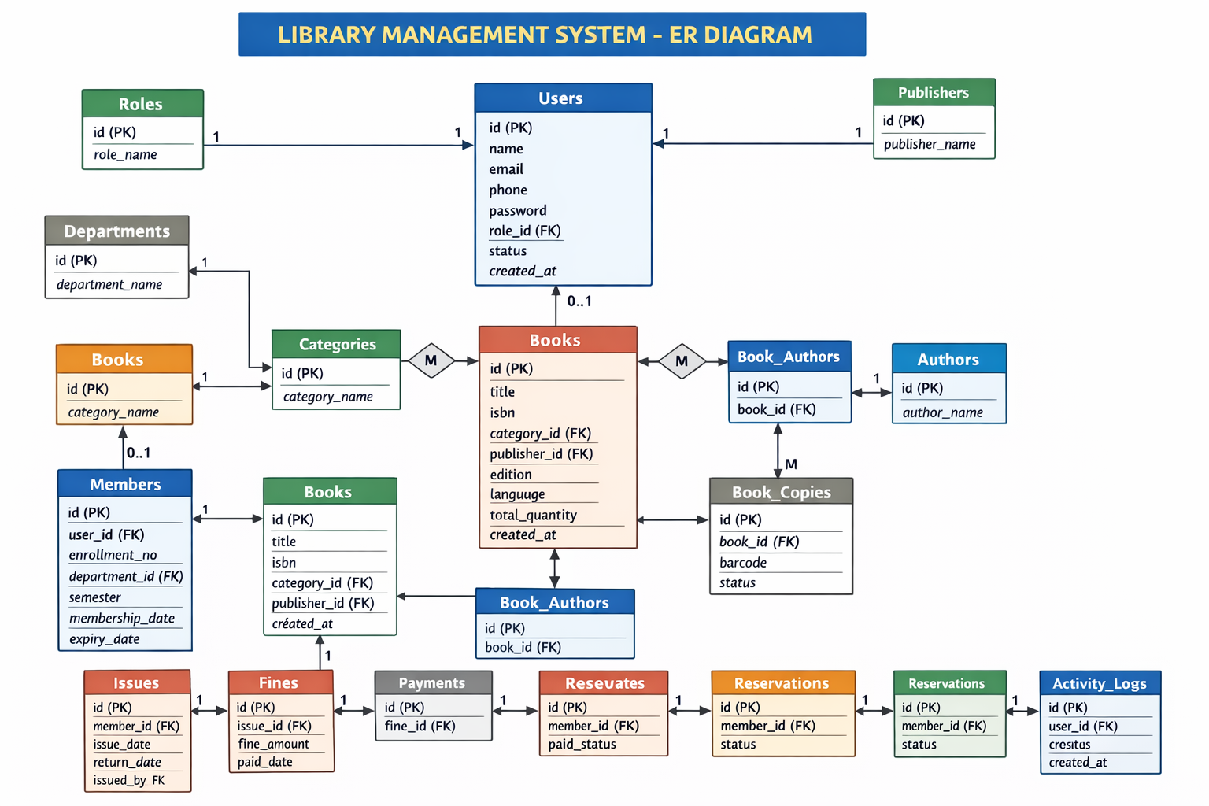

- Create a database.
CREATE DATABASE LibraryManagement;
- Switch to database.

- CREATE TABLE roles
CREATE TABLE roles (
id SERIAL PRIMARY KEY,
role_name VARCHAR(50) NOT NULL UNIQUE
);
- Roles Insert
INSERT INTO roles (role_name) VALUES
('Admin'),
('Librarian'),
('Student');
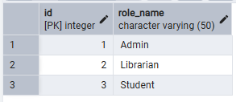
- Users Table.
CREATE TABLE users (
id SERIAL PRIMARY KEY,
name VARCHAR(100) NOT NULL,
email VARCHAR(100) NOT NULL UNIQUE,
phone VARCHAR(15),
password VARCHAR(255) NOT NULL,
role_id INTEGER NOT NULL,
status BOOLEAN DEFAULT TRUE,
created_at TIMESTAMP DEFAULT CURRENT_TIMESTAMP,

CONSTRAINT fk_role
FOREIGN KEY(role_id)
REFERENCES roles(id)
ON DELETE CASCADE
);

