Response to Reviewer Comment on Systematic Justification of the Five-Dimension Framework
Manuscript: “Making the Elephant Dance: Five Dimensions for Digital Government Transformation”
Journal: Public Administration Review
Date: 2025-12-13

Reviewer comment: “The theoretical framework lacks systematic justification… A more systematic literature review, such as coding or thematic analysis, may strengthen the scientific basis of the framework.”

We thank the reviewer for this valuable suggestion. We have revised the manuscript to strengthen the scientific basis of the theoretical framework by combining theory-informed conceptual scoping with a data-driven mapping of the thematic structure from literature.
Concretely, we conducted a structured keyword-based search to compile a corpus of 87 peer-reviewed studies on digital government transformation and bureaucratic change. Prior to the analysis, we employed TF-IDF (Term Frequency–Inverse Document Frequency) weighting to mathematically distinguish significant thematic keywords from generic administrative terminology, ensuring that the extracted topics reflected genuine theoretical variance rather than mere lexical repetition. More specifically, we then supplemented our theoretical approach with a systematic text mining analysis using Non-Negative Matrix Factorization (NMF) on the articles. The NMF was selected for its superior interpretability; unlike other dimensionality reduction techniques, NMF extracts topics based on additive, non-negative keyword associations, which produces clear and distinct thematic clusters.
We interpreted the top-weight terms for each topic and consolidated topics into higher-order categories through an iterative thematic synthesis (constant comparison and axial consolidation). This inductive consolidation converged on five stable higher-order dimensions: Public Service Delivery, Government Organizational Structure, Government Operating Logic and Processes, Departmental Responsibilities and Administrative Authority, and Leadership. The five dimensions repeatedly capture the dominant objects and drivers of bureaucratic change discussed in the literature.
To test whether these five dimensions were an artifact of a particular topic-number choice, we re-estimated the topic model under multiple topic-number specifications (remembering that higher topic numbers increase granularity rather than fundamentally changing the thematic structure). Across specifications (e.g., 5, 10, 12, and 15 topics), we found that altering the number of topics primarily subdivided or merged subthemes, while the same five higher-order dimensions consistently reappeared as the organizing structure. In other words, regardless of whether the model produces a coarser or a finer topic solution, the extracted topics can be systematically consolidated into the same five dimensions, and no persistent residual cluster emerges that would justify introducing an additional dimension.
As an illustrative example, we report the 10-topic solution in the response package. Figure R1 summarizes the top TF–IDF keywords in the corpus and shows the prominence of service-oriented, organizational, and governance-related language. Figure R2 shows the document distribution across the 10 NMF topics. Figure R3 then aggregates the topic assignments into the five higher-order dimensions; importantly, the unmapped category is zero (Unmapped = 0), indicating full coverage by the five dimensions. In the 10-topic solution, topics organized around citizen access, service provision, and service delivery consolidate into Public Service Delivery; topics emphasizing inter-agency collaboration, integration, and coordination consolidate into Government Organizational Structure; topics centered on automation, standardization, and workflow redesign consolidate into Government Operating Logic and Processes; topics clustering around discretion, accountability, and authority allocation consolidate into Departmental Responsibilities and Administrative Authority; and topics featuring strategic commitment, transformational leadership, and political support consolidate into Leadership. Together, these revisions provide a systematic and replicable basis for the framework: the five dimensions emerge inductively from the literature’s topic structure and remain robust as the number of extracted topics varies.
To reflect this strengthened justification, we add a concise description of the literature-mapping procedure and robustness checks in the Analytical Framework section, and we provide full procedural details and the topic-to-dimension consolidation outputs in the appendix.

Illustrative example (NMF with 10 topics). The following figures are included to document the intermediate outputs and the consolidation from multiple topics into the five dimensions.
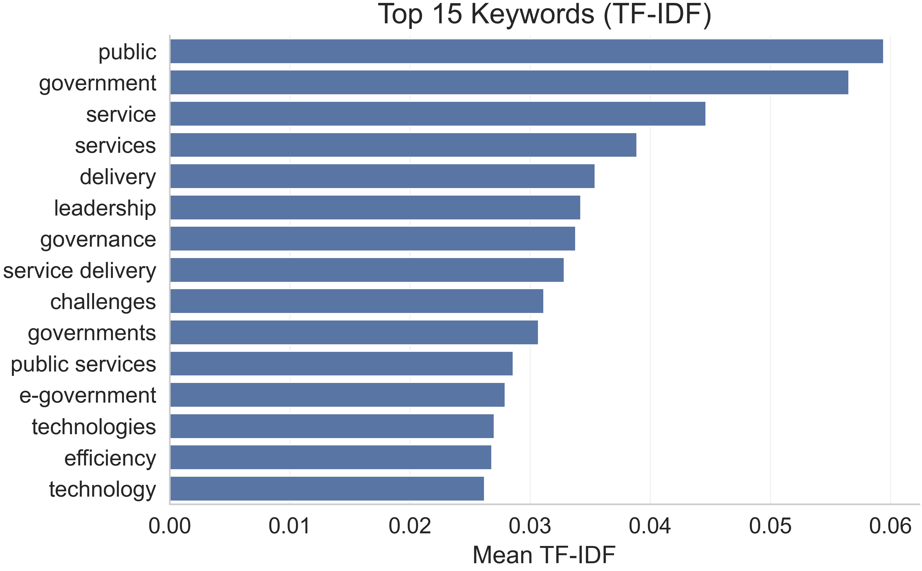
Figure R1. Top 15 keywords by mean TF–IDF weight in the 87-article corpus.

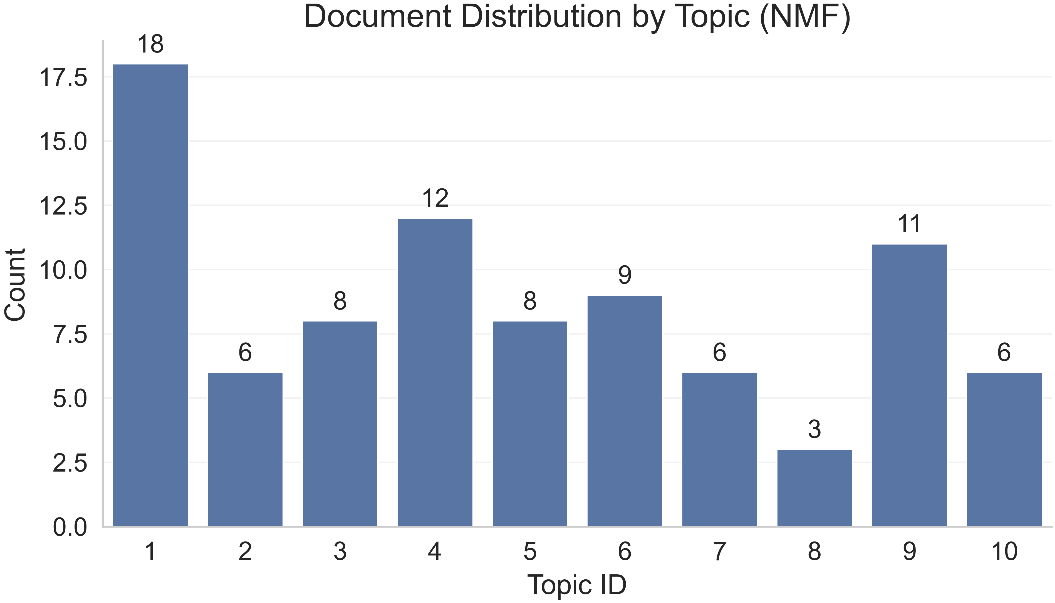
Figure R2. Document distribution across the 10 NMF topics (n_topics = 10).

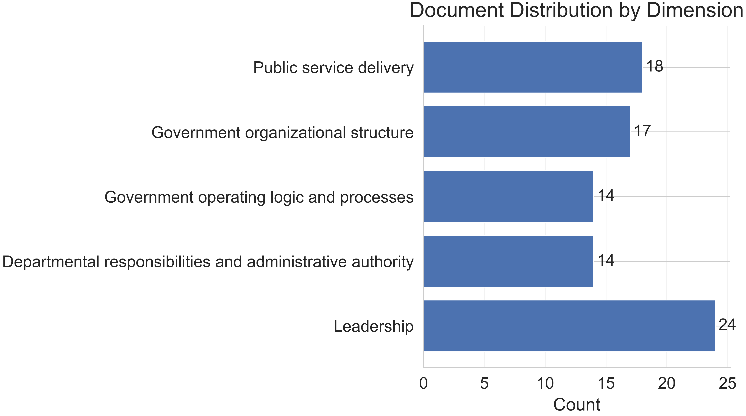
Figure R3. Document distribution aggregated from the 10 topics into the five dimensions; Unmapped = 0 (coverage-complete mapping).

Revisions made in the manuscript
In the revised manuscript, we adjust the framework-development narrative to make the derivation logic explicit. First, in Section 2 (Analytical Framework), immediately before the formal definition of the five dimensions, we add a short subsection titled “Inductive derivation and robustness of the five dimensions.” This subsection explains that the framework emerged from a two-stage procedure in which (a) NMF topic modeling was used to extract latent topics from a systematically assembled literature corpus and (b) those topics were iteratively consolidated into five higher-order dimensions through thematic synthesis. Second, we add one paragraph reporting the robustness checks across alternative topic numbers, emphasizing that topic-number variation changes granularity but does not yield an additional stable higher-order dimension. Third, to preserve readability, we move full methodological details—including the search protocol, preprocessing, NMF settings, alternative topic-number solutions, and the topic-to-dimension consolidation outputs—into an online appendix, where we also provide a compact topic-to-dimension table for the 10-topic solution and a short summary of coverage completeness (Unmapped = 0).

Text added to the manuscript (ready to paste)
To strengthen the scientific basis of the analytical framework and assess whether additional dimensions are warranted, we complemented theory-informed scoping with an inductive literature-mapping exercise. We compiled a corpus of 87 peer-reviewed studies on digital government transformation and bureaucratic change identified through structured keyword searches and screening. Using TF–IDF features (1–3 grams), we applied Non-Negative Matrix Factorization topic modeling to extract latent topics that represent recurring conceptual clusters in the corpus. We then interpreted the highest-weight terms for each topic and consolidated topics into higher-order categories through iterative thematic synthesis (constant comparison and axial consolidation). This inductive process converged on five stable higher-order dimensions—Public Service Delivery, Government Organizational Structure, Government Operating Logic and Processes, Departmental Responsibilities and Administrative Authority, and Leadership.
We assessed robustness by re-estimating models under multiple topic-number specifications (e.g., 5, 10, and 15 topics). Across specifications, varying the number of topics primarily affected the granularity of subthemes, while the same five higher-order dimensions consistently reappeared as the organizing structure. No persistent residual topic cluster emerged that would justify a sixth dimension. Full methodological details and topic-to-dimension consolidation outputs are provided in the online appendix.

