Hospital System - Daily Scrum Document

# Sprint 1 Week

|  |  |  |  |  |  |  |
| --- | --- | --- | --- | --- | --- | --- |
| Name | Question | Sunday | Monday | Tuesday | Wednesday | Thursday |
| Hossam | What did you do yesterday? | - | Create Basic Database ideation | Add Main database classes | Add user type classes | Add each user type attributes |
| What will you do today? | Create Basic Database ideation | Add Main database classes | Add super user type classes | Add super user attributes | Add relationship between super user and other classes |
| Do you have any obstacles? | Didn’t have any | Didn’t have any | Didn’t have any | Some main attributes were not defined | Didn’t have any |
| Youssef | What did you do yesterday? | - | Add Account Creation | Credentials Generation Support | Add Admin Support | Add User accounts Control |
| What will you do today? | Add Account Creation | Credentials Generation Support | Add Admin Support | Add User accounts Control | Add System Control |
| Do you have any obstacles? | Didn’t have any | Encryption on credentials is not working | Didn’t have any | Didn’t have any | System Doesn’t Respond at times |

# Sprint 1 Summary

## Goal

Create Super User Functionalities and should have full working control on the Hospital System

## Progress

All tasks met the definition of done but some tasks still need some refinement

## Next Sprint

System should start supporting basic user operations to use the system

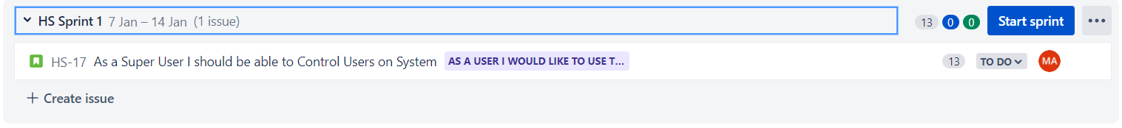

# Sprint 2 Week

|  |  |  |  |  |  |  |
| --- | --- | --- | --- | --- | --- | --- |
| Name | Question | Sunday | Monday | Tuesday | Wednesday | Thursday |
| Ahmed | What did you do yesterday? | - | Design User Welcome Screen | Design User Login Screen | Design Home screen according to user type | Design user profile Display |
| What will you do today? | Design User Welcome Screen | Design User Login Screen | Design Home screen according to user type | Design user profile Display | Design User profile Edit screen |
| Do you have any obstacles? | Didn’t have any | Didn’t have any | Some User types are missing | Didn’t have any | Didn’t have any |
| Essam | What did you do yesterday? | - | Create basic design assets and theme | Implement User Welcome Screen | Implement User Login Screen | Implement User Type Home Screen |
| What will you do today? | Create basic design assets and theme | Implement User Welcome Screen | Implement User Login Screen | Implement User Type Home Screen | Implement Profile Display |
| Do you have any obstacles? | Didn’t have any | Didn’t have any | Didn’t have any | Didn’t have any | Didn’t Implement profile editing screen |

# Sprint 2 Summary

## Goal

Create User Login, profile and home interfaces and implement their screens

## Progress

All tasks met the definition of done with 1 missing task

## Next Sprint

Add support for account delete request and having users able to check hospital schedule

