**Cyphering System**

**Team Code: S008**

**:Members:**

(Section 1) 2018170877: عمر عصام خضري حسين

(Section 1) 2018170870: زياد حسن محمد

(Section 2) 2018170882: كيرلس اسحاق عزت عشم الله

(Section 2) 2018170903: يوسف خالد محمد عبد الحميد

(Section 1) 2018170869: رامي هاني امين غالي

(Section 2) 2018170888: محمد زكي محمد

1. **Caesar cipher:**

.Text encryption:

.Text Decryption:

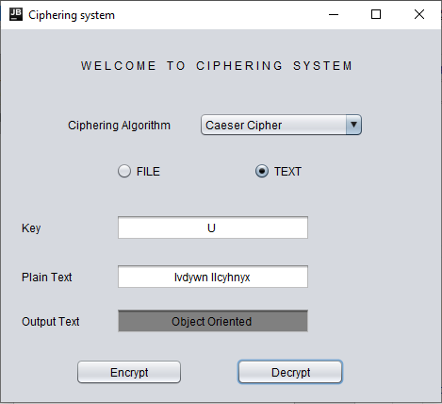

1. **Playfair Cipher:**

.Text decryption:

.Text encryption:

**Note:** The character table in Playfair has been modified to be 9x9, to handle both lower and upper case characters and some special characters.

1. **Vigenere Repeating key**:

.Text encryption:

.Text decryption:

1. **Vigenere Auto key:**

. Text encryption:

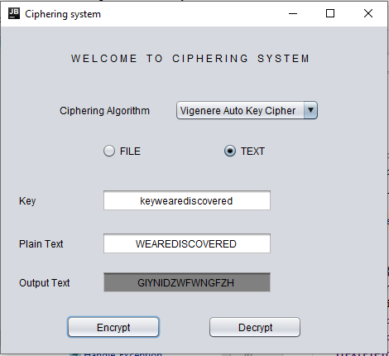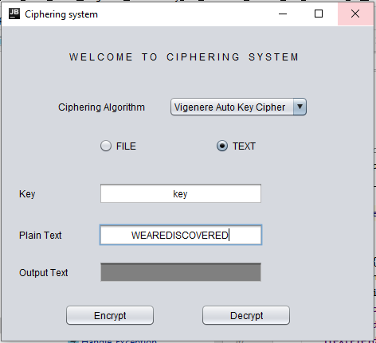.Before Pressing Encryption .After Pressing Encryption

**Note:**  After pressing encrypt the key textbox will show the new generated key (Given Key + Plain Text).

. Text Decryption:

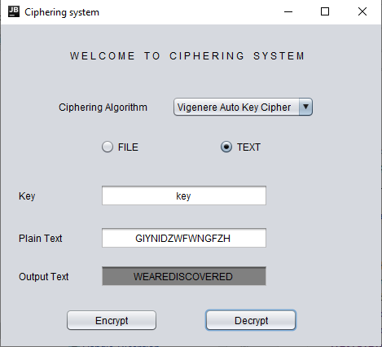

1. **Hill Cipher:**

. Text Encryption:

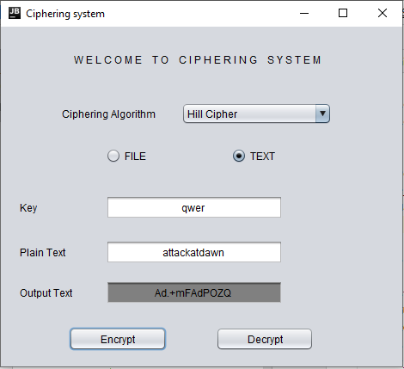

. Text Decryption:

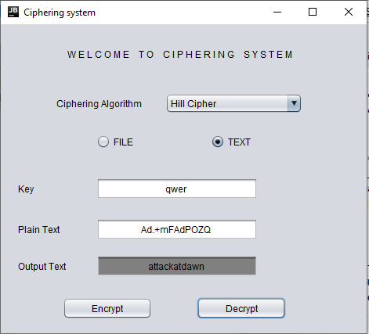

1. **Rail Fence:**

. Text Encryption:

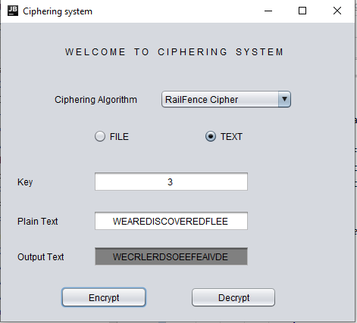

. Text Decryption:

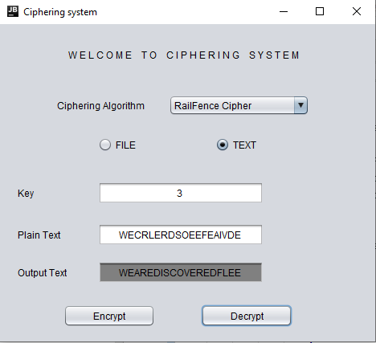

**Read/Write file handling:**

.text file encryption:

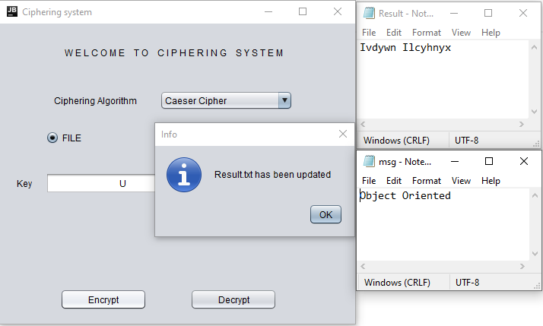

.text file decryption:

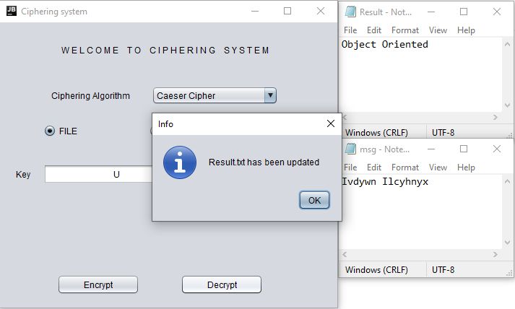

**Note:** The encrypted/decrypted text will be saved in a text file named “Result.txt”, saved in the project folder.

**Exception Handling:**

Exception will be thrown (In Any Chosen Cipher System) if the Encrypt/Decrypt button is pressed while there is missing info like key and plain text.

**General Note:** If no key is given or an invalid key was given (in Case of all ciphers except for Rail fence) the user will choose between generating a valid key or entering a valid key, but during decryption a valid key must be provided otherwise an error message will be displayed.

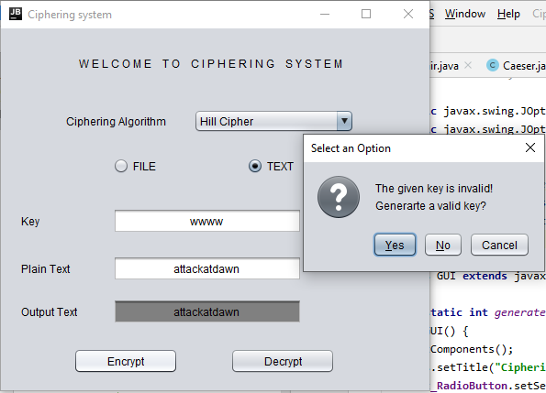

-Valid key generation + Encryption. -Decryption using the gen. valid key.

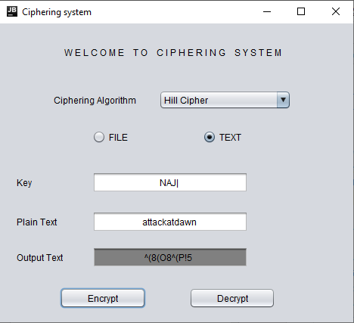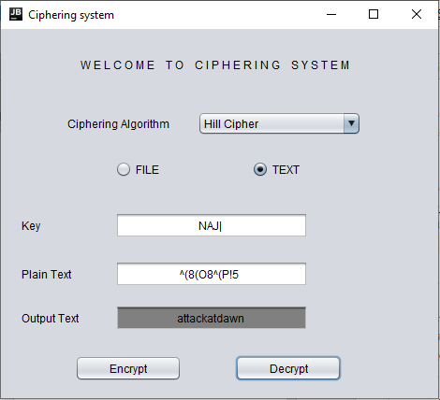

-In Rail Fence Cipher, Exception will be thrown if the Number of Rails (Key) is less than 2.

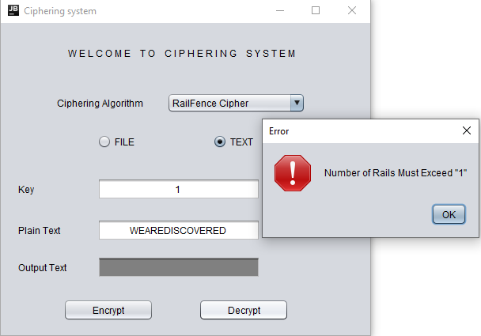

-In Rail Fence Cipher, Exception will be thrown if the Number of Rails (Key) isn’t a Number.

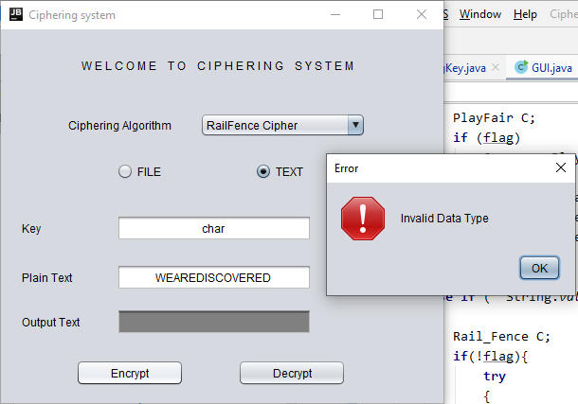

In Hill cipher, Exception will be thrown if the length of the key isn’t equal to 4.

