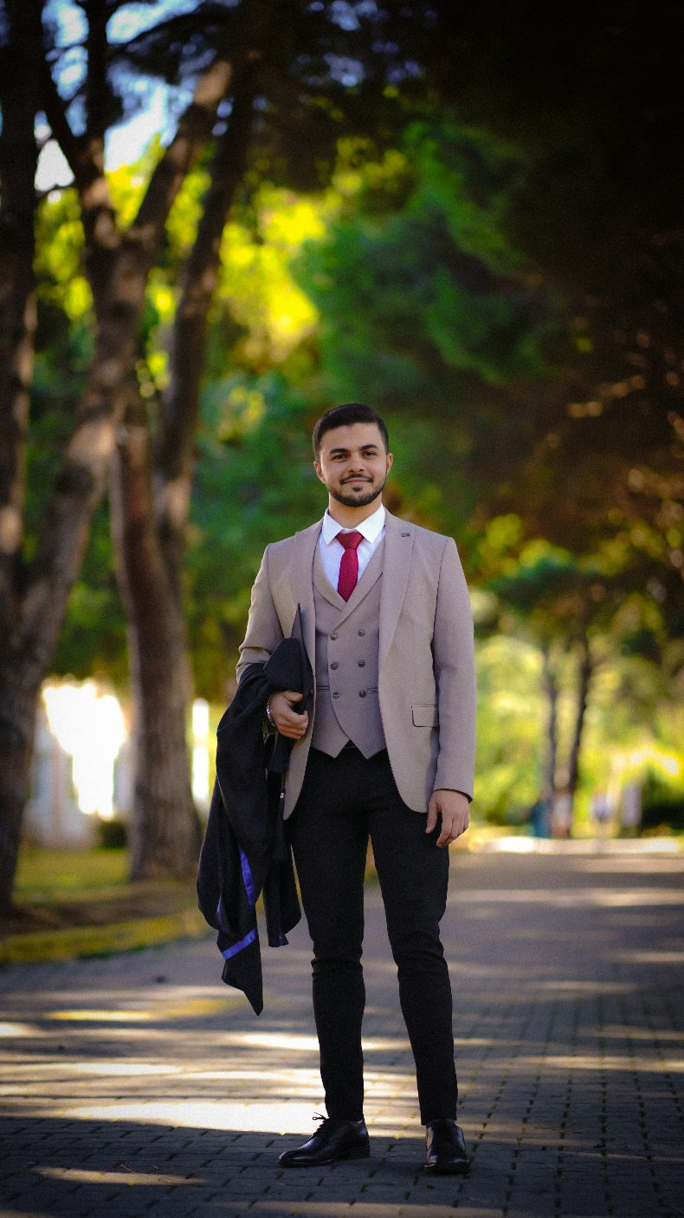

**Moayad Rajjoub**

**ELECTRONIC ENGINEER**



C:\Users\abdou\Desktop\Resumes for Customer\Customer Project\Resume 5\phone.png****C:\Users\abdou\Desktop\Resumes for Customer\Customer Project\Resume 5\phone.pngC:\Users\abdou\Desktop\Resumes for Customer\Customer Project\Resume 5\phone.pngC:\Users\abdou\Desktop\Resumes for Customer\Customer Project\Resume 5\location.pngC:\Users\abdou\Desktop\Resumes for Customer\Customer Project\Resume 5\mail.png[](http://www.linkedin.com/in/moayad-rajjoub-487665230)[](https://github.com/MoaRajj)[](https://www.instagram.com/moayyad_rajjoub/)

Syrian / Turkish

1998

+905537703774

Moayyad612@hotmail.com

Istanbul / Türkiye

**PERSONAL BRIEF**

Born and raised in Madinah, Saudi Arabia, lived there until I graduated from Abu Bekr Al-Razi High School with honors in 2016. Then moved to Istanbul, Turkey, to continue my educational journey at Gebze Technical University. During my studies I had the opportunity to gain valuable work experience in the field by interning at various respected research institutions, which paved the way for my current position as an engineer at one of the world's leading corporations in the household durables industry.

**PROFESSIONAL SUMMARY**

Electronic Engineer with **over 3 years of diverse experience** across software development, system integration, and project management. Proven ability to adapt to various technical environments, from automation and image processing systems to cross-functional engineering projects. Recognized for delivering high-quality work, strong problem-solving skills, and a collaborative approach that supports team and organizational success.

**EXPERIENCES**

* **(May) 2025 - Present** / **Promoted to be DMS** – **Specialist Engineer** at the Digital Manufacturing Systems department of **Beko Corporate**, Turkey.
* Leading the implementation of a computer vision system for detecting production defects through image processing. Responsible for adapting the code, planning, and executing installations, monitoring system performance, and developing new features to support deployment across multiple stations.
* **(January) 2024 - (April) 2025** / **DMS** - **Engineer** at the Digital Manufacturing Systems department of **Beko Corporate**, Turkey.
* Increasing the sustainability, safety, speed, and traceability of the production process by implementing new techniques and digitalizing others, with a main focus on **embedded systems**.
* Led and delivered the Operator Login Project, including code updates, deployment, documentation, and monitoring. The system ensures only qualified operators can work at specific stations, reducing production errors by checking permissions and EMC test results.
* **(October) 2022 - (November) 2023** / Project Assistant at **Material Physics Laboratory** in Gebze Technical University, Turkey. Supervised by Dr. Mahmut Akşit.

* I played a crucial role during my internship in constructing a three-axis machine, which is now an integral part of our ongoing work. In my current position as a lab researcher, my main responsibilities include **optimizing** and **testing** this machine to ensure its efficiency and functionality. This involves developing a user interface with a graphical user interface **(GUI)** using **Qt Designer**, introducing a substrate rolling function, and conducting thorough testing to identify and address any issues or necessary improvements in the machine.
* Additionally, I engaged in a collaborative project with TEI focused on polycarbosilane synthesis. Within this project, I am responsible for preparing the experimental setup for high-temperature and high-pressure reactor conditions, as well as closely monitoring temperature and pressure data during experiments.
* **(August - September) 2022** / Internship at **TÜBİTAK BİLGEM TÜTEL**. The Scientific and Technological Research Council of Türkiye (TÜBİTAK).
* I completed a one-month internship at the Integrated Circuits Design and Training Laboratory (TÜTEL). During this program, I successfully completed 8 assignments using the digital programming language **Verilog**. These assignments included designing and testing circuits such as **Up/Down Counter**, **Ripple Carry Adder**, **serial adder**, Hardware **Multiplier**, Parameterized First in First Out **(FIFO)**, and Universal Asynchronous Receiver-Transmitter **(UART)** using **FPGA** technology.
* **(October) 2021 - (July) 2022** / Internship at **Material Physics Laboratory** in Gebze Technical University, Turkey. Supervised by Dr. Mahmut Akşit.
* I resumed work on the three-axis machine structure, focusing on the electrical and electronic components. I completed the entire **GUI** user interface and automation system.
* Additionally, I provided assistance to one of our lab researchers in a collaborative project with TEI, specifically in the preparation of experimental procedures for high-temperature and high-pressure reactor conditions, as well as monitoring temperature and pressure data during experiments.
* **(July - September) 2021** / Internship by **ERASMUS+** program at **High Voltage Test & Research Center, AMBER**, Spain. Supervised by Dr. Juan Manuel Moreno Eguílaz.
* I was responsible for selecting a high-quality, precise, and high-pressure-resistant ultrasonic sensor to detect early-stage Corona Discharge. I designed a testing circuit on **LTspice**, implemented it, and conducted tests using an ultrasonic light source. The output was then read using an **oscilloscope**.
* **(February - June) 2021** / Internship at **Material Physics Laboratory** in Gebze Technical University, Turkey. Supervised by Dr. Mahmut Akşit.
* I contributed to the construction of a new three-axis machine, focusing on the electrical and electronic components to create an automation system for specific chemical experiments. This involved the use of various sensors and a main **Mega Arduino** board.
* Additionally, I gained experience operating different cutting machines, including **Universal Milling**, **Manual Lathes**, and **Horizontal Sawing**. I also expanded my knowledge of software tools like **SOLIDWORKS**, **MACH3**, and **GCode**, supporting projects such as the development of an under-vacuum thermoelectric measuring system within the lab.

**PROJECTS**

* Fully autonomous three-axis system with **GUI** written user interface and **PID** controller to implement an accurate, temperature and pressure controlled specific chemical method. [[For details](https://github.com/MoaRajj/Coating_Machine)]
* A voice recorder with audio return feature, using **STM32** Nucleo-32 microprocessor. Throughout the project, several modules, including **Timer**, **PWM**, **ADC**, and **External Interrupts**, will be employed. [[For details](https://github.com/MoaRajj/Digital_Voice_Recorder)]
* Reducing the noise in a talk where the project aims to obtain a noise-free audio signal at the output as much as possible by reducing the noise in the noise-added audio signal. The key element in this endeavor is a **filtering system** enclosed within a box. [[For details](https://github.com/MoaRajj/Reducing_Speech_Noise)]

**COURSES**

* Technical Programs
* TEI - Aviation Engines School 2022 ( TEI Havacılık Motorları Okulu ).
* ACCENTURE - Embedded Linux from Scratch.
* EGEMSOFT - Software Test Engineering Training (Certificated).
* Social Programs
* Who is Who? - Human recognition skills and quality communication.
* Mastery in Relationships - The Experiential Design Teaching Mastery Program in Relationships (Certificated).
* Success Psychology - The Experiential Design Teaching Success Psychology Seminar (Certificated).

**EDUCATION**

**Sep. 2017 – Sep. 2022** **/** Bachelor’s Degree**:**

Graduated as an Electronic Engineer from Gebze Technical University in Turkey with a **GPA** of **2.63** out of 4.

**2013 - 2016** **/** High School Diploma**:**

Finished high school with honors, scoring **98.5%** at Abu Bakr Al-Razi High School Madinah, **Saudi Arabia**.

**SKILLS**

* Proficiency in a diverse range of tools, languages, and platforms, including **MATLAB**, **C/C++**, **NI Multisim**, **LTspice**, and **Python** for simulation and programming tasks. Also, experienced in **GUI** development using **Qt Designer**.
* Reliable knowledge in different microcontrollers such as **ESP32**, **Arduino**, **STM32** and **Raspberry pi**.
* Well-versed in **Microsoft Office** applications such as Word, PowerPoint, and Excel for documentation and presentations.
* Some experience with **GCode** for **CNC** machining, **Mach3** for CNC machine control, **SOLIDWORKS** for 3D modeling, and **LightBurn** for laser engraving and cutting.
* Experience with **FPGA** development using **Intel Quartus Prime** and **Xilinx Vivado**, along with expertise in **Verilog** for hardware description and synthesis.
* Organized and **detail-oriented** to ensure excellent **time management** and a clean and **safe work** environment.
* Excellent complex **problem-solving** skills for using logic and reasoning to identify problems, strengths, and weaknesses in electronic engineering projects and using them to create and implement plans for a better project.

**LANGUGES**

English (Fluent)

Turkish (Fluent)

Arabic (Fluent)

**HOBBIES AND INTERESTS**

I like to spend time with friends, and I love the idea of meeting now people and learning about their experiences. It is enjoyable for me spending the time doing some sports like swimming, playing volleyball and tennis table. Animals is one of my favorite things, so I own a cat. I am also interested in bodybuilding, so I try to keep going to the gym.