King Abdulaziz University

Faculty Of Computing and Information Technology

Information Technology Department

CPIT-380

|  |  |  |
| --- | --- | --- |
| Name | ID | Section |
| Moath Alahmadi | 2135524 | IT1 |

1. Main Page

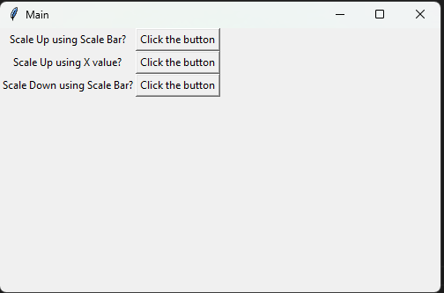

1. Scale Up Using Bar



The result



1. Scale Up using X value. And the result

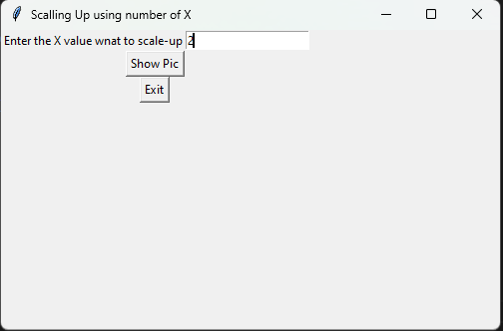



1. Scale down using Bar with result.

