|  |  |  |
| --- | --- | --- |
| **جامعة-أسوان شعار.jpg** | **Electrical Department**  **Third Year, 1st Semester**  **Electrical Test 3-A** |  |
| **Aswan University** |  | **Faculty of Engineering** |
|  |  |  |

**Report on**

**(Digital Clock)**

**Subject:**

**Electrical Test 3-A**

**Represented by:**

**Rowan Omar Ahmed**

**Presented to:**

**Eng. Abeer**

**Supervised by:**

**Dr. Mahmoud Ali**

**Mark:**

**…………………………………………**

**Q.1) Draw the circuit diagram of 24H digital clock.**

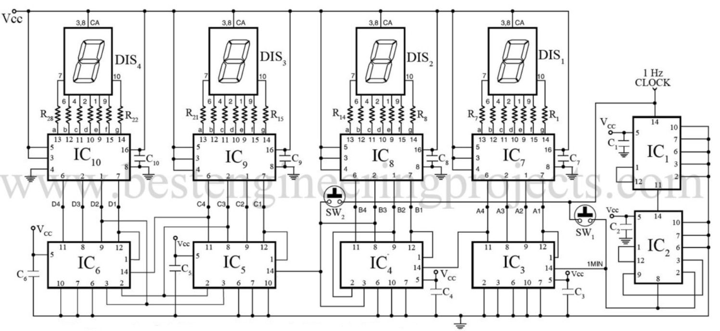

**Q.3) Extend the diagram to include seconds.**

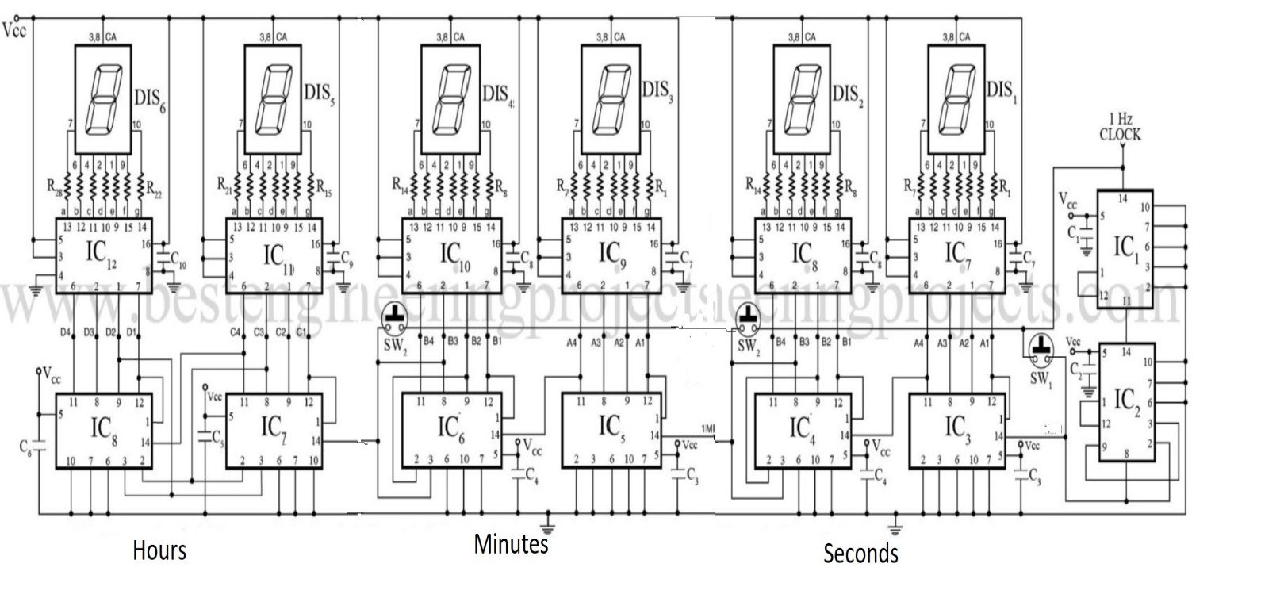

**Q.4) The hardware connection.**

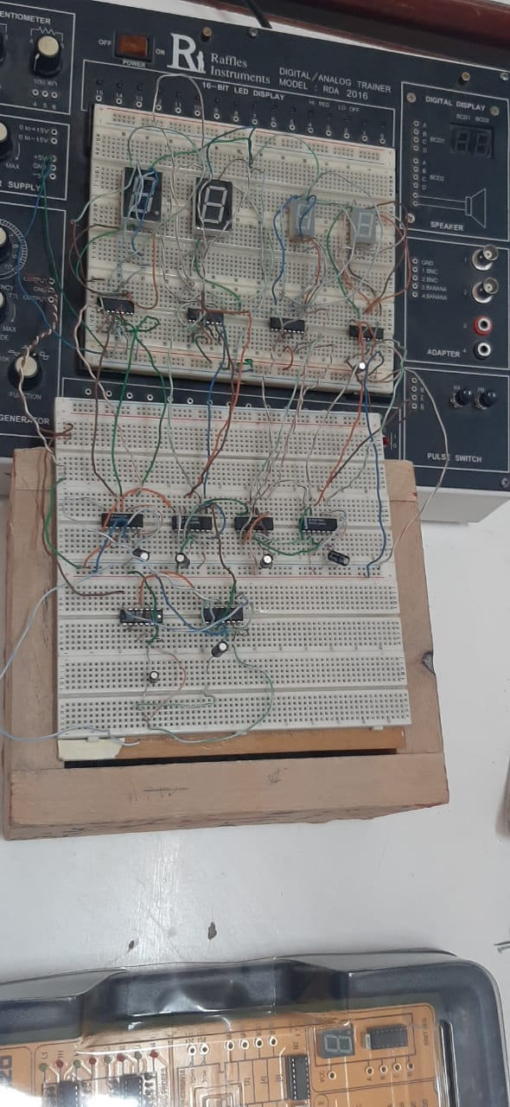

**Q.5) The sketch of 12H digital clock with months.**

