Suicides in India for the year 2021

Introduction
Every year 703,000 people take their own life and there are many more people who attempt suicide. Every suicide is a tragedy that affects families, communities and entire countries and has long-lasting effects on the people left behind. Suicide occurs throughout the lifespan and was the fourth leading cause of death among 15-29 year-olds globally in 2019.

Suicide does not just occur in high-income countries, but is a global phenomenon in all regions of the world. In fact, over 77% of global suicides occurred in low- and middle-income countries in 2019.

Suicide is a serious public health problem; however, suicides are preventable with timely, evidence-based and often low-cost interventions. For national responses to be effective, a comprehensive multisectoral suicide prevention strategy is needed.

Its important to analyze the data of the past suicide records to detect the reason that cause that and prevent it

We will analyze the suicides in India for the year 2021
In 2021
164033 human committed suicide
118979 of them were men
45026 were women
28 were transgender

After analyzing the data we got more information about the suicidals

Marital Status:
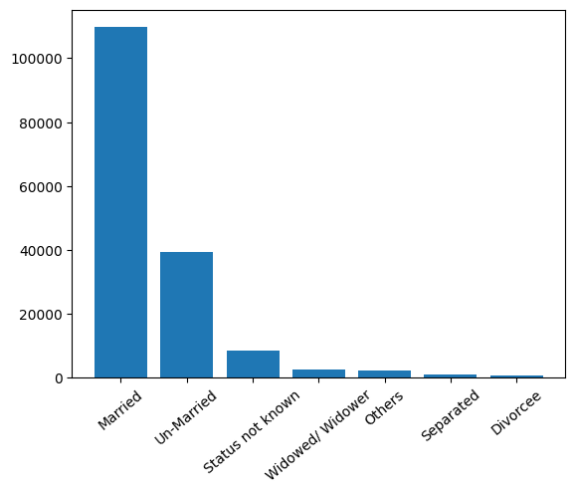
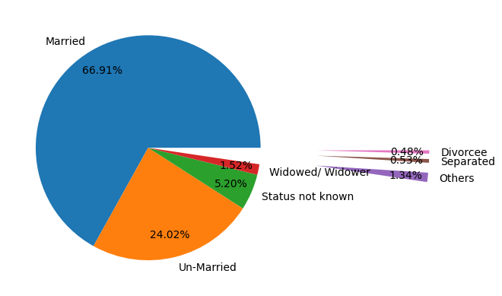
From the plot and pie chars we can see that 66.9 present of the people who committed suicide are married while only 24 present are unmarried
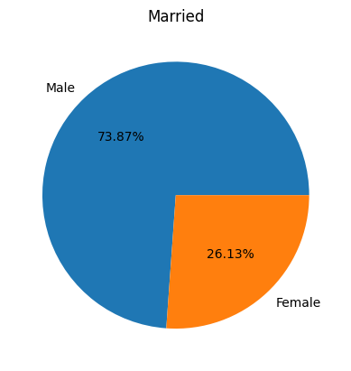
73.9 present of the married suicidal are men

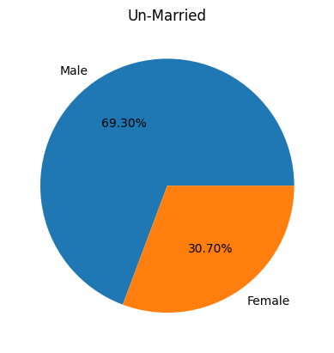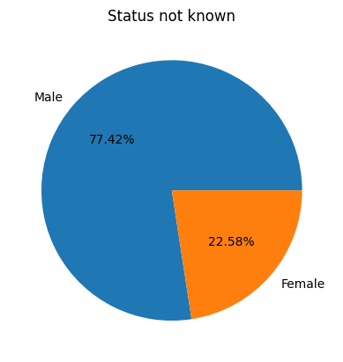
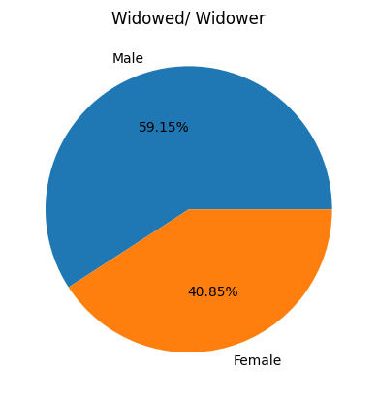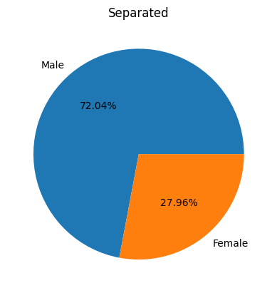

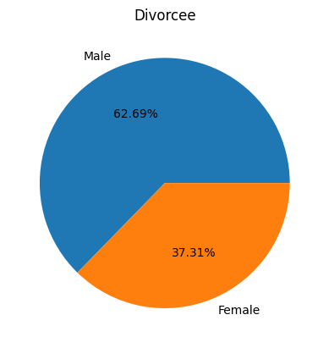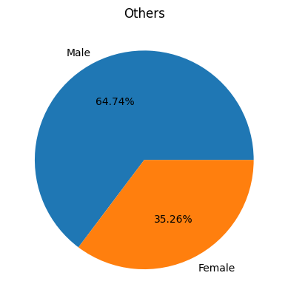

Economic Status
"The poorer one's socioeconomic conditions are, the higher one's risk is for mental disability and psychiatric hospitalization," said author Christopher G. Hudson, Ph.D., of Salem State College. This was found regardless of what economic hardship or type of mental illness the person suffered.

SES was assessed on the basis of community income, education and occupational status. The study considered economic stress as one of several possible explanations for the correlation between SES and mental illness, and this was determined by how much the local income income was below the federal poverty level, the rate of unemployment, and an index of rental housing unaffordability.

This study provides strong evidence that SES impacts the development of mental illness directly, as well as indirectly through its association with adverse economic stressful conditions among lower income groups, said Dr. Hudson. Furthermore, "the study highlights the need for the continued development of preventive and early intervention strategies that pay particular attention to the devastating impacts of unemployment, economic displacement, and housing dislocation, including homelessness."

And we can see that clearly from our data
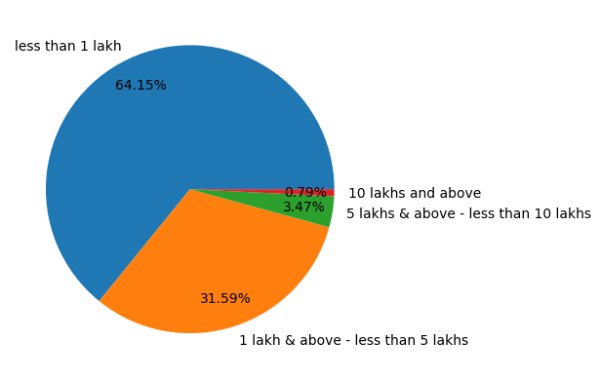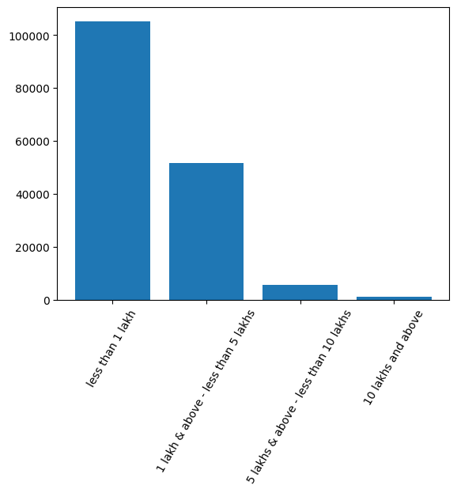
Its clear that the economic status affect the mental health from our data we can see that more than 64% of the suicidal people income is less than 1 lack (100000 rupees) yearly while only 0.8% of the suicidal people income is more than 10 lacks

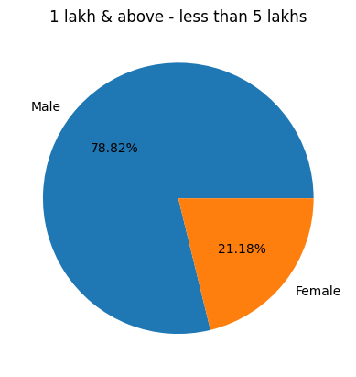
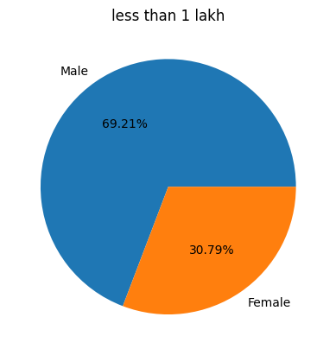
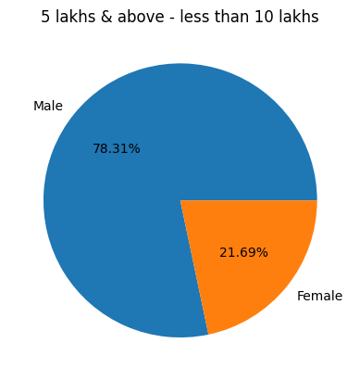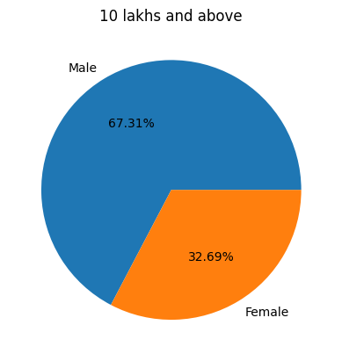

Educational Status
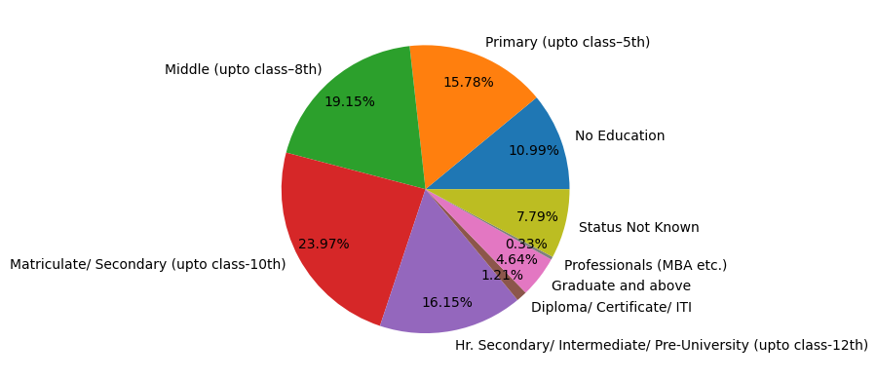
the role of education as a determinant of mental health. To do this, we leverage the age‐specific exposure to an educational reform as an instrument for years of education and find that the treated cohorts gained more education. This increase in education had an effect on mental health more than 2 decades later. An extra year of education led to a lower likelihood of reporting any symptoms related to depression (11.3%) and anxiety (9.8%). More educated people also suffered less severe symptoms – depression (6.1%) and anxiety (5.6%). These protective effects are higher among women and rural residents. The effects of education on mental well‐being that we document are potentially mediated through better physical health, improved health behavior and knowledge, and an increase in women's empowerment.

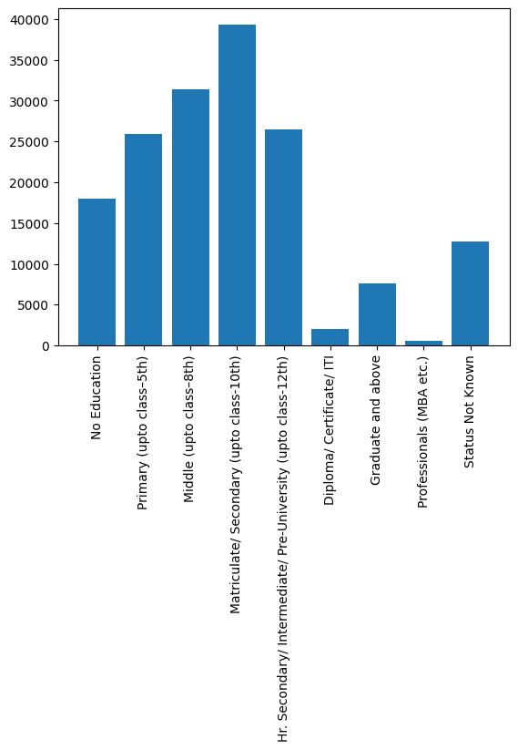

From the data we can see that the highest suicide rate is coming from the youth with a peak among the secondary school students with 24%

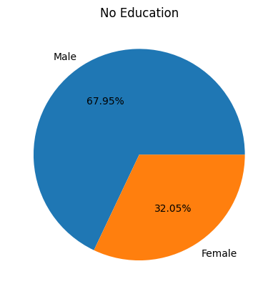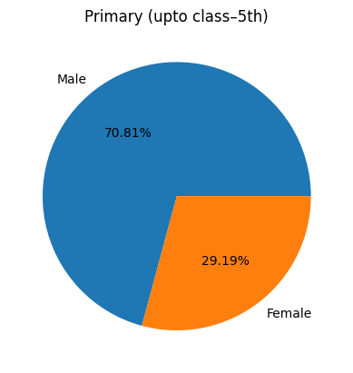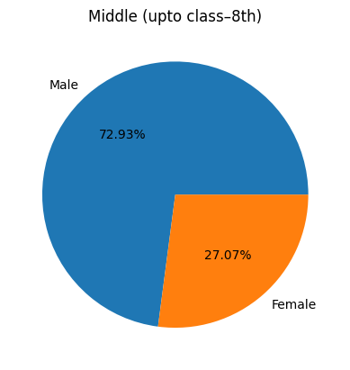

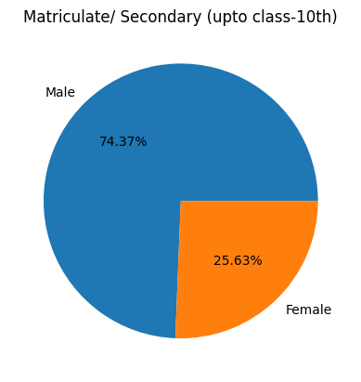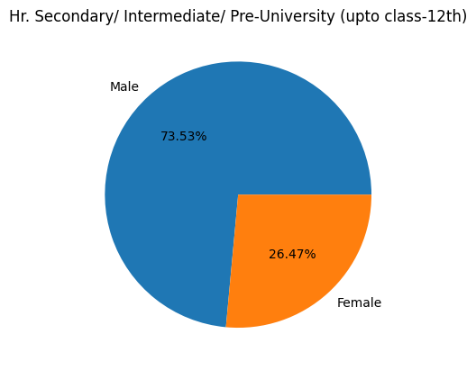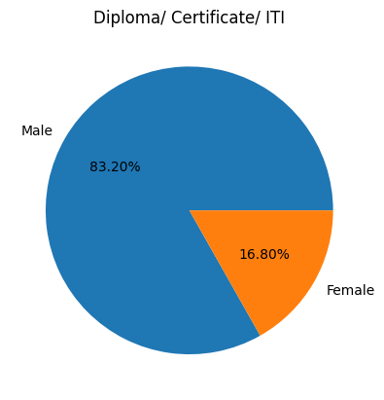

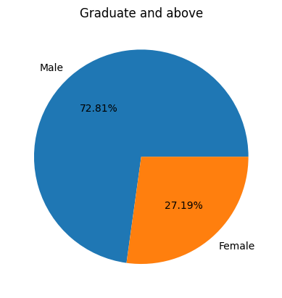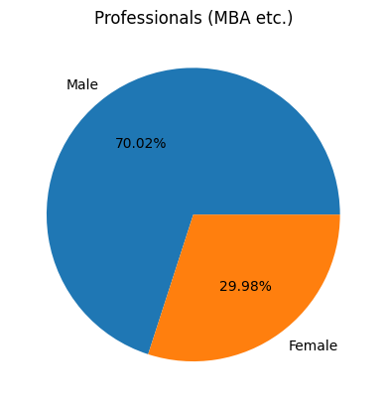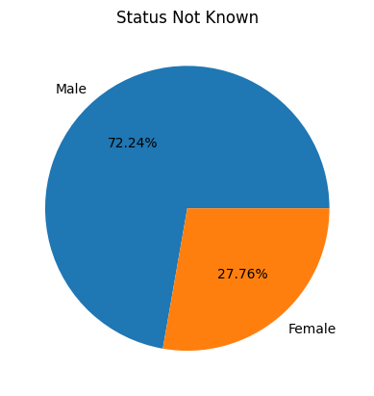
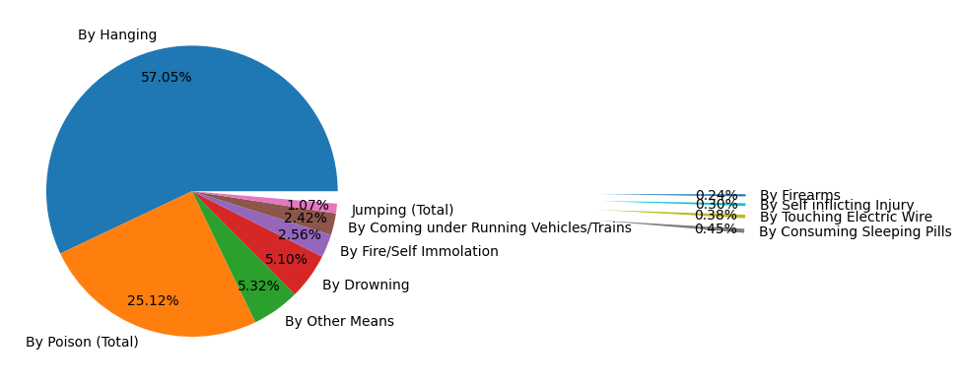
Methods of suicide
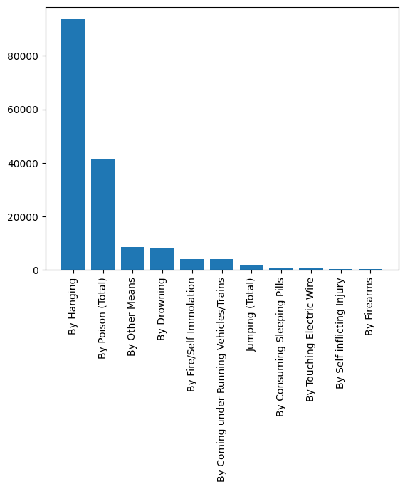

From the data we can see that the most common way of the suicides is by hanging (57%) and the second way is by poison (25%) while the least common way is by using firearms (0.24%)

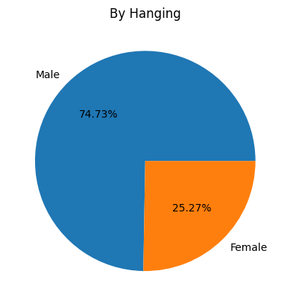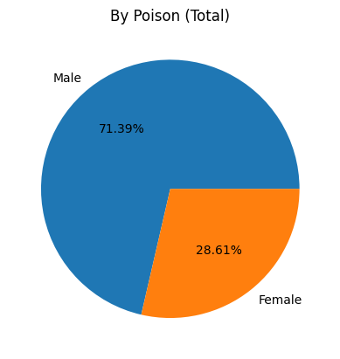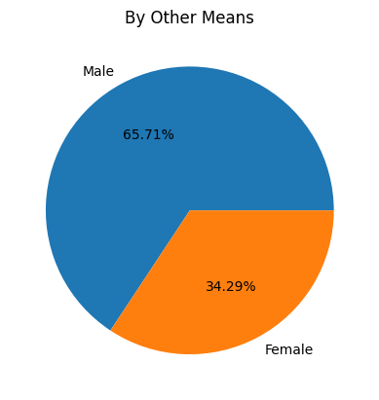
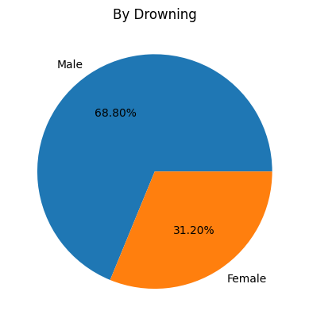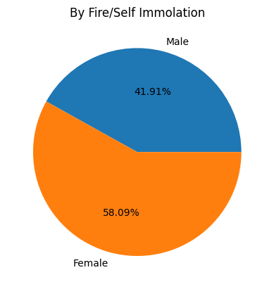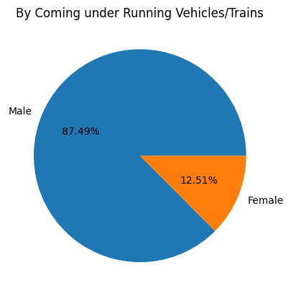

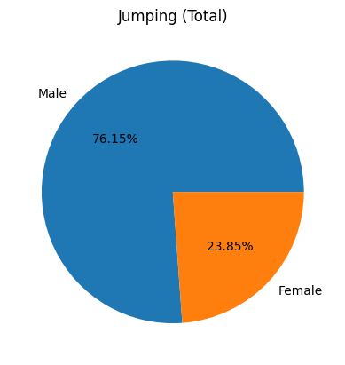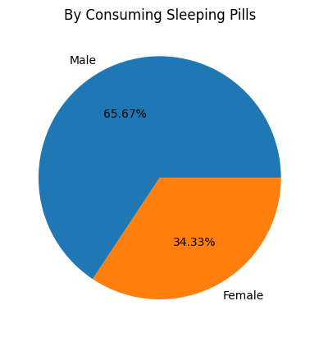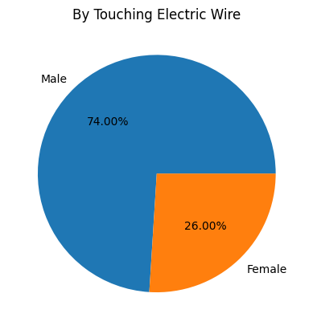

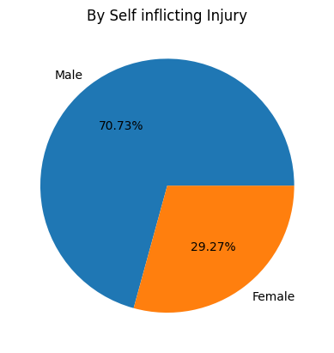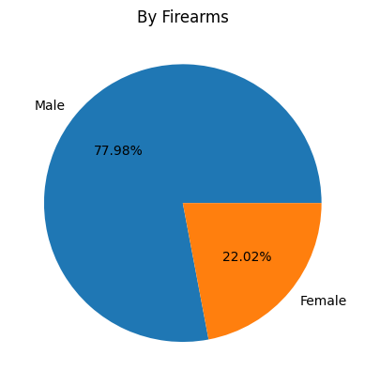
You can see how the percentage between men and women change by the change of the method of suicide

The reason of committing suicide
While the link between suicide and mental disorders (in particular, depression and alcohol use disorders) is well established in high-income countries, many suicides happen impulsively in moments of crisis with a breakdown in the ability to deal with life stresses, such as financial problems, relationship break-up or chronic pain and illness.

In addition, experiencing conflict, disaster, violence, abuse, or loss and a sense of isolation are strongly associated with suicidal behaviour.
Suicide rates are also high amongst vulnerable groups who experience discrimination, such as refugees and migrants; indigenous peoples; and prisoners. By far the strongest risk factor for suicide is a previous suicide attempt.
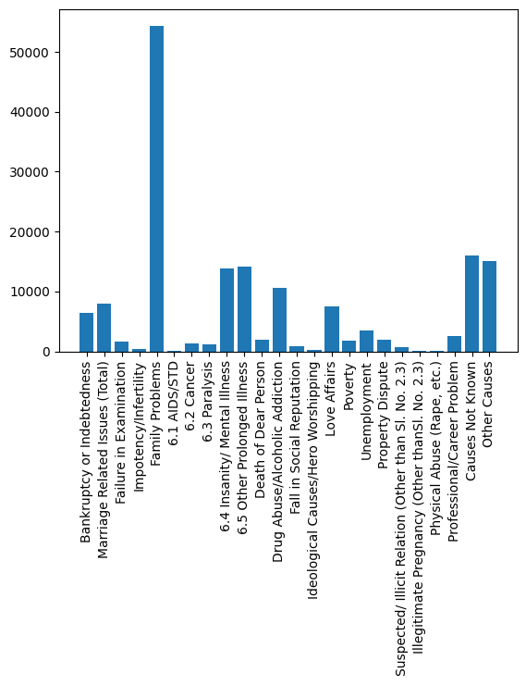
Sadly we can see from the data that the major cause of suicide is family problems
Both fatal and nonfatal suicidal behaviors have been linked consistently to negative parent-child relationships (e.g., high conflict, low closeness), child maltreatment, residing with less than two biological parents, and family history of affective and antisocial disorders. Parental separation/
divorces and family history of suicidal behavior and alcohol/substance abuse are more strongly associated with completed suicide than with other suicidal symptoms, but family systems problems (such as low cohesion and adaptability) and insecure parent-child attachments are more consistently associated with nonfatal suicidal symptoms than completed suicide

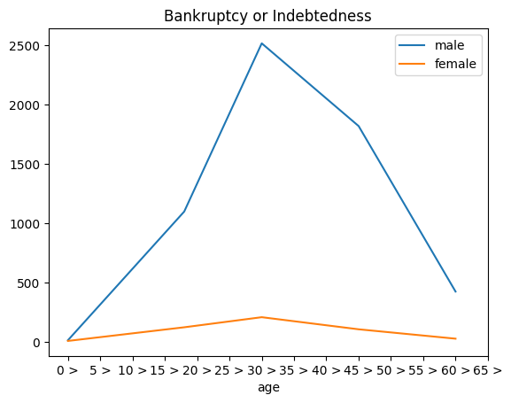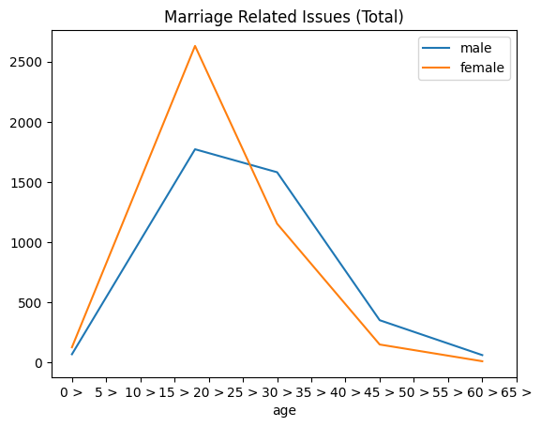
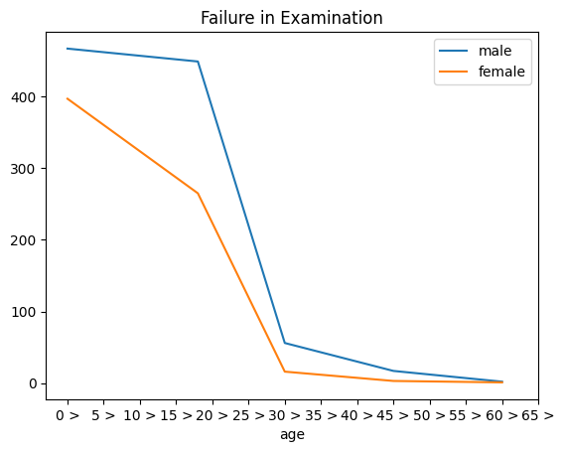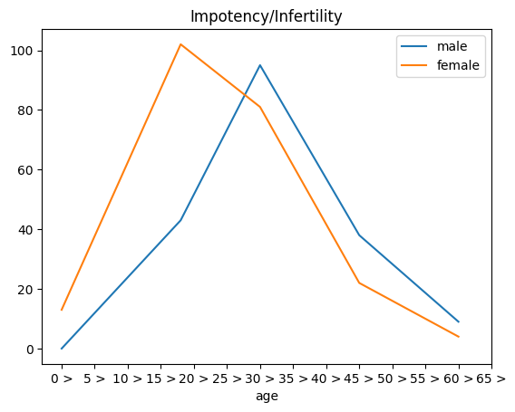

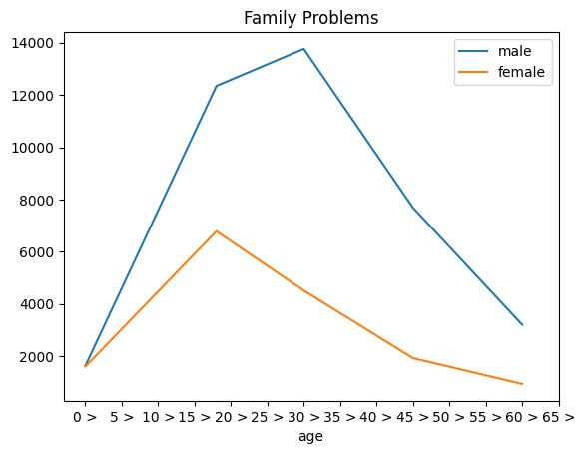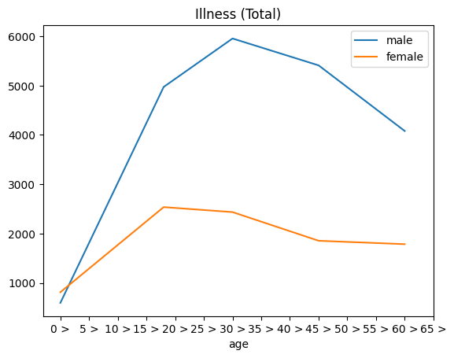

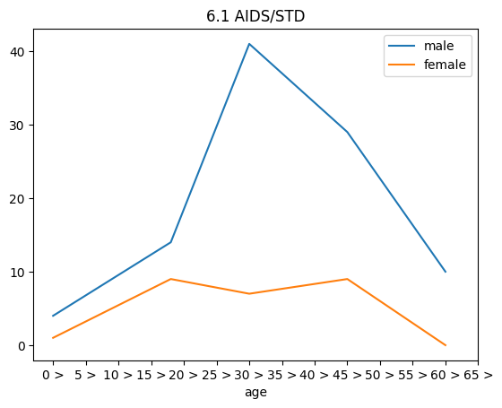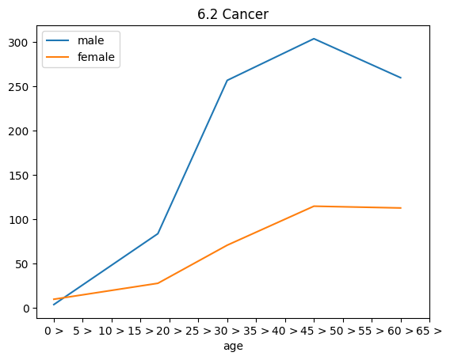
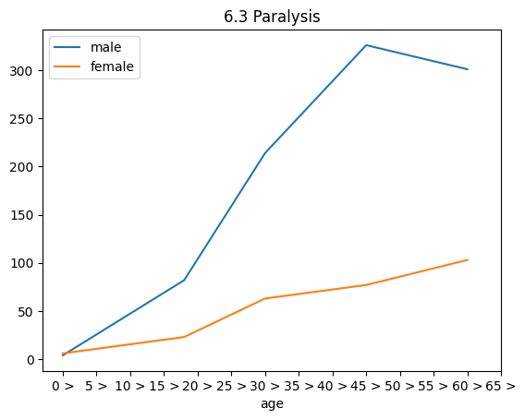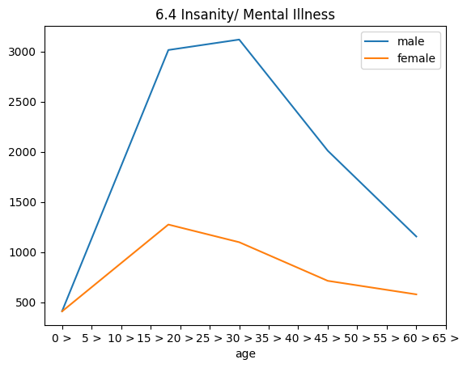

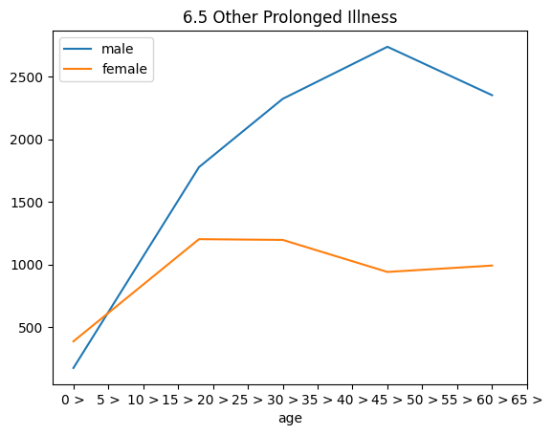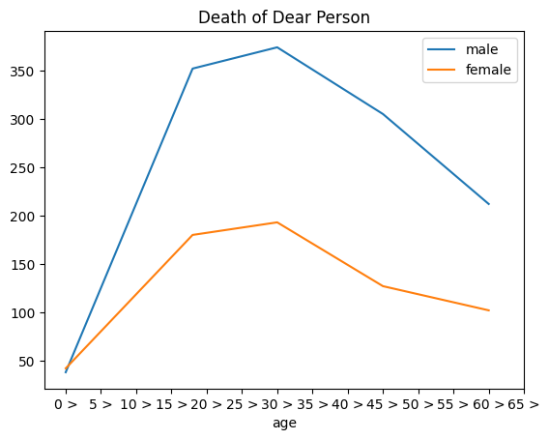
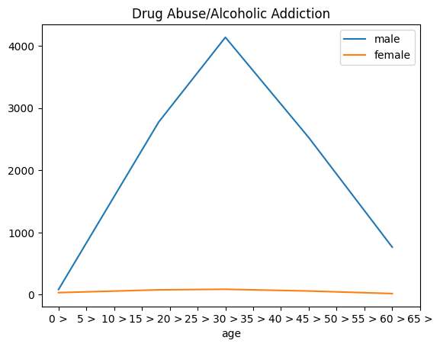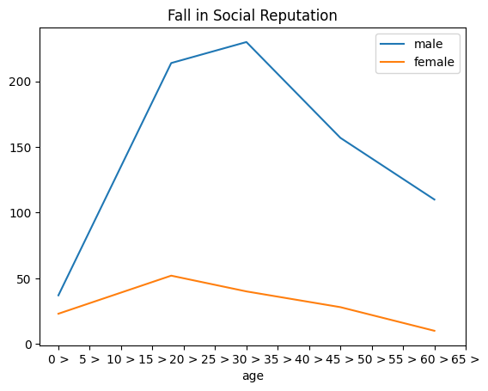
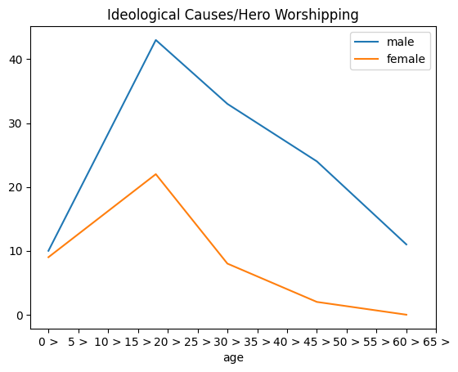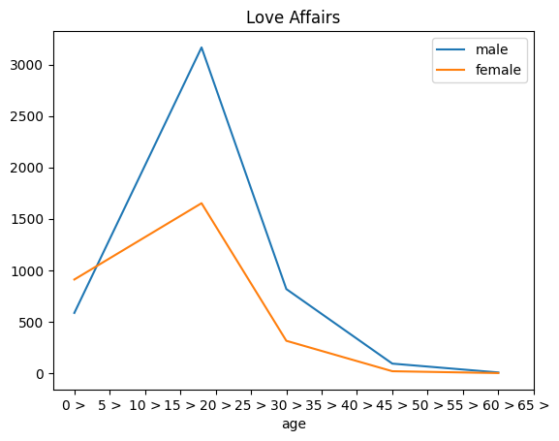

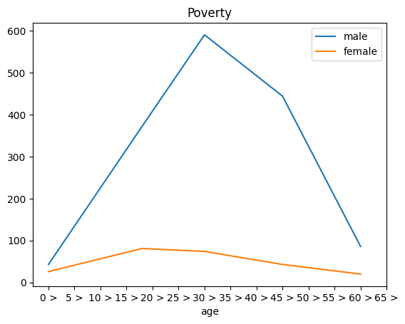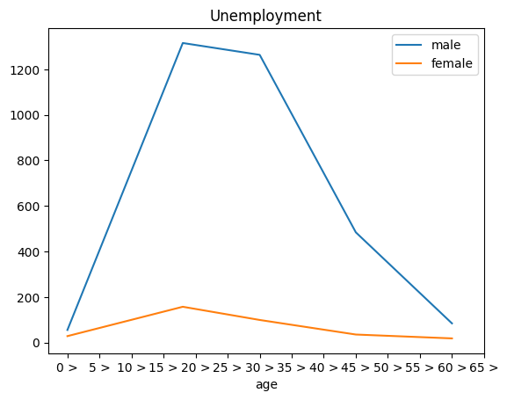
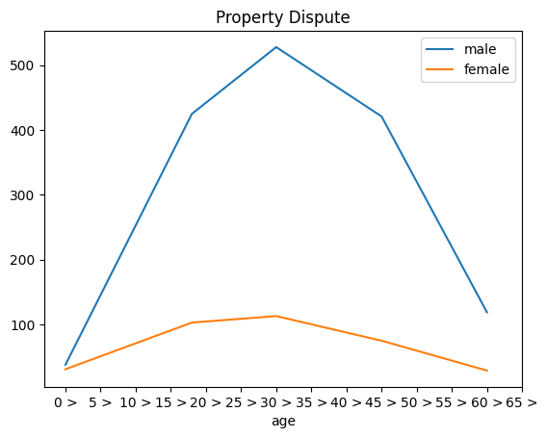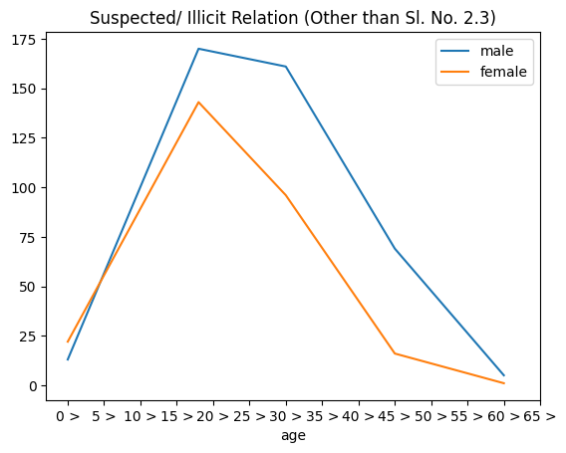
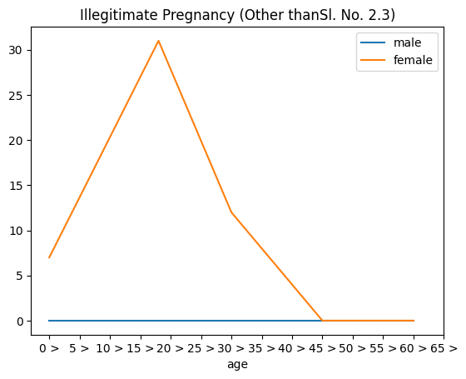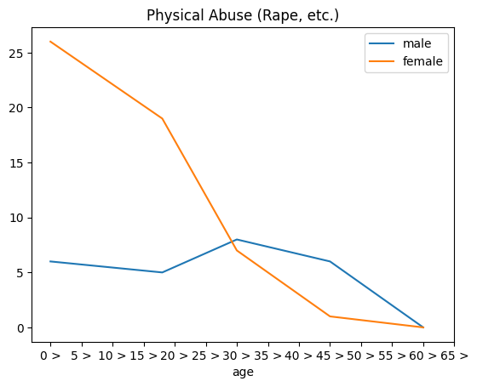

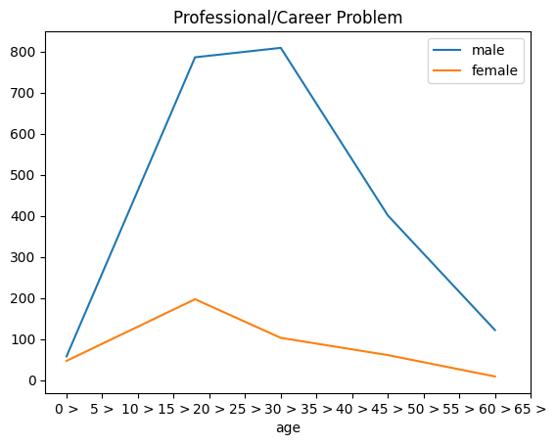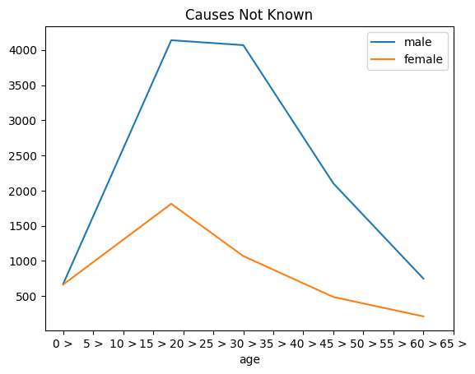
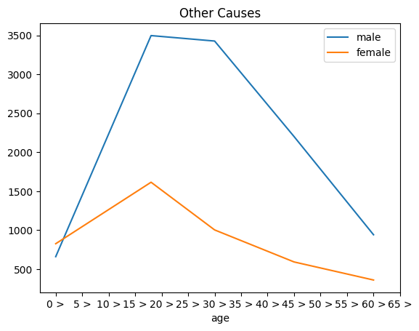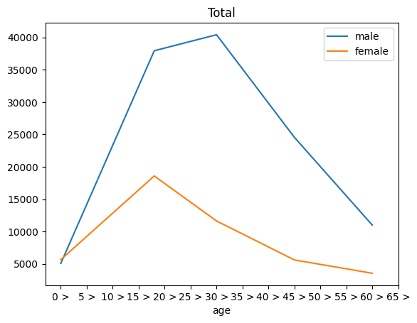

How to Prevent Suicide
Understanding the issues concerning suicide and mental health is an important way to take part in suicide prevention, help others in crisis, and change the conversation around suicide.
- Hope Can Happen
  - Suicide is not inevitable for anyone. By starting the conversation, providing support, and directing help to those who need it, we can prevent suicides and save lives.
- We Can All Take Action
  - Evidence shows that providing support services, talking about suicide, reducing access to means of self-harm, and following up with loved ones are just some of the actions we can all take to help others.
- Crisis Centers are Critical
  - By offering immediate counseling to everyone that may need it, local crisis centers provide invaluable support at critical times and connect individuals to local services.
Know the Warning Signs
Some warning signs may help you determine if a loved one is at risk for suicide, especially if the behavior is new, has increased, or seems related to a painful event, loss, or change. If you or someone you know exhibits any of these, seek help by calling the Lifeline.

- Talking about wanting to die or to kill themselves
- Looking for a way to kill themselves, like searching online or buying a gun
- Talking about feeling hopeless or having no reason to live
- Talking about feeling trapped or in unbearable pain
- Talking about being a burden to others
- Increasing the use of alcohol or drugs
- Acting anxious or agitated; behaving recklessly
- Sleeping too little or too much
- Withdrawing or isolating themselves
- Showing rage or talking about seeking revenge
- Extreme mood swings

