**FORMAN CHRISTIAN COLLEGE (A CHARTERED UNIVERSITY)**



**Information Security Section B**

**2023_FALL**

**Assignment#2**

**Moaeed Hussain – 241548737**

**Topic: EXECUTION OF EXPLOIT AND MSFVENOM COMMANDS**

**Basic msfvenom**

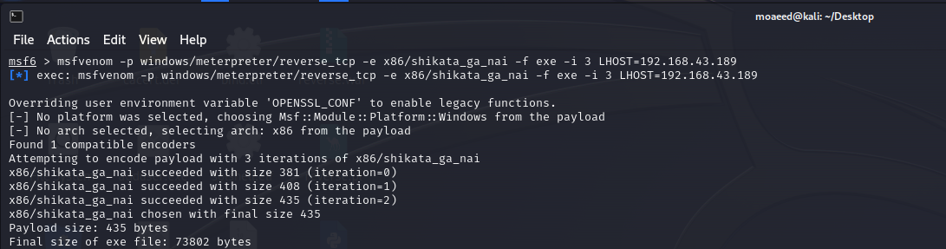

**Listing**

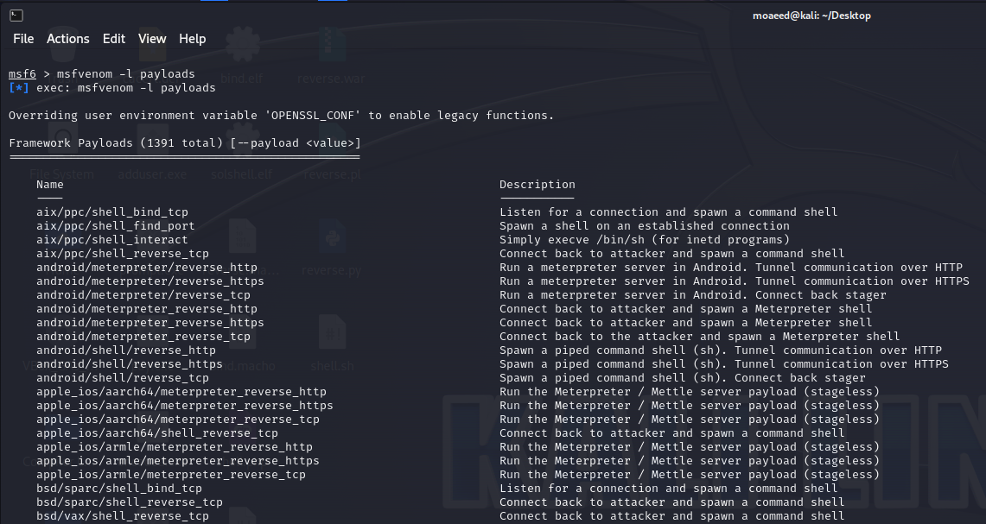

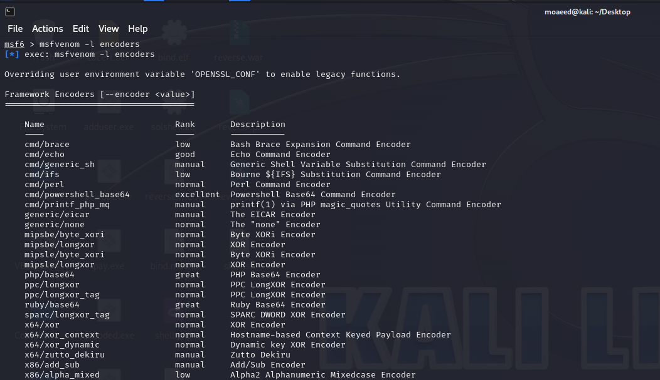

**Common params when creating a shellcode**

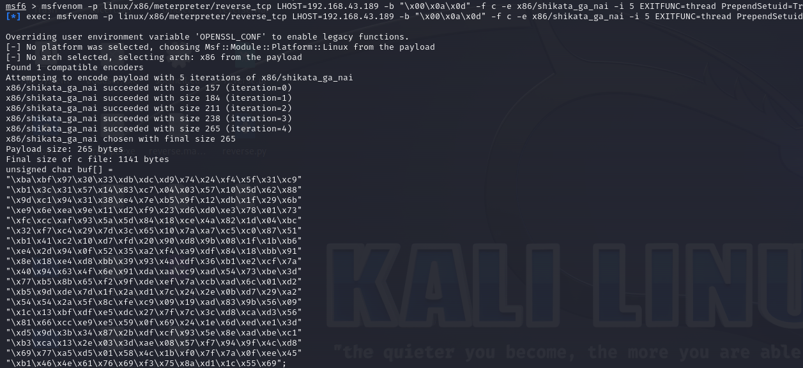

**Windows**

**Reverse Shell:**

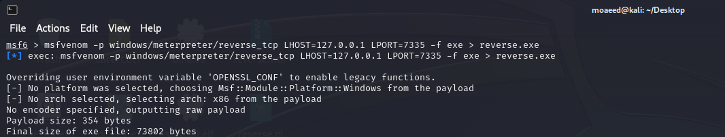

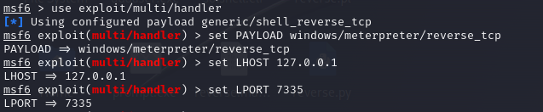

**Bind Shell:**

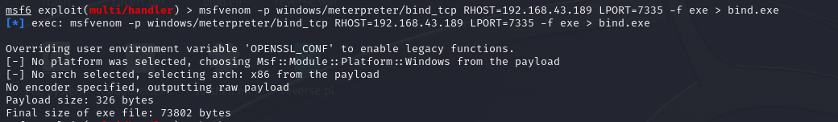

**Create User:**

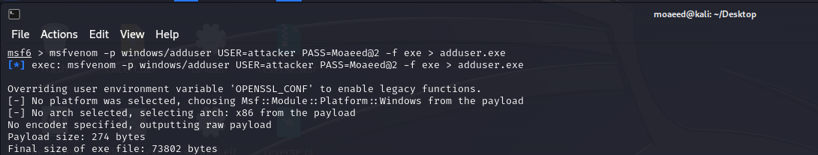

**CMD Shell:**

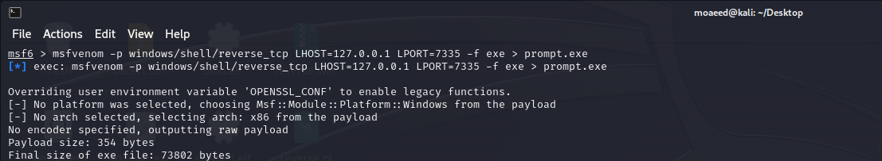

**Execute Command:**

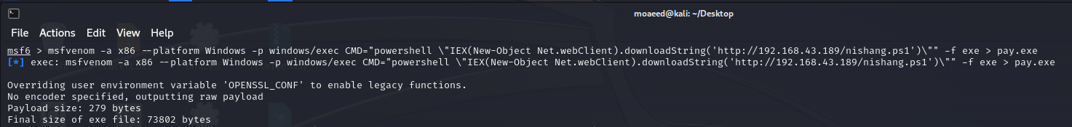

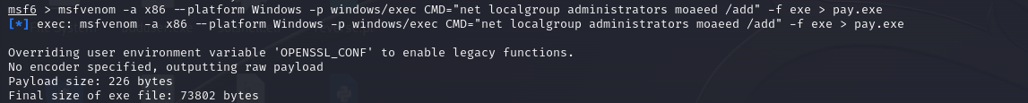

**Encoder:**

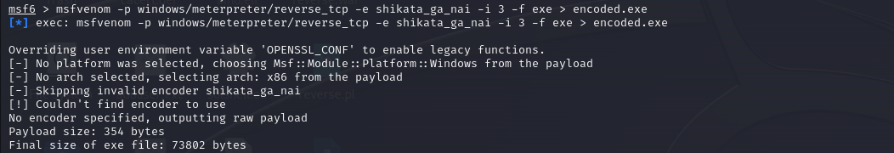

**Embedded inside executable:**

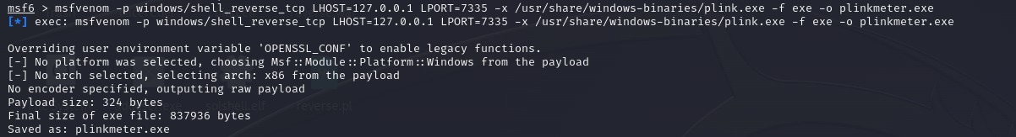

**Linux Payloads**

**Reverse Shell:**

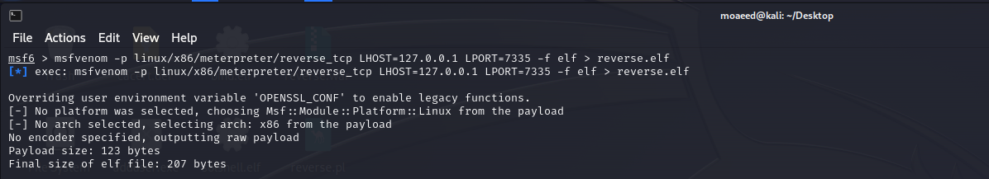

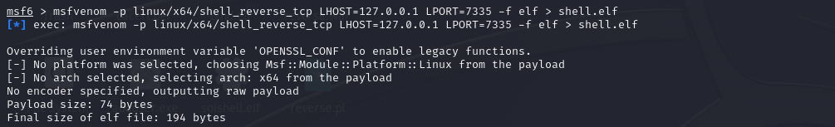

**Bind Shell:**

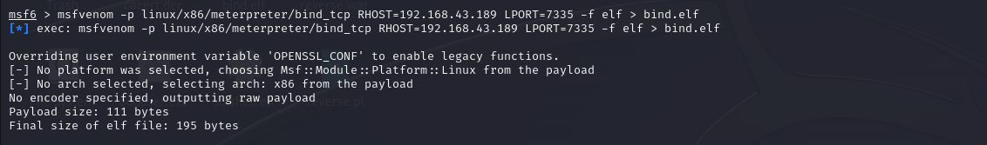

**SunOS (Solaris):**

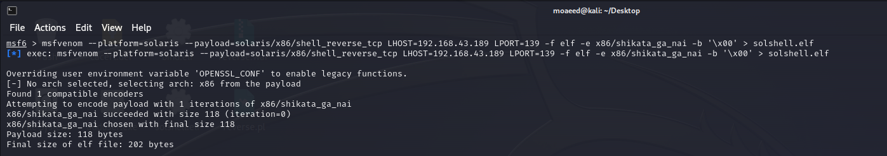

**MAC Payloads**

**Reverse Shell:**

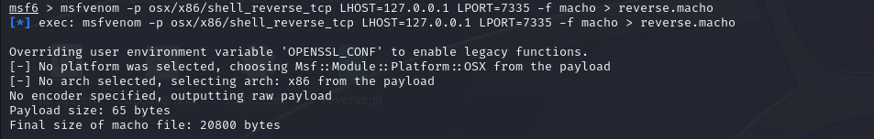

**Bind Shell:**

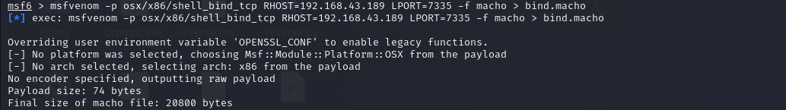

**Web Based Payloads**

**PHP**

**Reverse shell:**

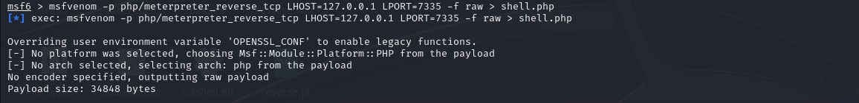

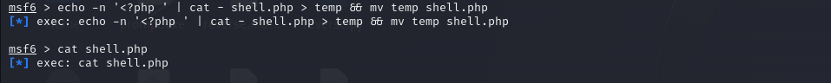

**ASP/x**

**Reverse shell:**

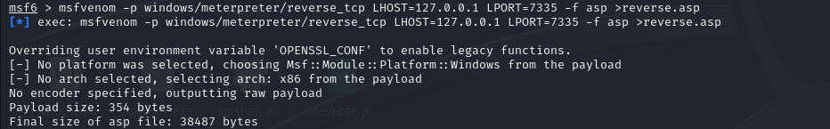

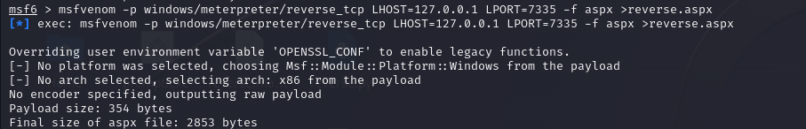

**JSP**

**Reverse shell:**



**WAR**

**Reverse Shell:**

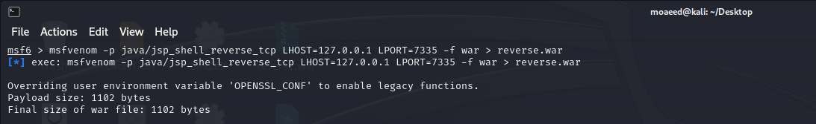

**NodeJS**

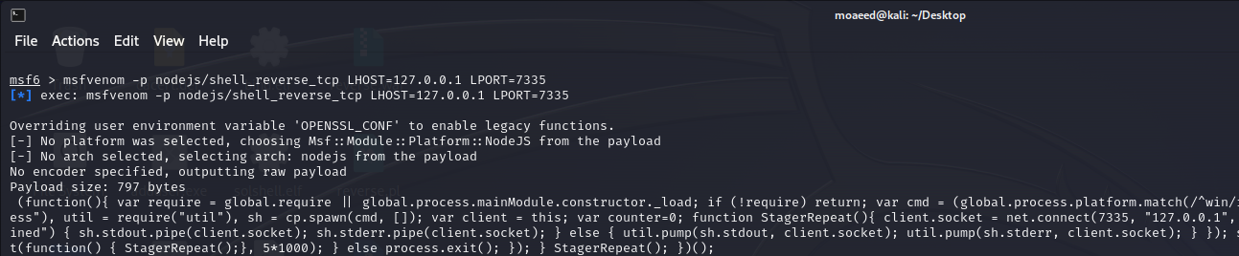

**Script Language payloads**

**Perl:**

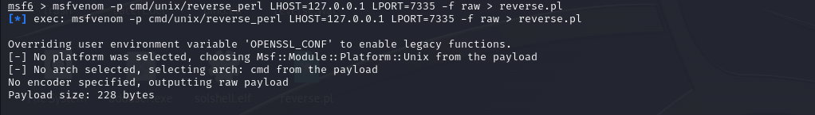

**Python:**

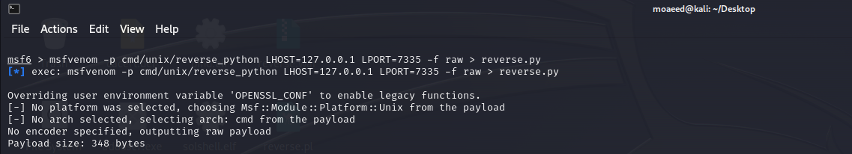

**Bash:**

