**Assignment :01**

**Task 1**

1Q. Install Jupyter notebook and run the first program and share the screenshot of the output.

Ans :Installed successfully.

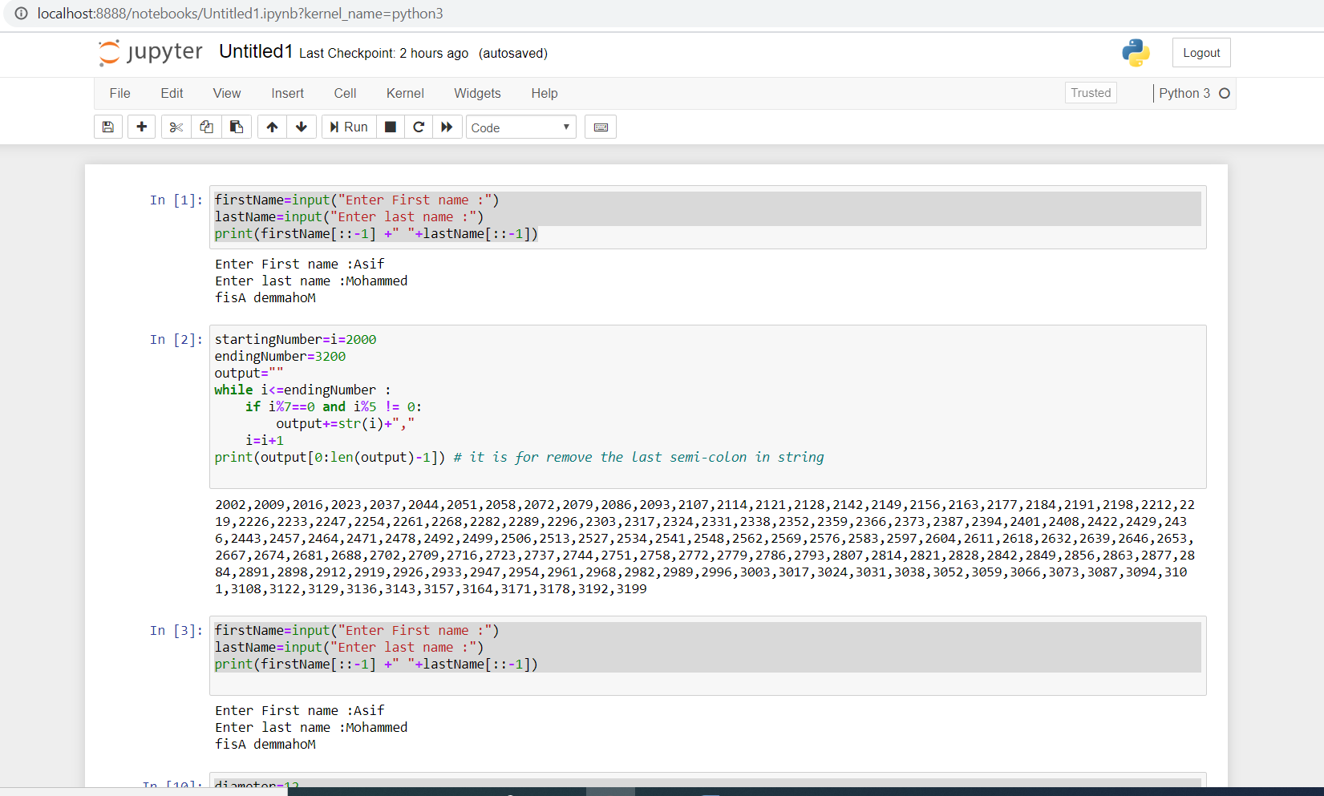

2Q. Write a program which will find all such numbers which are divisible by 7 but are not a multiple of 5, between 2000 and 3200 (both included). The numbers obtained should be printed in a comma-separated sequence on a single line.

Program :

startingNumber=i=2000

endingNumber=3200

output=""

while i<=endingNumber :

if i%7==0 and i%5 != 0:

output+=str(i)+","

i=i+1

print(output[0:len(output)-1]) # *it is for remove the last semi-colon in string*

Output:

2002,2009,2016,2023,2037,2044,2051,2058,2072,2079,2086,2093,2107,2114,2121,2128,2142,2149,2156,2163,2177,2184,2191,2198,2212,2219,2226,2233,2247,2254,2261,2268,2282,2289,2296,2303,2317,2324,2331,2338,2352,2359,2366,2373,2387,2394,2401,2408,2422,2429,2436,2443,2457,2464,2471,2478,2492,2499,2506,2513,2527,2534,2541,2548,2562,2569,2576,2583,2597,2604,2611,2618,2632,2639,2646,2653,2667,2674,2681,2688,2702,2709,2716,2723,2737,2744,2751,2758,2772,2779,2786,2793,2807,2814,2821,2828,2842,2849,2856,2863,2877,2884,2891,2898,2912,2919,2926,2933,2947,2954,2961,2968,2982,2989,2996,3003,3017,3024,3031,3038,3052,3059,3066,3073,3087,3094,3101,3108,3122,3129,3136,3143,3157,3164,3171,3178,3192,3199

**Screenshot :**

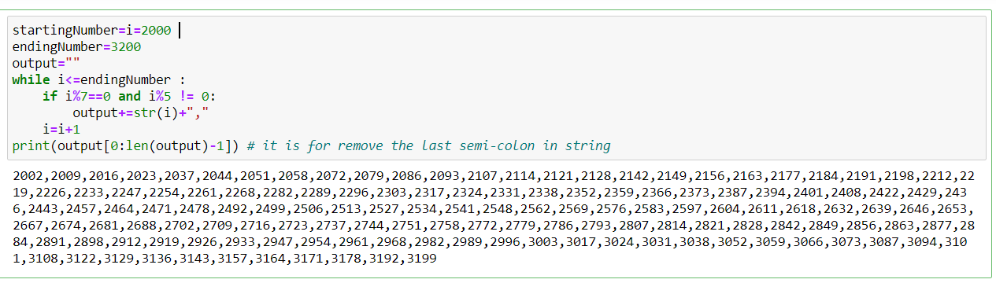

3Q. Write a Python program to accept the user's first and last name and then getting them printed in the the reverse order with a space between first name and last name.

Program :

firstName=input("Enter First name :")

lastName=input("Enter last name :")

print(firstName[::-1] +" "+lastName[::-1])

output :

Enter First name :Asif

Enter last name :Mohammed

fisA demmahoM

**Screenshot :**

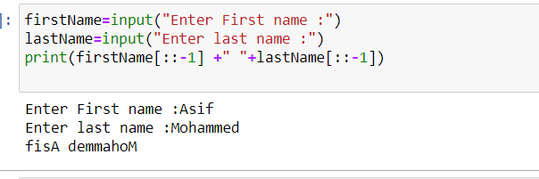

4Q. Write a Python program to find the volume of a sphere with diameter 12 cm.

Formula: V=4/3 * π * r 3

Program:

diameter=12

radius=diameter/2;

volumeOfSphere=4/3*3.14*radius*radius*radius

print(volumeOfSphere)

# trying with other way by importing the math module

import math

volumeOfsphere=(4/3)*math.pi*math.pow(radius,3)

print(volumeOfSphere)

output :

904.3199999999998

904.3199999999998

**Screenshot :**

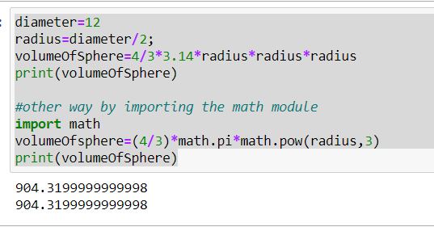

**Task 2**

1Q. Write a program which accepts a sequence of comma-separated numbers from console and generate a list.

Program :

numbers=input("enter the numbers "); # here all numbers are in string

l=list(numbers[::2]) # here to remove comma's(,) from string

list1=[]

for i in l:

list1.append(int(i)) # here appends the interger value to list

print(list1)

Output :

enter the numbers 1,2,3,4,5,6

[1, 2, 3, 4, 5, 6]

**ScreenShot**

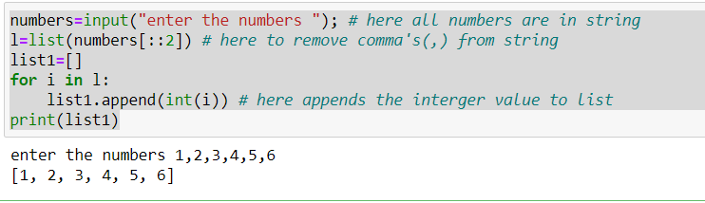

2Q. Create the below pattern using nested for loop in Python.

*

* *

* * *

* * * *

* * * * *

* * * *

* * *

* *

*

Program :

i=j=0

# Here range() funtion used to indicates the maximum star's in line

for i in range(6) : # here this code for minimum to maximum star's

for j in range(i):

print("*" ,end=" ")

print("\n")

else :

for i in range(4,0,-1) : #here code for maximum to minimum star's

for j in range(i) :

print("*" ,end=" ")

print("\n")

Output :

*

* *

* * *

* * * *

* * * * *

* * * *

* * *

* *

*

**ScreenShot**

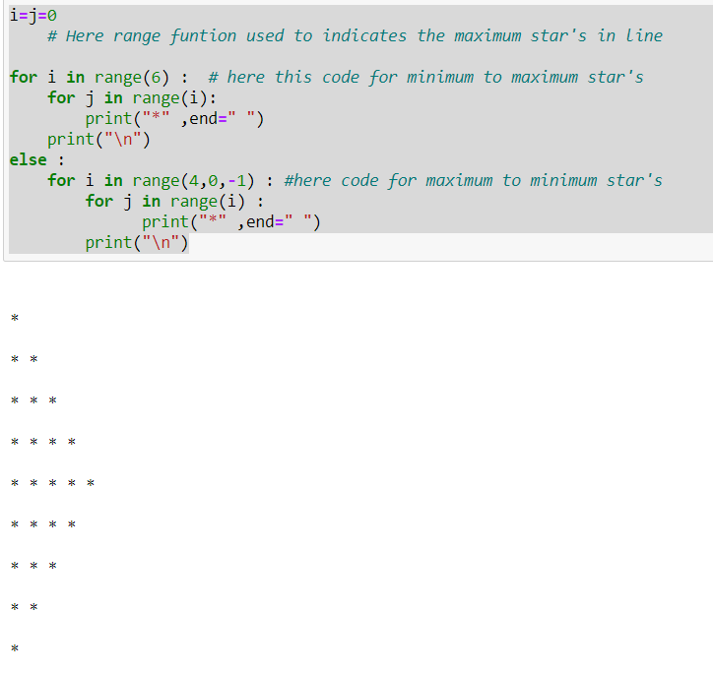

3Q. Write a Python program to reverse a word after accepting the input from the user.

Sample Output:

Input word: AcadGild

Output: dilGdacA

Program :

inputWord=input("Enter the Name :")

outputWord=inputWord[::-1]

print(outputWord)

Output :

Enter the Name: Asif Mohammed

demmahoM fisA

**Screenshot**

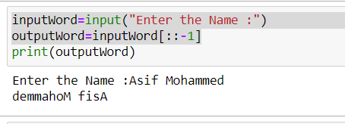

4Q. Write a Python Program to print the given string in the format specified in the sample output.

WE, THE PEOPLE OF INDIA, having solemnly resolved to constitute India into a SOVEREIGN, SOCIALIST, SECULAR, DEMOCRATIC REPUBLIC and to secure to all its citizens

**Sample output**

WE, THE PEOPLE OF INDIA,

having solemnly resolved to constitute India into a SOVEREIGN, !

SOCIALIST, SECULAR, DEMOCRATIC REPUBLIC

and to secure to all its citizens

**Program :**

string2 ='''WE, THE PEOPLE OF INDIA,

having solemnly resolved to constitute India into a SOVEREIGN, !

SOCIALIST, SECULAR, DEMOCRATIC REPUBLIC

and to secure to all its citizens'''

print(string2)

**Output :**

WE, THE PEOPLE OF INDIA,

having solemnly resolved to constitute India into a SOVEREIGN, !

SOCIALIST, SECULAR, DEMOCRATIC REPUBLIC

and to secure to all its citizens

**Screenshot:**

