* Entity description

Tows complement -> gets twos complement of input

Compare add sub -> one step of booth algorithm

Shift reg -> initialization and stopping of booth (states)

Booth integration ->perform multiplication using the previous components

Booth adder components -> 10 X booth integration and accumulation

Shift reg integration ->stops accumulation and raise done

------moamen

* Timing diagrams

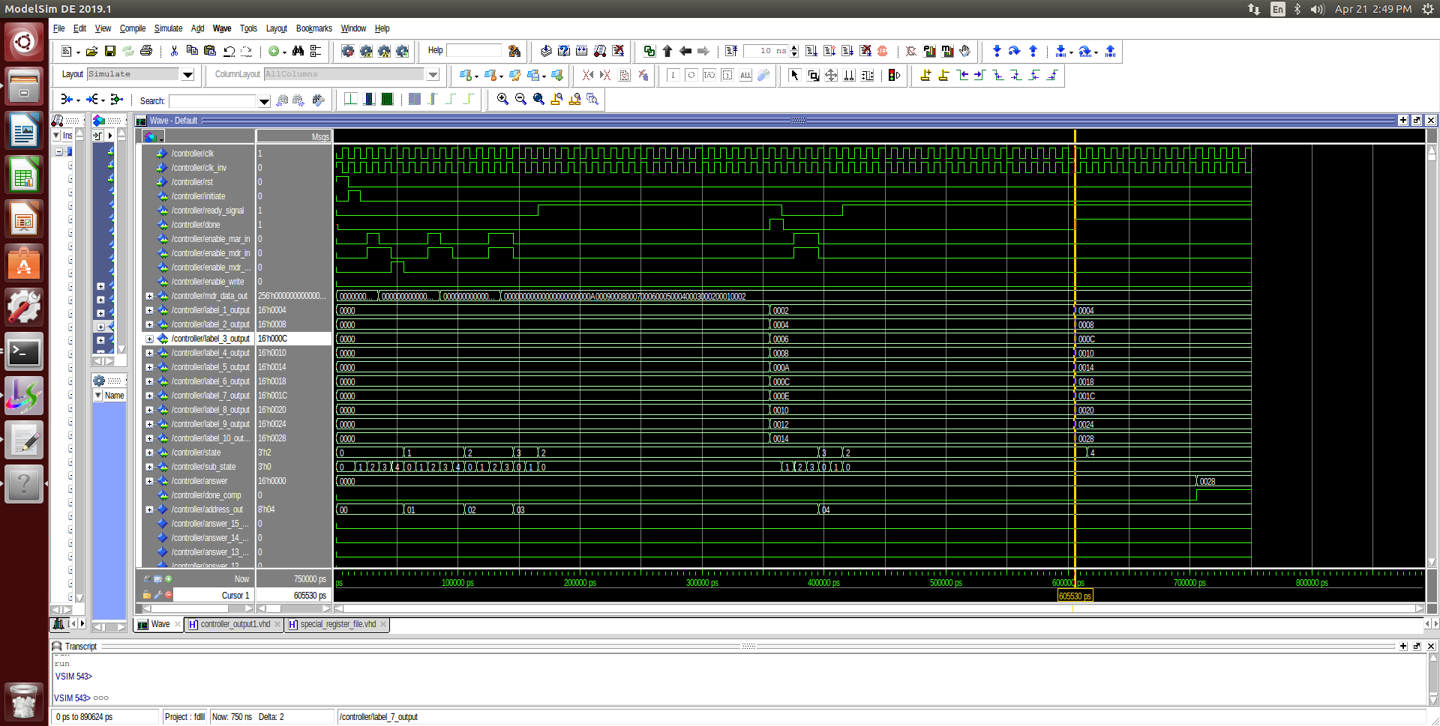

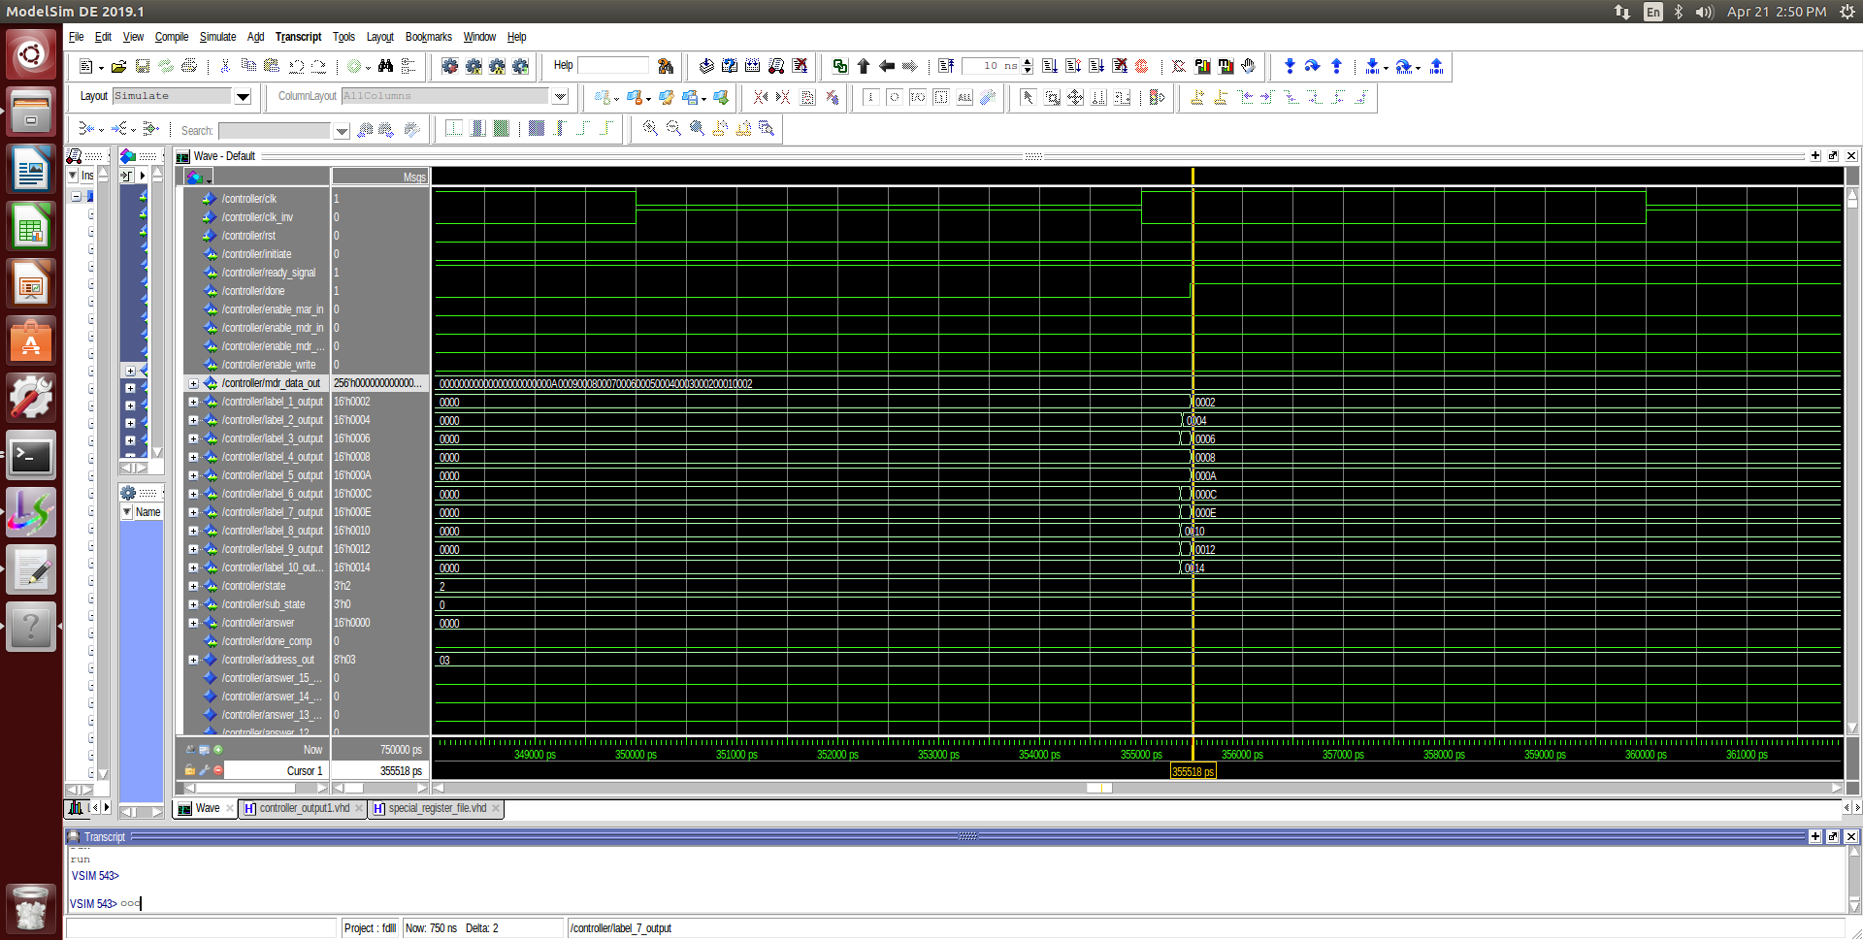

* Tree

