Name : moamen hamed mohammed

1- Ubuntu, Red Hat, Fedora.

2- man command is used to display a system-wide documentation system that is the traditional UNIX documentation.

3- rm: removes files or directories.  
rmdir: removes empty directories.

4-

a-

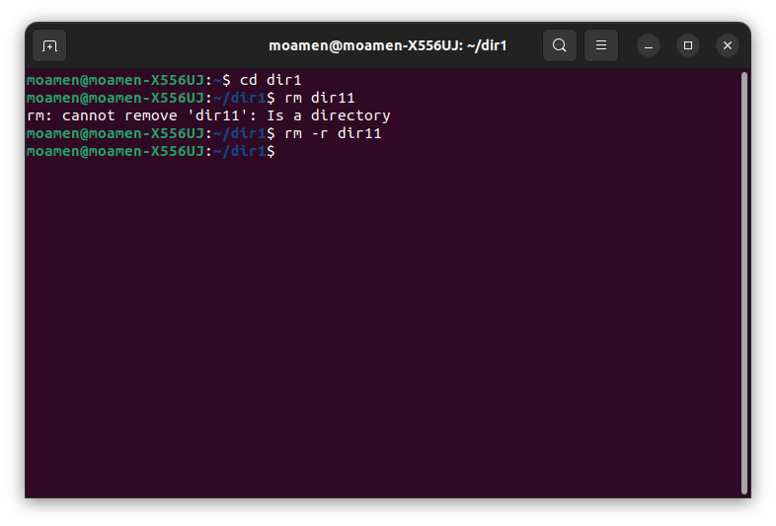

couldn’t remove dir11 in one step as the directory was not empty. Using [rm -r] overcomes this issue.

b- the case where oldfiles is a directory: it removes both oldfiles and documents.

c- absolute path: */ home / moamen / documents / mycv*

*- relative path: documents / mycv*

*5-*

*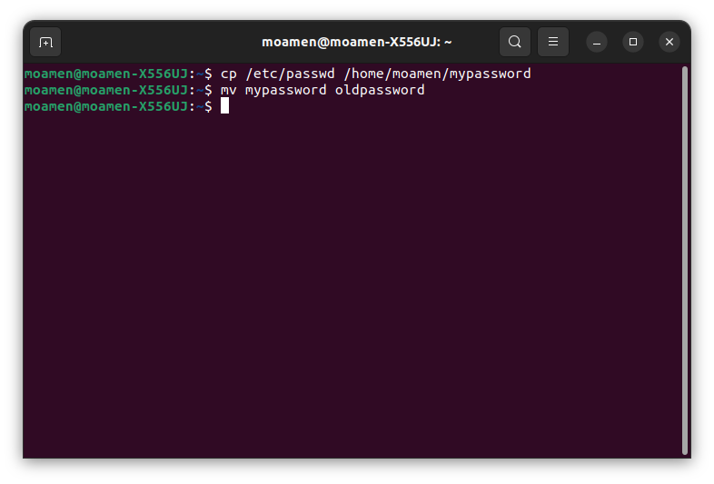*

*6-*

*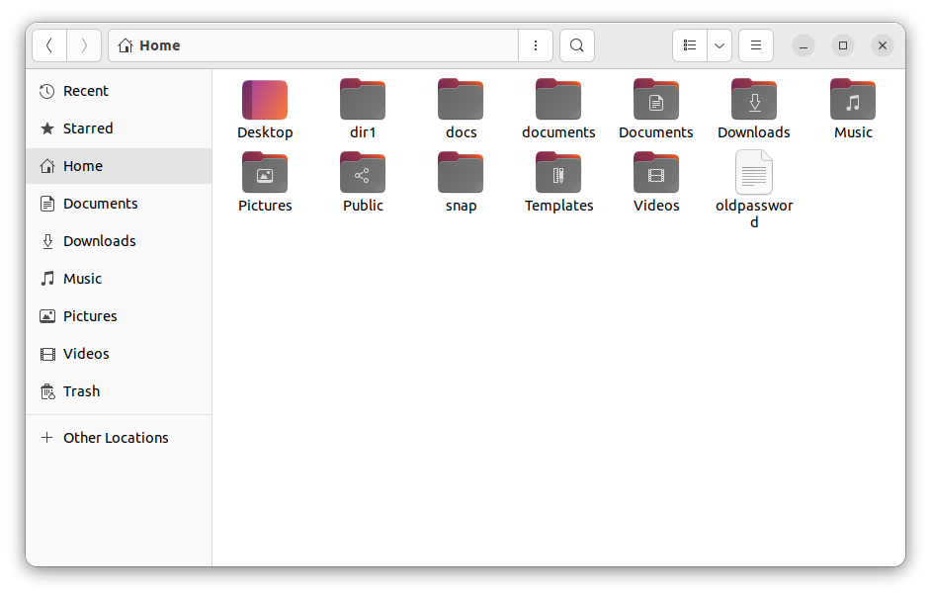*

*7- cd / home  
- cd .. / .. / home*

*- cd - (if we were in /home before)*

*- cd ~*

*8-*

*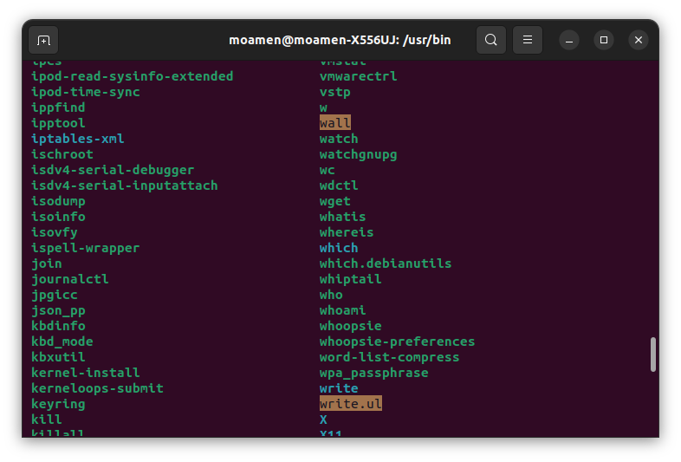*

*9- to display information about command type.*

*10-*

*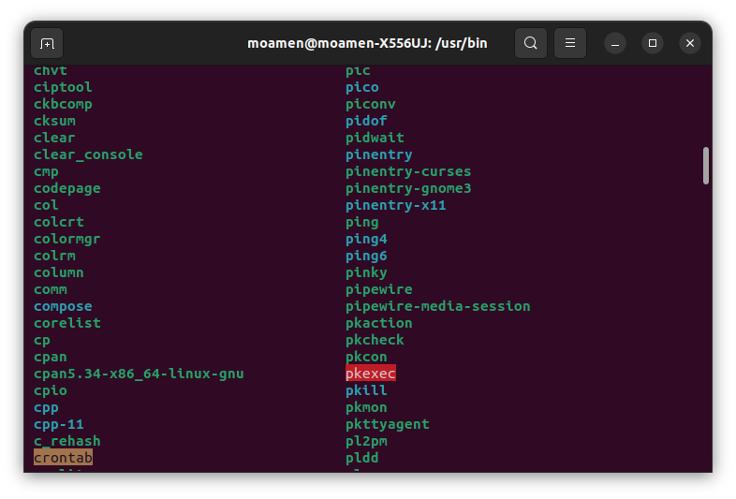*

*11- use man -k read file to get any commands related – the command is cat.*

*12- used to search the man page files.*