Name : moamen hamed mohammed

1- Ubuntu, Red Hat, Fedora.

2- man command is used to display a system-wide documentation system that is the traditional UNIX documentation.

3- rm: removes files or directories.
rmdir: removes empty directories.

4-
a-
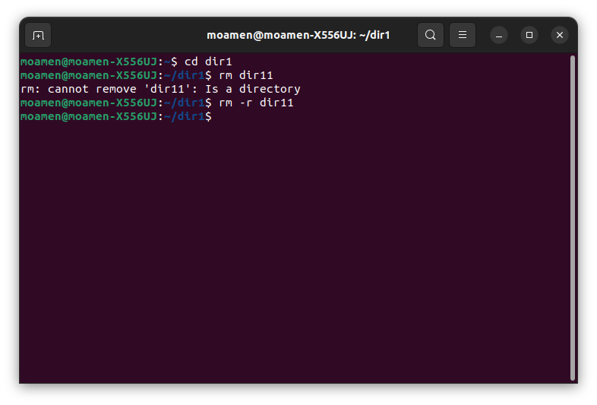
couldn’t remove dir11 in one step as the directory was not empty. Using [rm -r] overcomes this issue.

b- the case where oldfiles is a directory: it removes both oldfiles and documents.

c- absolute path: / home / moamen / documents / mycv
- relative path: documents / mycv

5-
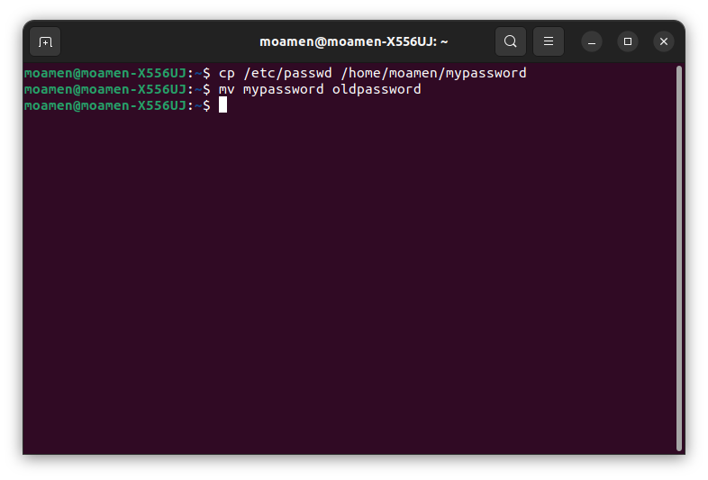

6-
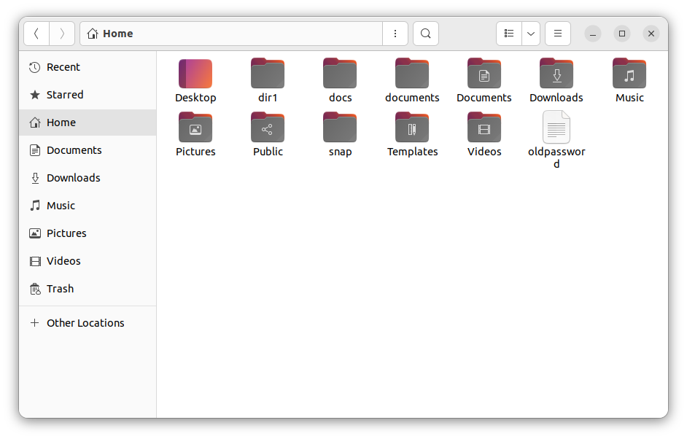

7- cd / home
- cd .. / .. / home
- cd - (if we were in /home before)
- cd ~

8-
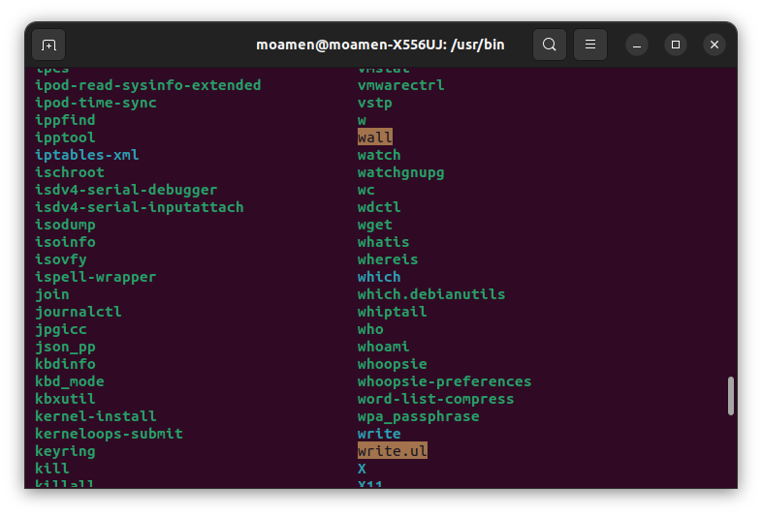

9- to display information about command type.

10-
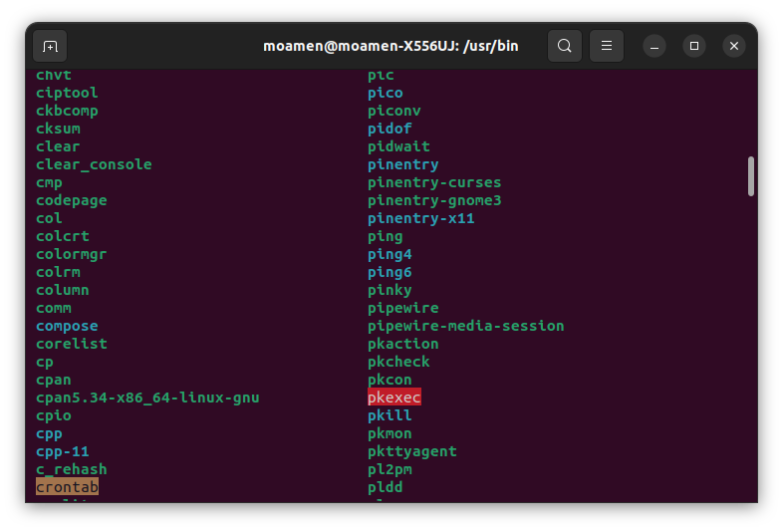

11- use man -k read file to get any commands related – the command is cat.

12- used to search the man page files.

