A table was created using the following query : CREATE TABLE logsTable(

sessionId int ,

log text ,

PRIMARY KEY(sessionId,log)

);

, then RESTful api project using .Net 6.0 was created :   
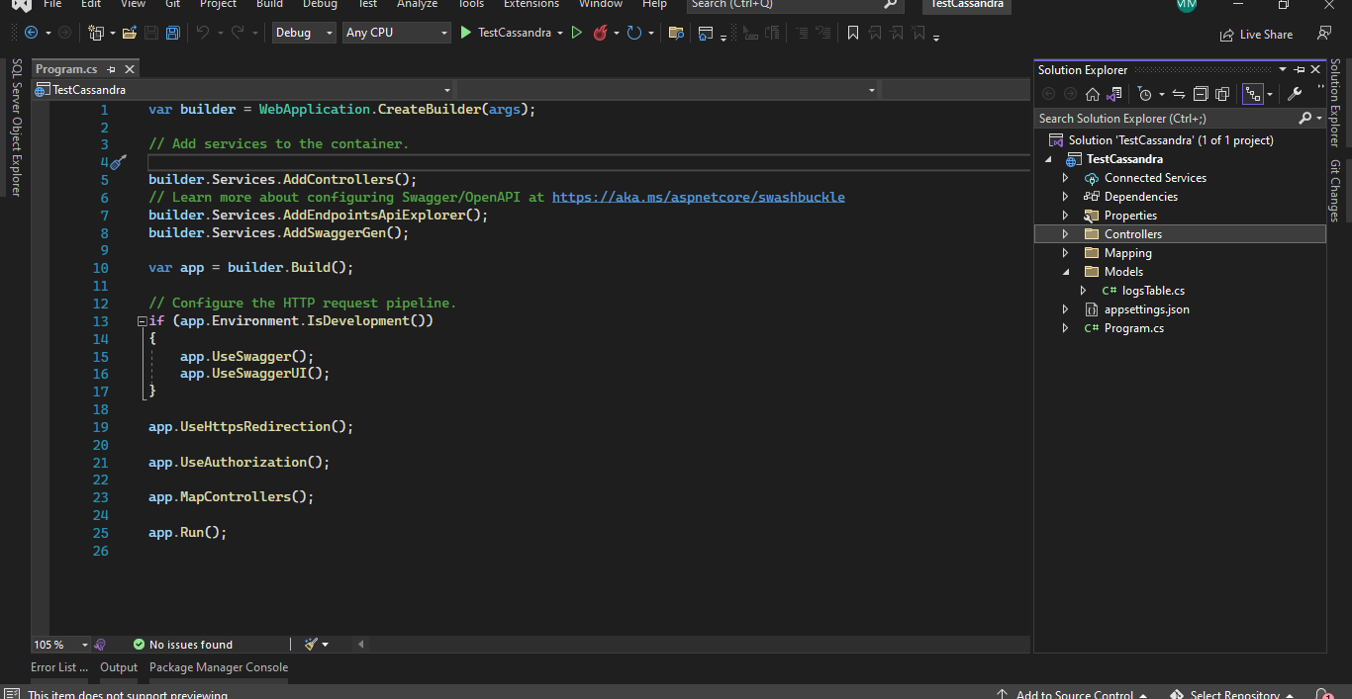

, Mapping class was created to map the properties to the fields in the table :

, Controller with the needed endpoints was created :

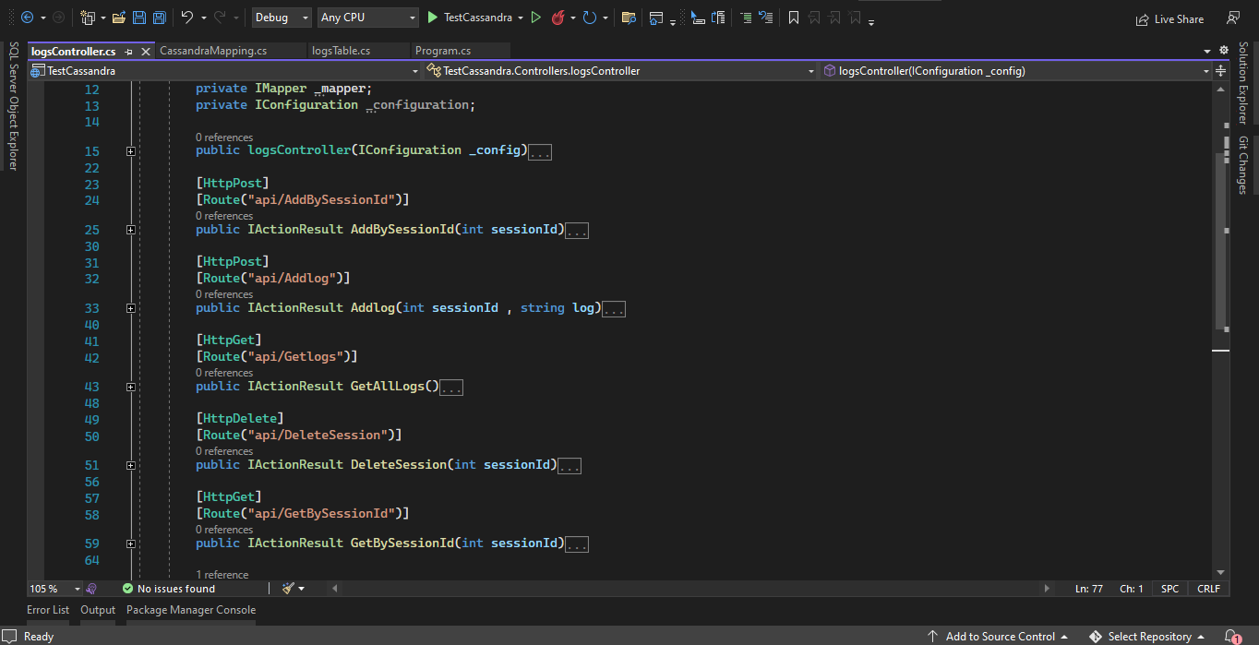

, appsettings.json file was created to have the needed configuration if exists such : DB connection :

, testing the api using the postman   
