

|  |  |  |
| --- | --- | --- |
|  |  |  |

**ELC201A-Project-1**

**[1] Transistor Characterization:**

* Perform DC sweep for Vout (from 0 to 3V) while Vin=2V and plot ID vs. Vout.

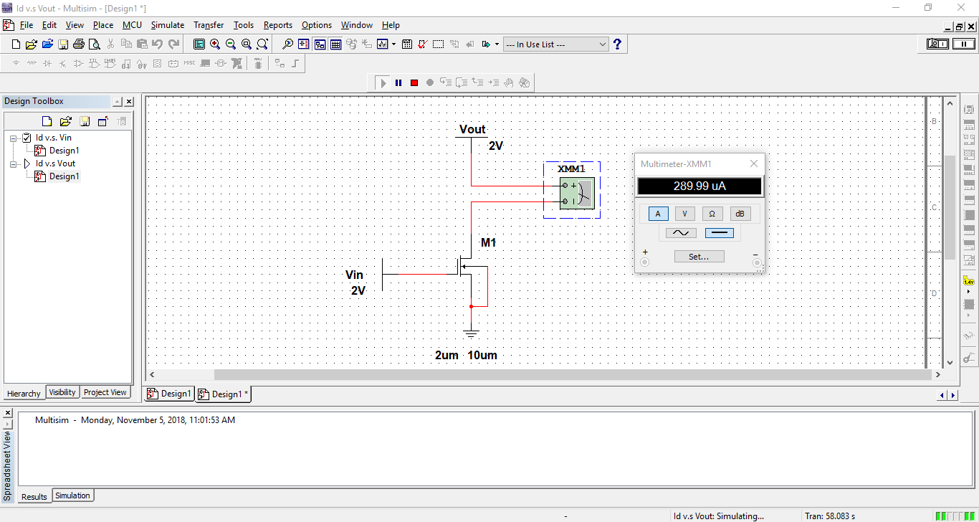

By sweeping from 0 to 3 volts and observe the change of :

vary from 0 to 3 volts, by step 0.1.

By using the Multimeter to measure the current of of the corresponding .

The Results:

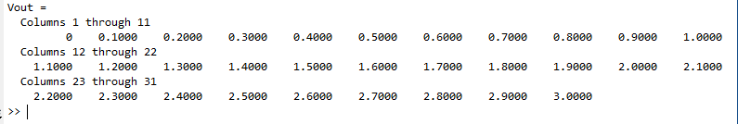

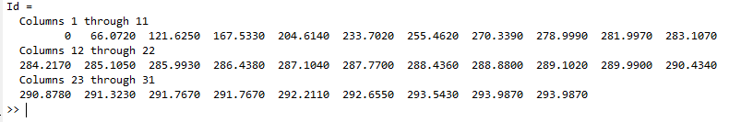

We used MATLAB to plot the result as shown in the figure.

From the curve shown we can notice that

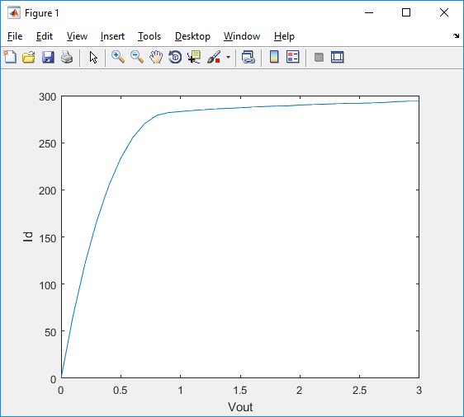

By Taking the slope of the curve from = 0.95 Volt to 3.0 Volt to get

Using the built-in function in MATLAB to get slope:



Therefore slope = 5.5021 μ .

Then Ω

Since λ = , where from the mean of the saturation region

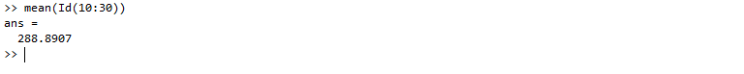

• Perform DC sweep for Vin (from 0 to 3V) while Vout=2V and plot ID vs. Vin.

Same as the above problem

By sweeping from 0 to 3 volts and observe the change of :

vary from 0 to 3 volts, by step 0.1.

By using the Multimeter to measure the current of of the corresponding .

The Results:

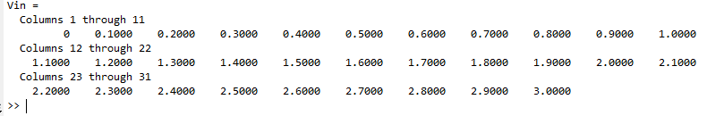

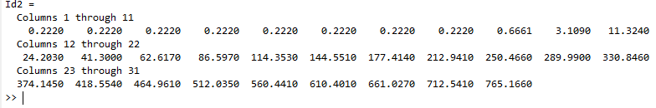

By plotting the results:

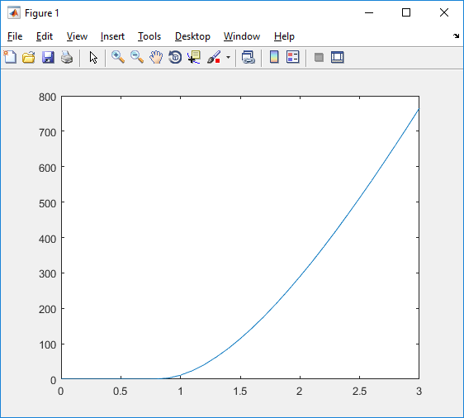

 

• To get :

We need to get from figure of vs. Vin.

Since

Using MATLAB to get slope



Therefore

• To get

Since, , by substituting

**[2] Single Stage Amplifier:**

Dc Analysis

1. V TH =0.95 V ,
2. .

3) , , µn Cox = ID=100 UA.

4) Assume Saturated:

* V gs =1.06257 volt.

* VD > VG- V TH.

5) From high frequency

* R<10.61k Ω .
* vg < 2.8889  
  Let Vg=V dc =2volt.
* R=10k Ω .

6) From the low frequency:

* C=3.1uF .

Midband Gain

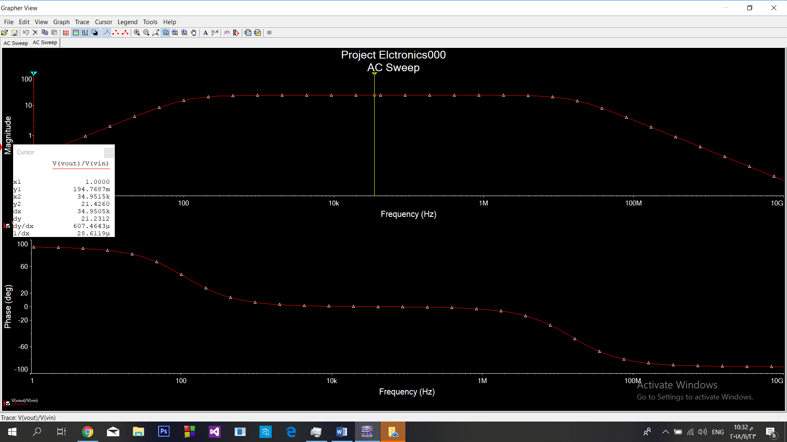

Low Frequency Analysis

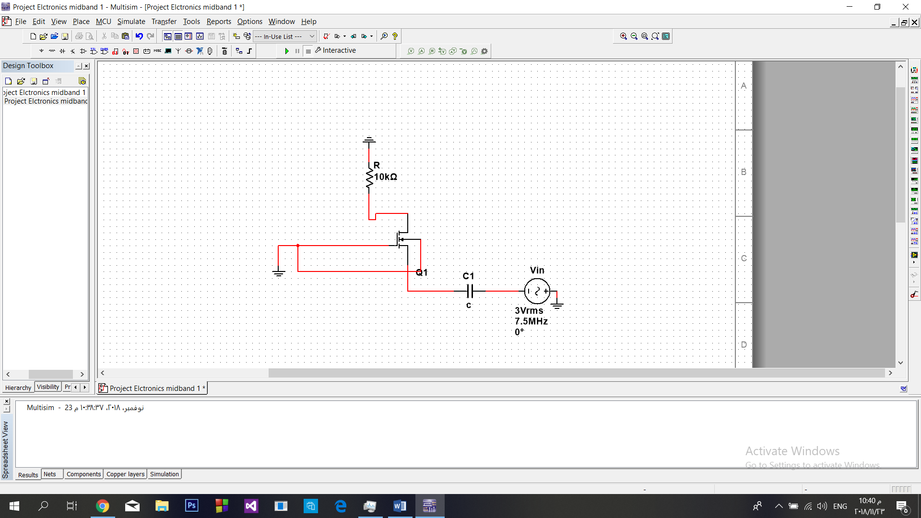

* c=3.1uF.

Simulation For AC Sweep

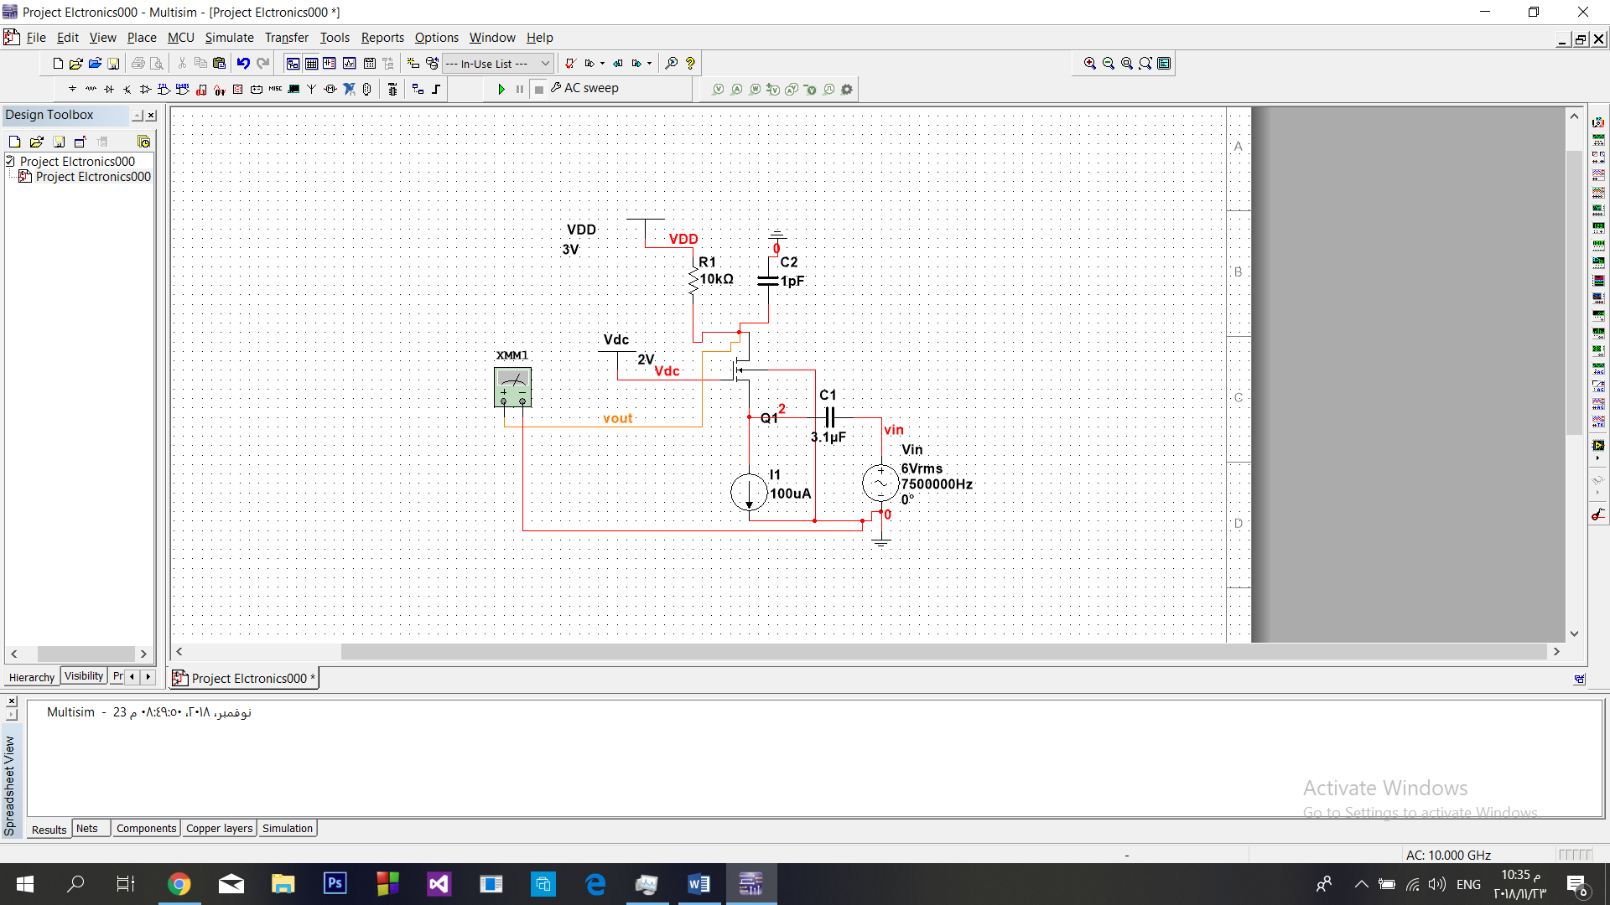

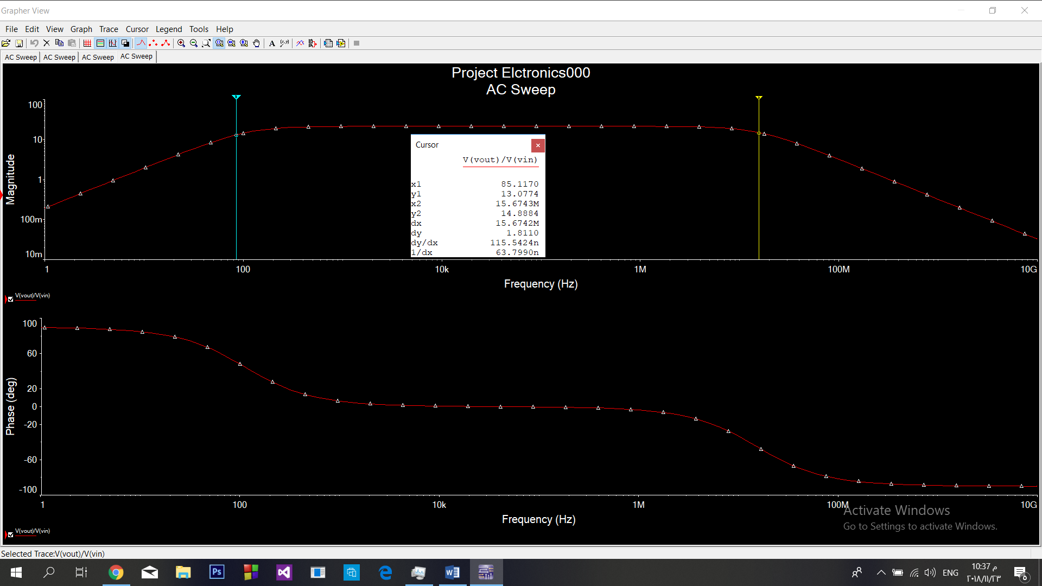

High Frequency Analysis

* R <10.61 kΩ .

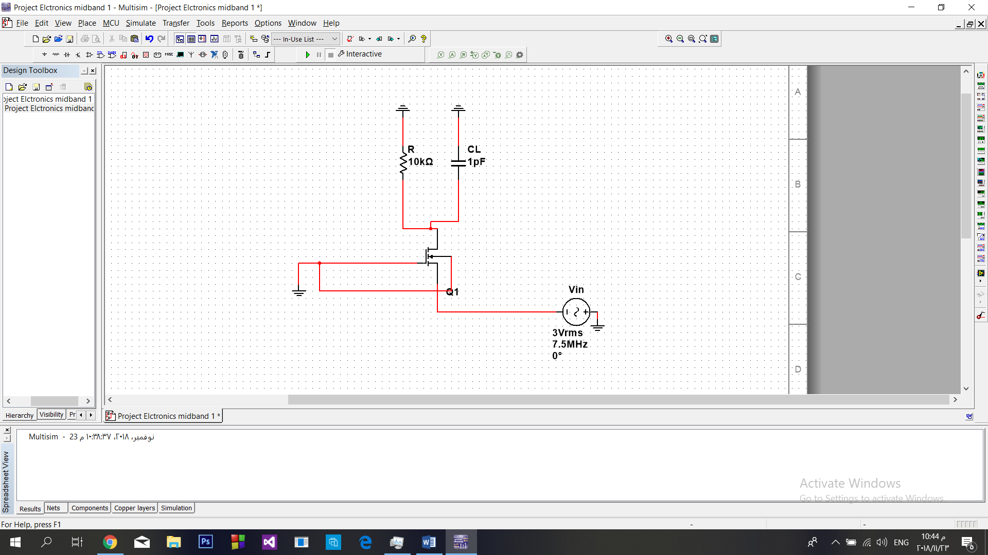

Rin And Rout

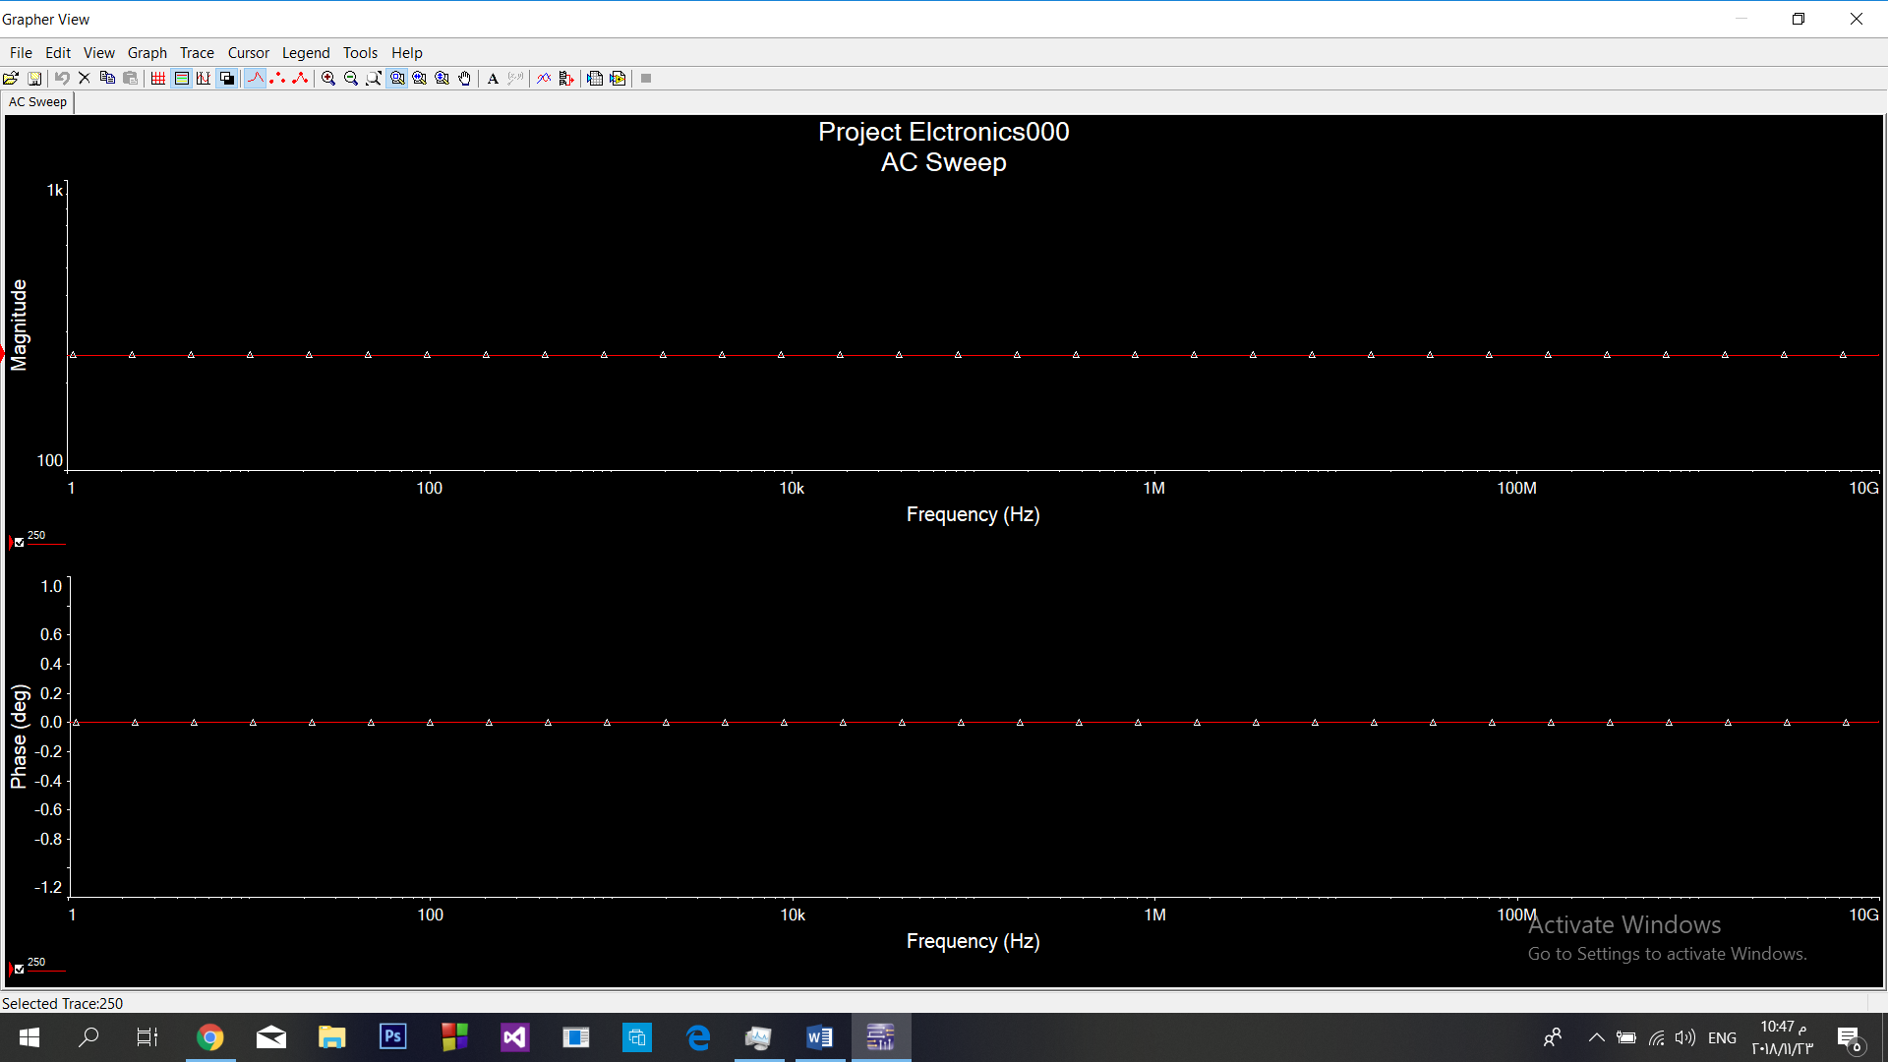

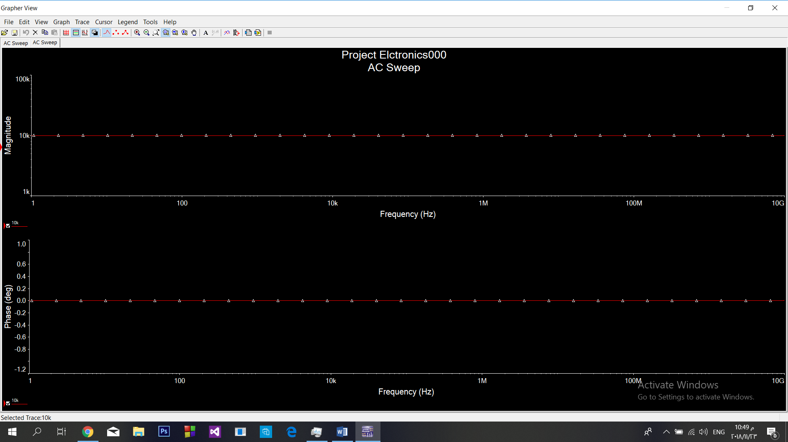

|  |
| --- |
| Transient analysis   * . * A= 10 mV. |

