 **Cairo University –Faculty of Engineering**

**Electronics & Electrical Communication Engineering Department**

**ELC405B**

**Activity#2**

**Submitted to:**

**Dr. Mohammed Alaa.**

**Group 3**

**Team Members**

|  |  |  |
| --- | --- | --- |
| **Name** | **Section** | **BN** |
| Islam Adel Wahdany | 1 | 40 |
| George Osama Edward | 2 | 9 |
| Hassan Hisham Hamdy | 2 | 17 |
| Moamen Nasser Saad | 3 | 37 |
| Mohamed Gamal Mohamed Saad | 3 | 44 |

* What is the purpose of this document?
* What is NTRA stands for?  
  The National Telecommunication Regulatory Authority
* Whom collaborated to prepare this protocol?  
  The National Telecommunication Regulatory Authority (NTRA), Ministry of Health and The Ministry of Environment Affairs prepared this protocol.  
  Some experiments and researches were developed(to help in modification of this protocol) by specialized international organizations and scientific institutes such as: American National Standards Institute(ANSI), International Electro-technical commission (IEC), International Commission on Non-ionizing Radiation Protection(ICNIRP) and Institute of Electrical and Electronics Engineers(IEEE).
* 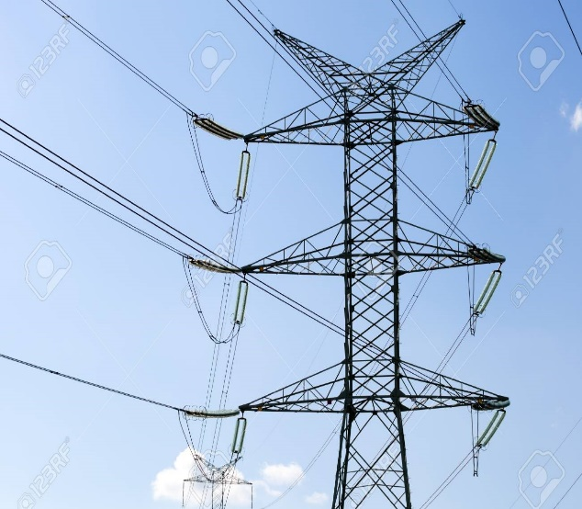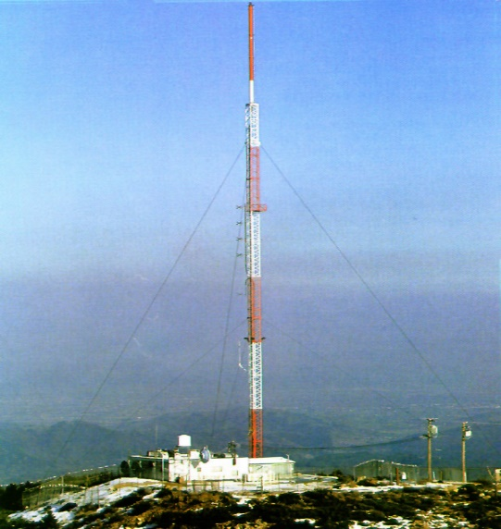What is the difference between a mast and a pylon? Attach a picture  
  The difference is the number of Antennas that can be carried as MAST can load only ONE antenna, but PYLON can carry MORE THAN ONE antenna  
  ALSO, MAST is a tall slim tower. While PYLON looks like that on the right
* What is the recommended height range for buildings to mount antennas on within residential areas? What should happen if such buildings do not exist?  
  The height for such buildings should range from 15-50 meters from ground level in the residential areas. In case no such buildings exist this high, antennas are fixed on a metal pylon or mast, so that antennas are at least 15-50 meters from the ground.
* How high the antenna should be installed over surrounding buildings? Attach a picture you have taken with your phone  
  The height for the antennas must be more than that of the surrounding buildings within 10-meter-radius circle.  
  *don’t forget to attach the Photo*
* Can a base station antenna be installed on wooden roofs?
* How many transmitting and receiving antennas can be installed on a roof? Illustrate an example with a picture you have taken with your phone
* How far should pylons be placed on the same building?
* What is the minimum front-to-back ratio of the used antennas?
* How far a human being is allowed from an installed base station antenna? Why in your opinion?
* Can base station antennas be installed over hospitals? Why?
* What are the measures taken to prevent approaching base station antennas on roofs?
* Which standards are required to be followed by operators upon installing base stations?
* How far a base station antenna’s main beam should be placed from playgrounds?
* When this document is signed? Whom signed it?