

**SCHOOL OF INFORMATICS & IT**

**Part 1: Project Proposal**

Student Name (Matric Number) : Ashok Kumar Moanish

Tutorial Group : PC09

Jenny LING (TP)

Tutor : Ms Huimei Hu

Submission Date : 5/5/2024

**Declaration of Originality**

I am the originator of this work and I have appropriately acknowledged all other original sources used as my references for this work.

I understand that Plagiarism is the act of taking and using the whole or any part of another person’s work, including work generated by AI, and presenting it as my own.

I understand that Plagiarism is an academic offence

and if I am found to have committed or abetted the offence of plagiarism in relation to this submitted work, disciplinary action will be enforced.

**Declaration on the use of Generative AI tools for assignments**

|  |
| --- |
| Describe how you have used Generative AI tools such as ChatGPT or Dall.E-2 in your assignment.  Show snapshots of the conversations with the AI tool (i.e., the prompts you used and the response you get from the AI tool). |
|  |
| How do you indicate the reference?  The content generated by AI tools are not retrievable except by the user who generated them, so they are considered non-recoverable sources. Although non-recoverable data or quotations in APA Style papers are usually cited as personal communications, with ChatGPT-generated text there is no person communicating. Quoting text from ChatGPT chat is therefore more like sharing the output of an algorithm, with a reference list entry and the corresponding in-text citation.  According to the official APA Style site, ChatGPT references should be cited as:  E.g. OpenAI. (2023). *ChatGPT* (Sep 25 version) [Large language model].  <https://chat.openai.com/chat> |

**Important Note:**

* Do not copy answers produced by the AI tool in totality as it is considered as plagiarism.
* Do not rely on any information produced by the AI tool blindly. You should always verify the answer with other sources. Do not assume that these answers provided by the AI tool are correct.

To achieve quality outputs from the AI tool, you should provide good prompt that is clear and specific. Be precise and provide context. Avoid asking open-ended questions.



School of Informatics & IT

**Mobile App Development (CIT2C18)**

**AY 24/25 Apr Semester**

**Project Proposal**

**(Part 1)**

|  |  |
| --- | --- |
| Name: | Ashok Kumar Moanish |
| Admission Number: | 2300821B |
| Class: | PC09 |

Table of Contents

Introduction 5

Project Scope 6

Database Design 7

Design Screenshots 8

Widget Tree 9

# Introduction

Include problem statement, application name, target audience, purpose of application and justification.

|  |  |
| --- | --- |
| **Problem Statement** | The current issue addressed is the lack of awareness, engagement and inconvenience in sustainable living practices among people in developed cities like Singapore. Many individuals lack the resources and guidance to adopt sustainable habits in their daily lives. |
| **Application Description** | **Application Name:**  Greenhub  **Target Audience:**  Residents in Singapore who are young adults aged between 16 and 45.  **Application Description:**  With reference to an article in [eco-business.com](https://www.eco-business.com/), nearly 70 per cent of millennials with young children cited ‘inconvenience’ as the top reason for not choosing sustainable practices.. GreenHub, aims to address the identified issue of promoting sustainable living practices among urban residents. Through its diverse features, user-friendly interface GreenHub encourages individuals to make environmentally conscious decisions and contribute to a much more greener future.  Reference Link: <https://www.eco-business.com/news/ocbc-climate-index-finds-large-gap-between-sustainability-awareness-and-adoption/> |
| **Purpose** | **Application Purpose:**  GreenHub is an innovative mobile application designed for users to share their efforts on how they are becoming much more environmentally friendly. This app serves as a platform that educates and motivates sustainable lifestyle choices for individuals to ensure they engage in more sustainable activities and have proper guidance to do so. |

**Project Scope**

State and describe the proposed functions.

**Scope:**

**Educational Resources & Community Forum:** Access to informative articles, videos, blogs on sustainability topics to increase awareness and knowledge for people from every age group. Also a platform for users to share their personal ideas, experiences, and tips on sustainable living, as well as organise a few local sustainability events for networking and bonding. Users can sort and search with additional filters to search for articles relevant to their age to make sure it is aimed towards to them. Users will have a feature to share the posts in the app to other social media apps like Facebook, Instagram or WhatsApp. The informative videos and articles are displayed within an in-app browser to ensure a seamless and smooth performance without hassle. If users allow notifications to be sent by the app, they will receive a few of the latest articles to catch up on the latest articles. There is also a download icon beside each article for users to download the articles and videos to read or watch later when they are not connected to the internet. Users can search for specific articles with their voice using the “Speech to Text” feature on the Search Bar section.

|  |  |  |  |
| --- | --- | --- | --- |
| **No.** | **Function Name** | **Description** | **Type** |
| 1. | Login | User able to login with a registered account | Authentication |
| 2. | Register | User able to sign up with a new account | Database Operation: Create |
| 3. | Reset Password | User able to delete old password and create new password | Database Operation: Delete and Create |
| 4. | View Posts | User able to view posts on the homepage | Database Operation: Read |
| 5. | View Articles and videos | Users able to view all the articles and informative videos posted on Greenhub | Database Operation: Read |
| 6. | Create New Post | Users able to create their own post which can either be an informative article or a blog | Database Operation: Create |
| 7. | View Personal Posts | Users are able to view their own posts under ‘YOUR POSTS’ page in the user profile section | Database Operation: Read |
| 8. | Update Content in Posts | Users are able to update the content they have uploaded | Database Operation: Update |
| 9. | Delete Posts | Users are able to delete posts that they have uploaded previously | Database Operation: Delete |
| 10. | Search | Users are able to search for posts they are looking for | Database Operation: Read |
| 11. | Change Profile Picture, Username, Email, Age | Users are able to edit their Profile Picture, Username, Email and Age through the ‘User Profile’ section | Database Operation: Update |
| 12. | Speech to Text | Users are able to search with their voice using the ‘Speech to Text’ feature | Additional Feature |
| 13. | Share Posts | Users able to share the posts on their homepage to others on Facebook, WhatsApp and Instagram | Additional Feature |
| 14. | Notifications | Users can turn on notifications to receive latest articles and videos | Additional Feature |
| 15. | Download Articles and Videos | Users able to download their favourite articles and videos to watch or read when they are offline under the ‘Your Downloads’ page | Additional Feature |

# 

# Database Design

Include Data dictionary and ER Diagram

**ER Diagram**

*Used Tool: MySQL Workbench*

**Data Dictionary (Table: User)**

|  |  |  |  |  |  |
| --- | --- | --- | --- | --- | --- |
| **Field Name** | **Data Type** | **Field Size** | **Primary/ Foreign key** | **Description** | **Example** |
| id | Integer | 8 | Primary key | Unique identifier for each user. | 10000001 |
| Profile_picture | BLOB | - | - | User’s Profile Picture |  |
| username | Varchar | 50 | - | User's chosen username for identification. | Moanish18 |
| email | Varchar | 45 | - | User’s Email address for communication and account management | ishnish@gmail.com |
| age | Integer | 3 | - | User's age for targeted content and engagement strategies based on demographic characteristics. | 15 |
| password | Varchar | 45 | - | Secure hash password for user authentication. | scoobydoo@551 |

**Data Dictionary (Table: forum_post)**

|  |  |  |  |  |  |
| --- | --- | --- | --- | --- | --- |
| **Field Name** | **Data Type** | **Field Size** | **Primary/ Foreign key** | **Description** | **Example** |
| id | Integer | 8 | Primary key | Unique identifier for every forum post | 10000001 |
| User_id | Integer | 8 | Foreign key | Unique identifier for every user | 10000001 |
| photo | BLOB | - | - | Images that are uploaded into the forum together with the posts. |  |
| video | BLOB | - | - | Videos that are uploaded into the forum together with the posts. | [video](https://www.youtube.com/watch?v=dQw4w9WgXcQ) |
| timestamp | TIMESTAMP | 14 | - | Date and time when the post was created, enabling chronological sorting and tracking of forum’s activity. | 2038-01-09 03:14:07 |
| Post_type | Varchar | 45 | - | Whether the post is an informative article or blog | Informative article |
| title | Varchar | 100 | - | Title of the forum post | Live Green, Love Green |
| content | MEDIUMTEXT | 16,777,215 | - | The main body of the forum post, containing detailed information or discussions on topics regarding sustainable living. | Happy Monday! Get your free Cup at Two Sister’s Pantry!☕️💕 |

**Data Dictionary (Table: info_videos)**

|  |  |  |  |  |  |
| --- | --- | --- | --- | --- | --- |
| **Field Name** | **Data Type** | **Field Size** | **Primary/ Foreign key** | **Description** | **Example** |
| id | Integer | 8 | Primary key | Unique identifier for every informative video | 10000001 |
| User_id | Integer | 8 | Foreign key | References the UserID of the user who uploaded the video. | 10000001 |
| Title | Varchar | 100 | - | Title of the informative video. | What is Sustainability? |
| Description | MEDIUMTEXT | 16,777,215 | - | Description of the informative video. | Description: Learn about the various ways that sustainability is defined. In simplest terms, sustainability is about our children and our grandchildren, and the world we will leave them. |
| Embedded_video | TINYTEXT | 255 | - | The code or link for embedding the video directly within the application’s miniplayer. | [video](https://www.youtube.com/watch?v=dQw4w9WgXcQ) |
| timestamp | TIMESTAMP | 14 | - | Date and time when the video was uploaded. | 2038-01-09 03:14:07 |

# 

# Design Screenshots

High-Fidelity Prototype:

Navigation Flow:

# Widget Tree

Identify the widgets that you will be using for the body of the main screen and construct the widget tree:

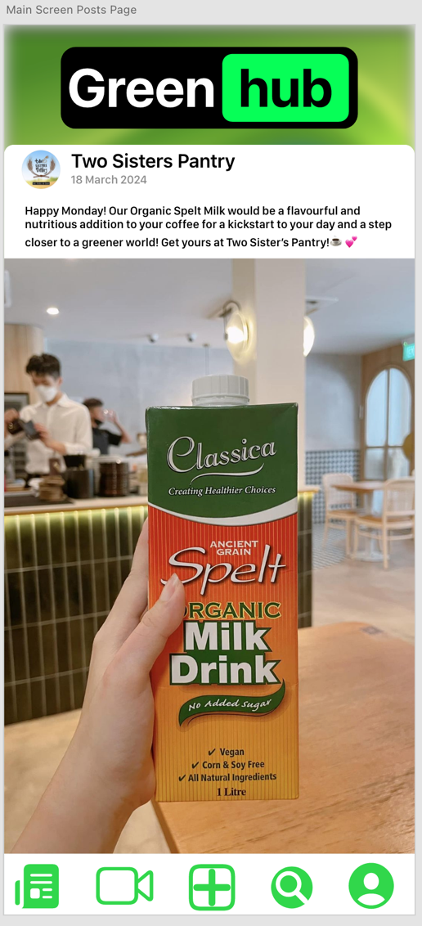

THE END