|  |
| --- |
| Faculty of Applied Sciences and Technology |
| **XML Data Processing** |
| ITC5202 - Project |
|  |
| **GROUP 11 - MOANISHA VELAYUTHEM - N01482302, RHEA CHRISTIAN – N01464054** |
| **2/27/2022** |

|  |
| --- |
| This document explains how to process Supplier/Product XML data …………………………. |

Table of Contents

Step 1 : 2

Step 2 and 3 : XML Structure 3

Step 4 : Design XSLT 4

Step 5 : XPath and XSLT 5

Step 6, and 7: Use JavaScript to process XML data 6

Step 8 : Modify Dataset and Redo Step 5 and 7 7

Bonus question 8

Summary 9

# Step 1 :

(Describe you answer. How did you prove that the document is well-formed and valid? Add screenshots)

It opens in the browser without any errors. So, it is a well-formed document.

It is not valid document since it doesn’t have a DTD document.

Namespace is available: xmlns=<http://www.adventure-works.com>.

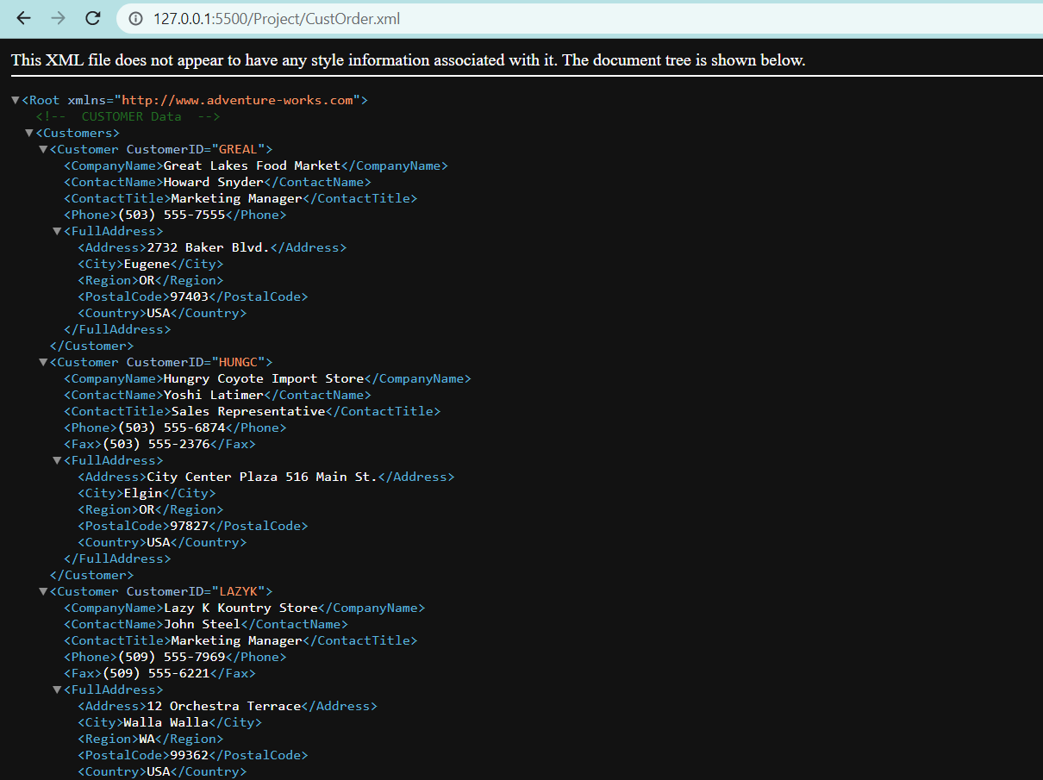

# Step 2 and 3 : XML Structure

(1) Explain the major steps that you take to create DTD. Did you create a .dtd file, or you keep the DTD declaration inside the XML file? Why?

I created an external DTD file and linked it to the xml. It is more organized that way so preferred this method.

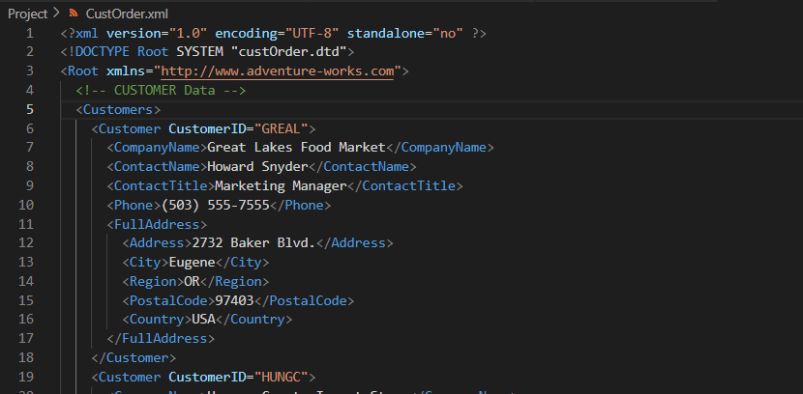

(2) Explain the major steps that you take to create XML Schema.

Used freeformatter to generate xml schema and created it as an external schema file and attached it to xml.

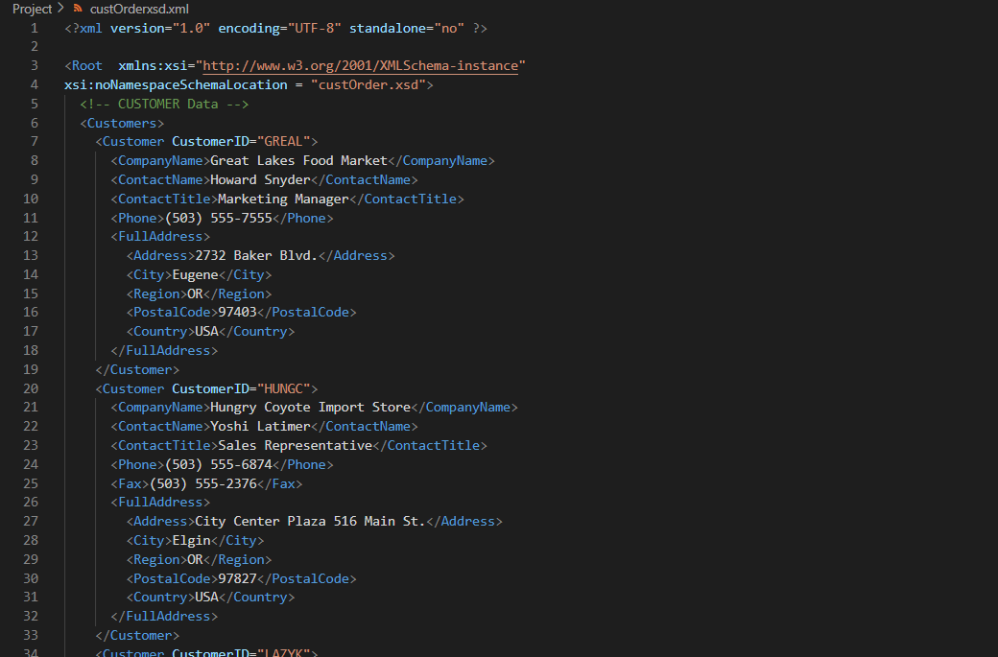

(3) How did you validate them? Add screenshots.

Validated DTD and schema using xmlValidation.com

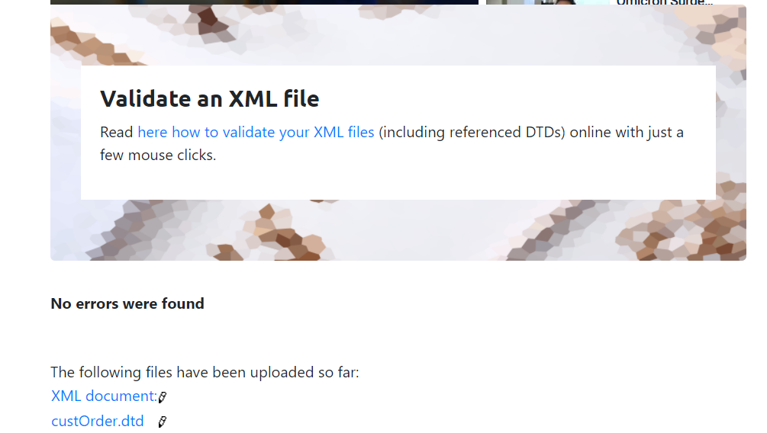

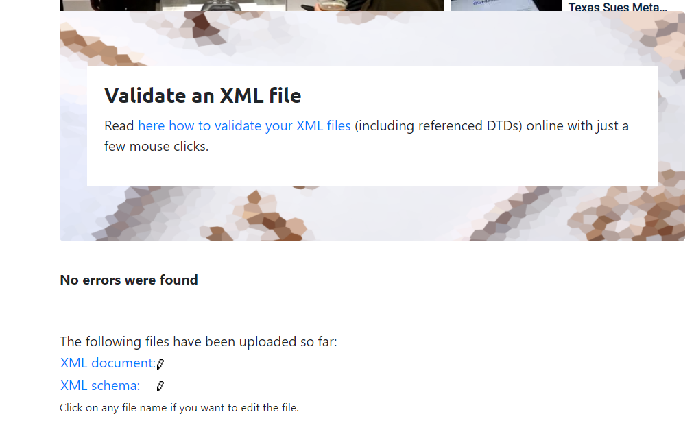

(4) Compare the DTD and Schema and show how DTD declaration are matched with Schema.



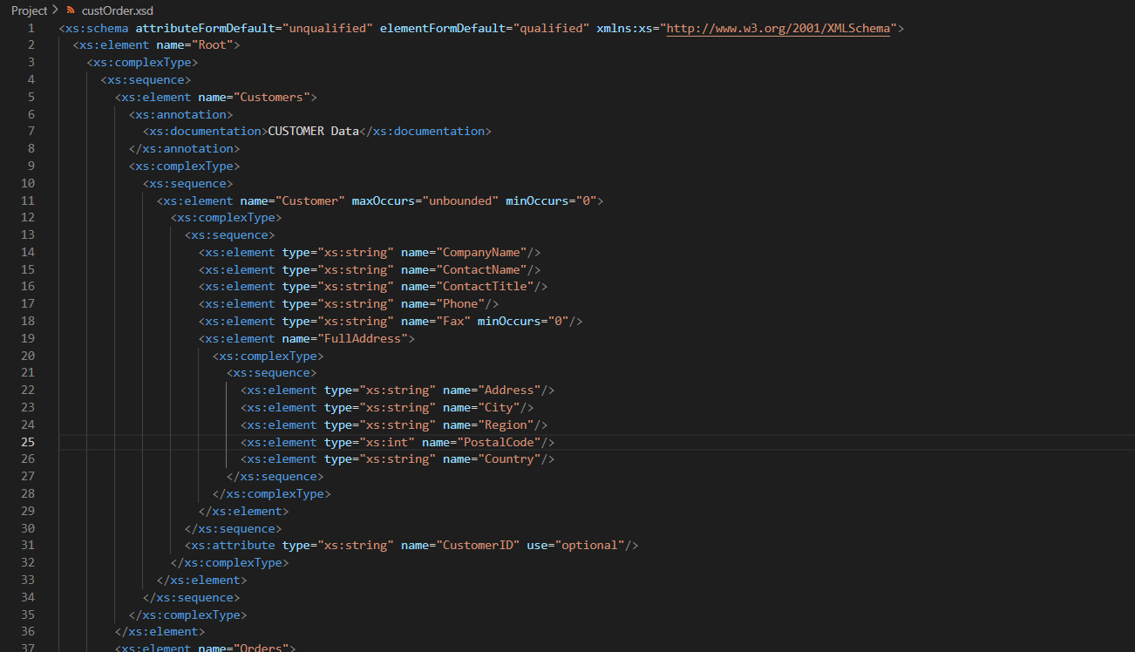

# Step 4 : Design XSLT

(Describe the major steps for designing the XSLT. Add screenshot of the output)

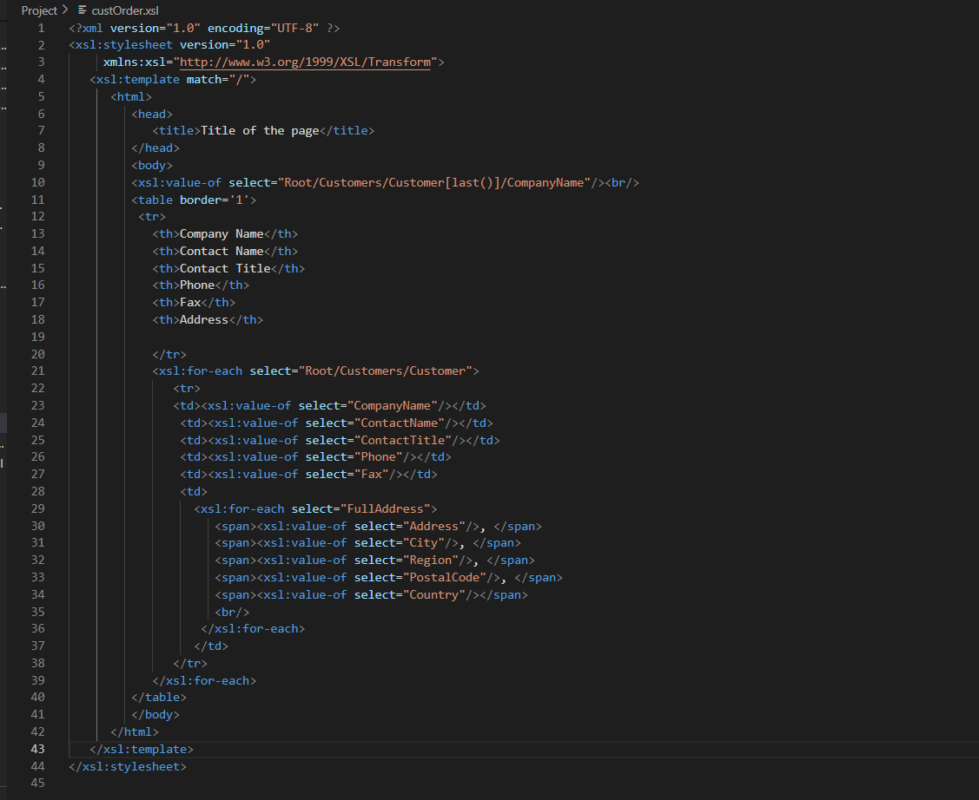

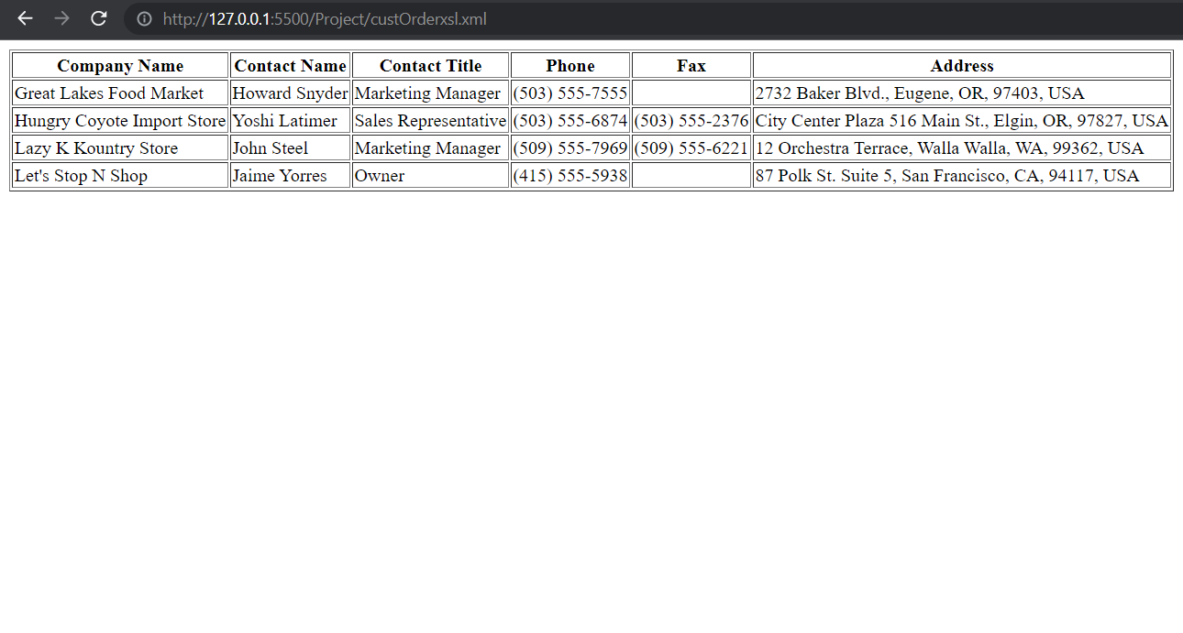

# Step 5 : XPath and XSLT

(Describe the major steps for designing the XPath and XSLT. How did you test the XPath? How did you use XPath in the XSLT?

Add screenshot of the XPath testing and the output of XSLT)

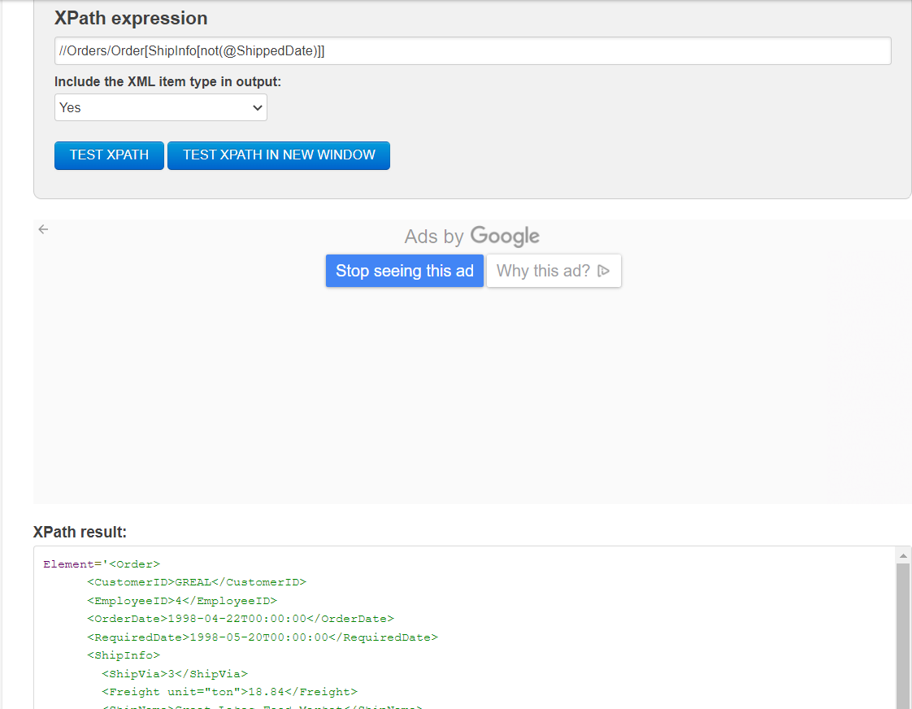

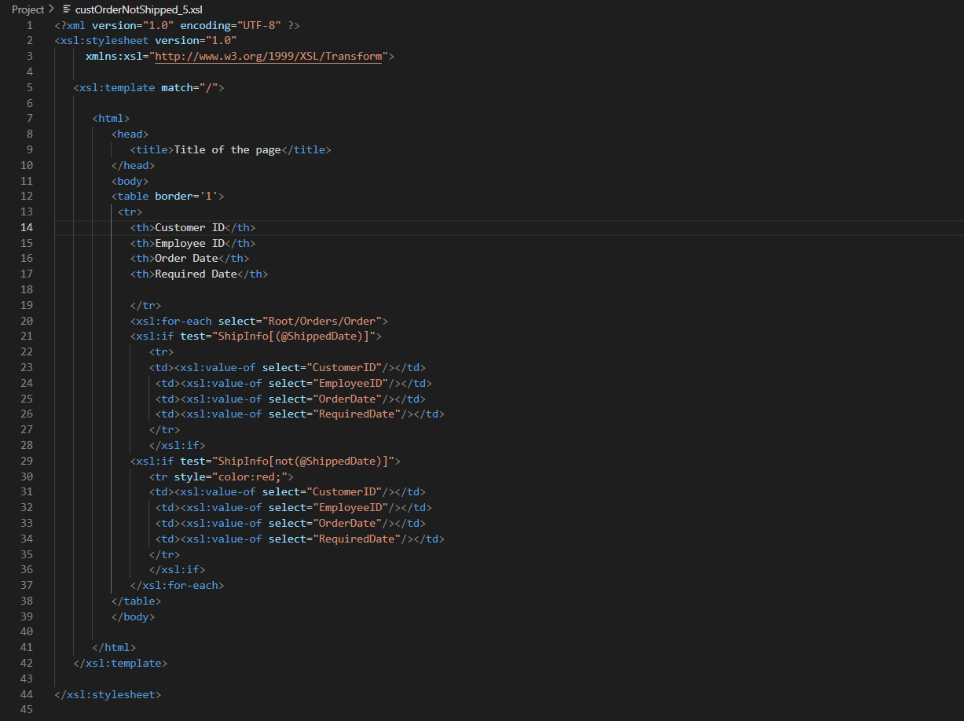

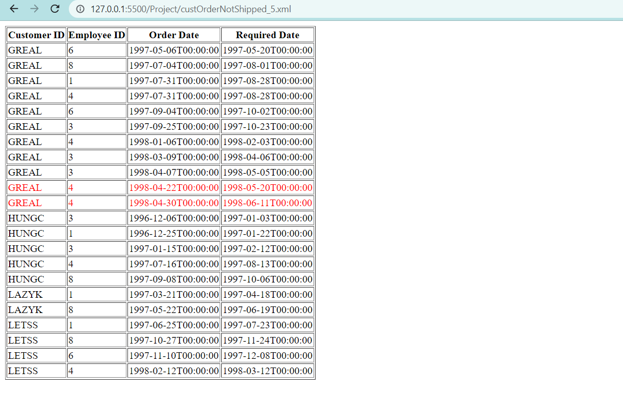

# Step 6, and 7: Use JavaScript to process XML data

(Describe the major steps for designing the JavaScript function(s), how you test this program, add some screenshots of the output )

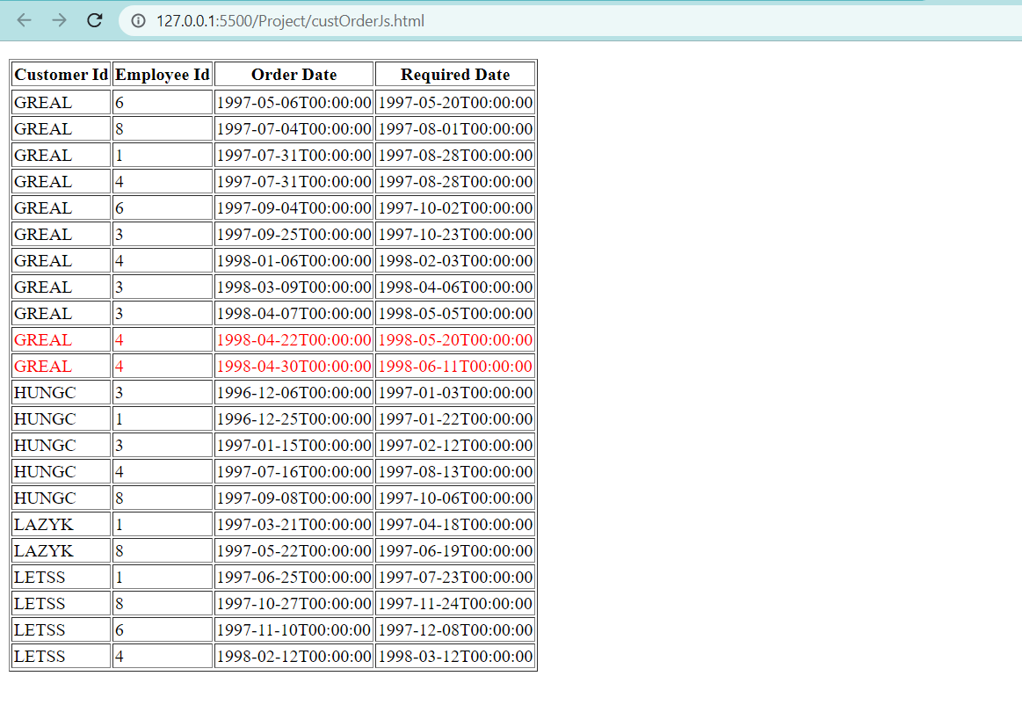

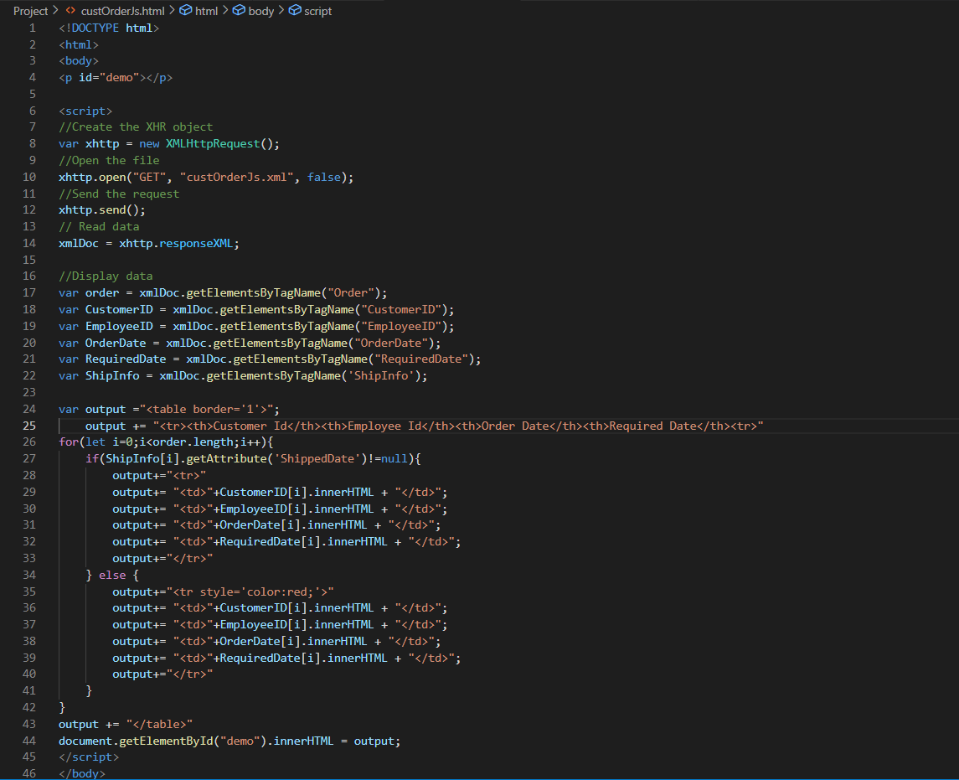

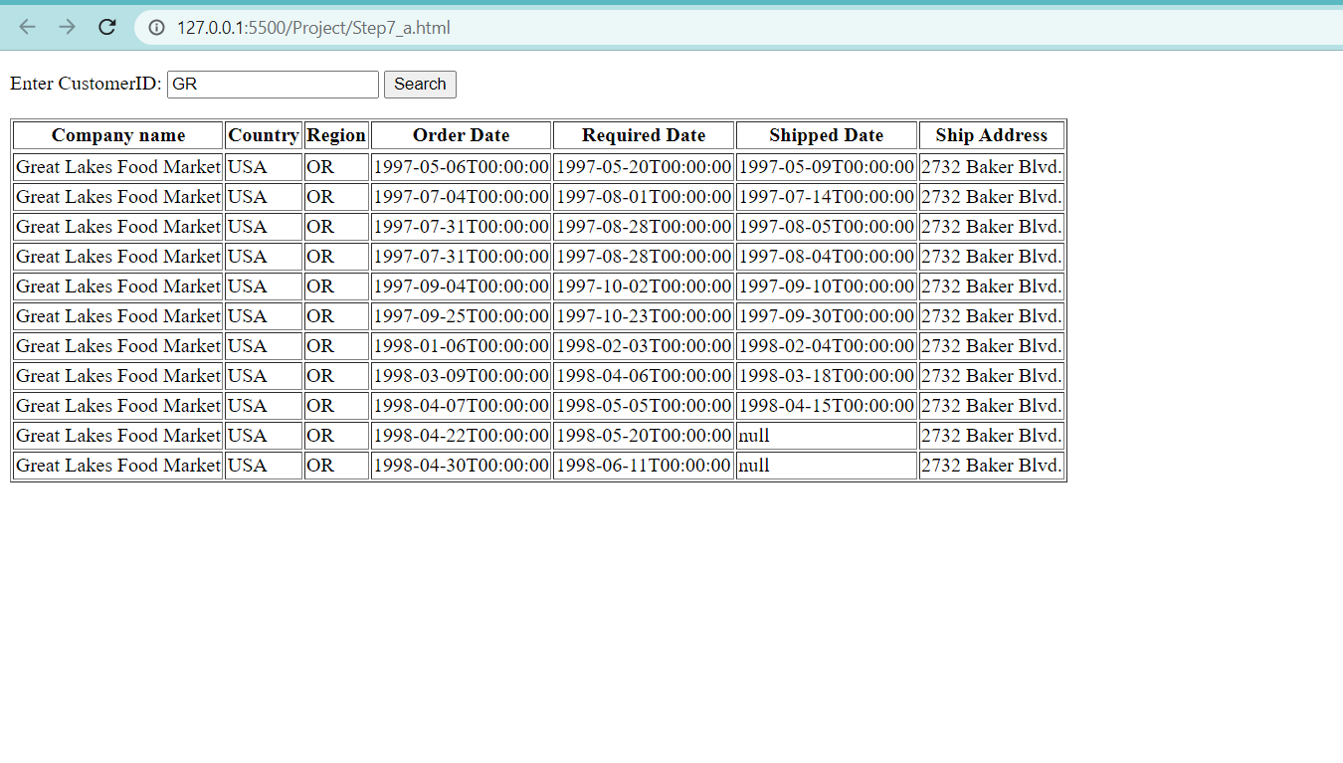

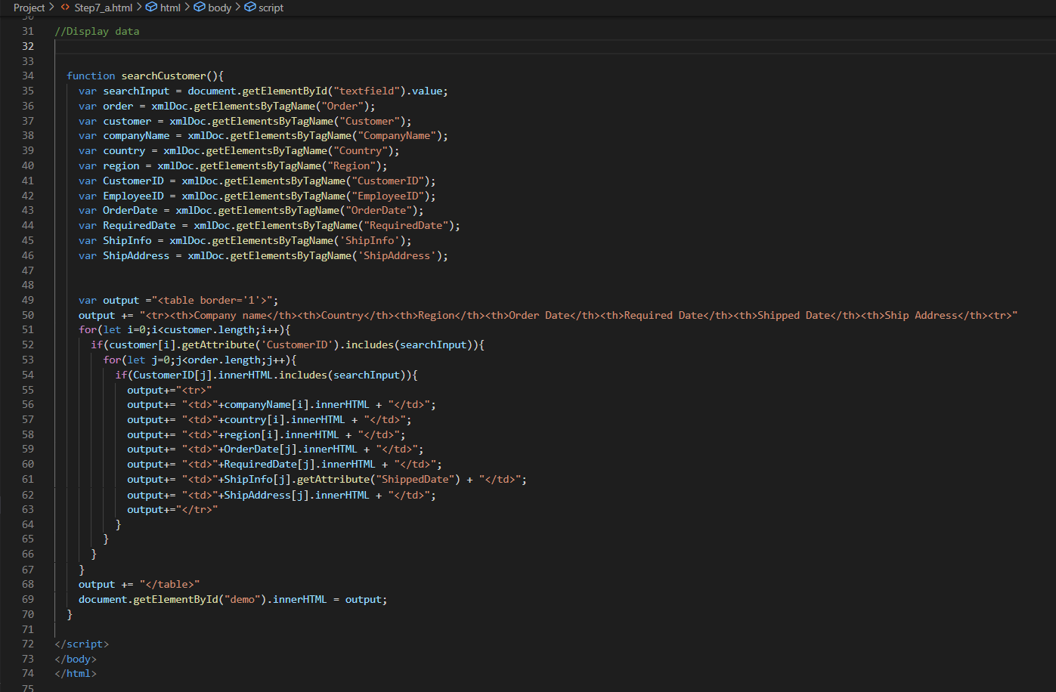

# Step 8 : Modify Dataset and Redo Step 5 and 7

(Describe your solution and add some screenshots of the output)

STEP 7

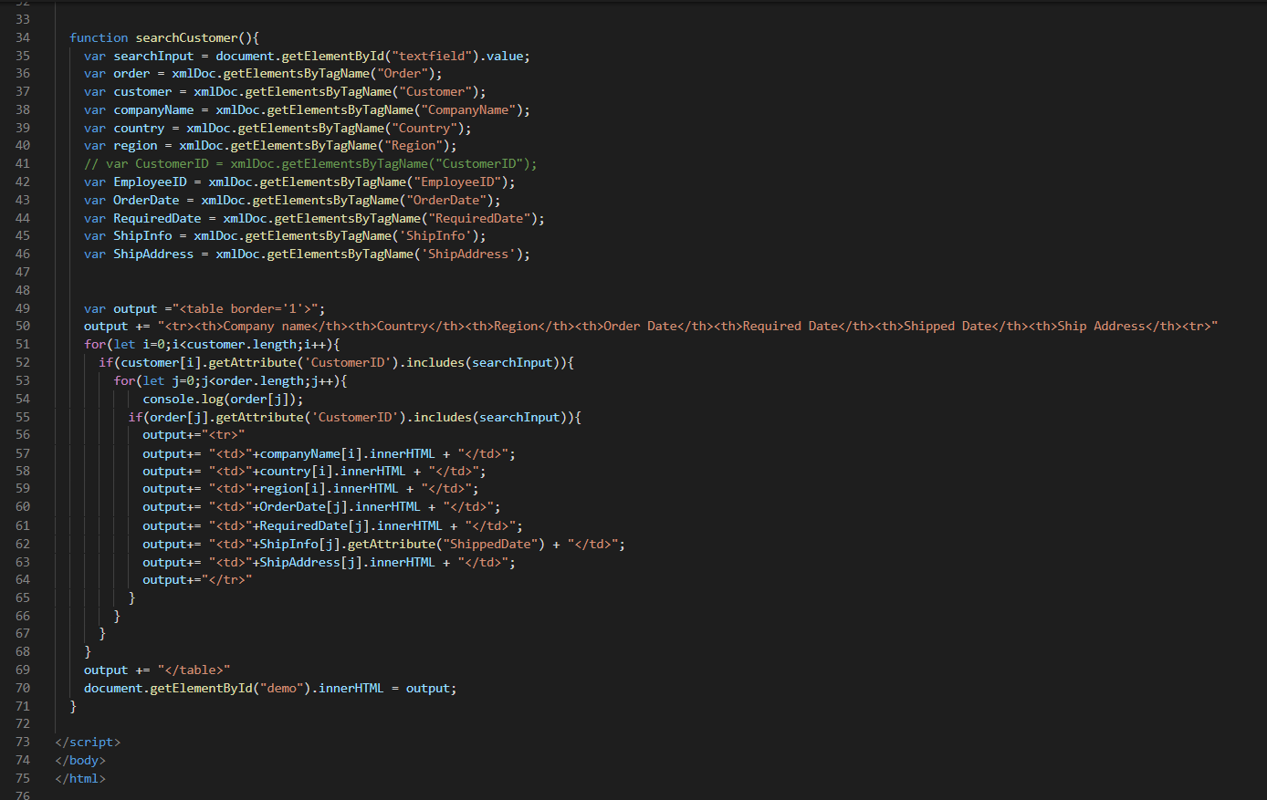

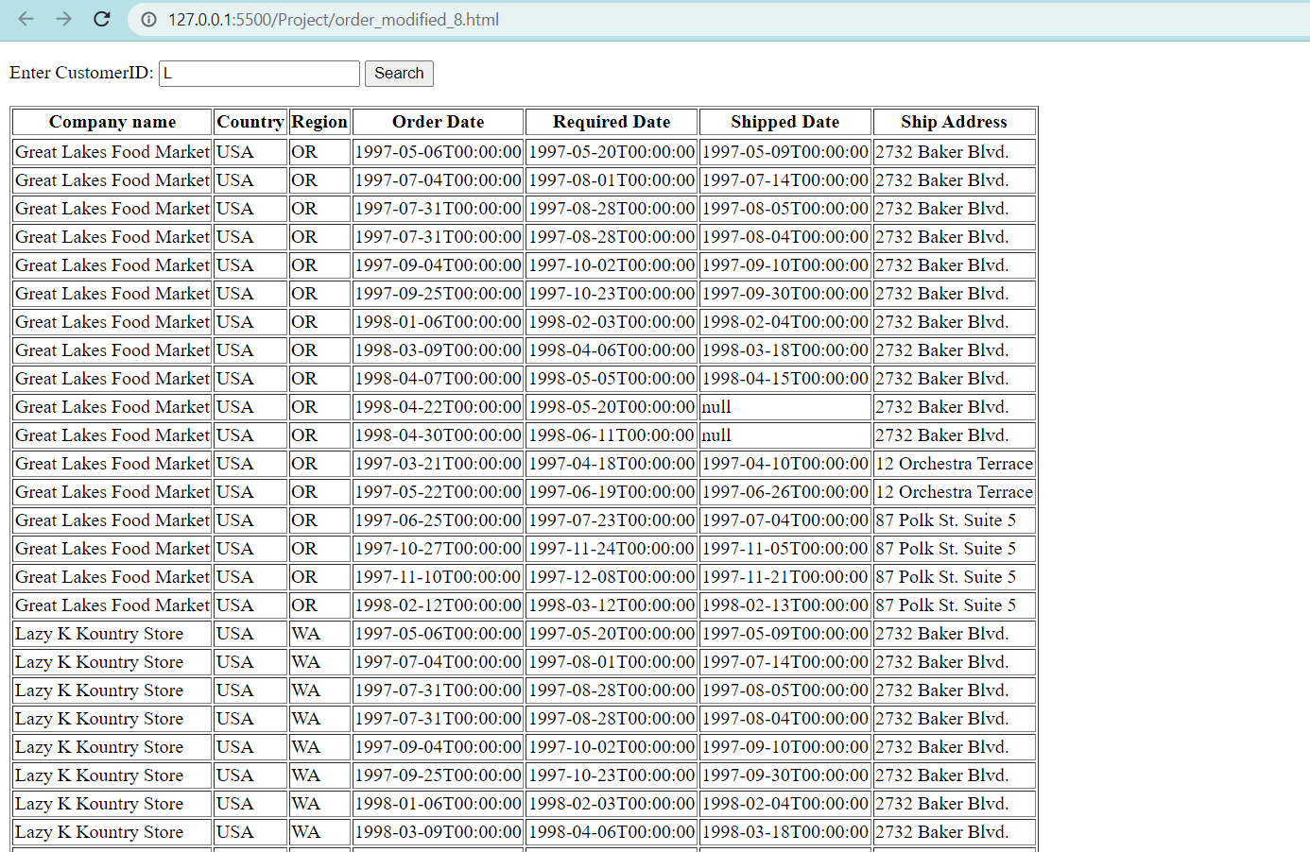

STEP 5

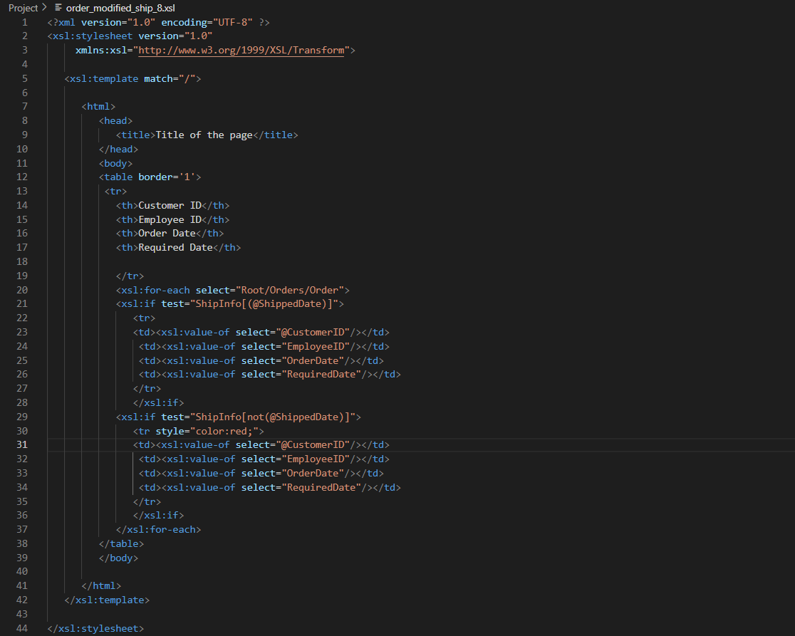

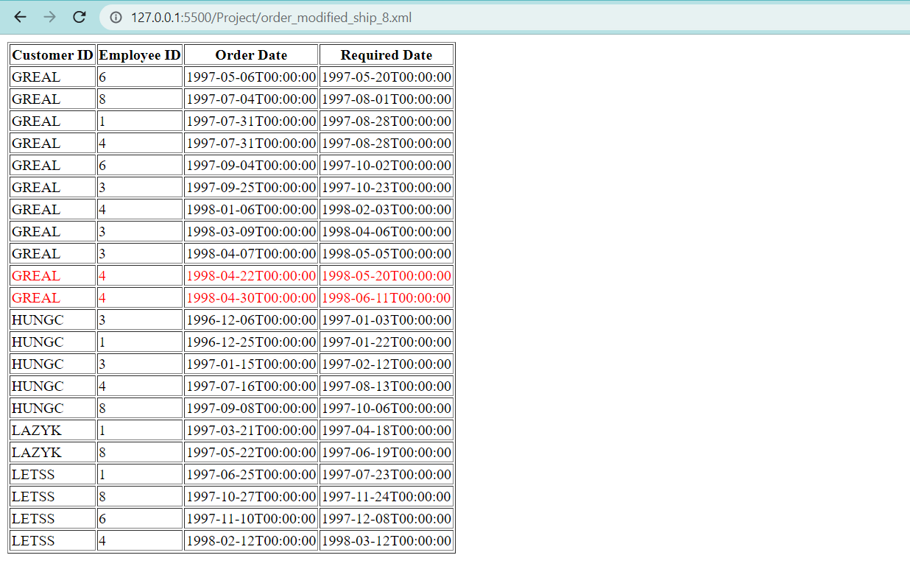

# Bonus question

(Describe your solution and add some screenshots of the output )

# Summary

(Describe how did you divide the work, share your feedback about this project like new points that you learn, challenges, …)