**GROUP 11**

**MOANISHA VELAYUTHEM -N01482302**

**RHEA CHRISTIAN – N01464054**

**1)The steps that you have completed**

Step 1, Step 2 and Step 3

**2) The breakdown of the work: Who is doing what during this project**

Step 4 – Rhea

Step 5 – Moanisha

Step 6 – Rhea, Moanisha

**Step 1) Try to explore and understand the structure of the given XML data. Is the XML file a well-form document? Is it a valid document? Is there any namespace?**

It opens in the browser without any errors. So, it is a well-formed document.

It is not valid document since it doesn’t have a DTD document.

Namespace is available: xmlns="http://www.adventure-works.com"

**Step 2) Design the DTD for this document and link it to the given XML file.**

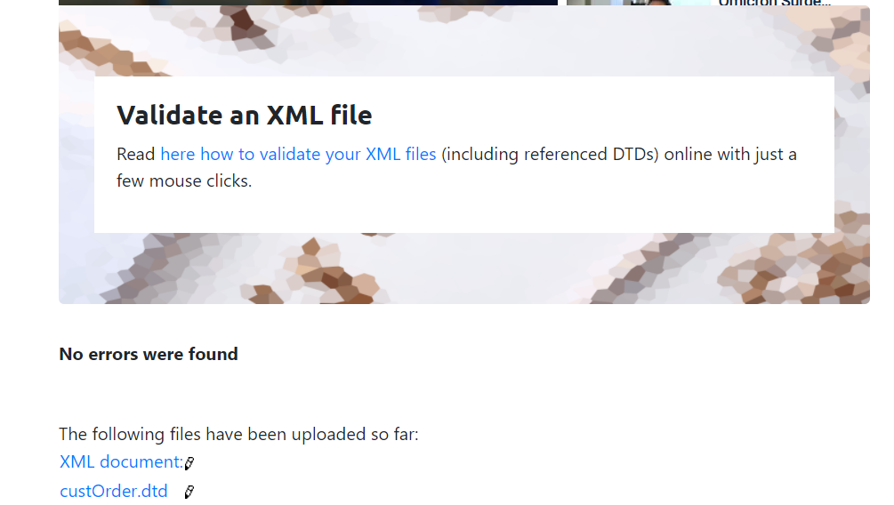

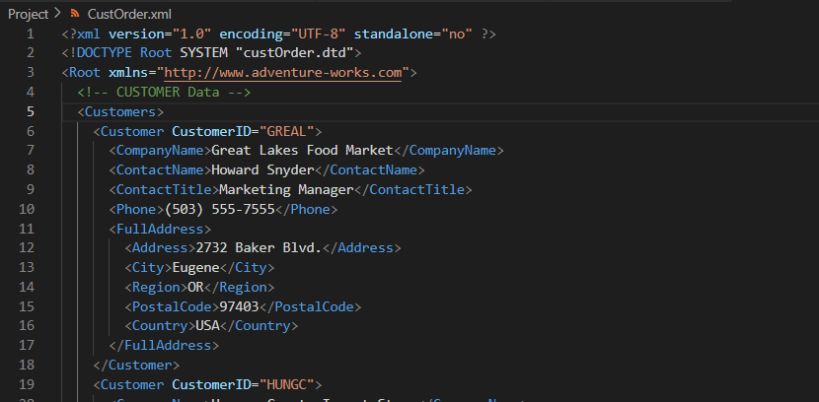

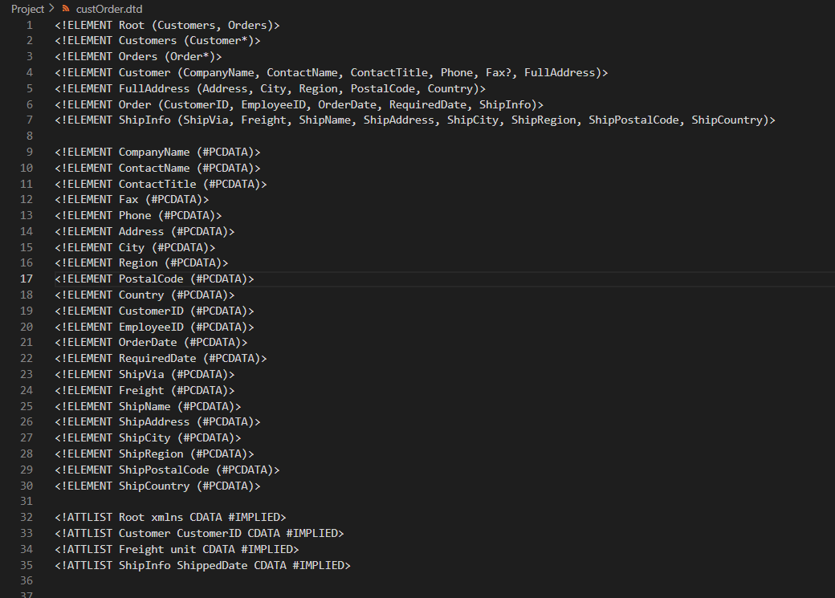

**Step 3) Design XML Schema for this document and link it to the given XML file.**

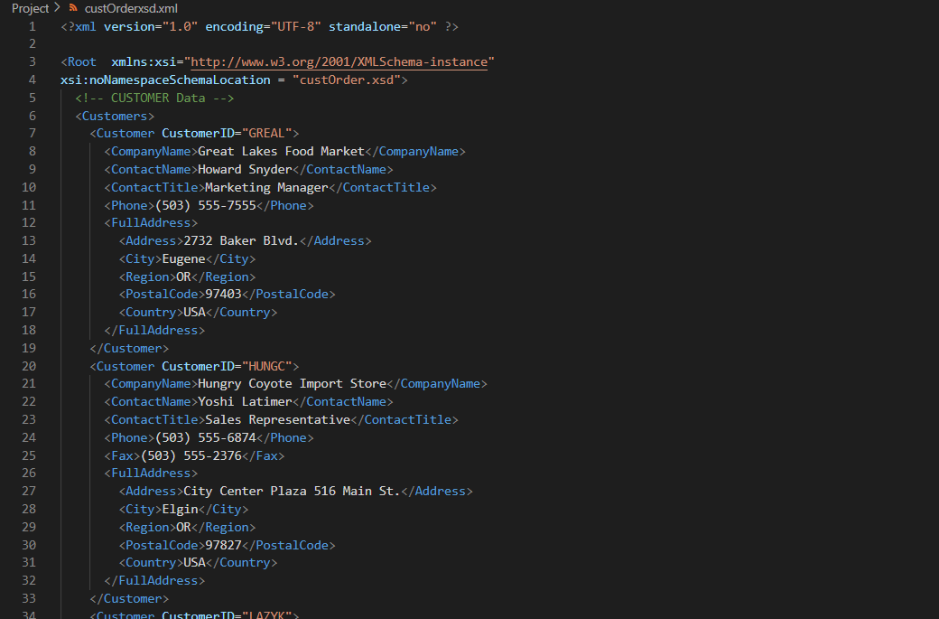

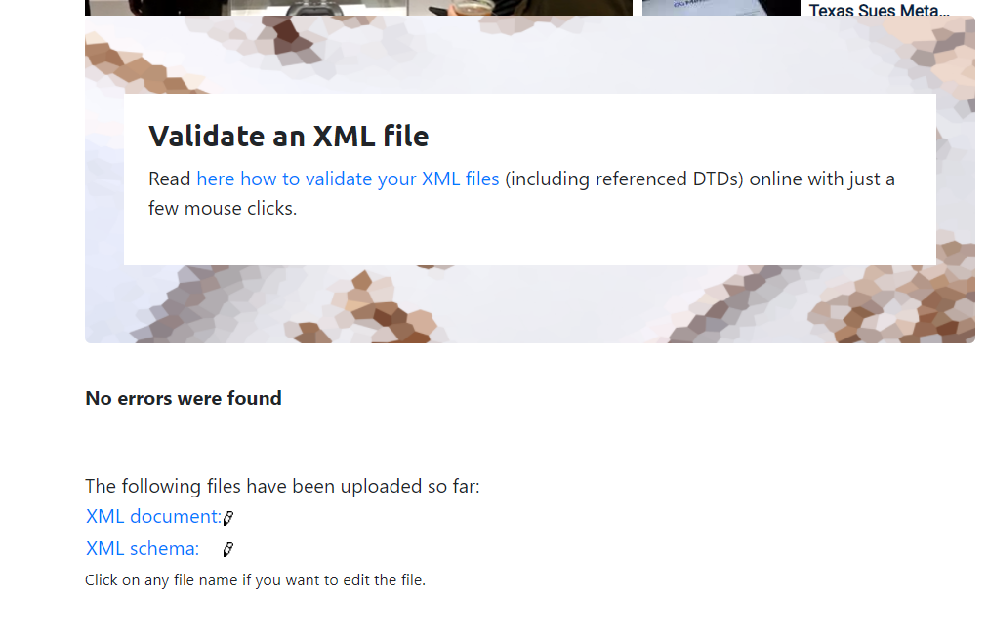

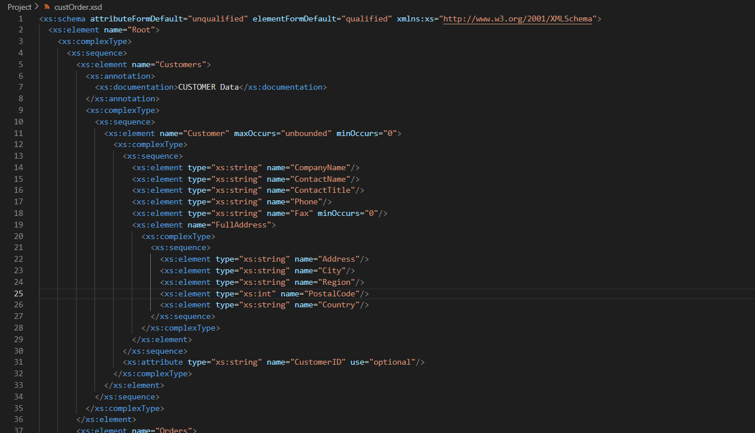

**Step 4) Write an XSLT document to transform order.xml into an HTML document that displays all "Customer's Data" in a HTML table format.**

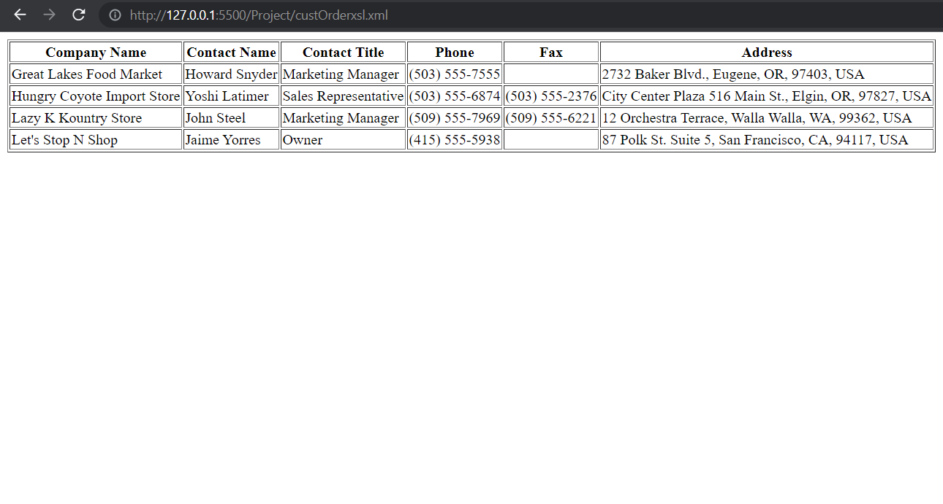

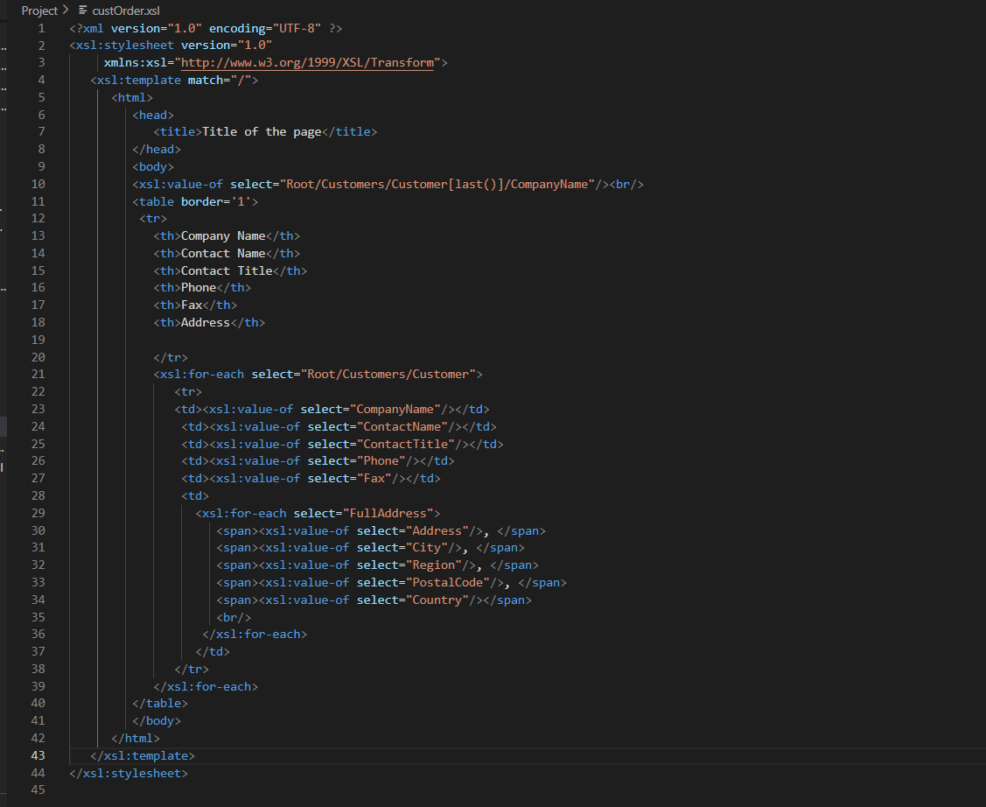

**Step 5) Write an XPATH query to show all orders that have not shipped yet (don't have "ShippedDate")**

**Design a new XSLT file that displays all "Orders" info (CustomerID, EmployeeID, OrderDate and RequiredDate), but displays these items (which you selected with XPATH) in red color.**

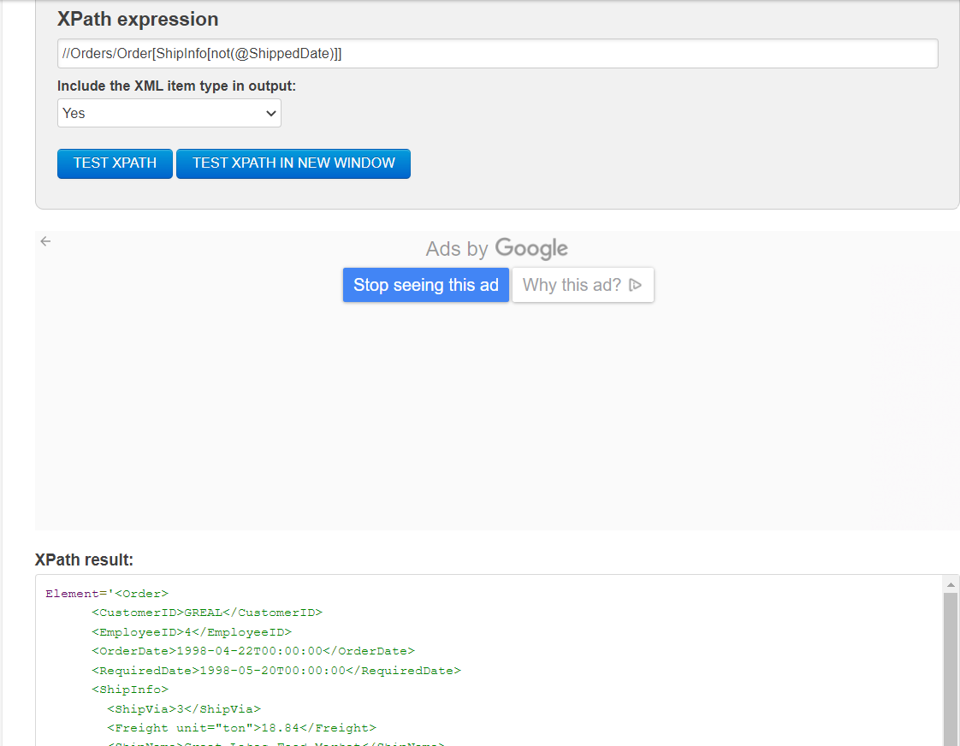

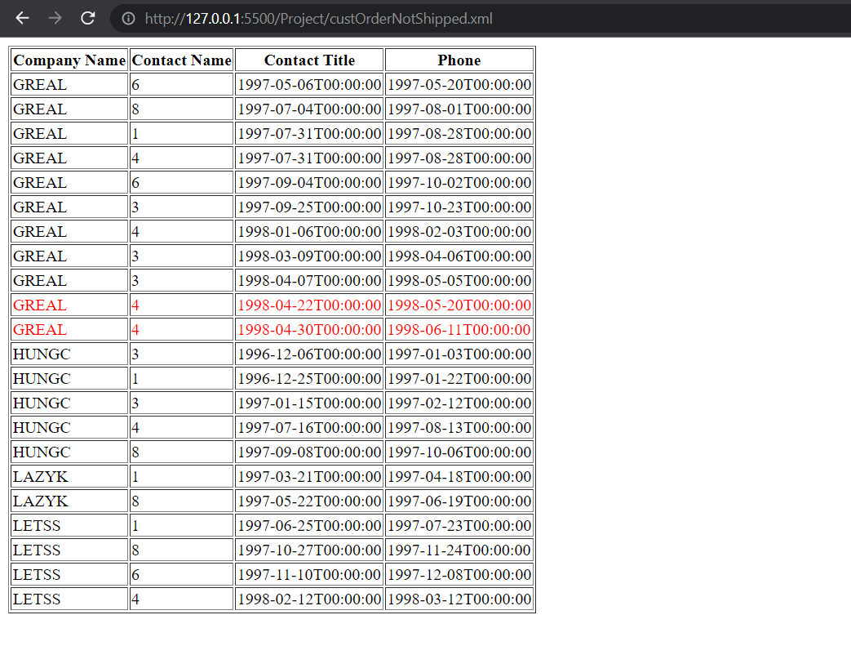

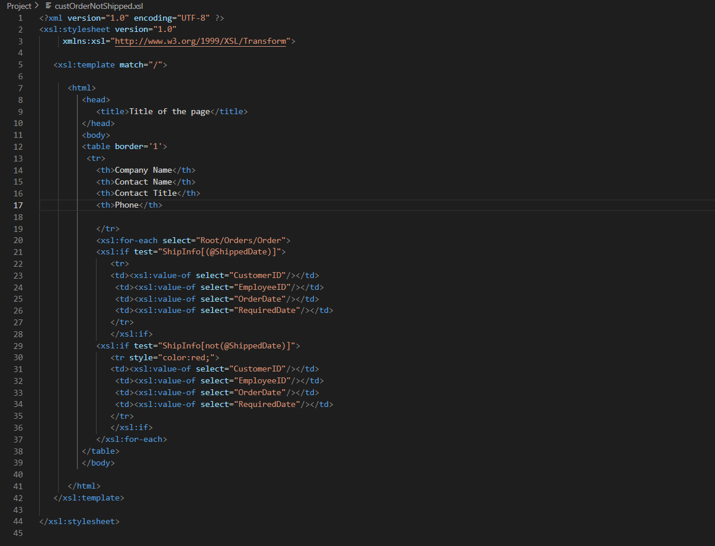

**Step 6) You are going to redesign Step5 using JavaScript. You need Develop a proper JavaScript that shows all orders' info (CustomerID, EmployeeID, OrderDate and RequiredDate) that have not shipped yet (don't have "ShippedDate")**

