Lab Practices:

1. Let M be the following DFAs.
   1. Write down four string accepted by M and the sequence of configurations that shows this.
   2. Write down four strings not accepted by M.

Accepted strings

1. baa
2. a
3. baba
4. aa

Not Accepted

1. aab
2. bab
3. abab
4. bb

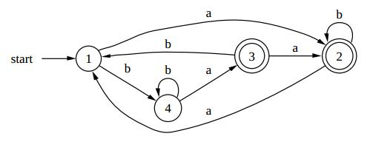

Accepted strings

1. aa
2. aaab
3. bb
4. bbbaa

Not Accepted

1. a
2. aaa
3. bb
4. ba

1. Convert to regular expressions:

2

1. Draw DFA to the following languages:
   * All strings that contain exactly 4 0s.

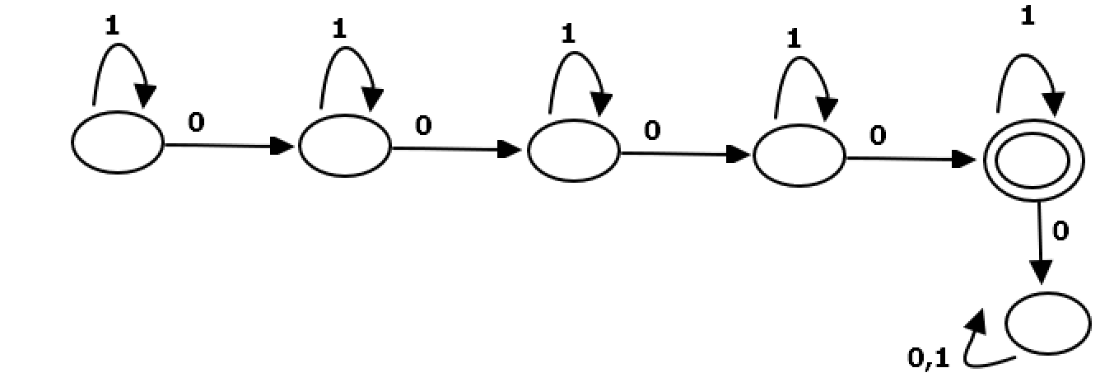

* + All strings that start with 0 and has odd length or start with 1 and has even length.
  + Diagram, schematic

    Description automatically generated
  + All strings that don’t contain the substring 110.

* + All strings that each a followed by exactly 1 or 3 b’s.

* + All strings that contain the substring 0101.

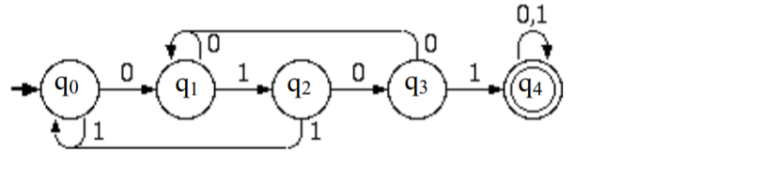

* + 1(1 ∪ 0)? 0 ∪ 0

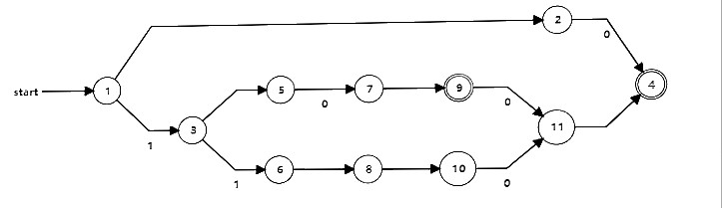

* + 0?10?

