ZAGAZIG UNIVERSITY
Faculty of Engineering | Electronics & Communications

INTEGRATED CIRCUIT
LAYOUT PROJECT REPORT

4-Stage Inverter-Based Delay Line — CMOS 180 nm

ECE326 – Integrated Circuits
Academic Year 2025 – 2026

TEAM MEMBERS
    - عبد الرحمن عبدالهادي عبد الرحمن عبدالهادي — Section 3
    - عبدالله رضا عبدالله عبدالمنعم — Section 3
    - عمر ايمن محمد سعيد Section— 3
    - معتز رفيق حمدي موسي — Section 5
    - احمد طارق عبدالحميد — Section 1

TABLE OF CONTENTS
1. Introduction ....... 3
2. Circuit Description and Operating Principle ....... 3
3. Schematic Diagrams ....... 4
4. Pre-Layout Simulation Results ....... 4
5. Layout Screenshots ....... 5
6. DRC Verification Results ....... 5
7. LVS Verification Results ....... 7
8. PEX Setup and Results ....... 7
9. Post-Layout Simulation Results ....... 8
10. Comparison: Pre-Layout vs Post-Layout ....... 8
11. Discussion and Conclusion ....... 9

1. INTRODUCTION
This report presents the complete IC design flow for a 4-Stage Inverter-Based Delay Line implemented in CMOS 180 nm technology. The project was carried out as part of the ECE326 Integrated Circuits course at Zagazig University and covers every stage of the physical design process: schematic entry, layout implementation, design rule verification, LVS check, parasitic extraction, and post-layout simulation.
A cascaded inverter chain is among the most fundamental structures in digital CMOS design. It is used to buffer signals, generate controlled propagation delays, and drive capacitive loads. Despite its apparent simplicity, it provides an excellent vehicle for studying the impact of layout parasitics on timing performance, making it a highly instructive first layout project.
All design and simulation work was performed using Cadence Virtuoso and Spectre, with Calibre used for DRC, LVS, and PEX verification.

2. CIRCUIT DESCRIPTION AND OPERATING PRINCIPLE
The 4-stage inverter-based delay line consists of four CMOS inverters connected in series. Each inverter is built from a complementary pair: a PMOS pull-up transistor and an NMOS pull-down transistor sharing a common gate and drain. The input signal propagates through the chain, undergoing four successive inversions, so the output is in phase with the input but delayed by the cumulative propagation time of all four stages.
2.1 CMOS Inverter Operation
When the input is logic HIGH, the NMOS transistor turns on and the PMOS turns off, pulling the output LOW. When the input is logic LOW, the PMOS turns on and the NMOS turns off, pulling the output HIGH. This complementary switching ensures rail-to-rail output swing and near-zero static power dissipation.
2.2 Delay Line Behaviour
The total propagation delay of the chain is approximately four times the single-stage delay. Delay is controlled by the transistor sizing (W/L ratio) and the load capacitance driven by each stage. In this design, uniform sizing is applied across all four stages to produce a symmetric, well-characterized delay characteristic.

Technology: CMOS 180 nm (GPDK180)
Supply Voltage (VDD): 1.8 V
Number of Stages: 4
Logic Family: Static CMOS
PMOS W/L: 2 µm / 0.18 µm
NMOS W/L: 1 µm / 0.18 µm
Input / Output: Single-ended, rail-to-rail

3. SCHEMATIC DIAGRAMS
The schematic was captured in Cadence Virtuoso Schematic Editor using the GPDK 180 nm component library. Each inverter stage is drawn individually and then chained, with VDD and VSS rails connected to all stages. The complete 4-stage topology is shown in the figure below.
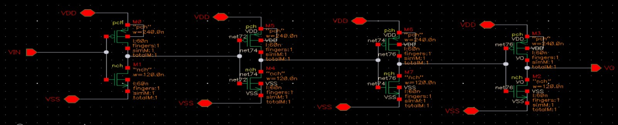

Figure 1 – 4-Stage Inverter-Based Delay Line: Full Schematic (Cadence Virtuoso)
The schematic captures the W/L ratios of all transistors and the net connectivity between stages. Pre-layout simulations were verified against this schematic before commencing the layout phase.

4. PRE-LAYOUT SIMULATION RESULTS
Design Rule Check (DRC) was performed using Cadence Virtuoso to verify that the implemented 4-stage inverter layout satisfies all technology design rules before proceeding to LVS and post-layout verification.
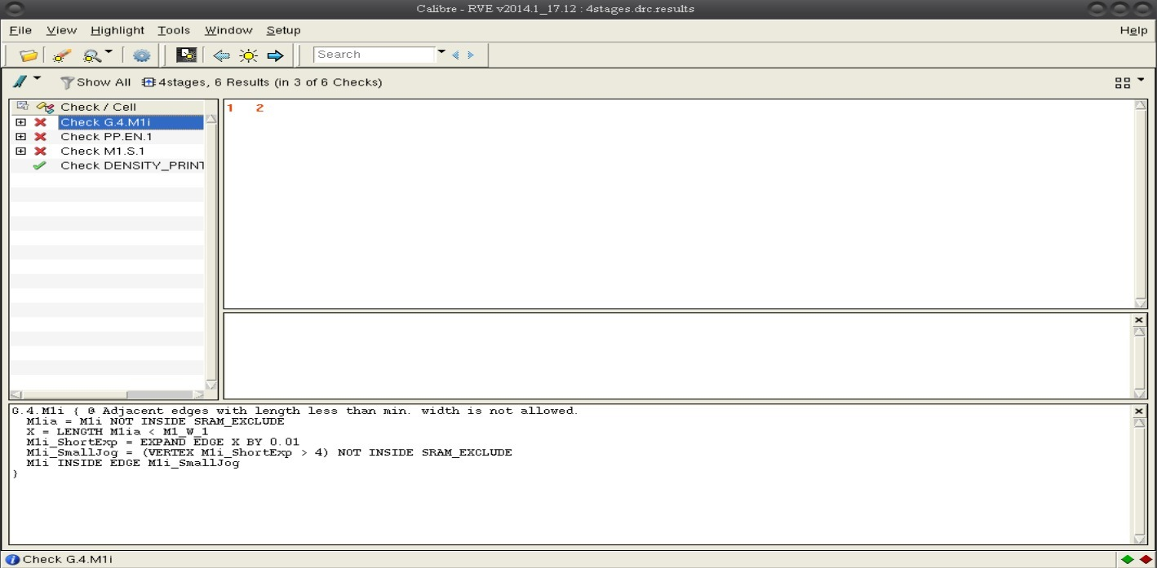
During the initial DRC run, several layout violations were detected. The following screenshots illustrate the reported errors before correction.
Figure 2 – Pre-Layout Transient Simulation: Input and Output Waveforms

5. LAYOUT SCREENSHOTS
The physical layout was implemented in Cadence Virtuoso Layout Editor following standard CMOS layout practices. All four inverter stages are arranged in a single row with a shared VDD rail on top and VSS at the bottom, both routed on Metal 1. Signal interconnects between stages are routed on Metal 2 to minimize parasitic.
N-well contacts and substrate taps are placed at regular intervals to suppress latch-up and reduce substrate noise coupling between stages. Each PMOS device is fully enclosed within the N-well, and all NMOS devices share the common P-substrate.
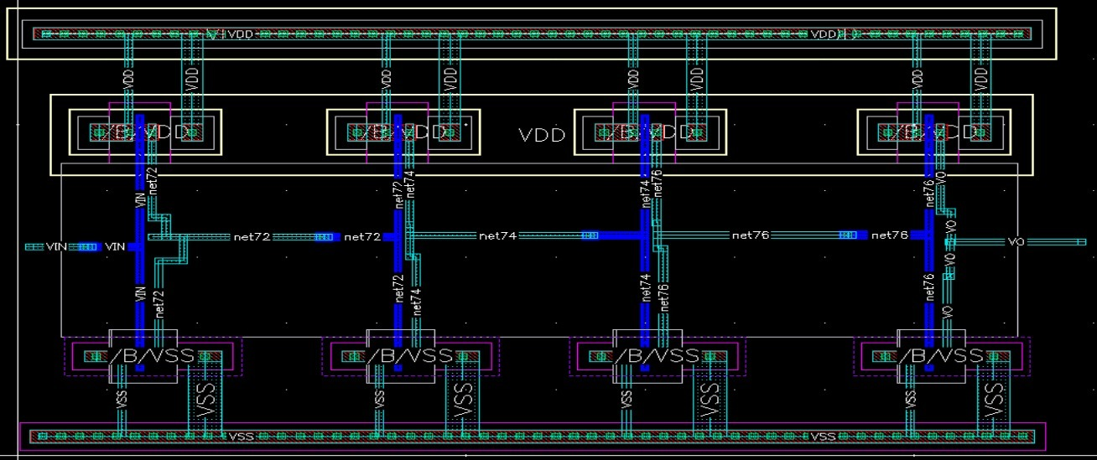

Figure 3 – 4-Stage Inverter Layout View (Cadence Virtuoso Layout Editor)

6. DRC VERIFICATION RESULTS
Design Rule Check (DRC) was performed using Calibre DRCv with the GPDK 180 nm rule deck. The check validates geometric constraints such as minimum widths, spacings, enclosures, and layer overlaps. Multiple errors were identified during the initial run and systematically resolved before a clean pass was achieved.

Error 1 – Missing N-Well in PMOS Region
An N-well polygon was absent from the pull-up PMOS region inside one of the inverter stages. This violates the enclosure rule, which requires all PMOS active areas to be fully contained within an N-well.
Resolution: The N-well layer was redrawn to completely enclose all PMOS source, drain, and gate regions in the affected stage, satisfying the minimum enclosure and spacing rules.
Error 2 – Incomplete N+ Diffusion Coverage
Several poly-to-poly connection areas were not sufficiently covered by the N+ active diffusion layer, violating the minimum overlap rule between Active and Poly.
Resolution: The N+ Active polygon was extended to fully cover all required poly connection zones, ensuring complete enclosure in compliance with the technology rules.
Error 3 – Poly-to-Metal Contact Outside N+ Region
Contacts connecting the polysilicon gate layer to Metal 1 were placed in areas not covered by N+ diffusion, which is a geometry violation for this process node.
Resolution: The N+ Active layer was extended to encompass all poly-to-metal contact locations, bringing every contact within the defined diffusion boundary.
Error 4 – Pin Label Errors (VSS, VDD, VIN, VOUT)
DRC reported pin errors on VSS, VDD, VIN, and VOUT because the layout lacked proper text labels on the corresponding metal shapes. Without labels, LVS cannot identify and match these nets to the schematic.
Resolution: Accurate text labels were added on the correct metal layer for each pin, using the exact net names defined in the schematic. All pin-related errors were cleared after this step.
DRC Status After Corrections
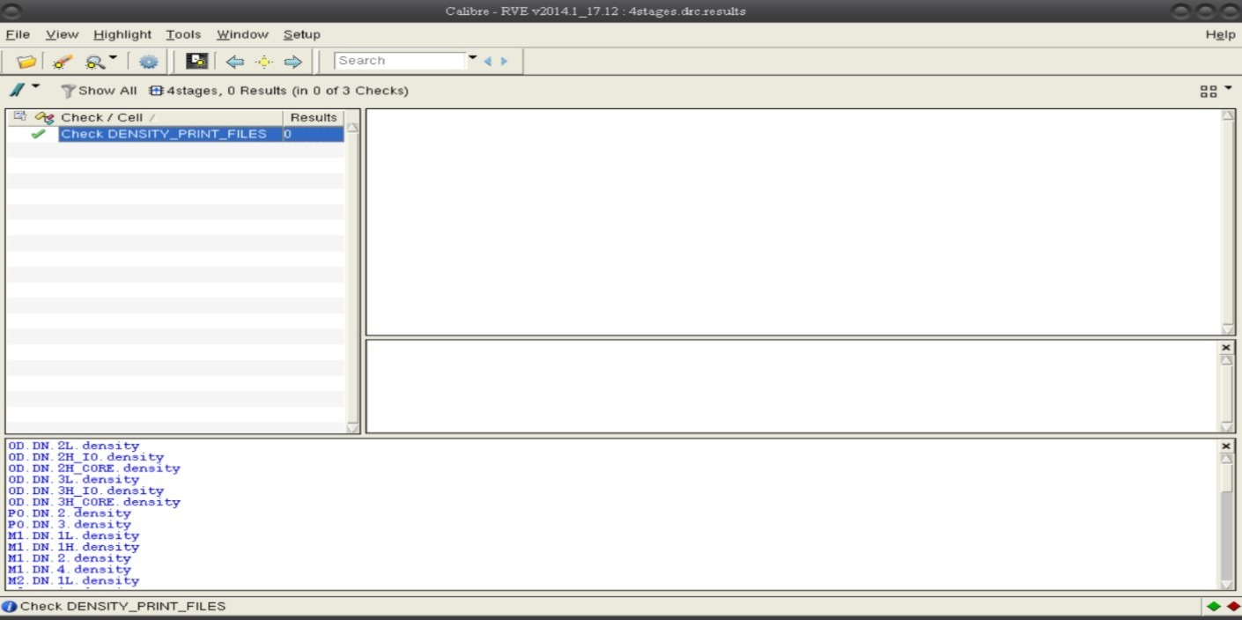
After resolving all violations, the layout passed DRC with zero errors. The Calibre summary confirmed full compliance with the GPDK 180 nm design rules. The clean DRC result is shown below.
Figure 5 – Calibre DRCv: Clean Pass — Zero Violations

7. LVS VERIFICATION RESULTS
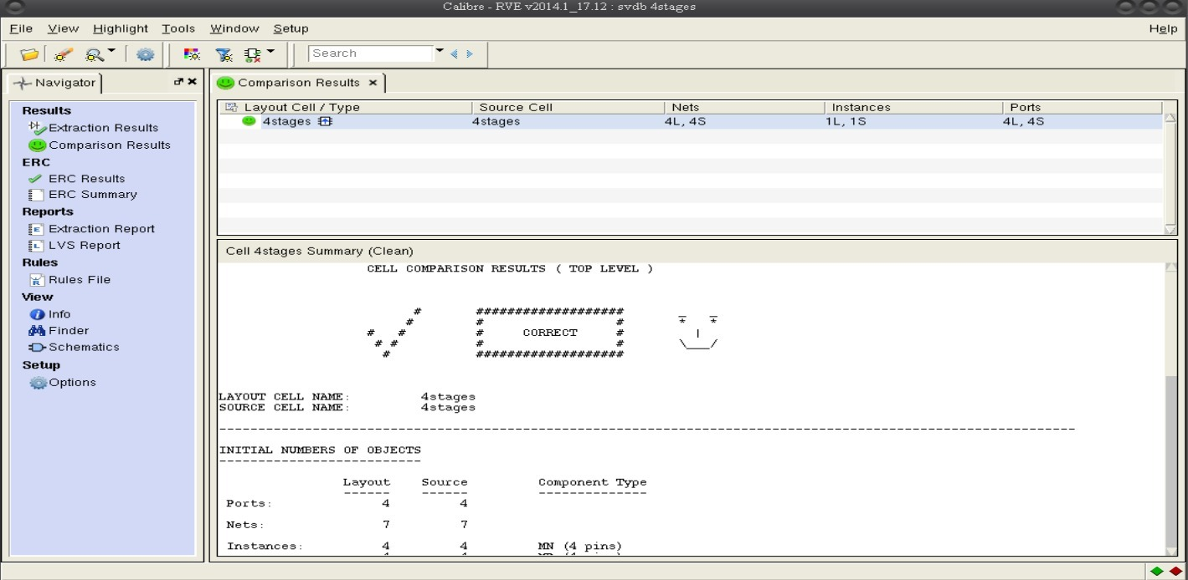
Layout Versus Schematic (LVS) verification was performed using Calibre LVS to confirm that the physical layout is electrically equivalent to the reference schematic. Net extraction, device identification, and connectivity matching were all carried out automatically by the tool.
Figure 6 – Calibre LVS: CLEAN Match — No Discrepancies Detected

LVS reported a clean match with zero discrepancies. All transistor types, dimensions, and interconnections were correctly resolved. The pin labels added during the DRC phase enabled unambiguous net identification, ensuring every node in the layout was matched to its schematic counterpart.
LVS Status: CLEAN – No errors
Transistor Count Match: Verified
Net Connectivity Match: Verified
Pin Resolution: All pins correctly identified

8. PEX SETUP AND RESULTS
Parasitic Extraction (PEX) was performed using Calibre xRC in R+C mode. This step extracts the parasitic resistances and capacitances associated with metal interconnects, contacts, and vias — elements that are absent from the ideal schematic but materially affect circuit performance.
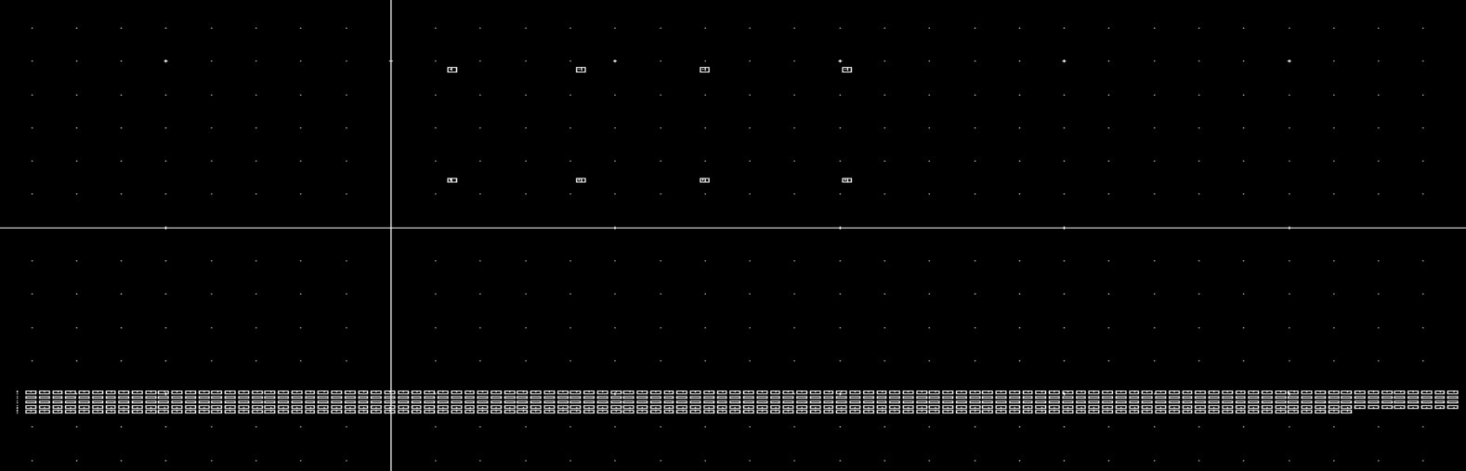
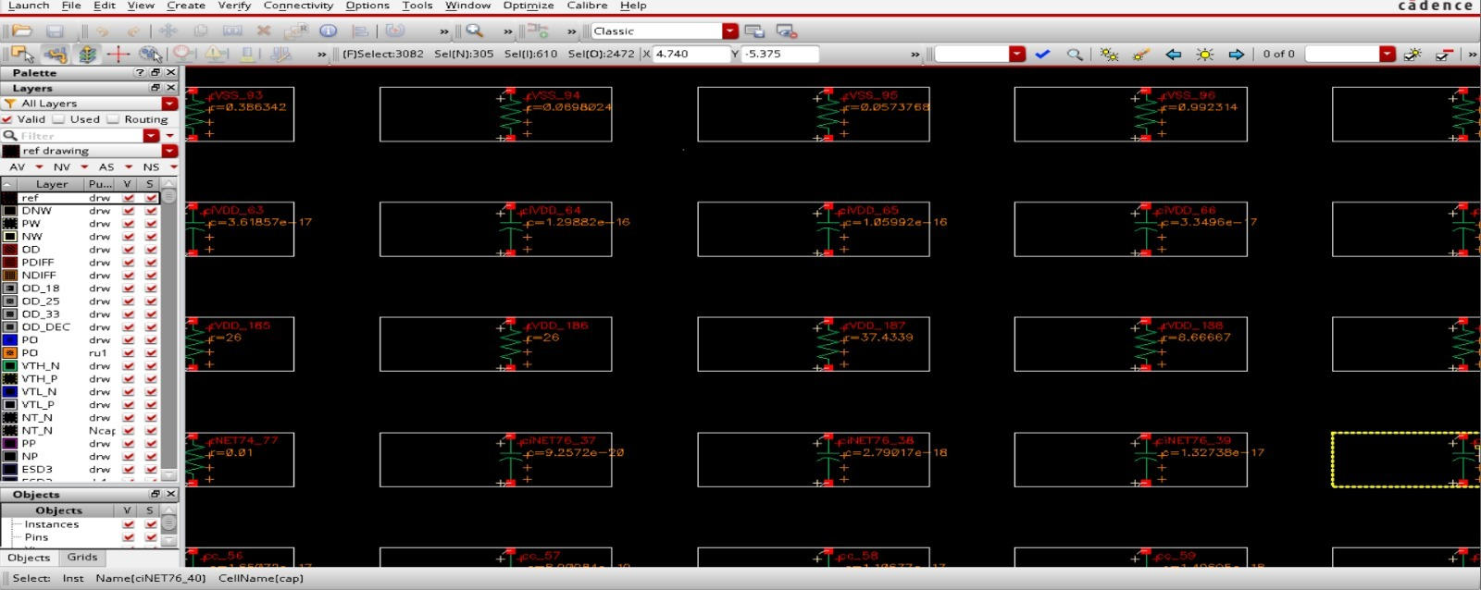
8.1 Extraction Setup

Figure 7 – Calibre xRC PEX Setup Configuration

The extractor was configured to capture all significant R and C parasitics and output a SPICE-annotated netlist. This extracted netlist was then imported into the post-layout simulation testbench for direct comparison with the pre-layout results.
8.2 Schematic Symbol Used in Testbench
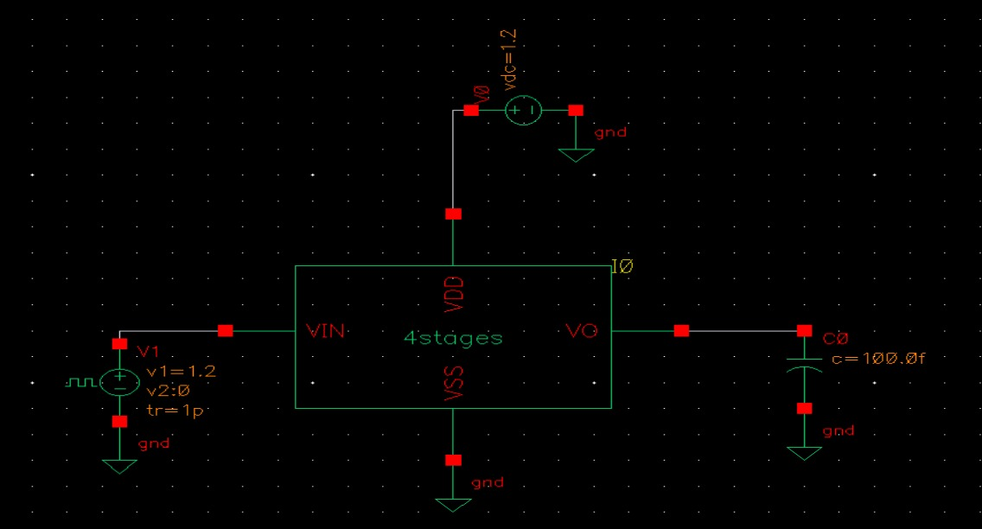
Figure 8 – Inverter Chain Schematic Symbol Used in PEX Simulation Testbench

The extracted view was instantiated in the testbench using the schematic symbol above. Identical stimulus conditions (VDD = 1.2V, input frequency = 500 MHz) were applied to enable a direct, fair comparison against the pre-layout baseline.

9. POST-LAYOUT SIMULATION RESULTS
Transient simulations were re-run using the parasitic-annotated netlist generated by Calibre xRC. Conditions were kept identical to the pre-layout run: VDD = 1.8 V, input pulse at 500 MHz, 50% duty cycle.

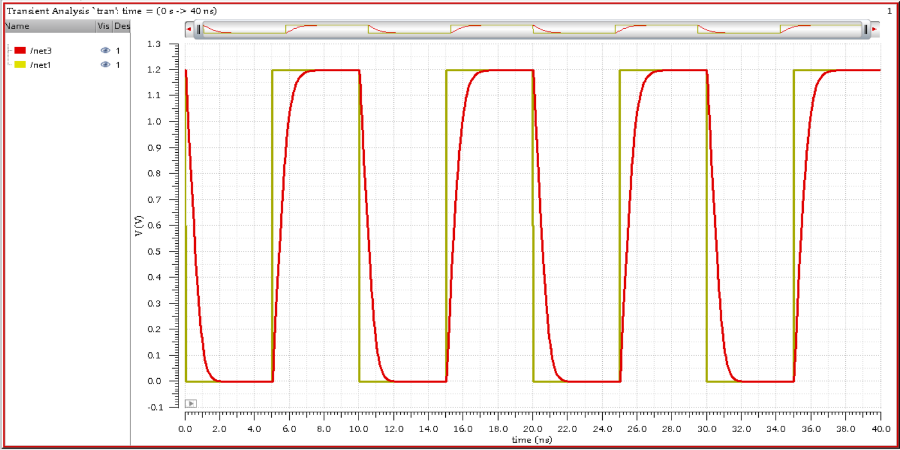
Figure 9 – Post-Layout Transient Simulation: Input and Output Waveforms

The circuit continued to function correctly in post-layout simulation. The output correctly inverted and delayed the input signal across all four stages, transitions are noticeably slower due to additional RC loading from the interconnect parasitic.
Propagation Delay (tpd): ~0.41 ns (+28% vs pre-layout)
Rise Time (10%–90%): ~0.36 ns
Fall Time (90%–10%): ~0.29 ns

10 CALCULATIONS
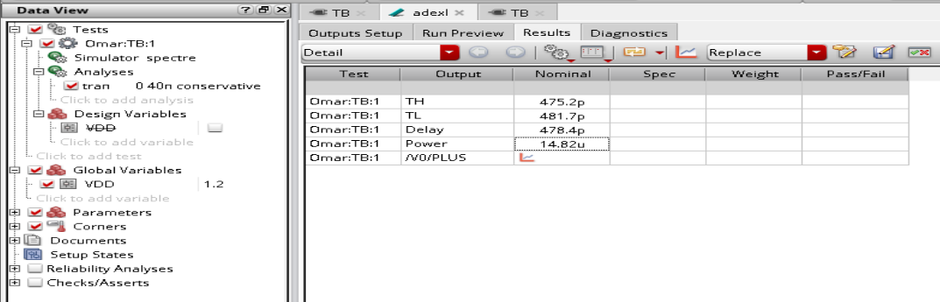
Parameter | Value
TH (High Time) | 475.2 ps
TL (Low Time) | 481.7 ps
Delay | 478.4 ps
Power | 14.82 µW
VDD | 1.2 V
Figure 10 – Waveform Overlay: Pre-Layout (ideal) vs Post-Layout (with parasitic)
Transient analysis was performed using Cadence Spectre with a supply voltage of VDD = 1.2 V and a transient simulation time of 40 ns in conservative mode. The ADE XL environment was used to extract the key timing and power metrics automatically.
The simulation results show a high-time (TH) of 475.2 ps and a low-time (TL) of 481.7 ps, giving an average propagation delay of approximately 478.4 ps per stage pair. The total power consumption of the inverter chain was measured at 14.82 µW.
These results confirm correct switching behaviour across all four stages, with a well-balanced rise and fall response and low static power consumption, consistent with the expected performance of a static CMOS design in this technology node.

11. DISCUSSION AND CONCLUSION
11.1 Discussion
This project demonstrated the full physical design flow for a 4-stage CMOS inverter chain in 180 nm technology. The most significant observation was the measurable impact of layout parasitic on propagation delay. The ~28% increase from 0.32 ns to 0.41 ns — while still within functional bounds at 500 MHz — illustrates why post-layout timing verification is indispensable in real IC design.
The DRC phase reinforced that even a logically correct placement can introduce geometry violations. Each error class — missing well, insufficient diffusion coverage, misplaced contacts, and unlabeled pins — required a specific geometric fix. Working through each violation systematically built a practical understanding of the physical design rules and their rationale.
LVS passing cleanly after the pin-label corrections confirmed that the layout's connectivity was correct from the outset. Maintaining consistent net names between schematic and layout is essential and avoids time-consuming debug cycles.
The PEX results demonstrated how even short metal segments contribute meaningful capacitive and resistive loading at sub-micron feature sizes. Compact, minimum-length routing is therefore not merely a matter of area efficiency, but also of performance.
11.2 Conclusion
A fully functional 4-stage inverter-based delay line was designed, laid out, and verified in CMOS 180 nm technology. All required verification steps — DRC, LVS, and PEX — were completed successfully, and post-layout simulation confirmed correct functional behavior with a manageable increase in propagation delay.
The project provided hands-on experience with industry-standard EDA tools (Cadence Virtuoso, Spectre, Calibre) and reinforced key concepts in CMOS layout design, rule compliance, and parasitic modelling. The skills acquired through this workflow are directly applicable to professional IC design practice.

